Week_4.R

Jason

2023-02-05

# Create variables for the our dataframe  
Frequency <- c(0.6,0.3,0.4,0.4,0.2,0.6,0.3,0.4,0.9,0.2)  
BP <- c(103,87,32,42,59,109,78,205,135,176)  
First <- c(1,1,1,1,0,0,0,0,NA,1)  
Second <- c(0,0,1,1,0,0,1,1,1,1)  
FinalDecision <- c(0,1,0,1,0,1,0,1,1,1)  
  
# Create a dataFrame of variables  
df <- data.frame(Frequency, BP, First,Second,FinalDecision)  
df

## Frequency BP First Second FinalDecision  
## 1 0.6 103 1 0 0  
## 2 0.3 87 1 0 1  
## 3 0.4 32 1 1 0  
## 4 0.4 42 1 1 1  
## 5 0.2 59 0 0 0  
## 6 0.6 109 0 0 1  
## 7 0.3 78 0 1 0  
## 8 0.4 205 0 1 1  
## 9 0.9 135 NA 1 1  
## 10 0.2 176 1 1 1

# Create a Box plot  
boxplot(df)

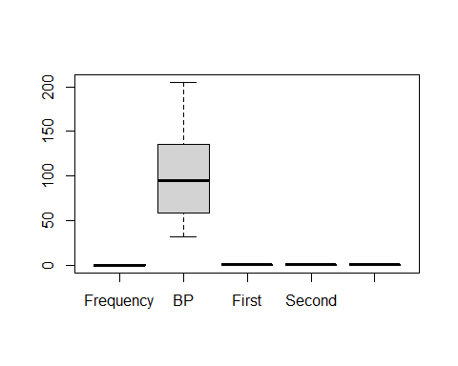

# Create a histogram of each variable  
hist(df$Frequency)

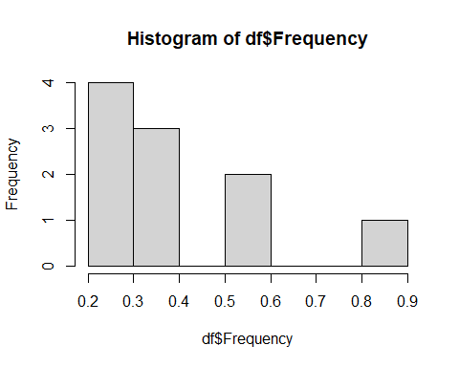

hist(df$BP)

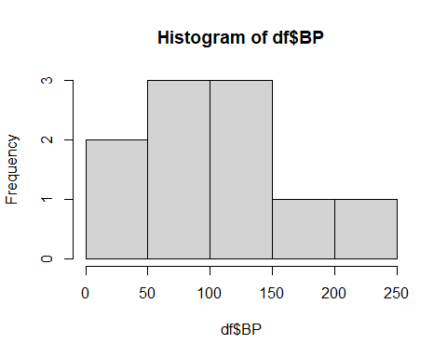

hist(df$First)

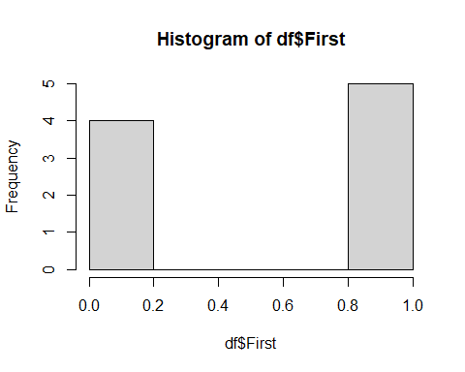

hist(df$Second)

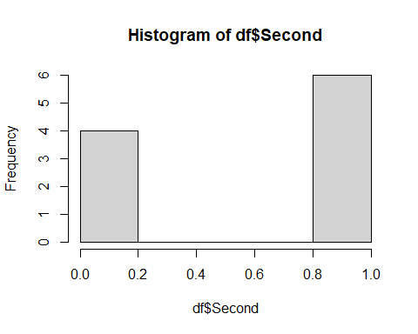

hist(df$FinalDecision)

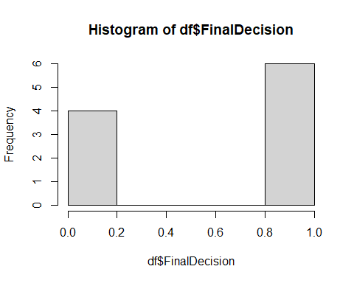

#The mean of the BP variable seems to be around 100 to 150, with a frequency of three.  
  
# Calculate mean of the Final Decision variable  
mean(df$FinalDecision)

## [1] 0.6