ACME SOLUTION INDUSTRY

NETWORK ARCHITECTURE DOCUMENT
Vulnerable Network Lab — Internal Infrastructure Design

Document Title | Network Architecture — Vulnerable Lab Infrastructure
Organisation | ACME Solution Industry
Project | Project 1 — Build & Attack a Vulnerable Network Lab
Authors | Ejiofor Godswill | Demilada
Assessment Period | 1 July 2026 – 8 July 2026
Version | 1.0 — Final
Classification | CONFIDENTIAL — FOR INTERNAL USE ONLY

ACME Solution Industry — Vulnerable Network Lab — July 2026

1. DOCUMENT PURPOSE

This document describes the network architecture and infrastructure design of the deliberately vulnerable network environment constructed by ACME Solution Industry as part of Project 1 — Build & Attack a Vulnerable Network Lab. The environment was designed to simulate a realistic enterprise network containing intentional security flaws, enabling a comprehensive penetration test to be conducted against it by a peer security team.
The architecture implements a three-tier network design consisting of a WAN-facing external segment, a De-Militarised Zone (DMZ) for public-facing services, and an isolated Internal network segment for sensitive internal resources. A Linux-based router enforces segmentation between these tiers using iptables firewall rules.
This document serves as a reference for the defensive team, the penetration testing team, and the grading assessors. It provides complete visibility into the network topology, host configurations, security controls, and the deliberate vulnerabilities introduced at each layer of the stack.

2. NETWORK TOPOLOGY

2.1 Topology Diagram
The following diagram illustrates the complete network topology of the vulnerable lab environment, including all hosts, network segments, IP addressing, and traffic flow paths:

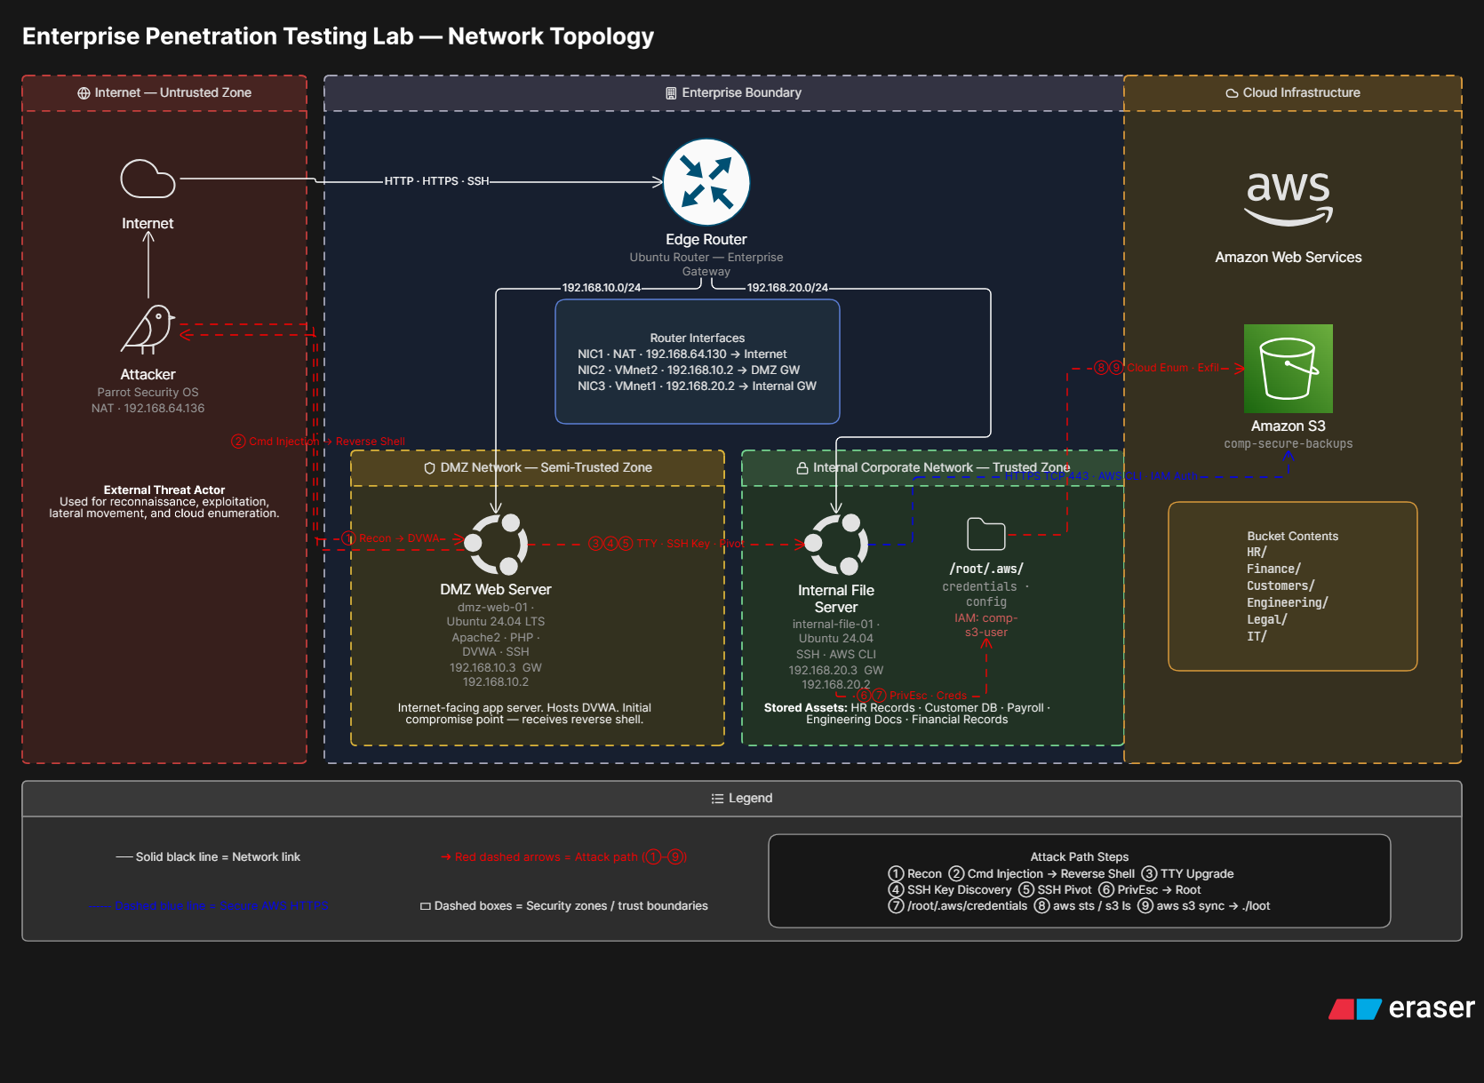
Figure 1 — Network Topology Diagram — ACME Solution Industry Vulnerable Lab

2.2 Network Segment Overview
The environment is divided into three distinct network segments enforced at the hypervisor level using VMware LAN Segments (not Host-only networks — LAN Segments provide genuine isolation by excluding the host machine's routing table from participating in inter-segment communication):

Segment | Type | VMware Network | Subnet | Gateway | Purpose
WAN / External | NAT | VMnet8 (NAT) | 192.168.64.0/24 | 192.168.64.2 (VMware NAT) | Simulates external internet — Parrot attacker and Router WAN interface
DMZ | Isolated | LAN Segment — DMZ | 192.168.10.0/24 | 192.168.10.2 (Router) | Public-facing service tier — DMZ Web Server only
Internal | Isolated | LAN Segment — Internal | 192.168.20.0/24 | 192.168.20.2 (Router) | Protected internal tier — Internal Host only

VMware LAN Segments were selected over Host-only networks specifically because Host-only networks expose routes on the Windows host machine, allowing inter-segment communication that bypasses the router VM entirely. LAN Segments provide true hypervisor-level isolation.

2.3 Traffic Flow
All inter-segment traffic flows exclusively through the Router VM. The following traffic paths are permitted by the iptables FORWARD chain:

Source | Destination | Protocol/Port | Purpose | Direction
Parrot (192.168.64.136) | Router WAN (192.168.64.130:80) | TCP/80 | HTTP access to DVWA via DNAT | Inbound →
Router (iptables DNAT) | DMZ-Web (192.168.10.3:80) | TCP/80 | Forwarded web traffic to DVWA | → DMZ
DMZ-Web (192.168.10.3) | Internal-Host (192.168.20.3) | TCP/22 | SSH lateral movement (deliberate) | → Internal
DMZ-Web (192.168.10.3) | Parrot (192.168.64.0/24) | TCP/4444 | Reverse shell callback | → WAN
Internal-Host (192.168.20.3) | Internet | TCP/443, UDP/53 | Outbound HTTPS and DNS | → WAN
ALL | ALL | ALL others | Denied by default DROP rule | ✗ BLOCKED

3. HOST INVENTORY

Hostname | Role | OS | IP Address(es) | Hypervisor | NICs
routervm | Firewall / Router | Ubuntu Server 24.04 LTS | 192.168.64.130 (WAN)  192.168.10.2 (DMZ)  192.168.20.2 (Internal) | VMware Workstation | 3x NICs (ens33, ens37, ens38)
DMZtarget | DMZ Web Server | Ubuntu Server 24.04 LTS | 192.168.10.3 | VMware Workstation | 1x NIC — LAN Segment DMZ
manager | Internal Host | Ubuntu Server 24.04 LTS | 192.168.20.3 | VMware Workstation | 1x NIC — LAN Segment Internal
Parrot | Attacker Platform | Parrot OS Security Edition | 192.168.64.136 | VMware Workstation | 1x NIC — VMnet8 NAT

4. HOST CONFIGURATION DETAIL

4.1 Router VM (routervm)

4.1.1 Role and Purpose
The Router VM acts as the sole boundary between all three network segments. It performs three distinct functions: IP packet forwarding between segments, Destination NAT (DNAT) to expose the DMZ web server through the WAN interface, and source address rewriting (MASQUERADE) to ensure return traffic is correctly routed back through the router rather than being dropped.

4.1.2 Network Interface Configuration
Interface | VMware Network | IP Address | Role
ens33 | VMnet8 (NAT) | 192.168.64.130/24 (DHCP) | WAN-facing — Parrot attacker side
ens37 | LAN Segment DMZ | 192.168.10.2/24 (Static) | DMZ gateway — DMZ-Web default gateway
ens38 | LAN Segment Internal | 192.168.20.2/24 (Static) | Internal gateway — Internal-Host default gateway

4.1.3 Netplan Static IP Configuration
Static IP addresses are configured via systemd-networkd using the following netplan configuration (/etc/netplan/01-static.yaml):
network:
version: 2
renderer: networkd
ethernets:
ens33:
dhcp4: true # WAN side — DHCP from VMware NAT
ens37:
dhcp4: false
addresses:
- 192.168.10.2/24 # DMZ gateway
ens38:
dhcp4: false
addresses:
- 192.168.20.2/24 # Internal gateway

4.1.4 iptables Firewall Rule Set
All firewall rules are loaded via a startup script (/home/manager/router_startup.sh) executed at boot via cron @reboot, ensuring rules persist across reboots:

Rule # | Chain | In IF | Out IF | Source | Destination | Proto/Port | Action | Purpose
1 | FORWARD | * | * | 0.0.0.0/0 | 0.0.0.0/0 | ESTABLISHED/RELATED | ACCEPT | Allow return traffic for existing sessions
2 | FORWARD | ens33 | ens37 | 0.0.0.0/0 | 192.168.10.3 | TCP/80 | ACCEPT | Parrot → DMZ-Web HTTP
3 | FORWARD | ens37 | ens38 | 192.168.10.3 | 192.168.20.3 | TCP/22 | ACCEPT | DMZ-Web → Internal SSH pivot
4 | FORWARD | ens37 | ens33 | 192.168.10.3 | 192.168.64.0/24 | TCP/4444 | ACCEPT | Reverse shell callback
5 | FORWARD | ens38 | ens33 | 192.168.20.3 | 0.0.0.0/0 | TCP/443 | ACCEPT | Internal HTTPS egress
6 | FORWARD | ens38 | ens33 | 192.168.20.3 | 0.0.0.0/0 | UDP/53 | ACCEPT | Internal DNS egress
7 | FORWARD | ens33 | ens37 | 0.0.0.0/0 | 192.168.10.3 | TCP/22 | ACCEPT | Management SSH to DMZ
8 | FORWARD | ens33 | ens38 | 0.0.0.0/0 | 192.168.20.3 | TCP/22 | ACCEPT | Management SSH to Internal
9 | FORWARD | * | * | 0.0.0.0/0 | 0.0.0.0/0 | ALL | DROP | Default deny — all other traffic

4.1.5 NAT Rules
Table | Chain | Rule | Purpose
nat | PREROUTING | -i ens33 -p tcp --dport 80 -j DNAT --to-destination 192.168.10.3:80 | Rewrites destination of incoming port-80 traffic to DMZ-Web — makes DVWA accessible via router WAN IP
nat | POSTROUTING | -o ens37 -j MASQUERADE | Rewrites source IP for DMZ-bound traffic — ensures DMZ-Web replies route back through router
nat | POSTROUTING | -o ens33 -j MASQUERADE | Rewrites source IP for WAN-bound traffic — ensures reverse shell replies reach Parrot correctly

IP forwarding is enabled persistently via net.ipv4.ip_forward=1 in /etc/sysctl.conf. Without this, the Linux kernel discards packets destined for other interfaces rather than forwarding them.

4.2 DMZ Web Server (DMZtarget)

4.2.1 Role and Purpose
DMZtarget is the public-facing entry point of the vulnerable network. It hosts DVWA (Damn Vulnerable Web Application) v2.5 on Apache 2.4.58, simulating a poorly secured, externally-accessible web application. It is reachable from Parrot only through the router's DNAT rule — it has no direct WAN-side interface.

4.2.2 Network Interface Configuration
Interface | VMware Network | IP Address | Gateway | Type
ens37 | LAN Segment DMZ | 192.168.10.3/24 (Static) | 192.168.10.2 (Router) | Sole network interface

4.2.3 Software Stack
Component | Version | Purpose | Configuration
Ubuntu Server | 24.04 LTS | Operating system | Minimal install, systemd-networkd
Apache HTTP Server | 2.4.58 | Web server | Listening on port 80, Indexes enabled (deliberate)
PHP | 8.3 | Server-side scripting | libapache2-mod-php installed, executes DVWA
DVWA | 2.5 | Vulnerable web application | Security level: LOW, database initialised
OpenSSH | 9.6p1 | Remote access | Running on port 22 (deliberately exposed on DMZ)
MySQL | 8.0 | Database backend | DVWA database configured with default credentials

4.2.4 Deliberately Introduced Vulnerabilities
Vulnerability | Location | Severity | Description
OS Command Injection | DVWA Command Injection module | CRITICAL | User input passed directly to shell_exec() with no sanitisation at LOW security level
Default Credentials | DVWA login | HIGH | Application accessible with default admin/password credentials
Unsecured SSH Private Key | /var/www/.ssh/id_rsa | CRITICAL | RSA private key owned by www-data, no passphrase, grants SSH access to Internal-Host
SSH Exposed on DMZ | Port 22 open externally | HIGH | SSH service should not be accessible on a DMZ-facing host
Apache Directory Listing | Apache Options: Indexes | MEDIUM | Directory contents of /var/www/html/ exposed to unauthenticated users
Apache Version Disclosure | Server HTTP header | LOW | Full version string Apache/2.4.58 (Ubuntu) broadcast in all responses

4.3 Internal Host (manager)

4.3.1 Role and Purpose
The internal host simulates a protected internal server accessible only via lateral movement from the DMZ web server. It contains a privilege escalation vulnerability via a misconfigured sudoers entry, and hosts planted cloud credentials used for the final exfiltration step. It is not reachable directly from the WAN — only via SSH from DMZtarget through the router's FORWARD rule.

4.3.2 Network Interface Configuration
Interface | VMware Network | IP Address | Gateway | Type
ens33 | LAN Segment Internal | 192.168.20.3/24 (Static) | 192.168.20.2 (Router) | Primary network interface
ens37 | VMnet8 NAT | 192.168.64.x (DHCP) | N/A (use-routes: false) | Internet access only — no default gateway pushed

The NAT interface on the Internal Host is configured with dhcp4-overrides: use-routes: false in netplan to prevent VMware's NAT gateway from overriding the router as the default gateway. This maintains correct inter-subnet routing while still allowing outbound internet access via VMware's NAT infrastructure for the cloud exfiltration step.

4.3.3 User Accounts
Username | Type | Shell | Purpose | Sudo Rights
root | System | /bin/bash | Root account — target for privilege escalation | Full (implicit)
manager | Admin | /bin/bash | Management account used during lab build | Full via sudo
devadmin | Low-privilege | /bin/bash | Simulated developer account — attack target | NOPASSWD: /usr/bin/vim only (deliberate misconfiguration)

4.3.4 Deliberately Introduced Vulnerabilities
Vulnerability | Location | Severity | Description
Sudo NOPASSWD — vim | /etc/sudoers | CRITICAL | devadmin ALL=(ALL) NOPASSWD: /usr/bin/vim — vim shell escape grants immediate root
SSH Key Authentication | /home/devadmin/.ssh/authorized_keys | CRITICAL | Public key installed granting password-free access to attacker holding DMZtarget's private key
Cloud Credentials on Disk | /root/.aws/credentials | CRITICAL | AWS/Oracle Cloud API keys stored in plaintext in root's home directory
Unrestricted Egress | Router iptables rule 5 | MEDIUM | Outbound HTTPS from internal host not restricted to approved destinations — enables data exfiltration

4.4 Attacker Platform (Parrot)

4.4.1 Role and Purpose
The Parrot OS instance simulates an external threat actor. It has no special privileges or prior knowledge of the target environment. It sits on the WAN-side NAT network and can only reach the target infrastructure through the router's WAN IP address (192.168.64.130).

4.4.2 Network Interface Configuration
Interface | VMware Network | IP Address | Gateway
ens33 | VMnet8 NAT | 192.168.64.136/24 (DHCP) | 192.168.64.2 (VMware NAT)

4.4.3 Tools Available
Tool | Purpose | Usage in This Assessment
nmap | Network scanning and service enumeration | Initial reconnaissance — port/service/version discovery on router WAN IP
gobuster | Web directory enumeration | Discovery of /DVWA/ path on target web server
Firefox | Web browser | DVWA interaction, command injection delivery
netcat (nc) | TCP listener and connectivity testing | Reverse shell listener on port 4444
curl | HTTP/HTTPS request tool | Testing web connectivity, cloud bucket exfiltration
SSH client | Secure shell | Management access via ProxyJump through router
python3 | Scripting | PTY spawn for shell upgrade post-exploitation

5. CLOUD INFRASTRUCTURE

5.1 Oracle Cloud Object Storage
An Oracle Cloud Infrastructure (OCI) Object Storage bucket was provisioned as the final target in the attack chain, simulating a misconfigured cloud storage resource containing sensitive organisational data. The bucket represents the exfiltration destination — data that an attacker with root access to the internal host and discovered cloud credentials can access and download.

5.2 Bucket Configuration
Setting | Configuration | Security Status
Visibility | Public | MISCONFIGURED — should be Private
Access Control | No authentication required for read | MISCONFIGURED — unauthenticated access enabled
Encryption at Rest | Default OCI-managed | Acceptable — does not prevent access once bucket is public
Access Logging | Disabled | MISCONFIGURED — no audit trail of access
Versioning | Disabled | Not configured — no object history
Data Contents | Seeded sensitive data (fake customer CSV, internal credentials) | CRITICAL EXPOSURE

5.3 Access Chain
The cloud infrastructure is accessed via the following chain during the penetration test:
- Attacker achieves root on Internal-Host (192.168.20.3) via the privilege escalation chain
- Attacker discovers /root/.aws/credentials containing Oracle Cloud API keys
- Internal-Host's outbound HTTPS rule (router FORWARD rule 5) permits TCP/443 to the internet
- Attacker uses curl to access the publicly-readable bucket endpoint directly — no API keys strictly required due to public-read misconfiguration
- Sensitive data is exfiltrated to /tmp/ on the Internal-Host and confirmed downloaded

6. INTENDED ATTACK CHAIN

The network was designed to support a specific, chained attack path from initial external reconnaissance through to cloud data exfiltration. Each vulnerability in the chain depends on the previous step, creating a realistic multi-stage compromise scenario:

Step | Stage | From | To | Technique | Vulnerability Exploited
1 | Reconnaissance | Parrot (External) | Router WAN IP | nmap -sV -sC | None — passive scanning
2 | Initial Access | Parrot | DMZtarget via router DNAT | OS Command Injection | DVWA Command Injection (LOW security)
3 | Discovery | DMZtarget (www-data shell) | Local filesystem | find /var/www -name id_rsa | Unsecured SSH private key
4 | Lateral Movement | DMZtarget (www-data) | manager (Internal-Host) | SSH with discovered key | Unprotected private key + authorized_keys
5 | Privilege Escalation | manager (devadmin) | manager (root) | sudo vim -c ':!/bin/bash' | sudo NOPASSWD vim misconfiguration
6 | Discovery | manager (root) | Local filesystem | cat /root/.aws/credentials | Cloud credentials stored in plaintext
7 | Exfiltration | manager (root) | Oracle Cloud Bucket | curl https://objectstorage... | Public cloud bucket + unrestricted egress

7. SECURITY CONTROLS

The following security controls are implemented in the environment. Note that while these controls are present, the deliberately introduced vulnerabilities provide clear bypass paths for each:

Control | Implementation | Bypass in This Lab
Network Segmentation | LAN Segments enforcing DMZ/Internal isolation at hypervisor level | Router's SSH FORWARD rule (rule 3) permits DMZ-to-Internal pivot via discovered SSH key
Firewall (iptables) | Default-deny FORWARD policy with explicit allow rules | Reverse shell uses permitted port 4444 outbound; SSH pivot uses permitted port 22
DNAT / NAT | DMZ-Web not directly reachable — accessed only via router DNAT | Attacker reaches DVWA via DNAT as intended; same rule enables exploitation
MASQUERADE | Source IP rewriting hides internal addressing from WAN | Does not prevent exploitation — functional security measure only
SSH Key Authentication | Password authentication not the primary vector | Key discovered on DMZ-Web filesystem — bypassed by T1552.004
User Account Separation | devadmin lacks general sudo rights | NOPASSWD vim entry provides trivial privesc — GTFOBins T1548.003

8. MANAGEMENT ACCESS

8.1 Administrative SSH Access Pattern
Administrative access to DMZ-Web and Internal-Host is provided via a bastion/jump host pattern through the Router VM. The router is the only VM with a NAT-side interface accessible from the Windows host machine. All management connections to isolated VMs are proxied through it:

# Windows host ~/.ssh/config
Host router
HostName 192.168.64.130
User manager

Host dmz-web
HostName 192.168.10.3
User <admin-user>
ProxyJump router

Host internal-host
HostName 192.168.20.3
User devadmin
ProxyJump router
IdentityFile ~/.ssh/lab_internal_id_rsa

This management pattern reflects real-world enterprise bastion host architecture. In production, the bastion host function and the router/firewall function would be separated onto dedicated infrastructure to prevent a compromised jump host from also being the network firewall.

9. KNOWN ISSUES & DESIGN DECISIONS

Issue | Root Cause | Decision / Workaround
Router WAN IP is DHCP | VMnet8 NAT assigns IPs dynamically — static not possible without VMware config changes | Accepted — WAN IP floats; iptables rules use interface names not IPs; payloads must reference current WAN IP
Docker installed on all VMs | Pre-existing Ubuntu template had Docker installed | Disabled permanently via systemctl disable docker on all VMs — Docker hijacks iptables nat table which breaks custom routing rules
iptables rules lost on reboot | netfilter-persistent unreliable when switching from NetworkManager to networkd | Replaced with cron @reboot startup script (/home/manager/router_startup.sh) that reloads all rules on every boot
Internal-Host dual NIC | NAT NIC added for internet access (cloud exfil step) | dhcp4-overrides: use-routes: false prevents NAT gateway from overriding router as default — both internet and inter-subnet routing work correctly
VMware Host-only initial design | Initially used Host-only VMnets — Windows host machine has routes to all Host-only subnets, bypassing router | Switched to LAN Segments — truly isolated, host machine has no routes to these networks

10. DOCUMENT SIGN-OFF

Role | Name | Signature | Date
Cybersecurity Lead | Ejiofor Godswill | ________________________ | 8 July 2026
Cloud Engineering Lead | Demilada | ________________________ | 8 July 2026
Assessor / Grader | ________________________ | ________________________ | ________________________

ACME Solution Industry — Network Architecture Document — CONFIDENTIAL — July 2026

