To receive all points, the written report presents a cohesive written analysis that:

* Summarises the analysis (5 points)
* The major task to help school board and mayor to make strategic decisions regarding future school budgets and priorities.
* With the provided data its easy to pull the record area-wide standardised test results for analyse. After sorting the data I have access to every student's maths and reading scores, as well as various information on the schools they attend.
* I can provide 15 school’s test results in maths and reading, per student budget, overall school budget and size of the schools
* Low performance school’s dataset indicates which schools needs more help in which area
* High performance schools indicate most top schools, May in reading or Maths or may be overall
* Larger schools are clearly underperforming schools.
* A screenshot of a loading bar

  Description automatically generated
* It again giving feedback, when spending amount is higher performance drops
* 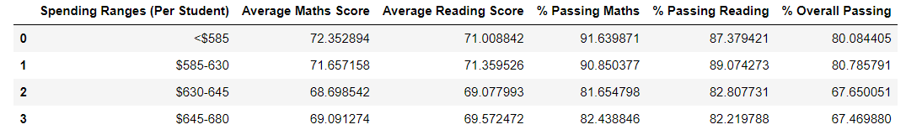

now we have the filtered data set for lowest performing schools

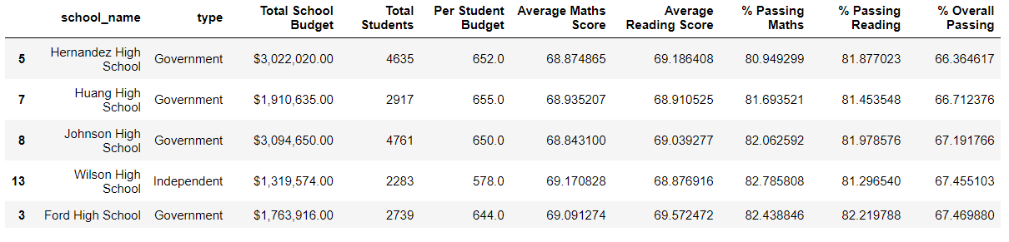

Which support the per spending per student budget falls into higher.

* Some schools are government, and some schools are independent.

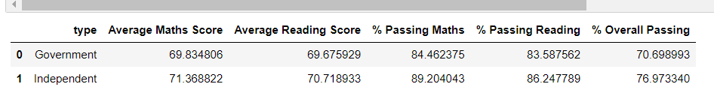

With this data it’s easy to determine that independent schools are performing better than Government