[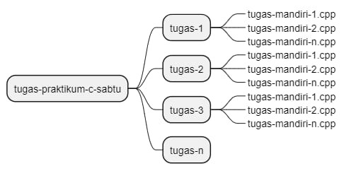](ek)

[https://github.com/Eka567/tugas-mandiri-eka-ramdani](ek)

[https://github.com/Eka567/tugas2](ek)

<https://github.com/Eka567/tugas3>

<https://github.com/Eka567/tugas1.5>