Retail Performance Analytics — Executive Report
1. Executive Summary
2. Business Objective
3. Data & Methodology
4. Key Performance Indicators
5. Revenue Performance
6. Customer Segment Analysis
7. Product Performance
8. Geographic Performance
9. Key Insights
10. Business Recommendations
11. Conclusion

Executive Summary
This analysis evaluates the performance of retail businesses in terms of sales, orders, customers, products, customer segments and geographic markets. The aim is to identify the main drivers of commercial performance, understand customer and product behaviour, and highlight opportunities to increase revenues, maintain customers, and improve market performance. The business generated total revenues of £10,642,110.80 from 19,960 orders and 4,338 unique customers, with an average order value of about £533. These headlines show a significant level of commercial activity throughout the studied period, with significant variations in performance between the months, customers groups, products and markets. The monthly results were uneven. Revenues reached their highest level in November 2011, at approximately £50 million, while revenues in December 2011 reached approximately £638,000. As a result, monthly trends indicate significant demand fluctuations, suggesting seasonal changes, purchasing patterns, and changes in customer activities could affect overall performance.

The customer analysis shows that the value concentration is high among the most efficient customer segments. The Champions segment generated approximately £5.74 million in revenue and was the largest contributor among the identified RFM segments. This highlights the importance of maintaining high-value customers, while developing strategies to move customers from low engagement or risk groups towards more frequent and higher-value purchasing behaviour.

Product performance is similarly concentrated in a relatively small number of products. REGENCY CAKESTAND 3 TIER was the most profitable individual product, producing about £174,157 during the analysis period. The focus on revenue between leading products provides opportunities to protect the availability and performance of high-value products, while identifying complementary products that can increase the basket.

From a geographical perspective, the United Kingdom has maintained its position as the leading market in terms of overall revenue, generating around £7.28 million in the customer-country analysis. Nevertheless, various international markets have shown significantly higher revenue per customer, suggesting that market size does not always equate to customer value. This presents an opportunity to assess international markets by considering both total revenue and customer-level value, rather than depending solely on aggregate sales.

In summary, the analysis reveals a business with robust revenue generation, yet with notable concentration across customers, products, and markets. The most promising opportunities are likely to arise from safeguarding high-value customer relationships, enhancing engagement with at-risk and less engaged customers, comprehending the factors influencing monthly revenue variations, and expanding into international markets where customer value is relatively high.

Business Objective
The aim of this project is to evaluate retail performance using transactional sales data and to identify factors influencing revenue, customer value, product performance, and geographic performance.
The analysis focuses on five key business issues:
1. How will revenues change over time and when will the strongest and weakest periods occur?
2. What customer groups produce the highest value and require more engagement or retention efforts?
3. What products contribute most to revenue?
4. What countries and markets generate the greatest commercial value?
5. What actionable insights can be derived from the analysis to support revenue growth, customer retention and improved commercial decision-making?
The overall objective is to convert transaction data into practical business intelligence to support evidence-based decisions on customer, product, market, and revenue performance.

Data & Methodology
The analysis was conducted using a transactional retail dataset containing invoice-level sales information, including invoice numbers, product codes and descriptions, quantities, prices, customer identifiers, transaction dates and countries. Data was prepared and analysed using PostgreSQL and Tableau was used to develop the final interactive dashboard.
The data preparation process included reviewing the structure and quality of source data, removing or excluding records that are not suitable for income analysis, calculating transaction revenues, and creating clean analytical fields for date, order, product, and customer. Revenues were calculated from transaction quantities and unit prices, while cancelled or non-merchandising operations were excluded from the relevant product-level analysis. The analysis was structured around several complementary techniques. Monthly revenue analyses are used to identify changes in sales performance over time. The customer-level analysis examined order frequency, revenue contributions, and customer value. RFM segmentation was applied using Recency, Frequency and Monetary Value to classify customers into groups, including champions, loyal customers, potential loyalists, new customers, at risk, at high risk of value, at low engagement and need attention.
Product analysis analysed sales units, order activity, and revenues, including revenue concentration in the best products. Geographical analyses compare customers, orders, total revenue and revenue per customer across countries. Order-level analysis is also used to evaluate basket behaviour, average order values, and distribution of order values. SQL is used as the main analytical tool for the conversion and aggregate of data, and Tableau is used to communicate the results of information through KPI cards, trend analysis, and comparative visualisation.
The methodology was designed to transfer from data preparation and descriptive analysis to customer, product and geographic insights that can support practical business decisions.

Key Performance Indicators
Four headline performance indicators were identified from the analysis conducted, and these indicators provide an overall view of the business: total revenue, total orders, unique customers and average order value.
- Total Revenue – £10,642,110.80
- Total Orders – 19,960
- Unique Customers – 4,338
- Average Order Value – approximately £533
The baseline for assessing the scale and efficiency of the business was provided by these indicators. Total revenue represents total commercial value generated during the entire period. Total orders and unique customers give insight into the volume and breadth of customer activity. Average order value provides insight into the value generated per transaction and this is used with customer and product analysis for better understanding into purchasing behaviour.
The KPIs indicate a substantial retail operation with broad customer base and major transaction activity. However, these figures do not only explain the generated revenue or how and where performance can be improved. As such, further analysis examines revenue trends, customer segments, geographic and product markets to aid in identifying the underlying drivers of performance.

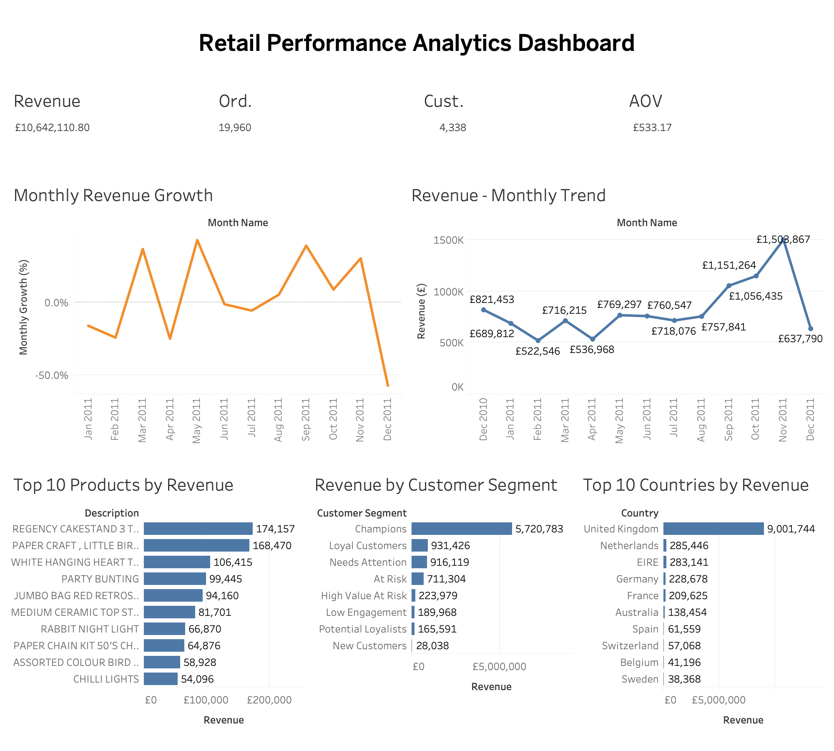
Figure 1. Retail Performance Analytics Executive Dashboard
Source: Retail transaction analysis and Tableau dashboard

Revenue Performance
Revenue did perform much differently for this analysed timeframe. Monthly Revenue increased from £821,453 in December 2010 to £1.50 million in November 2011 and then decreased to approximately £638,000 in December of 2011.
November 2011 generated the most revenue out of the months listed, with revenues around £1.50 million, and the lowest monthly revenue in 2011 was recorded in December at approximately £638,000. The sharp decline shows that month-over-month purchasing behaviours changed much throughout this period. There were periods of recovery and expansion throughout the year. Performance was comparatively weaker during in the beginning and middle months of 2011 before a substantial bounce back from September to November. £1.06 million, £1.15 million and £1.50 million were recorded during September to November respectively.

The monthly growth analysis reinforces the volatility of sales performance. Instead of following a consistent upward trajectory, revenue changed throughout the period, insinuating that purchasing patterns and seasonal factors may have played an important role. Further, the significant December drop following the rise between September and November needs further inspection to check if these trends are simply seasonable, or if the business made any strategic change or customers stopped buying for some reason.

In summary, it appears that the business demonstrated the strength to generate significantly higher monthly revenue during peak periods. Understanding these peaks could aid management in learning which strategy could help replicate successful sales conditions while preparing for predictable periods of weaker demand.
Customer Segment Analysis
The customer analysis was performed using order frequency and RFM segmentation to understand the differences in the customer's value and engagement. The RFM framework assesses Recency, Frequency and Monetary Value, allowing customers to group according to the pace of purchases and revenues generated. The Champions segment was the strongest customer group with sales of approximately £5.74 million. This represents a significant proportion of the value of the customer and shows the importance of maintaining customers who often buy and generate high monetary value. Other segments showed significantly lower revenue contributions. Needs Attention and Loyal customers represent additional sources of income, while customers At Risk, High Value At Risk and Low Engagement represent groups in which buying behaviours could potentially be improved by targeted retention and reengagement strategies.
Analysis has shown that the number of customers and the value of customers are not distributed uniformly. Relatively few customers may contribute to disproportionate revenue, so customer segmentation is particularly useful in determining marketing and retention priorities. From a commercial point of view, the results suggest that companies should protect their most valuable relationships and develop targeted strategies for customers with signs of reduced participation. Transforming promising customers into loyal customers and restoring highly appreciated customers that are becoming inactive could provide opportunities to increase the value of customer life without relying solely on the acquisition of new customers.
Product Performance
Product-level analysis found significant differences in sales volume and revenue contributions in the product catalogue. The analysis took into account the sales units, transaction activities, revenue and revenue per unit to distinguish products that generate high revenue from products that generate a large volume of sales.

REGENCY CAKESTAND 3 TIER was the most profitable product identified, getting approximately £174,157 during the analysis period. Other high-performance products include the PAPER CRAFT, LITTLE BIRDIE, the WHITE HANGING HEART T-LIGHT HOLDER, PARTY BUNTING, and the JUMBO BAG RED RETROSPOT. The results show that the revenue from the product is concentrated in a relatively small group of high-performing products. This creates opportunities and risks: strong products provide a reliable source of income, but excessive dependence on a limited number of products increases risk to stock availability, demand changes, and product specific performance.

Therefore, product analysis should support decisions on inventory planning, product promotion and cross-selling. High-value products should be given the appropriate attention to availability and stock levels, while complementary products can be promoted alongside popular products to increase the value of the basket and diversify revenue across the product range.

Geographic Performance
Geographical analysis shows that the United Kingdom is the dominant market for global revenues and generated around £7.28 million in customer-country analysis. This reflects the size of British clients and their importance to the overall commercial performance of the company. However, total revenues alone do not provide a complete picture of market performance. Some smaller international markets have generated significantly higher sales per customer. For example, the Netherlands generated about £31,716 per customer, while Australia generated about £15,384 per customer. These results indicate that some small markets may have particularly valuable customers despite their absolute low sales.

Other European markets, such as Germany, France, Switzerland, Spain and Denmark, also demonstrated significant customer activity and income levels. This proves that international clients have been established beyond the United Kingdom. The results suggest that geographical strategies should take both market size and customer value into account. The United Kingdom should remain an important core market, while smaller international markets with high customer revenues can provide opportunities for targeted expansion, retention and customer acquisition initiatives.

Key Insights
- Revenue is primarily concentrated during peak periods – Monthly revenue saw a significant increase in the last quarter of 2011, peaking at around £1.50 million in November before experiencing a sharp decline in December. This reflects considerable fluctuations in purchasing behaviour throughout the year.
- High-value customers account for a considerable portion of revenue – The Champions segment alone generated about £5.74 million, illustrating that a relatively small group of highly engaged customers plays a crucial role in contributing to overall customer value.
- Product performance is highly concentrated – A limited selection of products yields a disproportionately large amount of revenue, with the REGENCY CAKESTAND 3 TIER standing out in the merchandise analysis at approximately £174,157.
- The UK serves as the primary revenue market – The United Kingdom accounted for roughly £7.28 million in the customer-country analysis, establishing it as the leading market in terms of total revenue.
- Smaller international markets can exhibit high customer value – Countries like the Netherlands and Australia produced significantly higher revenue per customer compared to the UK, revealing opportunities that may not be evident from total revenue figures alone.
- Customer retention presents a notable opportunity – The existence of At Risk, High Value At Risk, and Low Engagement segments suggests that the business has customers whose purchasing behaviour could potentially be revitalised or enhanced through targeted engagement strategies.

Business Recommendations
- Enhance the retention of high-value customers – Prioritise Champions and Loyal Customers by offering personalised promotions, early access to new products, loyalty rewards, and targeted communications. Safeguarding these relationships is crucial as these customers significantly contribute to revenue.
- Create targeted re-engagement campaigns – Design distinct campaigns for At Risk, High Value At Risk, and Low Engagement customers. High-value customers exhibiting a decline in engagement should receive priority retention efforts, while lower-value inactive customers can be approached through cost-effective automated campaigns.
- Leverage peak-period insights to enhance sales planning – Examine the reasons behind the robust performance from September to November and utilise these insights to guide future promotional, inventory, and marketing strategies. In cases of seasonal demand patterns, resources should be allocated in advance of anticipated peaks.
- Ensure the availability of high-performing products – Closely monitor inventory and demand for the highest-revenue products. Popular items should be prioritised in stock planning, while recommendations for complementary products can be employed to increase basket size and lessen reliance on a limited range of products.
- Selectively develop high-value international markets – Assess smaller markets that exhibit high revenue per customer for targeted expansion, rather than concentrating solely on total market revenue. Factors such as customer value, repeat purchasing, and order economics should be taken into account when distributing international marketing resources.
- Utilise customer and product analytics as a continuous management tool – Regularly refresh RFM, product, geographic, and revenue analyses to promptly identify and respond to changes in customer behaviour, product demand, and market performance.

Conclusion
This analysis offers a thorough overview of retail performance in terms of revenue, customer base, product offerings, and geographic markets. The business exhibits robust overall commercial activity; however, performance is notably concentrated within specific customer segments, products, and markets.

The results underscore the significance of retaining high-value customers, effectively managing top-performing products, comprehending monthly demand fluctuations, and pinpointing international markets that present substantial customer-level value. Implementing these insights through focused retention strategies, sales planning, product management, and market development can foster more sustainable revenue growth and enhance customer relationships. The Tableau dashboard presents a unified view of the essential findings and can act as a valuable management tool for tracking performance and facilitating data-driven commercial decisions.

