**PROJECT SYNOPSIS**

**HOME AUTOMATION**

SUBMITTED IN PARTIAL FULFILLMENT OF THE REQUIREMENT FOR THE AWARD OF

THE DEGREE OF

##### BACHELOR OF TECHNOLOGY

**(Electronics and Communication Engineering)**



JAN-JUNE 2023

###### SUBMITTED BY:

###### NIBHAPRIET KAUR (12002012)

**DEPARTMENT OF ELECTRONICS AND COMMUNICATION ENGINEERING**

PUNJABI UNIVERSITY, PATIALA

**CHAPTER – 1**

**HOME AUTOMATION**

**INTRODUCTION**

Smart homes are becoming increasingly popular with the advancement in technology. A smart home is a home equipped with technology that enables remote monitoring and control of various household appliances and systems. In this project, we aim to design and develop a smart home system that allows users to control various household appliances and systems using their smartphones.

The proposed smart home system consists of various components, including sensors, controllers, and communication devices. We will use various sensors such as temperature sensors, humidity sensors and motion sensors to collect data about the environment in the house. The collected data will be transmitted to a controller that will analyse it and make decisions based on the data. The controller will then send commands to various appliances and systems to control them.

The communication between the controller and the appliances will be through a wireless network. We will use Wi-Fi or Bluetooth technology for this purpose. The users will be able to access the system using their smartphones, where they will have a user interface to control various appliances and systems.

For the implementation of the smart home system, we will use a microcontroller board such as the Arduino or Raspberry Pi. We will connect various sensors to the microcontroller board and write code to collect data from the sensors. We will also write code to analyse the collected data and make decisions based on it.

For controlling various appliances and systems, we will use relays. The relays will be connected to the microcontroller board, and we will write code to control the relays based on the decisions made by the microcontroller board. The relays will be used to turn appliances on and off, adjust their settings, and control other systems such as lighting and security.

To allow users to access the system using their smartphones, we will develop a mobile application. The mobile application will have a user interface where users can control various appliances and systems in their homes.

**BLOCK DIAGRAM**

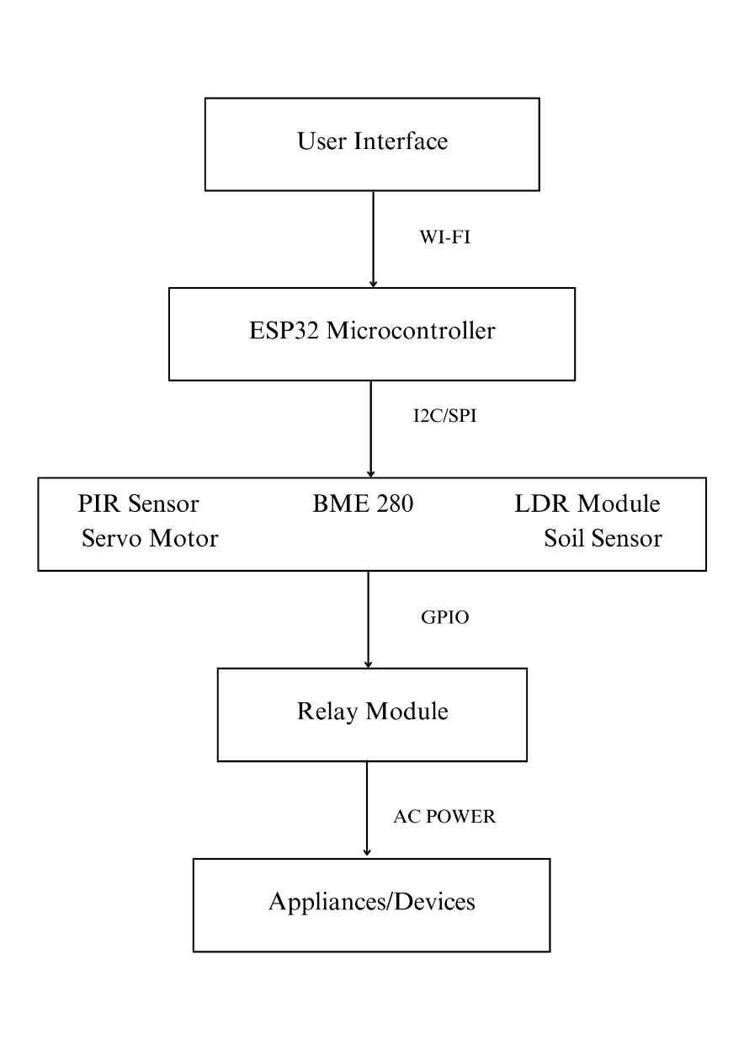

Fig Block Diagram.

**CIRCUIT DIAGRAM**

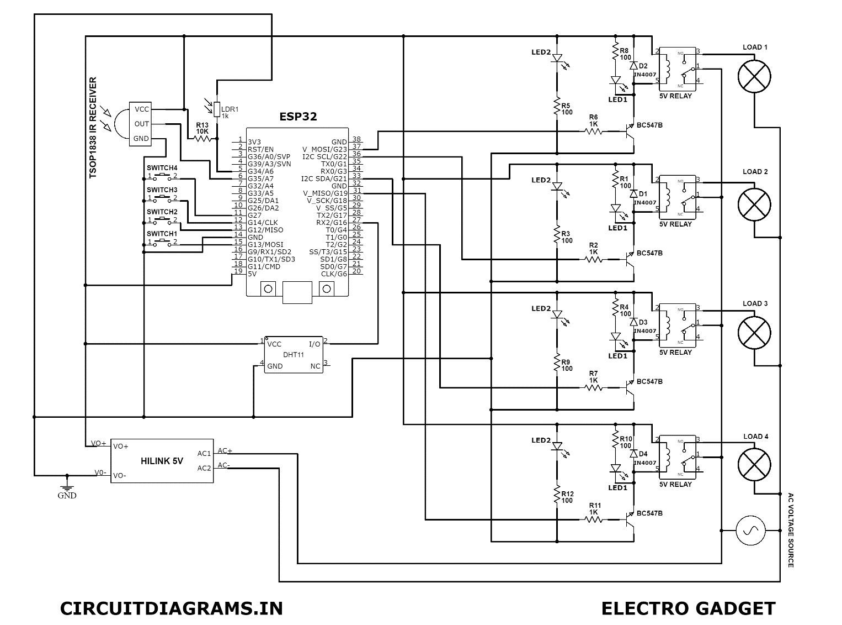

**COMPONENTS USED**

1 ESP32 MODULE

2. RELAY MODULE

3. BME 280

4. IR SENSOR

5. LDR MODULE

6. SERVO MOTOR

7. SOIL SENSOR

**SOFTWARE USED**

ANDUINO IDE

**ADVANTAGES**

There are several advantages of home automation, including:

1. Convenience: Home automation allows you to control various aspects of your home from a single device, such as your smartphone or tablet. You can turn on/off lights, adjust the thermostat, lock/unlock doors, and even start your coffee maker with the touch of a button.

2. Energy efficiency: By automating your home's lighting, heating, and cooling systems, you can save energy and reduce your utility bills. For example, you can set your thermostat to adjust the temperature based on your schedule or turn off lights in unoccupied rooms to save energy.

3. Improved security: Home automation can help you keep your home safe and secure. You can install smart locks, security cameras, and motion sensors to monitor your home and receive alerts if there is any suspicious activity.

4. Increased comfort: With home automation, you can customize the settings in your home to suit your preferences. For example, you can set the temperature to your preferred level or adjust the lighting to create the perfect ambiance.

5. Remote access: With a home automation system, you can control your home from anywhere in the world as long as you have an internet connection. This means you can check on your home, adjust settings, and receive alerts from your smartphone, tablet, or computer.

Overall, home automation can make your life easier, more comfortable, and more secure while also saving you time and money.