LearnSphere AI Active Workspace Booklet
MindForgeAI Internship 2026 | Chatake Innoworks Pvt. Ltd.
LearnSphere AI Team: Vaishnavi Mali (2026IT012, Team Lead), Nagweni Kumbhar (2026IT011), Aishwarya Ekanath (2026IT010)
Companion files: ACTIVE_WORKSPACE_BOOKLET.md, CHANGE_MAP.md, INTEGRATION_GUIDE.md, RELEASE_CHECKLIST.md, and CHANGE_REQUEST_TEMPLATE.md.

1. Purpose
The active workspace at D:\LearnSphere_AI_ActiveWorkspace is the approved place for future changes. It is separate from the baseline project folder and has its own local server on port 5051.

2. Start and Stop Localhost
Run .\04_active_workspace\RUN_LOCALHOST.ps1 from the active workspace, then open http://localhost:5051. Stop the server with Ctrl+C or run .\04_active_workspace\STOP_LOCALHOST.ps1.

3. Page-Level Code Structure
The application shell is 06_code/frontend/index.html. Interactive behavior is in assets/app.js and shared styling is in assets/app.css. Understandable information pages are stored separately in 06_code/frontend/pages: overview.html, planner.html, library.html, practice.html, and team.html. Their shared rules are in pages.css.

4. Change Map
Use 04_active_workspace/CHANGE_MAP.md before editing. It maps each desired change to its frontend file, backend route, database concern, deployment setting, and verification method.

5. Integration
Locally, the browser calls the Flask API through /api. Flask routes work with SQLite. On GitHub Pages, assets/runtime-config.js points to the Render API. Render must allow https://ekanath2417.github.io through CORS_ORIGINS.

6. Git Commands
Use git status to see work, git pull origin master to receive approved changes, git switch -c feature/name to create a branch, git add and git commit to record work, and git push -u origin feature/name to send it to GitHub. Always inspect git diff before committing.

7. Quality Rules
Run python -m unittest discover -s 08_testing before committing. Never commit .env files, passwords, student uploads, or databases. Keep learning insights supportive and never describe marks as certain or diagnostic.

8. Deployment
GitHub Pages publishes the static website. Render hosts the Flask API. Confirm Pages workflow success, Render /api/health response, CORS origin, and runtime API URL before testing hosted sign-in.

9. Troubleshooting
If a change is not visible, confirm that localhost:5051 is open, refresh with Ctrl+F5, inspect the terminal log, confirm the file was edited in the active workspace, and consult the change map. If hosted sign-in fails, check Render health, CORS, and runtime-config.js.

Local Portal Screenshot
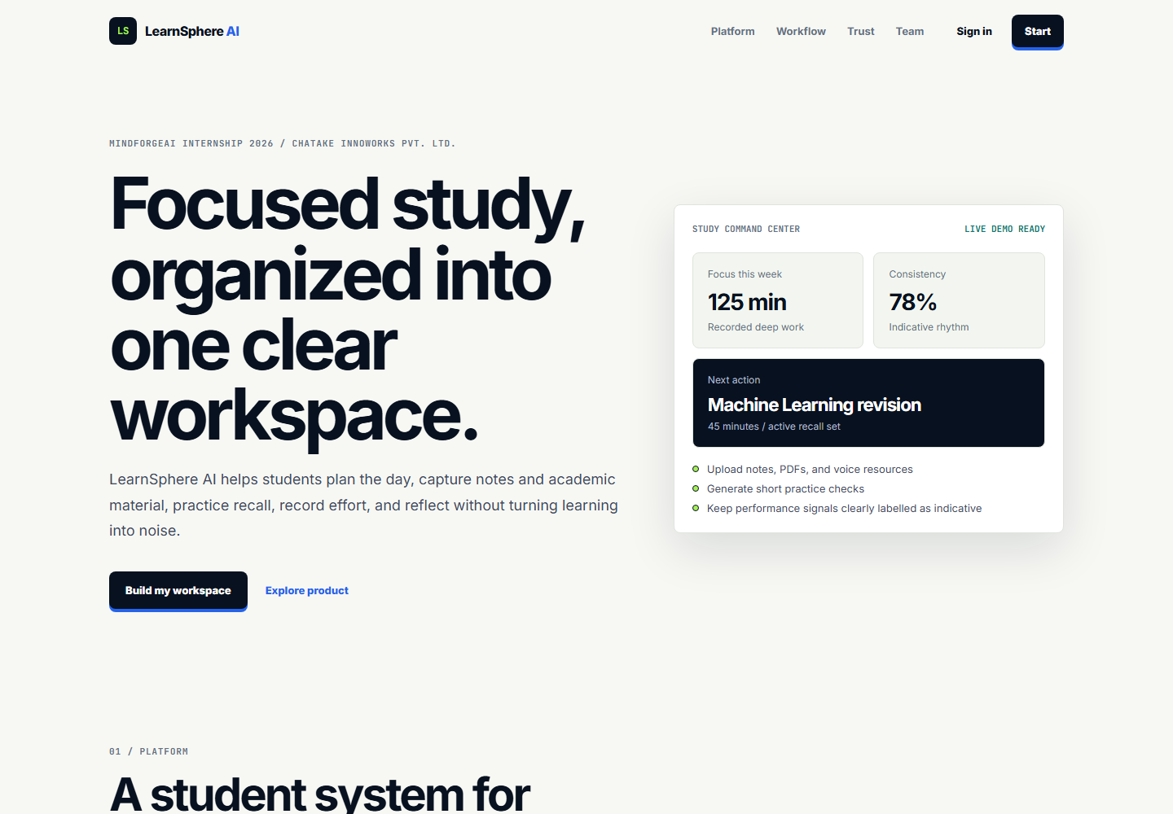
Prepared for the LearnSphere AI internship project.

