SRM INSTITUTE OF SCIENCE AND TECHNOLOGY
School of Computing — 21CSP302L Minor Project — VI Semester
Review II — 28th March 2026
ARCHITECTURE DOCUMENT
Vision-Based Dynamic Traffic Signal Optimization
Using Classical CV / YOLOv8 and PPO Reinforcement Learning in SUMO

1. Architecture Overview
This project adopts a Monolithic architecture with a clearly defined 3-layer internal structure. The entire system runs as a single Python application on a local workstation, with all components — perception, decision-making, and control — tightly integrated within one codebase. This design was chosen to minimise inter-process communication overhead, simplify debugging during research, and ensure deterministic execution across training and evaluation runs.
The three internal layers are:
- Layer 1 — Perception: Responsible for translating raw visual data (SUMO screenshots or real CCTV images) into normalised lane vehicle counts.
- Layer 2 — RL Brain: A PPO agent (Stable-Baselines3) that consumes the state vector and outputs a signal phase decision.
- Layer 3 — Control: The TraCI API interface that applies the agent's decision to the SUMO simulation.

1.1 Architecture Style Justification
A monolithic architecture was selected over microservices or event-driven alternatives for the following reasons:
- Research reproducibility: All components share the same process space, eliminating network latency and serialisation inconsistencies.
- RL training requirement: PPO requires tight synchronous coupling between environment step, reward computation, and agent update — microservices would add prohibitive latency.
- Scope: As a minor research project, operational complexity of distributed architecture is not justified.
- Modularity is maintained through Python class hierarchy and file structure, not service boundaries.

2. High-Level Design (HLD)

2.1 System Context Diagram
The system interacts with three external entities: the SUMO Simulation Engine (via TraCI API), the Roboflow Real-World Image Dataset (for Step 11 validation), and the Researcher/User (who initiates training, evaluation, and demo runs).

 | [ Researcher / User ]
 | | run scripts
[ SUMO Engine ] <--TraCI--> | TRAFFIC SIGNAL OPTIMIZATION SYSTEM | <-- YOLO --> [ Roboflow Dataset ]
 | | results / plots
 | [ results/ directory ]

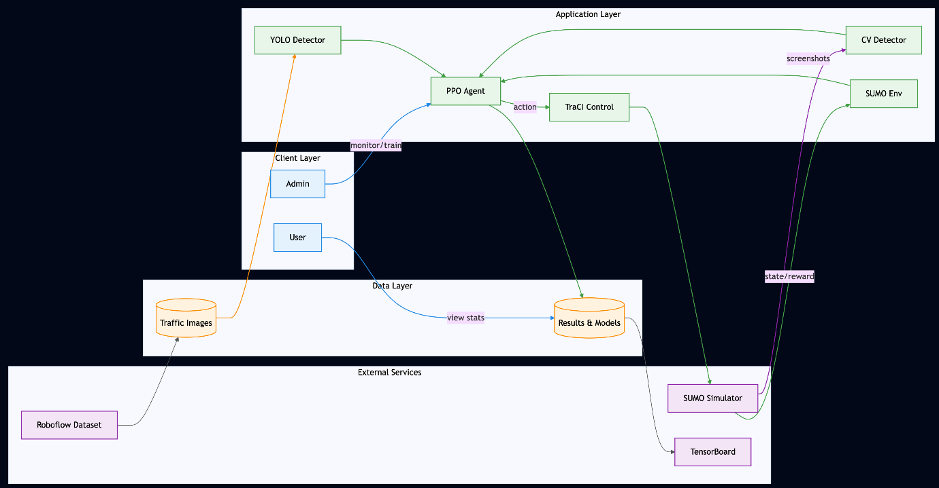

2.2 Layer Architecture Diagram

LAYER 1 — PERCEPTION
Training Mode: SUMO Screenshot → HSV+Contour Detector → Lane Counts
Real Data Mode: CCTV Image → YOLOv8s → ROI Counting → Normalised Counts
▼ State Vector: [lane1, lane2, lane3, lane4, phase_norm, est_wait]
LAYER 2 — RL BRAIN (PPO AGENT)
Stable-Baselines3 PPO | 200,000 timesteps | Discrete(4) action space
Reward: −(total_waiting_time + total_queue_length) from TraCI
▼ Action: Phase 0-3 (NS-Straight, NS-Turn, EW-Straight, EW-Turn)
LAYER 3 — CONTROL (TraCI)
TraCI API → traci.trafficlight.setPhase('center', action) → SUMO-GUI

Key Design Principle: Only Layer 1 changes between SUMO training and real-world deployment. Layers 2 and 3 remain completely unchanged regardless of data source.

3. Detailed Design (LLD)

3.1 Component Diagram
The system is composed of the following primary components and their dependencies:

Component | File | Responsibility
TrafficEnv | env/traffic_env.py | Gymnasium environment, TraCI interface, reward computation
ClassicalTrafficEnv | env/traffic_env.py | Subclass overriding _get_state() with HSV perception
SB3EnvWrapper | env/traffic_env.py | Wraps TrafficEnv for Stable-Baselines3 compatibility
ClassicalDetector | perception/classical_detector.py | HSV thresholding, morphological ops, contour detection
YOLODetector | perception/yolo_detector.py | YOLOv8s inference, ROI counting, confidence filtering
PPOAgent | agents/train_ppo.py | Trains PPO with TraCI ground truth state (Condition B)
PPOClassicalAgent | agents/train_ppo_classical.py | Trains PPO with Classical CV state (Condition C)
FixedTimeBaseline | baselines/fixed_time.py | Cycles phases 0→1→2→3 every 30 steps (Condition A)
Evaluator | evaluation/evaluate.py | Loads all results, generates 4 comparison charts
RealDataDemo | real_world/real_data_demo.py | End-to-end real CCTV image pipeline with YOLO+PPO
CountNormalizer | real_world/real_data_demo.py | Maps real vehicle counts to SUMO training range (0-1)

3.2 Use Case Diagram
The primary actor is the Researcher. The secondary actor is the SUMO Simulation Engine.

ACTOR: Researcher |  | USE CASES |  | ACTOR: SUMO Engine
 | ----> | UC1: Run Fixed-Time Baseline | <----
 | ----> | UC2: Train PPO Agent (Condition B) | <----
 | ----> | UC3: Train PPO with CV (Condition C) | <----
 | ----> | UC4: Evaluate All Conditions | <----
 | ----> | UC5: Run Live Demo | <----
 | ----> | UC6: Validate on Real CCTV Images |  | (Roboflow Dataset)

3.3 Sequence Diagram — PPO Training Cycle
This diagram shows the interaction sequence for one training episode in Condition C (PPO + Classical CV):

Researcher | train_ppo_classical.py | ClassicalTrafficEnv | SUMO / TraCI
--> run script | initialise PPO
 | --> env.reset() | start SUMO-GUI | <-- traci.start()
 |  | screenshot() | --> get frame
 |  | HSV detect | → lane counts
 | <-- state vector | normalise()
 | PPO.predict(state) | --> action
 |  | setPhase(action) | --> traci.setPhase
 |  | step 10 sim-sec | <-- traci.simulationStep()
 | <-- reward, done | compute_reward() | <-- wait/queue
 | PPO.update() | repeat 300 steps
 | save model .zip |  | <-- traci.close()

3.4 Data Flow Diagram (DFD) — Level 1

SUMO SIM | ──screenshot──> | PERCEPTIONLAYER | ──state vec──> | PPO AGENT | ──action──> | TraCICONTROL
 |  | HSV or YOLOROI counting |  | reward <──wait+queue |  | setPhase()to SUMO
<──reward data──

3.5 Deployment Diagram
The system is deployed entirely on a single local workstation (Developer Machine). There are no cloud services or network dependencies required for training or evaluation.

DEVELOPER WORKSTATION (Windows 10/11 — Python 3.10)
SUMO 1.25 Simulation Engine | SUMO-GUI (real-time visualisation)
Python Environment: Stable-Baselines3 | OpenCV | Ultralytics YOLOv8 | NumPy | Matplotlib
Project Files: D:\Minor Project\ (sumo_files, env, perception, agents, real_world, results)
External: Roboflow Dataset (downloaded once to data\real_images\) | YOLOv8s.pt (downloaded once)

3.6 Class Diagram — Core Classes

TrafficEnv | ClassicalTrafficEnv | SB3EnvWrapper
+ sumo_cfg: str+ max_steps: int+ gui: bool──────────────+ reset() → state+ step(action) → obs+ _get_state() → arr+ _compute_reward()+ close() | extends TrafficEnv──────────────+ gui = True (forced)+ _get_state() [override] → screenshot() → ClassicalDetector → lane counts+ reward: TraCI ground truth | wraps TrafficEnv──────────────+ observation_space+ action_space+ reset() → np.array+ step(a) → tuple (obs, rew, done, info)

ClassicalDetector | YOLODetector | CountNormalizer
+ roi_config: dict──────────────+ detect(frame) → HSV threshold → morphological ops → contour filter → {lane: count} | + model: YOLO+ vehicle_classes: set──────────────+ detect(frame, rois, conf) → model inference → bbox center check → {lane: count} | + SUMO_MAX: int = 10──────────────+ normalize(lane_counts) → min(raw/MAX, 1.0) → {lane: float}

4. Technology Stack
Category | Technology | Purpose
Language | Python 3.10 | Primary development language
Simulation | SUMO 1.25 + TraCI | Traffic simulation and signal control API
RL Framework | Stable-Baselines3 | PPO algorithm implementation
CV — Training | OpenCV | HSV thresholding, morphological ops, contour detection
CV — Real World | Ultralytics YOLOv8s | Real vehicle detection in CCTV images
Data | NumPy | State vector construction, normalisation
Visualisation | Matplotlib + TensorBoard | Result charts and training reward convergence
Dataset | Roboflow (CC BY 4.0) | 30 real CCTV intersection images for Step 11 validation

5. Ethical Considerations
- Data source: Roboflow Traffic Intersection dataset is licensed CC BY 4.0 — properly cited in all documentation.
- Privacy: No personally identifiable information (PII) is collected. YOLO detections are vehicle bounding boxes only — no faces or licence plates are stored or processed.
- Synthetic training: SUMO simulation uses randomly generated synthetic traffic — no real driver data is used for RL training.
- Code attribution: All third-party libraries are properly credited. No proprietary code is used.
- Research integrity: All results are reported honestly including known limitations (throughput bug, reward discrepancy, NS-Turn dominance) without concealment.

