Database Management System

[21CSC205P]

WHEELIFY  
VEHICLE RENTAL SYSTEM

MADE BY:  
EKANSH LAMBA-RA2311003012132

SHRAVANI NIKAM-RA2311003012142

KRISSH BATRA-RA231100301245

ER Diagram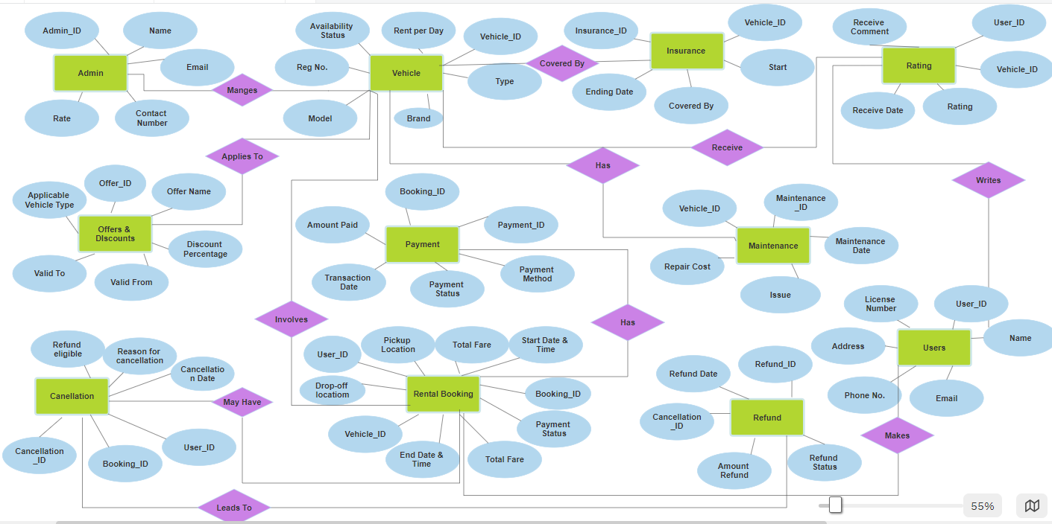

Admin

| Admin_ID | Name | Role | Contact number | Email |
| --- | --- | --- | --- | --- |
| 0001 | Shravani | Administrative Manager | 9362703782 | sm33@gmail.com |
| 0002 | Ekansh | HR Administrator | 6372890375 | eh66@gamil.com |
| 0003 | Krissh | Executive Assistant | 8362734921 | ke99@gmail.com |

CREATE TABLE ADMIN ( Admin_ID INT PRIMARY KEY,   
Name VARCHAR(100) NOT NULL,  
 Role VARCHAR(100) NOT NULL,   
Contact_Number int(10) UNIQUE NOT NULL,   
Email VARCHAR(100) UNIQUE NOT NULL );

VEHICLE

| Vehicle_ID | Availability Status | Rent Per Day | Reg_No | Model | Brand | Type |
| --- | --- | --- | --- | --- | --- | --- |
| 0001 | Available | 2000 | MH04NO4488 | SWIFT | MARUTI SUZUKI | CAR |
| 0002 | Rented | 2500 | TN06BO8866 | BREZZA | MARUTI SUZUKI | CAR |
| 0003 | Available | 3500 | UP78SD9669 | INNOVA | TOYOTA | CAR |
| 0004 | Under Maintenance | 4000 | MH04BM8543 | XYLO | MAHINDRA | CAR |

CREATE TABLE VEHICLE (

Vehicle_ID INT PRIMARY KEY AUTO_INCREMENT,

Availability_Status ENUM('Available', 'Rented', 'Under Maintenance') NOT NULL,

Rent_Per_Day DECIMAL(10,2) NOT NULL,

Reg_No VARCHAR(50) UNIQUE NOT NULL,

Model VARCHAR(100) NOT NULL,

Brand VARCHAR(100) NOT NULL,

Type VARCHAR(50) NOT NULL

);

INSURANCE

| Insurance_ID | Vehicle_ID | Start Date | Expiry Date | Covered By |
| --- | --- | --- | --- | --- |
| 12453 | 0001 | 01.12.24 | 01.12.25 | ICICI |
| 75536 | 0002 | 02.12.24 | 02.12.25 | UIIC |
| 43748 | 0003 | 03.12.24 | 03.12.24 | UIIC |
| 43647 | 0004 | 04.12.24 | 04.12.24 | ICICI |

CREATE TABLE Insurance (

Insurance_ID INT PRIMARY KEY ,

Vehicle_ID INT NOT NULL,

Start_Date VARCHAR(20) NOT NULL,

Expiry_Date VARCHAR(20) NOT NULL,

Covered_By VARCHAR(20) NOT NULL

);

RATING

| User_ID | Vehicle_ID | Receive Date | Receive Comment | Ratings |
| --- | --- | --- | --- | --- |
| 0001 | 0001 | 04.01.25 | GOOD | 4.5 |
| 0002 | 0002 | 05.01.25 | VERY GOOD | 5 |
| 0003 | 0003 | 06.01.25 | AVERAGE | 3.5 |
| 0004 | 0004 | 07.01.25 | GOOD | 4.5 |

SYNTAX:CREATE TABLE RATING (

User_ID INT NOT NULL,

Vehicle_ID INT NOT NULL,

Receive_Date DATE NOT NULL,

Receive_Comment Varchar2(20),

Ratings DECIMAL(2,1) CHECK

PRIMARY KEY (User_ID, Vehicle_ID)

);

OFFERS & DISCOUNTS

| Offer_ID | Applicable_Vehicle_Type | Offer_Name | Valid_From | Valid_To | Discount_Percentage |
| --- | --- | --- | --- | --- | --- |
| 9456 | CAR | MONTH BONANZA | 09.06.24 | 09.07.24 | 30% |
| 0856 | SCOOTY | FESTIVE DEAL | 03.06.24 | 03.07.24 | 15% |
| 9856 | BIKE | INSTANT SAVER | 02.06.24 | 02.07.24 | 20% |
| 0756 | CAR | WELCOME DEAL | 05.06.24 | 05.07.24 | 25% |

CREATE TABLE OFFERS_DISCOUNTS (

Offer_ID INT PRIMARY KEY ,

Applicable_Vehicle_Type VARCHAR(50) NOT NULL,

Offer_Name VARCHAR(100) NOT NULL,

Valid_From DATE NOT NULL,

Valid_To DATE NOT NULL,

Discount_Percentage DECIMAL(5,2) CHECK (Discount_Percentage BETWEEN 0 AND 100)

);

PAYMENT

| Payment_ID | Booking_ID | Payment Method | Amount Paid | Transaction Date | Payment Status |
| --- | --- | --- | --- | --- | --- |
| 0001 | 0001 | UPI | 2500 | 19/02/25 | Completed |
| 0002 | 0002 | UPI | 3000 | 01/03/25 | Completed |
| 0003 | 0003 | UPI | 3500 | 17/02/25 | Completed |
| 0004 | 0004 | UPI | 4000 | 05/02/25 | Pending |

CREATE TABLE PAYMENT (

Payment_ID INT PRIMARY KEY AUTO_INCREMENT,

Booking_ID INT NOT NULL,

Payment_Method VARCHAR(50) NOT NULL,

Amount_Paid DECIMAL(10,2) NOT NULL,

Transaction_Date DATETIME NOT NULL,

Payment_Status ENUM('Pending', 'Completed', 'Failed', 'Refunded') NOT NULL

);

MAINTENANCE

| Maintenance_ ID | Vehicle_ID | Maintenance_date | Description_of_issue | Repair_cost |
| --- | --- | --- | --- | --- |
| 1001 | 0001 | 03.08.24 | SEIZED ENGINE | 1000 |
| 1002 | 0002 | 01.08.24 | BROKEN GAS PIPE | 1200 |
| 1003 | 0003 | 02.08.24 | BRAKE FAIL | 1600 |
| 1004 | 0004 | 05.08.24 | ELECTRICAL DISCONNECTIVITY | 1800 |

CREATE TABLE MAINTENANCE (

Maintenance_ID INT PRIMARY KEY AUTO_INCREMENT,

Vehicle_ID INT NOT NULL,

Maintenance_Date DATE NOT NULL,

Description_of_Issue Varchar2(50) NOT NULL,

Repair_Cost DECIMAL(10,2) NOT NULL

);

CANCELLATION

| User_ID | Booking_ID | Cancellation _ID | Refund_eligible | Reason_for_ cancellation | Cancellation_Date |
| --- | --- | --- | --- | --- | --- |
| 0001 | 0002 | 3454 | Yes | Change in plan | 27/02/2025 |
| 0002 | 0008 | 5659 | Yes | Needed a different car | 06/03/2025 |
| 0003 | 0010 | 1232 | No | Tyre were not upto mark | 23/02/2025 |

CREATE TABLE CANCELLATION (

Cancellation_ID INT PRIMARY KEY AUTO_INCREMENT,

User_ID INT NOT NULL,

Booking_ID INT NOT NULL,

Refund_Eligible ENUM('Yes', 'No') NOT NULL,

Reason_for_Cancellation TEXT NOT NULL,

Cancellation_Date DATE NOT NULL

)

RENTAL BOOKING

| Booking_id | User_ ID | Total_ffare | Start_ date_ time | Payment_status | End_ Date_ time | Vehicle_id | Drop_Off_Location | Pickup_ location |
| --- | --- | --- | --- | --- | --- | --- | --- | --- |
| 0001 | 0001 | 3000 | 06.03.24 6PM | DONE | 07.03.24 6PM | 1001 | SRM KTR | SRM KTR |
| 0002 | 0002 | 3500 | 02.03.24 7PM | DONE | 03.03.24 7PM | 2002 | GUINDY | CHENGALPATTU |
| 0003 | 0003 | 4500 | 02.03.24 9AM | PENDING | 03.03.24 9AM | 3003 | LOWER PAREL | MAHIM |
| 0004 | 0004 | 5000 | 04.03.24 11AM | DONE | 05.03.24 11AM | 4004 | DADAR | MALAD |

CREATE TABLE RENTAL_BOOKING (

Booking_ID INT PRIMARY KEY AUTO_INCREMENT,

User_ID INT NOT NULL,

Vehicle_ID INT NOT NULL,

Start_Date_Time DATETIME NOT NULL,

End_Date_Time DATETIME NOT NULL,

Pickup_Location VARCHAR(255) NOT NULL,

Drop_Off_Location VARCHAR(255) NOT NULL,

Total_Fare DECIMAL(10,2) NOT NULL,

Payment_Status ENUM('Pending', 'Completed', 'Failed', 'Refunded') NOT NULL

);

REFUND

| Refund_ID | Cancellation_ID | Amount refunded | Refund status | Refund date |
| --- | --- | --- | --- | --- |
| 001 | 3454 | 2500 | Processed | 22/02/2025 |
| 002 | 5659 | 3000 | Pending | 05/03/2025 |
| 003 | 1232 | 3500 | Failed | 19/02/20225 |

CREATE TABLE REFUND (

Refund_ID INT PRIMARY KEY AUTO_INCREMENT,

Cancellation_ID INT NOT NULL,

Amount_Refunded DECIMAL(10,2) NOT NULL,

Refund_Status ENUM('Pending', 'Processed', 'Failed') NOT NULL,

Refund_Date DATE NOT NULL

);

USER

| User_ID | Name | Email | Phone number | Address | License number |
| --- | --- | --- | --- | --- | --- |
| 0001 | Raghav | raghav@gmail.com | 8989123245 | Delhi | DL031221 |
| 0002 | Rohan | rohan@hotmail.com | 7866721231 | Meerut | UP345221 |
| 0003 | Muthu | muthuswami@gmai.com | 6643239078 | Chennai | TN356782 |
| 0004 | Adani | adani@yahoo.com | 9810438790 | Ahmedabad | GJ786633 |
| 0005 | Sahil | sahil123@gmail.com | 9823124563 | Mumbai | MH021133 |

CREATE TABLE USER (

User_ID INT PRIMARY KEY AUTO_INCREMENT,

Name VARCHAR(100) NOT NULL,

Email VARCHAR(100) UNIQUE NOT NULL,

Phone_Number VARCHAR(15) UNIQUE NOT NULL,

Address TEXT NOT NULL,

License_Number VARCHAR(50) UNIQUE NOT NULL

);

**RELATIONS MODELS**

**VEHICLE** → **INSURANCE**

| Vehicle_ID | Availability Status | Rent Per Day | Reg NO. | Model | Brand | Type | Insurance_ID |
| --- | --- | --- | --- | --- | --- | --- | --- |
| 0001 | Available | 2000 | MH04NO4488 | SWIFT | MARUTI SUZUKI | CAR | 12453 |
| 0002 | Rented | 2500 | TN06BO8866 | BREZZA | MARUTI SUZUKI | CAR | 75536 |
| 0003 | Available | 3500 | UP78SD9669 | INNOVA | TOYOTA | CAR | 43748 |
| 0004 | Under Maintenance | 4000 | MH04BM8543 | XYLO | MAHINDRA | CAR | 43647 |

**One-to-Many Relationship:**

**USER** → **RENTAL_BOOKING**

**USER 0001**

| Booking_id | User_ ID | Total_ffare | Start_ date_ time | Payment_status | End_ Date_ time | Vehicle_id | Drop_Off_Location | Pickup_ location |
| --- | --- | --- | --- | --- | --- | --- | --- | --- |
| 0001 | 0001 | 3000 | 06.03.24 6PM | DONE | 07.03.24 6PM | 1001 | SRM KTR | SRM KTR |
| 0008 | 0001 | 3500 | 02.03.24 7PM | DONE | 03.03.24 7PM | 2002 | GUINDY | CHENGALPATTU |
| 0015 | 0001 | 4500 | 02.03.24 9AM | PENDING | 03.03.24 9AM | 3003 | LOWER PAREL | MAHIM |

**VEHICLE** → **MAINTENANCE**

**vehcile 0003**

| Maintenance_ ID | Vehicle_ID | Maintenance_date | Description_of_issue | Repair_cost |
| --- | --- | --- | --- | --- |
| 1001 | 0001 | 03.08.24 | SEIZED ENGINE | 1000 |
| 1020 | 0001 | 01.10.24 | BROKEN GAS PIPE | 1200 |
| 1031 | 0001 | 02.12.24 | BRAKE FAIL | 1600 |

**CANCELLATION** → **REFUND**

| User_ID | Booking_ID | Cancellation _ID | Refund_eligible | Reason_for_ cancellation | Cancellation_Date | Refund_ID |
| --- | --- | --- | --- | --- | --- | --- |
| 0001 | 0002 | 3454 | Yes | Change in plan | 27/02/2025 | 001 |