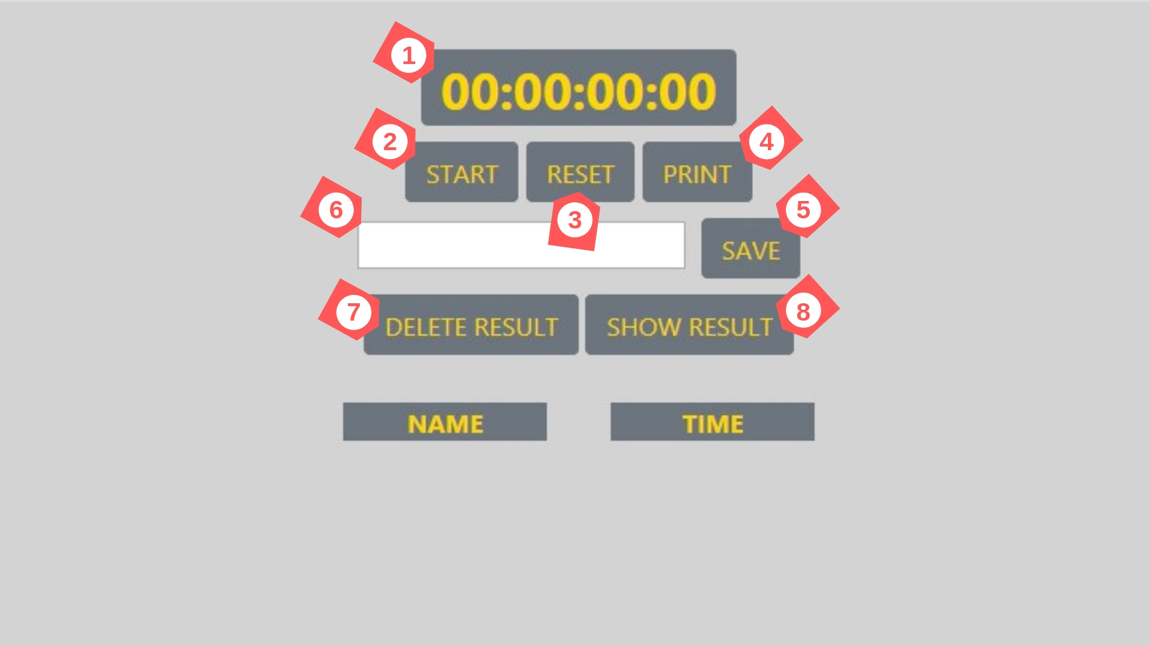

1> Function chrono who make difference between new Date() at start and new Date() at end,

2> Button who operates the function chrono and pause him with a « else if » , resume with a « else »,

3> This button operates the function resetChrono who reload document.

4> This function printPage who operates a window,print().

5> Button who operates the function saveTimer(). This function save timer.innerHTML and inputName.value into localStorage.

6> inputName is a input necessary to save timer.

7> This button clears the leaderboard list & the localstorage.

8> Display the array’s object in 2 lists down below.

