**WORLD BANK EDUCATION GLOBAL PRACTICE**

**Russian Federation: Analytical Services and Advisory Activity: P170978**

**Returns to Education in the Russian Federation: Some New Estimates**

**Harry Patrinos1 |Suhas Parandekar1 |Ekaterina Melianova1 |Artëm Volgin1**

|  |
| --- |
| This paper presents some new estimates of the returns to education in the Russian Federation.The estimates use a Mincerian specification common to one that has been carried out for over one hundred countries. The paper shows that Mincerian returns to higher education are three times greater for higher education compared to vocational education, and that the returns to education for females is higher than for males. Returns for females shows an inverse U-shaped curve over the past two decades, but this phenomenon needs to be explored more closely to derive policy conclusions.  **KEYWORDS**  Returns to Education, Russian Federation *JEL Codes: I26, I28, J16* |

*Education Global Practice, Europe and

Central Asia

**Correspondence**

Email: sparandekar@worldbank.org

**DataandCode**

Thanks are due to the Higher School of

Economics, Moscow for making the Russian

Longitudinal Monitoring Study (RLMS) Household data readily available for reseachers around the world. The code used for this paper is made freely available for all researchers at [https://bitbucket. org/zagamog/edreru/src/master/](https://bitbucket.org/zagamog/edreru/src/master/)

1

# | MOTIVATION

*“How Wealthy is Russia?”* is a recently published World Bank report that analyzed human, natural, and produced capital of the Russian Federation (Naikal et al. 2019). Human capital only accounts for 46% of total wealth in Russia, as compared to the OECD average of 70%. The report showed that even as growth rates of per capita wealth was ten times higher in Russia as compared to OECD, the gap in levels with OECD is still very wide. The per capita human capital wealth level at average for the OECD in 2014 was about USD 500,000 - five times that of Russia’s 95,000 (measured in 2014 dollars). In order to catch up faster with the OECD, returns to education in Russia will need to

**Acknowledgments:** *Country Director:* Renaud Seligman; *Regional Director:* Fadia Saadah; *Practice Manager:* Harry Patrinos; *Program Leader:* Dorota Nowak; *Peer Reviewers*: Cristian Aedo; Ruslan Yemtsov; Husein Abdul-Hamid; *Team members:* Polina Zavalina; Zhanna Terlyga. Thanks to seminar participants at the World Bank Moscow office on Jan.

29, 2020 for useful feedback. Any errors are a responsibility of the authors.

be increased. This paper presents the first in a series of papers on returns to education that will be instrumental in generating policy recommendations to improve the share of human capital as part of Russia’s natural wealth. This paper examines the trends in returns to education in the Russian Federation using a common methodology used for 100 countries (Montenegro and Patrinos 2014; Psacharopoulos and Patrinos 2018).

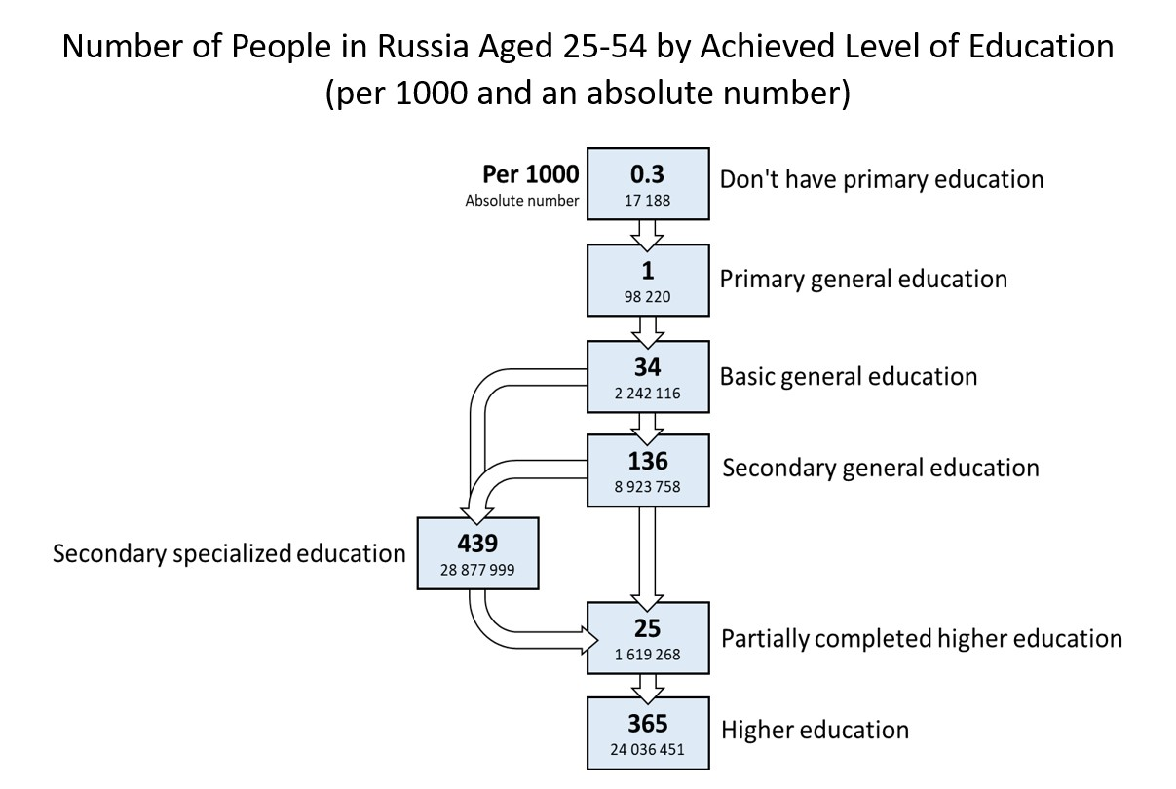

**FIGURE 1.1** Labor Force Distribution by Educational Level (Rosstat)

Figure 1.1 indicates the educational attainment of the population segment 25 to 54 years, which is the age group for which Rosstat provides this information. Figure 1.1 shows less than 14% of the labor force with a final attainment of secondary general education (academic High School) - the main choice is between vocational education (nearly 45%) and university education (about 40%). It is a well-known fact that on cognitive attainment at Grade 9, Russian students are already at par with OECD students (PISA scores are designed with an OECD mean of 500); what comes in later education levels and the labor market is the crucial issue for convergence with OECD on human capital wealth levels.

A detailed analysis of the returns to education in the Russian Federation will provide insights into the stylized facts mentioned above. Together with other research being implemented by the World Bank and by researchers outside of the World Bank, the purpose of this analysis is to come up with a set of evidence based policy recommendations to enhance the human capital wealth of the Russian Federation.

# | LITERATURE

[Reminder from Harry - needs to include Gimpelson 2019.

Lorem ipsum dolor sit amet, consectetuer adipiscing elit. Ut purus elit, vestibulum ut, placerat ac, adipiscing vitae, felis. Curabitur dictum gravida mauris. Nam arcu libero, nonummy eget, consectetuer id, vulputate a, magna.

Donec vehicula augue eu neque. Pellentesque habitant morbi tristique senectus et netus et malesuada fames ac turpis egestas. Mauris ut leo. Cras viverra metus rhoncus sem. Nulla et lectus vestibulum urna fringilla ultrices. Phasellus eu tellus sit amet tortor gravida placerat. Integer sapien est, iaculis in, pretium quis, viverra ac, nunc. Praesent eget sem vel leo ultrices bibendum. Aenean faucibus. Morbi dolor nulla, malesuada eu, pulvinar at, mollis ac, nulla. Curabitur auctor semper nulla. Donec varius orci eget risus. Duis nibh mi, congue eu, accumsan eleifend, sagittis quis, diam. Duis eget orci sit amet orci dignissim rutrum.

Nam dui ligula, fringilla a, euismod sodales, sollicitudin vel, wisi. Morbi auctor lorem non justo. Nam lacus libero, pretium at, lobortis vitae, ultricies et, tellus. Donec aliquet, tortor sed accumsan bibendum, erat ligula aliquet magna, vitae ornare odio metus a mi. Morbi ac orci et nisl hendrerit mollis. Suspendisse ut massa. Cras nec ante. Pellentesque a nulla. Cum sociis natoque penatibus et magnis dis parturient montes, nascetur ridiculus mus. Aliquam tincidunt urna. Nulla ullamcorper vestibulum turpis. Pellentesque cursus luctus mauris.

Nulla malesuada porttitor diam. Donec felis erat, congue non, volutpat at, tincidunt tristique, libero. Vivamus viverra fermentum felis. Donec nonummy pellentesque ante. Phasellus adipiscing semper elit. Proin fermentum massa ac quam. Sed diam turpis, molestie vitae, placerat a, molestie nec, leo. Maecenas lacinia. Nam ipsum ligula, eleifend at, accumsan nec, suscipit a, ipsum. Morbi blandit ligula feugiat magna. Nunc eleifend consequat lorem. Sed lacinia nulla vitae enim. Pellentesque tincidunt purus vel magna. Integer non enim. Praesent euismod nunc eu purus. Donec bibendum quam in tellus. Nullam cursus pulvinar lectus. Donec et mi. Nam vulputate metus eu enim.

Vestibulum pellentesque felis eu massa.

# | DATA

In this paper we use the Russian Longitudinal Monitoring Survey (RLMS) - the only representative Russian survey with a sizable panel component allowing for a dynamic analysis (Kozyreva, Kosolapov, and Popkin 2016). The data are notable for their reliability, diversity, and applicability to a variety of research questions. The RLMS embraces information on people’s income and expenditure structure, their material well-being, educational and occupational behavior, health state and nutrition, migration, etc. RLMS sampling procedures have been thoroughly and extensively described elsewhere (Kozyreva, Kosolapov, and Popkin 2016). The present research uses all 23 waves (1994 - 2018) that are available as of April 9, 2020. Two years (1997 and 1999) are missing in the data because data was not collected in those years due to funding problems. The sub-sample selected for empirical investigation in this paper consists of

working individuals aged 25-64 who are out of school and have positive labor market experience and income.

# | ESTIMATION

The empirical analysis in this paper presents results for the general working population of the Russian Federation aged 25-64. We use a basic Mincerian specification shown in equation (1):

*Log* (*Wage*) = *b*0 +*b*1 · *Educ* +*b*2 · *Exp* +*b*3 · *Exp*2 +(1)

where *Log* (*Wage*) is a logarithm of monthly wage, *Educ* stands for the years of education or highest attained level of education, *Exp* and *Exp*2 reflect the years of working experience and its quadratic term respectively, *b*0 is an intercept, *b*1...*bn* are the respective slope estimates, refers to a normally distributed error term.

## Dependent variable

For the dependent variable, we used the logarithm of an average monthly wage within the past year on a person’s primary job (variable *J*13.2 in the RLMS dataset). If a person had an additional job, the maximum wage value among the two (variables *J*13.2 and *J*40) was selected for the analysis. In the waves from 1994 to 1996, the question mentioned above was absent; for those waves, we exploited a variable about the average amount of money earned by a respondent within the past 30 days (variable *J*10) as a reasonable approximation.

## Independent variables

The present research uses both metric (measured in years) and categorical education variables. The metric version was created by assigning the average expected number of years corresponding to each attained education level. For the categorical version (EDUC), we distinguished three categories: *(1) secondary, (2) vocational, and (3) higher*. Incomplete levels were incorporated into the respective upper categories (e.g., incomplete higher - into higher). We are interested in exploring returns to education in general, and vocational and higher education. Estimations of premiums to primary and secondary schooling levels are technically unreachable to us since the number of adults without primary education, and the number of adults with only primary level is minuscule in the general population. The experience variable was calculated as a difference between current age and years of education minus 6. Regression (1) was estimated separately for each year for the entire sample and separately for males and females. The Appendix presents the results for each year.

Figure 4.1 summarizes the results, showing rates of overall and gender-wise returns to education in Russia for the period 1994-2018: the percentage increment in a person’s earnings due to one additional year of schooling. Overall, one can notice a moderate curved growth in returns to education in Russia, achieving its peak in the early 2000s, which is followed by a downward pattern. Education payoffs for women are higher than those of men, but the difference appears to have narrowed in recent years.

We are particularly interested in the returns to specific levels of education, estimated through a series of dummy variables. Using Secondary Education completed as the base or omitted dummy for purpose of interpretation, we use dummies for Vocational Education and for Higher Education. The specification is presented in equation (2):

*Log* (*Wage*) = *a*0 + *a*1 · *DV oc* + *a*2 · *DHigher* + *a*3 · *Exp* + *a*4 · *Exp*2 + *a*5 · *Gender* +(2)

Figure 4.2, panel (a) displays rates of returns to Higher and Vocational education (as compared to Secondary education) in Russia for the period 1994-2018. The results suggest that on average wage premiums to university education in Russia are roughly 3-5 times greater than to vocational schooling. The observed trend for premiums to both Vocational and Higher education levels is similar to the trend for education in general with the following peaks: 18% per year for Higher education and 6% per year for Vocational education compared to the average earnings of workers with a Secondary education. The interesting pattern to note from panel 4.2a is the apparent co-movement of vocational education and higher education - the higher education smoothing curve turns a bit more sharply than the one for vocational education, but their movement is matching, even at second-order levels of smoothness. Further, even though higher education premium remains much above the premium for vocational education, there is a perceptible narrowing of the difference in recent years. Panel 4.2b, which is drawn from a presentation made by Marina Telezhkina at the WB-HSE Summer School on the Economics of Education in July 2019, shows the interesting pattern of higher education enrollment rates for the population of 17-25 year olds. Panel 4.2b shows the downturn in returns reflected in enrollments, with the peak in enrollments coming about 10 years later.

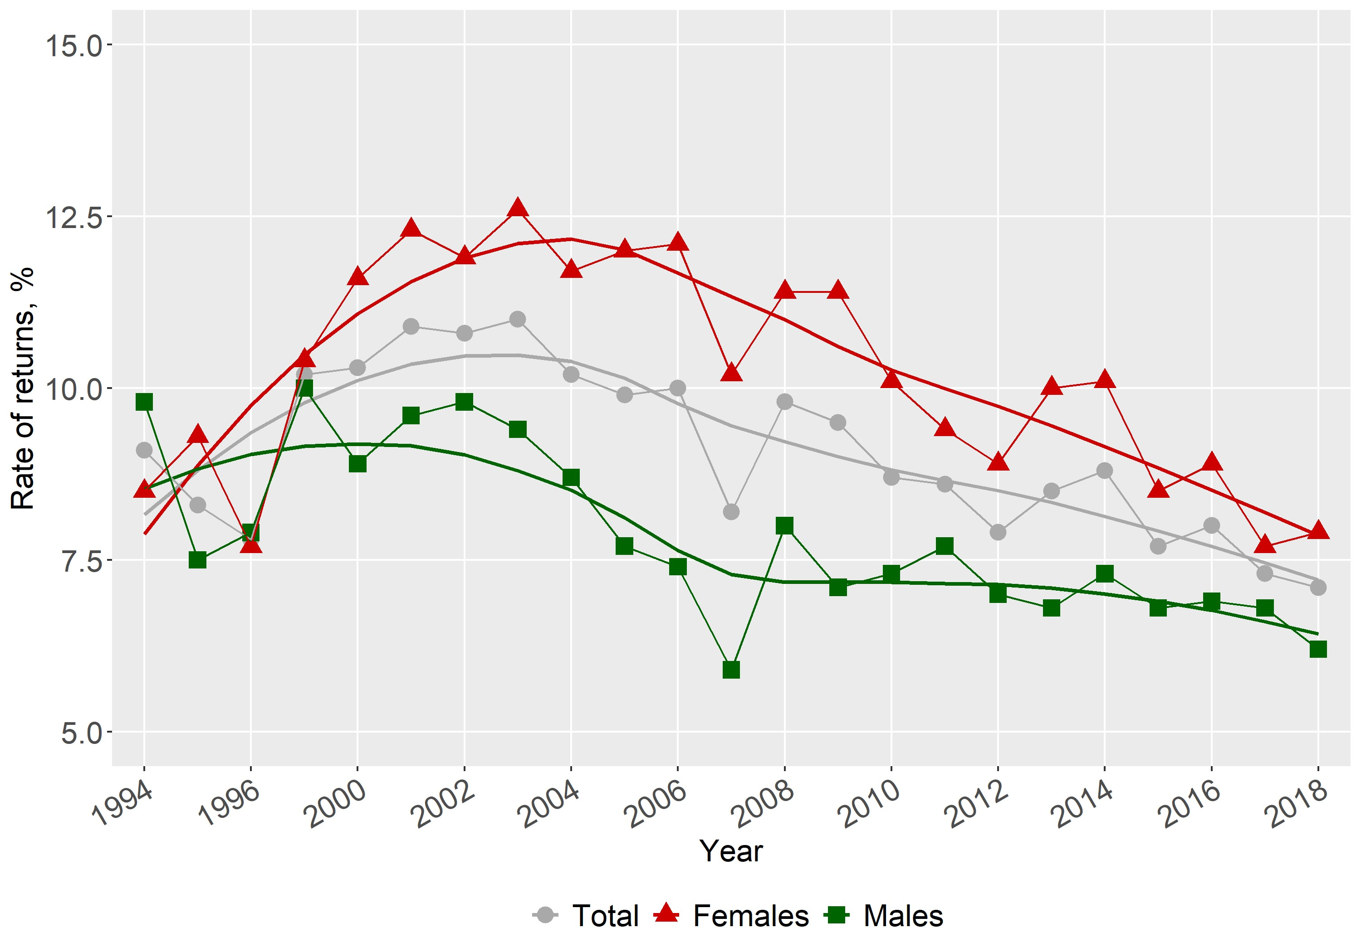

**FIGURE 4.1** Rates of Returns to Education in Russia, RLMS 1994-2018

## FIGURE 4.2 Rates of Returns to Higher and Vocational Education in Russia, RLMS 1994-2018

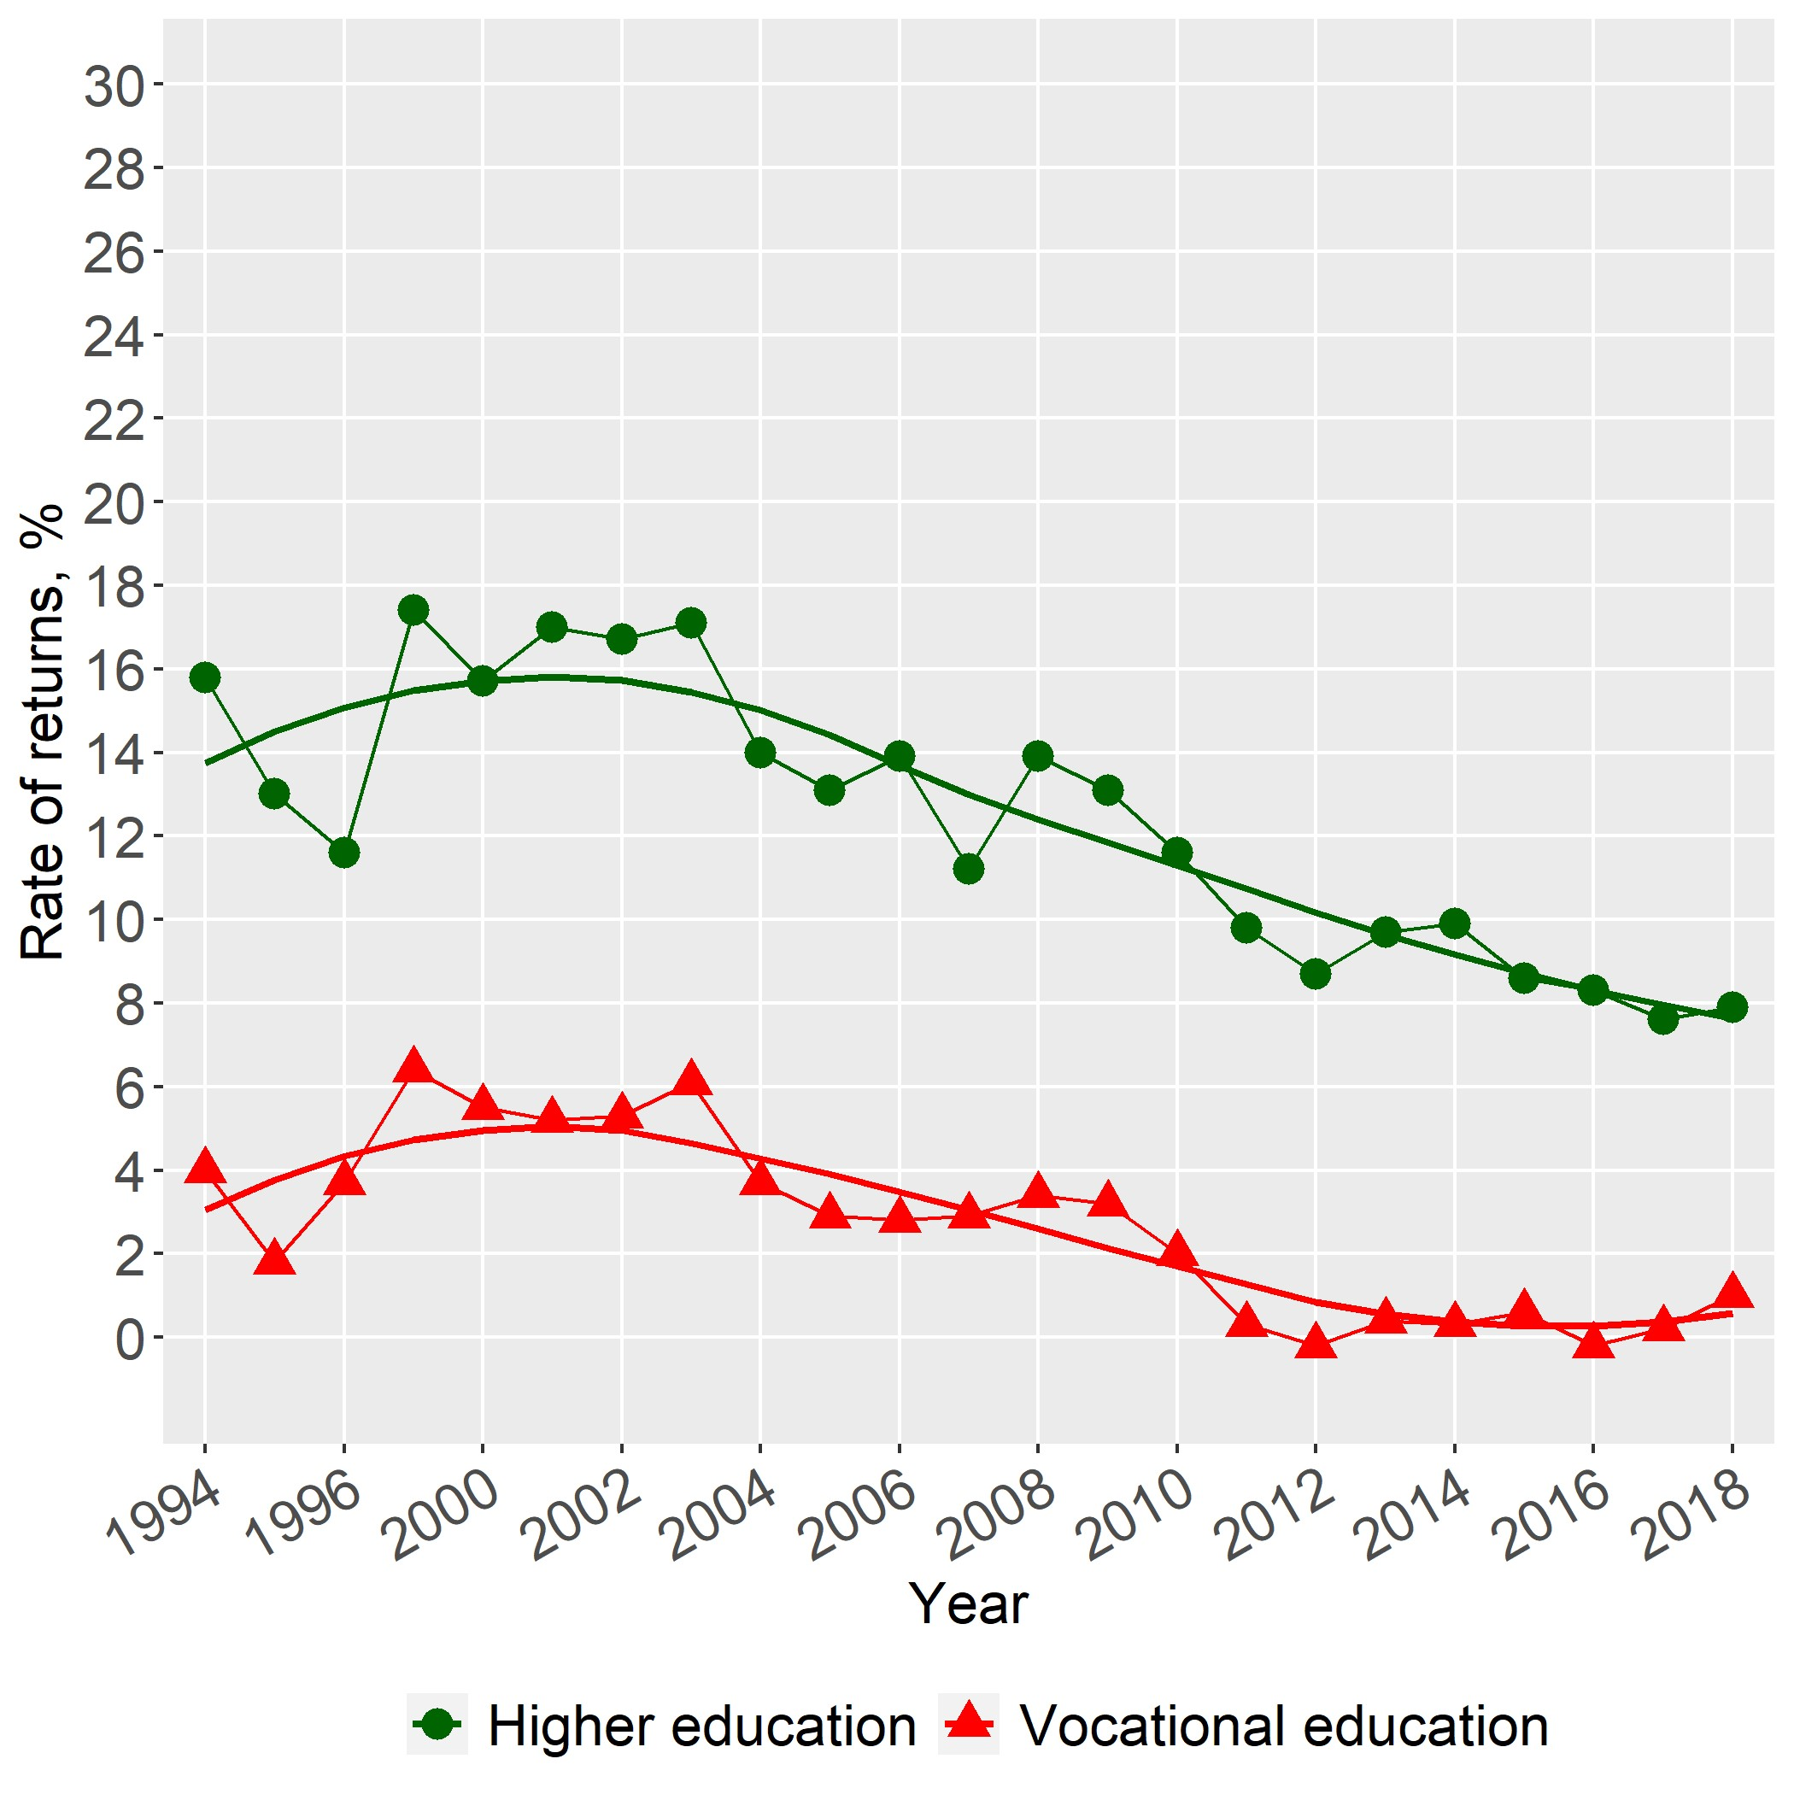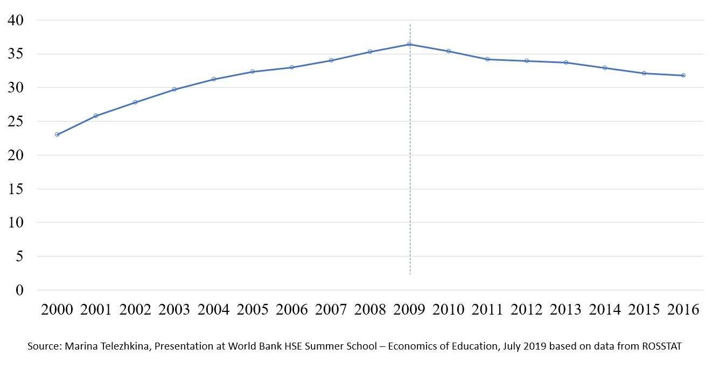

(a) Rates of Return (b) Enrollment in Higher Education

When estimated separately by gender, we find trend variation by gender. The results from estimation of earnings functions show that annual returns to Higher education for males varied from 9% to 15%, whereas women’s returns are described by an inversely U-shaped pattern, reaching their maximum of 28% in 2003. Within roughly the last 5 years, wage premiums to higher education for women have stabilized at around 12%, a couple of percentage points ahead of men. Gender wise enrollment rates in higher education (not shown) ten years later appears to match the differences in rates of return, strengthening the hypothesis that market rates of return to education in Russia do indeed influence individual continuing school decisions.

A similar comparative picture is observed with respect to vocational education, albeit with a different kind of variation by gender (see Figure 4.3): returns for males are almost flat within the time period while returns for females shows a concave pattern. The overall outcome concerning payoffs to schooling isolated by gender has been confirmed in a similar fashion by past studies (e.g., Cheidvasser and Benítez-Silva 2007).

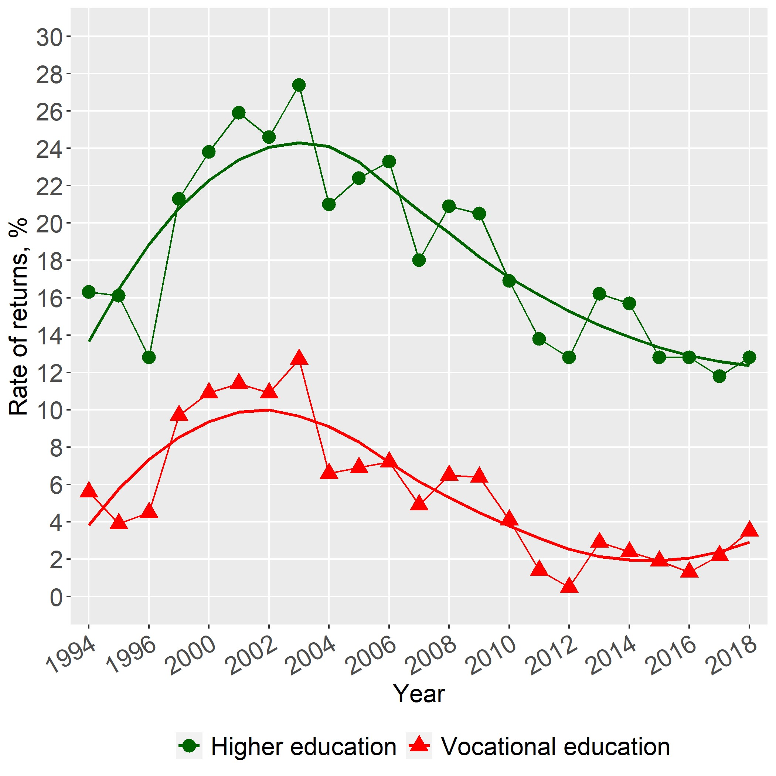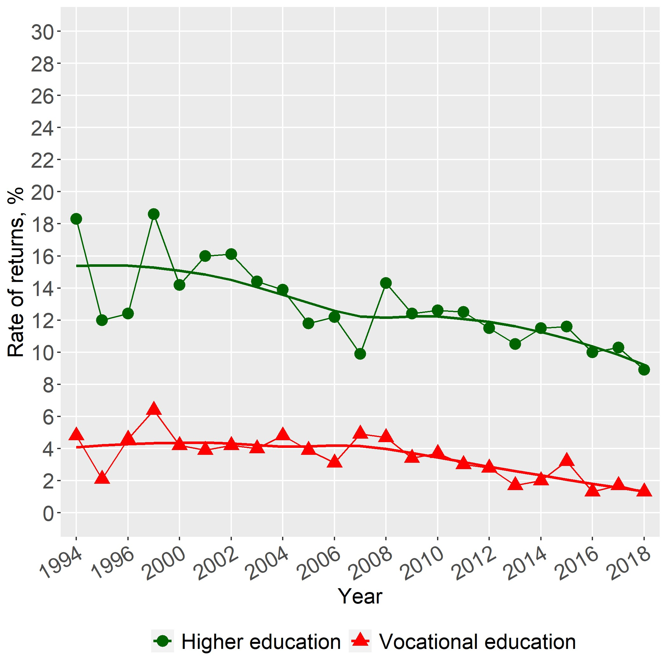

(a) Females (b) Males

**FIGURE 4.3** Rates of Returns to Higher and Vocational Education in Russia, RLMS 1994-2018

# References

Cheidvasser, Sofia, and Hugo Benítez-Silva. 2007. “The Educated Russian’s Curse: Returns to Education in the Russian Federation during the 1990s”. *Labour* 21 (1): 1–41.

Gimpelson, Vladimir. 2019. “The Labor Market in Russia, 2000-2017”. *IZA World of Labor* 2019:466 ().

Kozyreva, Polina, Mikhail Kosolapov, and Barry M. Popkin. 2016. “Data Resource Profile: The Russia Longitudinal Monitoring Survey—Higher School of Economics (RLMS-HSE) Phase II: Monitoring the Economic and Health Situation in Russia, 1994–2013”. *International Journal of Epidemiology* 45 (2): 395–401.

Montenegro, Claudio E., and Harry Anthony Patrinos. 2014. *Comparable estimates of returns to schooling around the world*. Policy Research Working Paper Series 7020. The World Bank. [https://ideas.repec.org/p/wbk/ wbrwps/7020.html.](https://ideas.repec.org/p/wbk/wbrwps/7020.html)

Naikal, Esther, et al. 2019. *How Wealthy is Russia? Measuring Russia’s Comprehensive Wealth from 2000-2017*. World Bank. [http://documents.worldbank.org/curated/en/811321575350027422/pdf/How-Wealthy-is-RussiaMeasuring-Russias-Comprehensive-Wealth-from-2000-2017.pdf.](http://documents.worldbank.org/curated/en/811321575350027422/pdf/How-Wealthy-is-Russia-Measuring-Russias-Comprehensive-Wealth-from-2000-2017.pdf)

Psacharopoulos, George, and Harry Anthony Patrinos. 2018. “Returns to Investment in Education: A Decennial Review of the Global Literature”. *Education Economics* 26 (5): 445–458.

**APPENDIX**