Working Paper 1: Returns to Education in the Russian Federation - Zeroth Draft *

Ekaterina Melianova, Suhas D. Parandekar, Harry A. Patrinos, Art¨em Volgin Tuesday 10th December, 2019

**Abstract**

This is the first cut at Working Paper 1 (of proposed 3 working papers) on the Returns of Education in the Russian Federation. The paper shows an inter- esting pattern of variation in the returns to education from 1994-2018. The paper shows the co-movement of returns to higher education and the return to vocational education. From a policy viewpoint, it shows that returns to education may be strongly influencing decisions of individuals or families regarding their future ed- ucation trajectories. Policy initiatives seeking to influence enrollment trends at specific educational levels would need to consider the empirical antecedents.

# RLMS Results

## Data

To estimate returns to education in Russia we employed the Russian Longitudinal Moni- toring Survey (RLMS) - the longest panel survey of individuals and households in Eastern Europe and Asia and the only representative Russian survey with a sizable panel compo- nent allowing for a dynamic analysis (Kozyreva and Sabirianova Peter, 2015). The data are notable for their reliability, diversity, and applicability to a variety of research ques- tions. The RLMS embraces information on people’s income and expenditure structure, their material well-being, educational and occupational behavior, health state and nutri- tion, migration, etc. RLMS sampling procedures have been thoroughly and extensively described elsewhere (Kozyreva and Sabirianova Peter, 2015). The present research uses all 23 waves (1994 - 2018) that are available as of Tuesday 10th December, 2019. The sub-sample selected for empirical investigation in this paper consists of working individu- als aged 25-64 who are out of school and have positive labor market experience and income.

* Arranged in alphabetical order of author last names. The entire code used to generate the graphs and tables presented in this paper is available on bitbucket at [https://bitbucket.org/zagamog/edreru/](https://bitbucket.org/zagamog/edreru/src/master/) [src/master/](https://bitbucket.org/zagamog/edreru/src/master/) , starting from the raw RLMS data graciously provided in the public domain by the National Research University-Higher School of Economics (HSE).

## Methods

Our empirical analysis pertains to the examination of a slightly modified basic specification of a mincer-type wage equation (Mincer, 1974). We present results for the general working population of the Russian Federation aged 25-64 as well as by gender and nationality. The specification of focus is as follows:

*Log*(*Wage*) = *b*0 + *b*1 · *Educ* + *b*2 · *Exp* + *b*3 · *Exp*2 + *b*4 · *Gender* + *b*5 · *Nationality* + *e*

where *Log*(*Wage*) is a logarithm of monthly wage, *Educ* stands for the highest at- tained level of education, *Exp* and *Exp*2 reflect the years of working experience and its quadratic term respectively, *Gender* is a dummy variable for gender, *Nationality* repre- sents a person’s nationality, *b*0 is an intercept, *b*1...*bn* are the respective slope estimates, *e* refers to a normally distributed error term.

## Measures

**Dependent variable**

For the dependent variable we used the logarithm of an average monthly wage within the past year on a person’s primary job (J13.2 variable in the RLMS dataset). If a person had an additional job, the maximum wage value among the two (J13.2 and J40) was selected for the analysis. In the waves from 1994 to 1996 the above mentioned question was absent; for those waves we exploited a variable about the average amount of money earned by a respondent within the past 30 days (J10) as a reasonable approximation.

**Independent variables**

We distinguished 3 categories for the **education** variable (EDUC): (1) secondary, (2) vocational, and (3) higher. Incomplete levels were incorporated into the respective upper categories (e.g., incomplete higher - into higher). We are interested in exploring returns to vocational and higher education. Estimations of premiums to primary and secondary schooling levels are technically unreachable to us since the number of adults without pri- mary education and the number of adults with only primary level are minuscule in the general population.

## Construction of experience variable

Absence of data regarding a person’s actual experience profile often compels researchers to employ a heuristic such as experience is equal to age less the official age of entrance into school and less the duration of schooling in years. However, this method introduces measurement error that drives imprecision in results, especially important if we want to compare changes in the rate of returns to education over time. Fortunately, RLMS is a panel data with most individuals surveyed over multiple years, which allows the creation of a factual experience variable. There is considerable attrition in the data over time, with like for like replacements of households to maintain national representativeness of

the sample. RLMS also follows the somewhat innovative practice of continuing to sample a dwelling if the household residing in the dwelling has moved away; a sampling practice which implies an increasing sample size over time. Another implication of the sampling scheme is that computing labor market experience is a bit complicated and necessitates some assumptions and imputations that are explained below.

To create a variable displaying a person’s **experience** we leveraged four questions on the year and a month of starting the primary job and the month of starting an additional job, if applicable (J5A, J5B, J35.2Y, and J25.2M). Based on these variables and the infor- mation of the interview date, a labor market experience variable was generated for each unique respondent in the sample by summing up his or her experience registered *across* RLMS waves. If an employed individual had missing values on a date of his or her start of work in a particular survey year, and the individual had appeared at any time in a previous year, the first non-missing record from previous waves was chosen. If only the year of a job start was provided, we standardized computation by imputing the month to be January of that year. In cases of the absence of a valid answer with regard to both year and month of job start in both primary and additional job in all RLMS waves a person was surveyed, such cases (*<* 1%) were dropped from the analysis. List-wise deletion strategy was also applied to the observations with ”negative” experience (*<* 1%) when according to one’s responses a job started allegedly ”after” the interview occurred1

A routine was therefore elaborated for detecting and fixing inconsistent responses to the questions about experience. The ‘quality control’ on the experience variable revealed two opposing apparent recollection errors:

* + 1. individuals whose starting date of a first job became at a later date over successive waves (e.g., an individual said in 2001 that she started working in 2000; the same individual in 2005 said she started working in 2002);
    2. individuals, naming an earlier job starting date compared to the mentioned preced- ing dates (e.g., a respondent in 2005 said he had started to work in 2000, but in 2001 he or she replied 1995 had been in fact the beginning year of his or her working activity).

Ideally, people would have perfect recall and not give inconsistent responses about their job history over time. However, we found inconsistent responses for 52% of unique respondents or 40% of instances in the pooled RLMS database (1994 - 2018).In both situ- ations (whether computed experience increased or decreased due to different recollections of start date of first job), the routine used in this paper prioritizes earlier responses, based on the reasoning that memory fades over time. The method used in this paper is not able to eliminate the error, but dealing with it in a consistent manner appears a better approach than simply imputing an experience variable assuming a person started working since finishing education and has been working ever since.

Table 1 shows the results of averaging all the three ways of generating labor market ex- perience by cohorts of respondents aggregated on the basis of the number of incidences in

1This step is necessitated because of the mixed panel nature of RLMS. Without proper accounting of experience, with education at a fixed level and changing income for an individuala cross years, there would be avoidable noise and possibly bias introduced on the education coefficient in the Mincerian equation.

the RLMS survey. The first column shows that there were 6667 individuals who appeared only once in the RLMS, 3463 who appeared twice (though could have been different pairs of years), 2793 who appeared three times and so on until the 119 individuals who ap- peared 23 times in the survey. Table 1 shows the mean values of the experience variable in years as computed by three methods: (EX1) The method outlined above, chosing ear- liest available data in case of inconsistencies; (EX2) method looking at each year of data independently, ignoring any inconsistencies, and (EX3) Na¨ıve estimates which is simply the age - duration of schooling - 6.

The table demonstrates that the two corresponding versions of experience computed with (EX1) and without (EX2) inconsistency correction gradually increase with the rise of the number of instances an individual appeared in RLMS. These differeces are mostly statistically significant as can be seen from the displayed p-values for a t-test of no sig- nificant difference. Overall, this indicates the necessity of harmonizing the data in the described manner.

**Table 1:** Comparison between Initial and Corrected Versions of the Experience Variable

Cohort - number

N indi-

Experience

Experience

Experience

N instances t-tests

t-tests

|  |  |  |  |  |  |  |  |
| --- | --- | --- | --- | --- | --- | --- | --- |
| of appearances | in | viduals | correct- | ignoring | na¨ıve | EX1- | EX1- |
| RLMS |  |  | ing error | error | (EX3) | EX2: | EX3: |
|  |  |  | (EX1) | (EX2) |  | pvalue | pvalue |
| 01 |  | 6667 | 05.91 | 06.25 | 18.91 | 6667 0.01 | 0.00 |
| 02 |  | 3463 | 06.53 | 06.97 | 19.26 | 6926 0.02 | 0.00 |
| 03 |  | 2793 | 07.60 | 08.10 | 20.41 | 8379 0.03 | 0.00 |
| 04 |  | 2556 | 08.41 | 08.90 | 20.35 | 10224 0.04 | 0.00 |
| 05 |  | 1729 | 07.99 | 08.82 | 20.35 | 8645 0.00 | 0.00 |
| 06 |  | 1532 | 08.56 | 09.43 | 20.02 | 9192 0.00 | 0.00 |
| 07 |  | 1273 | 09.41 | 10.36 | 20.45 | 8911 0.00 | 0.00 |
| 08 |  | 1177 | 10.14 | 10.88 | 21.13 | 9416 0.02 | 0.00 |
| 09 |  | 910 | 10.66 | 11.75 | 21.32 | 8190 0.00 | 0.00 |
| 10 |  | 597 | 10.58 | 12.08 | 21.56 | 5970 0.00 | 0.00 |
| 11 |  | 541 | 10.52 | 12.04 | 20.85 | 5951 0.00 | 0.00 |
| 12 |  | 495 | 11.50 | 12.93 | 22.42 | 5940 0.00 | 0.00 |
| 13 |  | 508 | 12.27 | 13.95 | 22.46 | 6604 0.00 | 0.00 |
| 14 |  | 325 | 12.63 | 14.10 | 22.47 | 4550 0.01 | 0.00 |
| 15 |  | 339 | 13.60 | 15.28 | 22.95 | 5085 0.01 | 0.00 |
| 16 |  | 245 | 12.59 | 15.28 | 22.07 | 3920 0.00 | 0.00 |
| 17 |  | 235 | 13.77 | 15.99 | 22.91 | 3995 0.00 | 0.00 |
| 18 |  | 216 | 14.47 | 15.72 | 22.97 | 3888 0.06 | 0.00 |
| 19 |  | 212 | 14.52 | 16.34 | 23.67 | 4028 0.00 | 0.00 |
| 20 |  | 153 | 14.97 | 16.84 | 23.06 | 3060 0.00 | 0.00 |
| 21 |  | 96 | 16.34 | 17.13 | 25.34 | 2016 0.33 | 0.00 |
| 22 |  | 97 | 17.05 | 18.92 | 25.06 | 2134 0.04 | 0.00 |
| 23 |  | 119 | 19.63 | 20.88 | 25.87 | 2737 0.16 | 0.00 |

Finally, two socio-demographic variables were incorporated into the analysis, namely gender and nationality. Gender is included in the specification in the form of a dichoto- mous dummy variable with ”1” standing for females, ”0”- for males. Nationality is reflected with a 1 if a person did not identify him/herself as Russian and 0 if Russian.

## Findings from Estimation of Mincerian Equation

Figure 1, panel (a) displays rates of returns to higher and vocational education (as com- pared to secondary education) in Russia in 1994-2018. The results suggest that on average wage premiums to university education in Russia are roughly 3-5 times greater than to vocational schooling. Overall, there is a moderate curved growth in both return types, achieving their peak in the early 2000s (83% for higher education and 26% for vocational education compared to the average earnings of workers with the secondary level), which is followed by a downward pattern (see Figure 1). The interesting pattern to note from panel (a) is the apparent co-movement of vocational education and higher education - the higher education smoothing curve turns a bit more sharply than the one for vocational education, but their movement is matching, even at second order levels of smoothness (SP note to team - we need to superimpose with lighter line showing unsmoothed points). Further, even though higher education premium remains much above the premium for vocational education, there is a pereceptible narrowing of the difference in recent years. Panel (b) which is drawn from a presentation made by Marina Telezhkina at the WB- HSE Summer School on the Economics of Education in July 2019, shows the interesting pattern of higher education enrollment rates for population of 17-25 year olds. Figure 1(b) shows the downturn in returns reflected in enrollments, with the peak in enrollments coming about 10 years later.

**Figure 1: Rates of Returns to Higher and Vocational Education in Russia, RLMS 1994-2018**

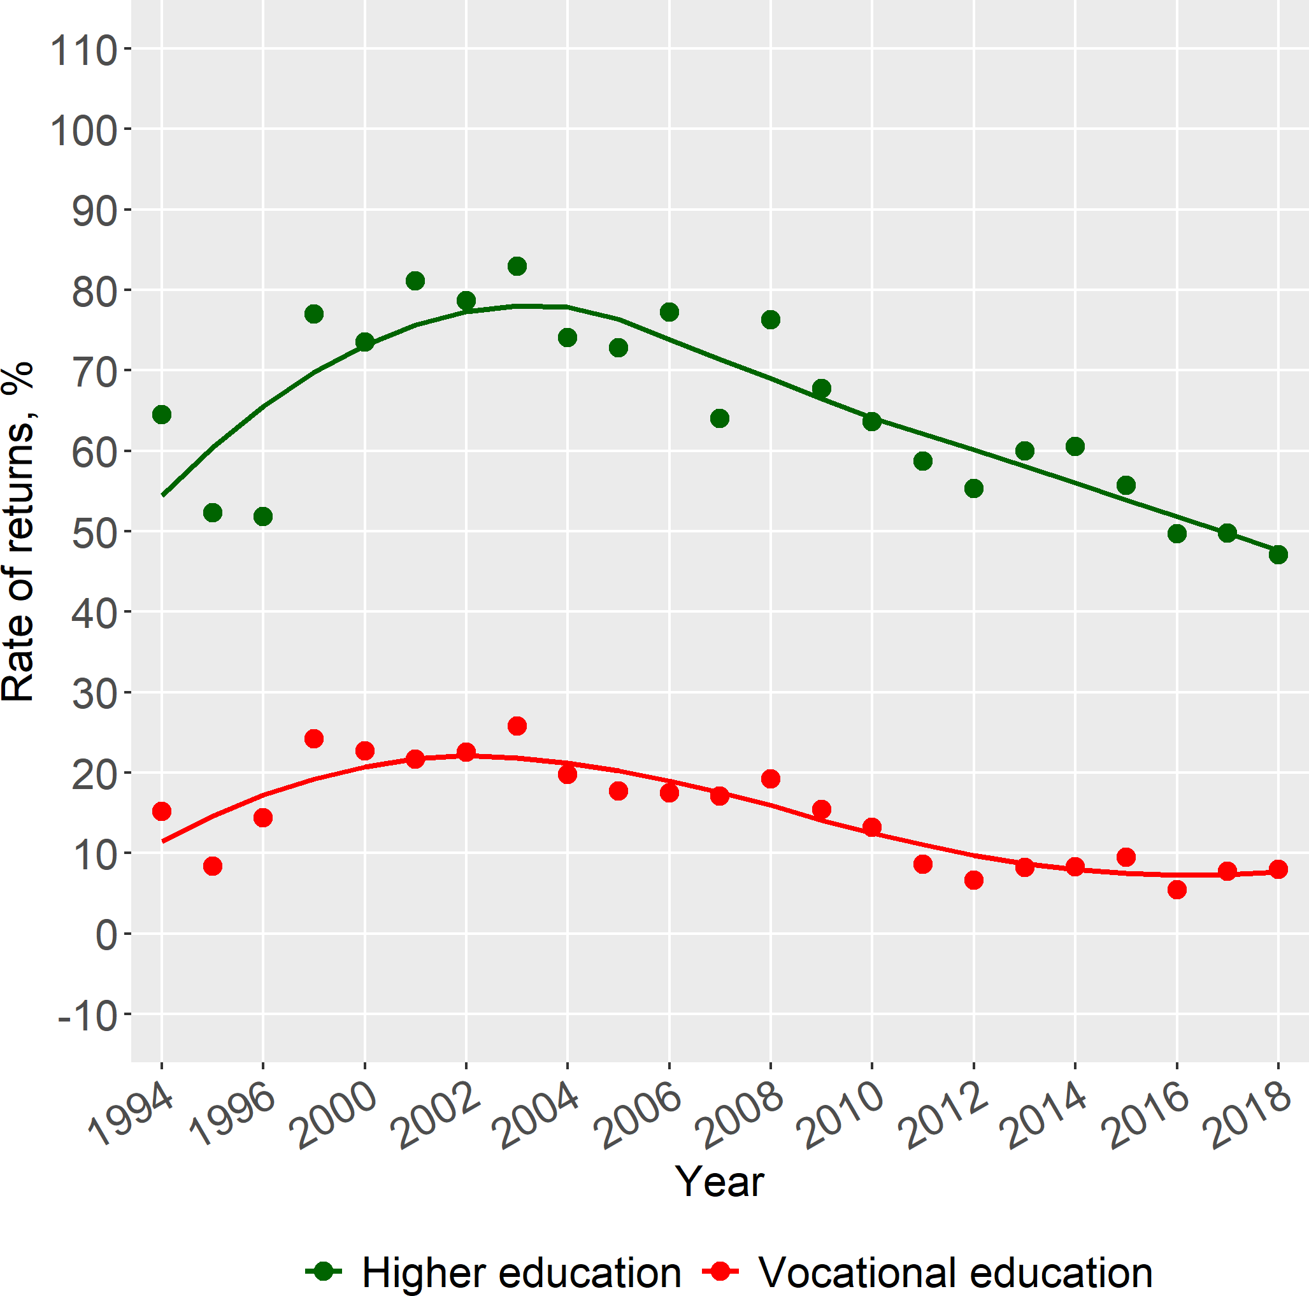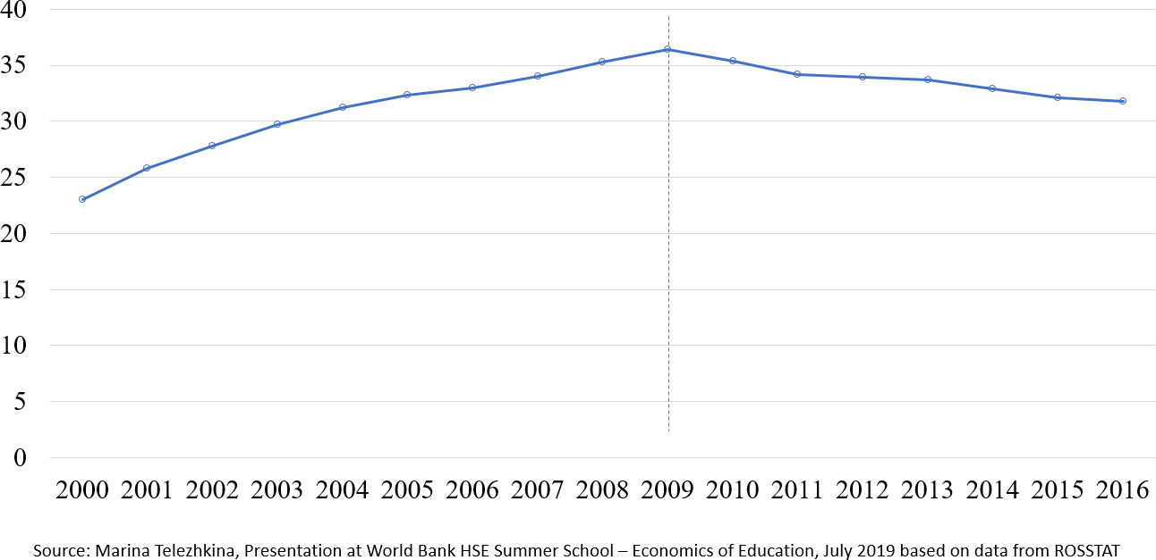

1. Rates of Return **(b)** Enrollment in Higher Education

When we look at the same data with information by gender, it is quite interesting that gender-based trends in Russia have a different shape across time with regard to schooling premiums. Though the percentage fluctuated slightly from year to year, there were about 55% females in the sample compared to 45% males. Particularly, males’ payoffs to higher education (varying from 45% to 76%) turn out to be on a slightly decreasing slope, whereas women’ returns are described by an inversely U-shaped pattern, reaching their maximum of 104% in 2001. Within the last roughly 5 years wage premiums to higher education for

women have stabilized around the level of men ( 50%). Gender wise enrollment rates in higher education (not shown) ten years later appears to match the differences in rates of return, strengthening the hypothesis that market rates of return to education in Russia do indeed influence individual continuing school decisions.

A similar comparative picture is observed with respect to vocational education, how- ever, the described regularities are way less pronounced (see Figure 2): returns for males are almost flat within the time period under focus and the parabolic association for females is tangibly less concave. The overall outcome concerning payoffs to schooling isolated by gender has been confirmed in a similar fashion by past studies (Cheidvasser and Ben´ıtez- Silva, 2007), etc .

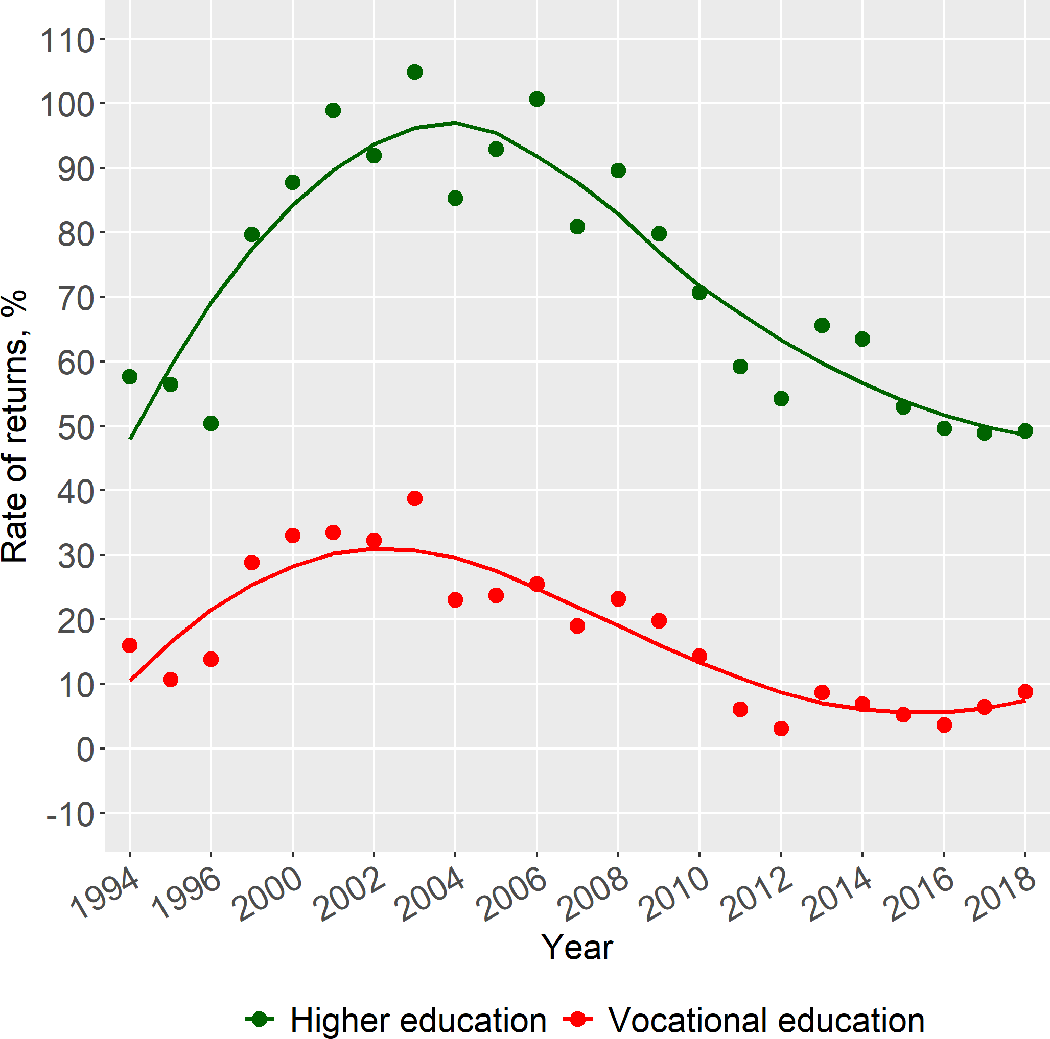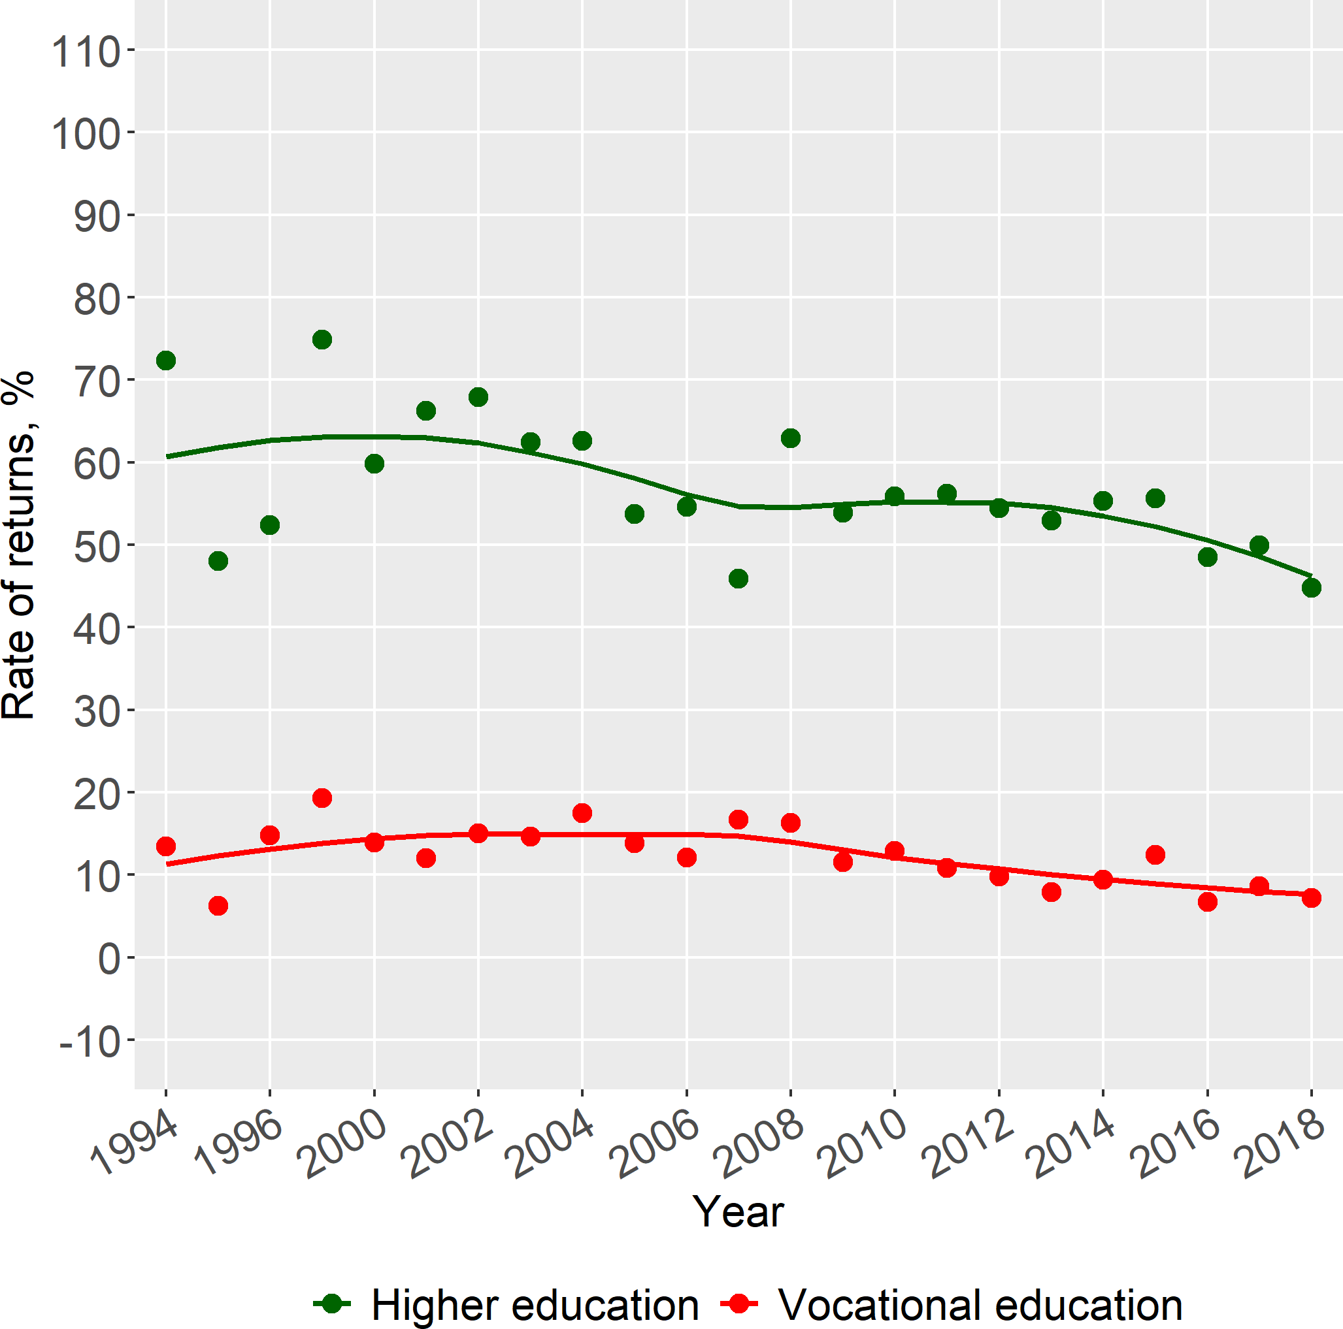

* 1. Females **(b)** Males

**Figure 2:** Rates of Returns to Higher and Vocational Education in Russia, RLMS 1994-2018

Looking at the pattern by nationality, there were approximately 15% non Russian nationals or immigrants in the RLMS database. We find that for Russian nationals, the payoffs to higher and vocational education are characterized by a pattern almost identical to the one uncovered for the whole population. As for non-Russians, the estimates of wage advantages regarding people with university education level compared to those with only secondary level are not statistically significant in the majority of time periods investigated (except for 2002-2006 and 2008). Nevertheless, the payoffs to vocational education for those who identified themselves as non-Russians are significant and the respective time trend is loosely distinguishable from the one registered for Russians. In other words, nationality seem to affect returns to higher education, but does not play a similar part with respect to vocational education.

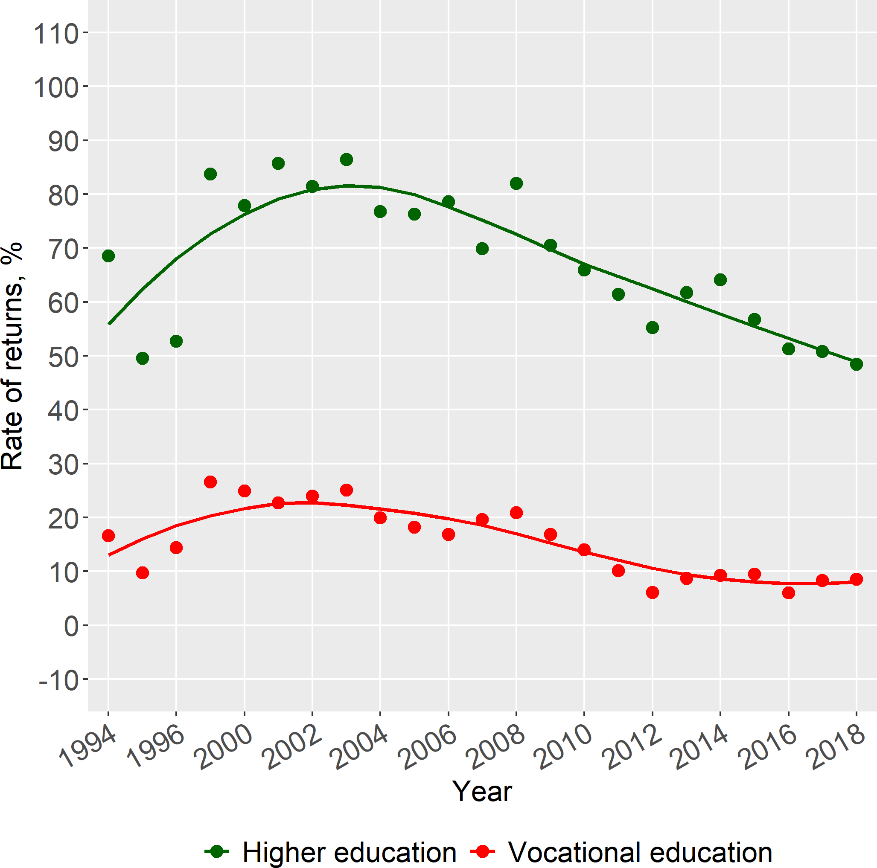 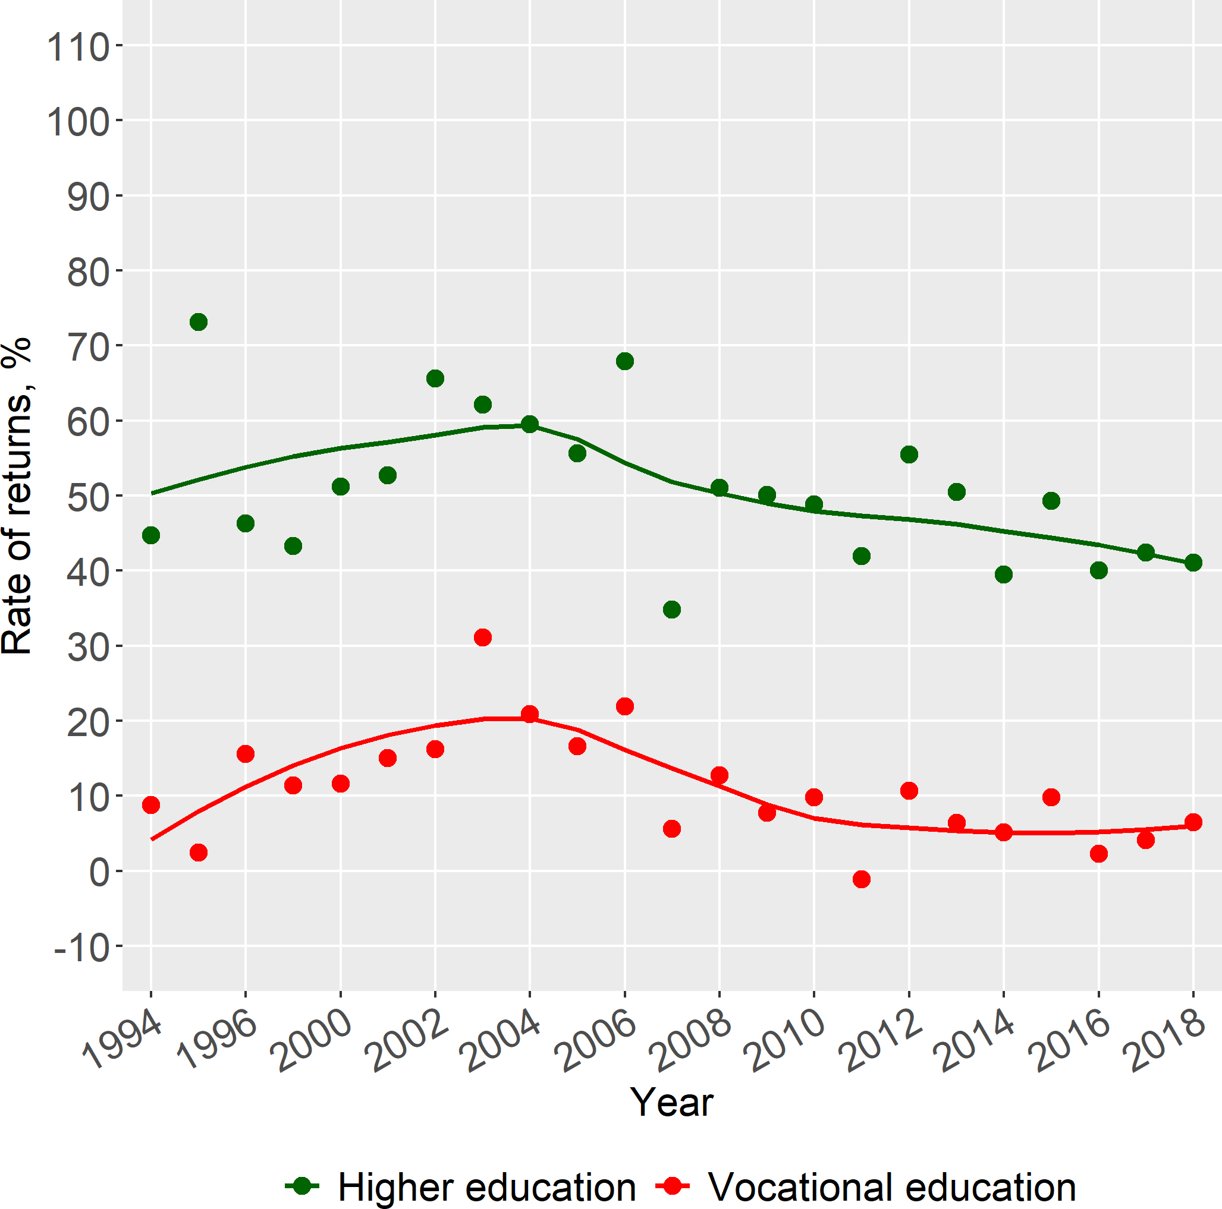

**(a)** Russians **(b)** Non-Russians

**Figure 3:** Rates of Returns to Higher and Vocational Education in Russia, RLMS 1994-2018

# Depreciation of Human Capital in the Russian Fed- eration

Age-earnings profiles are invariably concave downward shaped - earnings rise after a la- bor market entrant completes full-time schooling, they reach a peak, usually a few years before retirement and then steadily decline. The shape is an outcome of two countervail- ing tendencies - the rise attributed to continued accumulation of human capital through training, and the decline due to depreciation. The precise shape and location of the peak is an object of analytical interest. Training derived human capital is either general and transferable to other jobs, or specific to a job, sector, or industry. Depreciation of human capital is useful to investigate from a policy perspective. Just like some physical capital (machinery, buildings) are built stronger and last longer, is it possible that some kinds of education inherently generates human capital that is slower to depreciate? What at- tributes of the labor market lead to lower or higher levels of depreciation? What about the welfare implications of changes in the age at which individuals retire from the labor force? How has the depreciation rate of human capital changed over time?

## Analytical treatment of depreciation

Rosen, 1976 and Mincer and Ofek, 1982 were early treatments on depreciation of human capital. However, in terms of a focus on depreciation, Neuman and Weiss, 1995 was a seminal paper that established the basic parameters and has guided the research since that time. The authors introduce the important distinction between two kinds of depreciation or loss of productive potential of human capital. The first one, termed as ‘obsolescence’ or ‘vintage effect’ is due to an overall upgrading of technology or the operation of other

market forces that lowers the value of education or training obtained in a previous period. This is also termed as an ‘external depreciation’, presumably as it is a given for an individual. The second kind of depreciation is attributed to the deterioration of physical and mental abilities of an individual due to the progression of a person’s age, or the simple passage of time. This is also termed as ‘internal depreciation’. Neuman and Weiss posited that external effects would be more important for higher levels of education, under the assumption that changes in the labor market are transmitted more readily to higher education. They give the example that a recently educated electrical engineer would be learning many new things compared to one of more ancient vintage.

Figure 4 shows for the Russian Federation the effects described by Neuman and Weiss. There are three panels in the figure, and three lines in each figure. The vertical axis indicates the monthly earnings in constant 2018 Rubles, using the Rosstat CPI deflator. The horizontal axis indicates the years of experience. All three panels show an upward drift in the experience-earnings profiles in the period. Only Figure 4a shows a clear concave downwards profile for Higher Education, the concave tendency is much less pronounced for the other two levels of Vocational education and Secondary education. Putting the curves together would suggest that the premium for university education over the other two levels does narrow at higher levels of experience. This converging tendency would suggest that depreciation is indeed higher for university graduates. In the next two sub-sections, we present a more rigorous quantitative treatment of this issue.

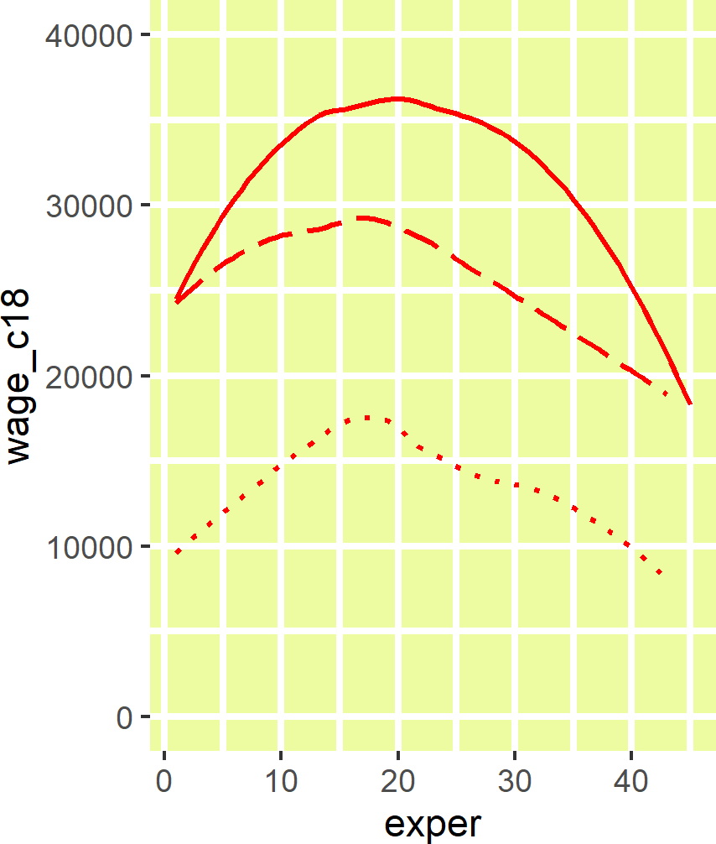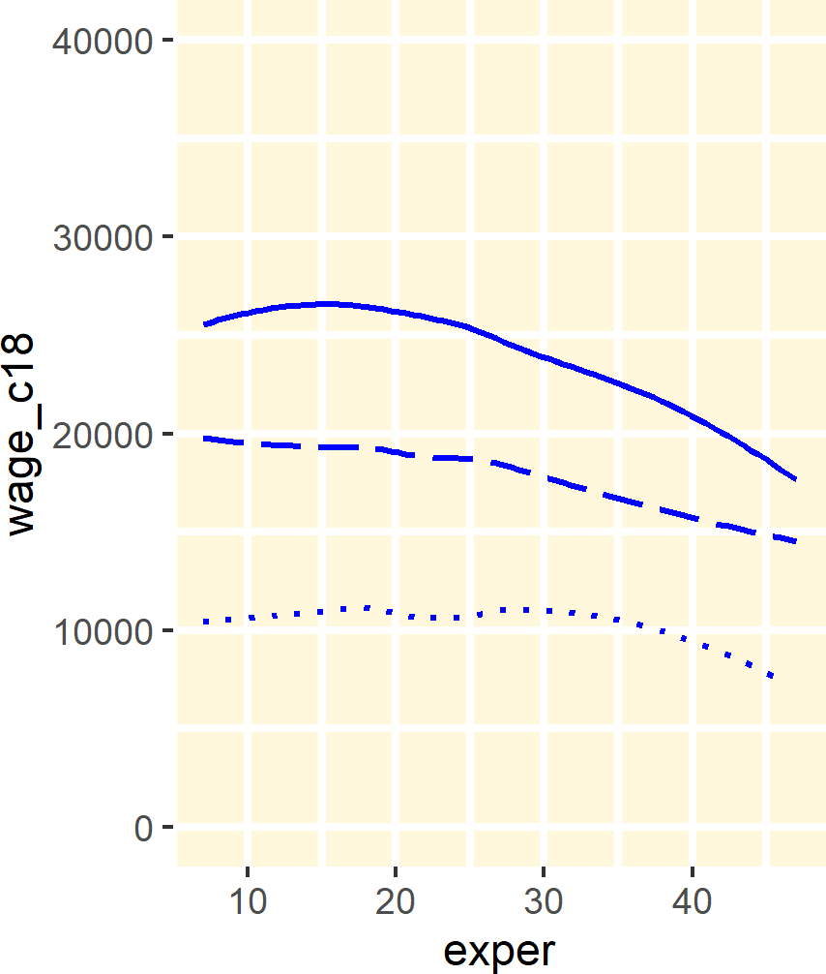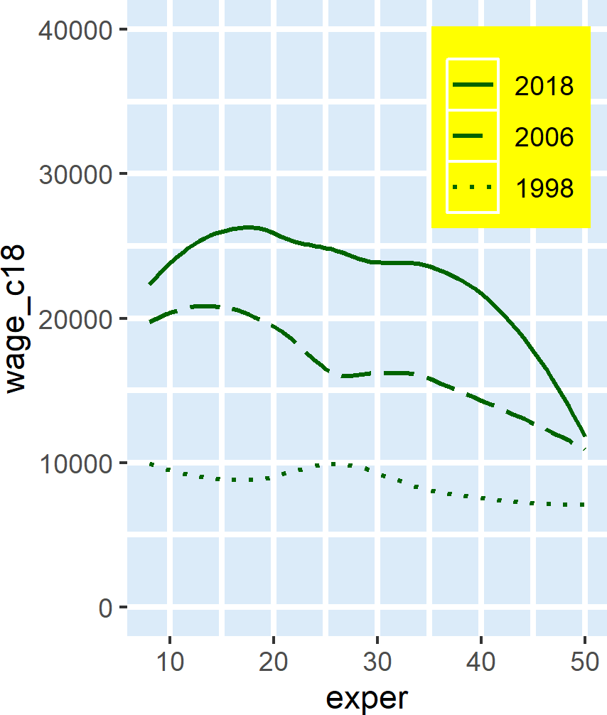

**(a)** Higher Education **(b)** Vocational Education **(c)** Secondary Education

**Figure 4:** Neuman-Weiss vintage effects by education level from RLMS Rounds 1998, 2006 and 2018

## Differential Depreciation affecting Education and Training

Murillo, 2006 followed the Neuman and Weiss model with a focus on empirical imple- mentation to Spain. We follow the Murillo notation in the implementation of the model, which begins with the following earnings equation:

*log*(*WT*) = *α* + *β*1*KST* + *β*2*KET* (2.1)

where *W* represents earnings, *KS* the stock of human capital derived from schooling of *S* years, and *KE* the stock of human capital acquired from on the job training or experience, and *T* indexes the number of years of experience since completing formal education. In

this set-up, the parameters *β*1 and *β*2 are the productivity parameters for the respective parts of the stock of human capital. Both are assumed to suffer from depreciation or the loss of productive value. At this stage, we do not distinguish between the causes (internal or external) of this loss. The path of the stock of human capital due to education is given by

*KST* = *S* + *hTS* (2.2)

where *h* is the rate of loss of the stock. The next equation for the loss of stock gained from experience is a bit more complicated. The stock from Schooling, *S* is taken to be fixed at the end of the full time schooling period and the beginning of the working period. However, experience is being built up every year at the same time as the capital acquired from previous experience depreciates.

*KET* = {1 + (*T* − 1)*γ*} + {1 + (*T* − 2)*γ*} + {1 + (*T* − 3)*γ*} + . . . + {1} (2.3)

where *γ* is the rate of loss applied every year. The equation can be simplified and summarized as

*KET* =

*T* + *γ*{(*T*

− 1) + (*T*

− 2) + (*T*

− 3) +

. . .

+ 1} =

*T*2

*T* + *γ* 2 (2.4)

Substituting equations 2.1 and 2.2 into equation 2.4, we get

*log*(*W*) = *α* + *β*1*S* + *β*1*hTS* + *β*2*T* + *β*2*γ T*2 = *α* + *β*1*S* + *π*1*TS* + *β*2*T* + *π*2*T*2 (2.5)

2

where *π*1 = *β*1*h* and *π*2 = *β*2*γ* .

2

From 2.5, the depreciation rate during *T* years applied to Schooling can be computed as *π*1*S* and the depreciation rate applied to Experience as 2*π*2*T*.

# Extension: Investigation of Gender dimension and depreciation?

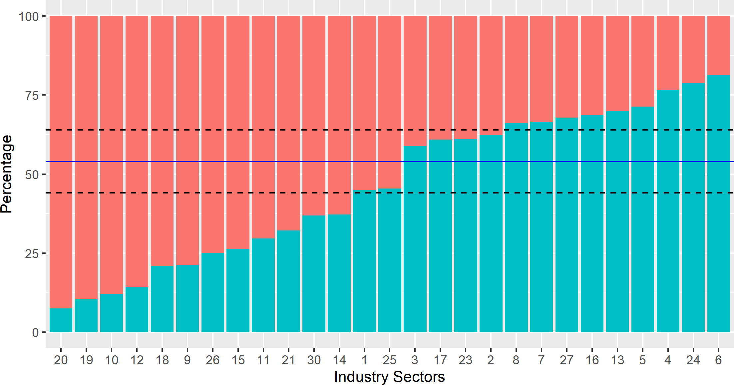

**Figure 5:** Distribution of Employment in RLMS 2018 by Industry and Gender

**Table 2:** Industries by Strength of Female Proportion: RLMS 2018

|  |  |  |  |  |
| --- | --- | --- | --- | --- |
| Category | Sector | Female  Sample | Female Percentage | Total  Sample |
| Female | Social Services | 37 | 92.5% | 40 |
| dominated | Other | 17 | 89.5% | 19 |
|  | Education | 609 | 88.0% | 692 |
|  | Public Health | 412 | 85.7% | 481 |
|  | Real Estate Operations | 19 | 79.2% | 24 |
|  | Government and Public Administration | 155 | 78.7% | 197 |
|  | General Public Services | 15 | 75.0% | 20 |
|  | Finance | 107 | 73.8% | 145 |
|  | Science, Culture | 100 | 70.4% | 142 |
|  | Jurisprudence | 19 | 67.9% | 28 |
| Neutral | Mass Media, Telecommunications | 24 | 63.2% | 38 |
|  | Trade, Consumer Services | 738 | 62.8% | 1175 |
|  | Light industry, Food industry | 209 | 55.0% | 380 |
|  | Sports, Tourism,Entertainment | 18 | 54.5% | 33 |
| Male | Miltary Industrial Complex | 67 | 41.1% | 163 |
| dominated | Housing and Community Services | 95 | 39.1% | 243 |
|  | Chemical Industry | 14 | 38.9% | 36 |
|  | Civil Machine Construction | 51 | 37.8% | 135 |
|  | Agriculture | 79 | 33.9% | 233 |
|  | Transportation, Communication | 186 | 33.6% | 553 |
|  | Information Technology | 9 | 32.1% | 28 |
|  | Energy or Power Industry | 41 | 31.3% | 131 |
|  | Army, Internal Security | 90 | 30.1% | 299 |
|  | Other Heavy Industry | 60 | 28.7% | 209 |
|  | Oil and Gas Industry | 52 | 23.5% | 221 |
|  | Wood, Timber, Forestry | 7 | 21.2% | 33 |
|  | Construction | 73 | 18.7% | 391 |
|  | Total | 3303 | 54.3% | 6089 |

Lorem ipsum dolor sit amet, consectetuer adipiscing elit. Ut purus elit, vestibulum ut, placerat ac, adipiscing vitae, felis. Curabitur dictum gravida mauris. Nam arcu libero, nonummy eget, consectetuer id, vulputate a, magna. Donec vehicula augue eu neque. Pellentesque habitant morbi tristique senectus et netus et malesuada fames ac turpis egestas. Mauris ut leo. Cras viverra metus rhoncus sem. Nulla et lectus vestibulum urna fringilla ultrices. Phasellus eu tellus sit amet tortor gravida placerat. Integer sapien est, iaculis in, pretium quis, viverra ac, nunc. Praesent eget sem vel leo ultrices bibendum. Aenean faucibus. Morbi dolor nulla, malesuada eu, pulvinar at, mollis ac, nulla. Curabitur auctor semper nulla. Donec varius orci eget risus. Duis nibh mi, congue eu, accumsan eleifend, sagittis quis, diam. Duis eget orci sit amet orci dignissim rutrum.

Nam dui ligula, fringilla a, euismod sodales, sollicitudin vel, wisi. Morbi auctor lorem non justo. Nam lacus libero, pretium at, lobortis vitae, ultricies et, tellus. Donec aliquet, tortor sed accumsan bibendum, erat ligula aliquet magna, vitae ornare odio metus a mi. Morbi ac orci et nisl hendrerit mollis. Suspendisse ut massa. Cras nec ante. Pellentesque a nulla. Cum sociis natoque penatibus et magnis dis parturient montes, nascetur ridiculus mus. Aliquam tincidunt urna. Nulla ullamcorper vestibulum turpis. Pellentesque cursus luctus mauris.

Nulla malesuada porttitor diam. Donec felis erat, congue non, volutpat at, tincidunt tristique, libero. Vivamus viverra fermentum felis. Donec nonummy pellentesque ante. Phasellus adipiscing semper elit. Proin fermentum massa ac quam. Sed diam turpis, molestie vitae, placerat a, molestie nec, leo. Maecenas lacinia. Nam ipsum ligula, eleifend at, accumsan nec, suscipit a, ipsum. Morbi blandit ligula feugiat magna. Nunc eleifend consequat lorem. Sed lacinia nulla vitae enim. Pellentesque tincidunt purus vel magna. Integer non enim. Praesent euismod nunc eu purus. Donec bibendum quam in tellus. Nullam cursus pulvinar lectus. Donec et mi. Nam vulputate metus eu enim. Vestibulum pellentesque felis eu massa.

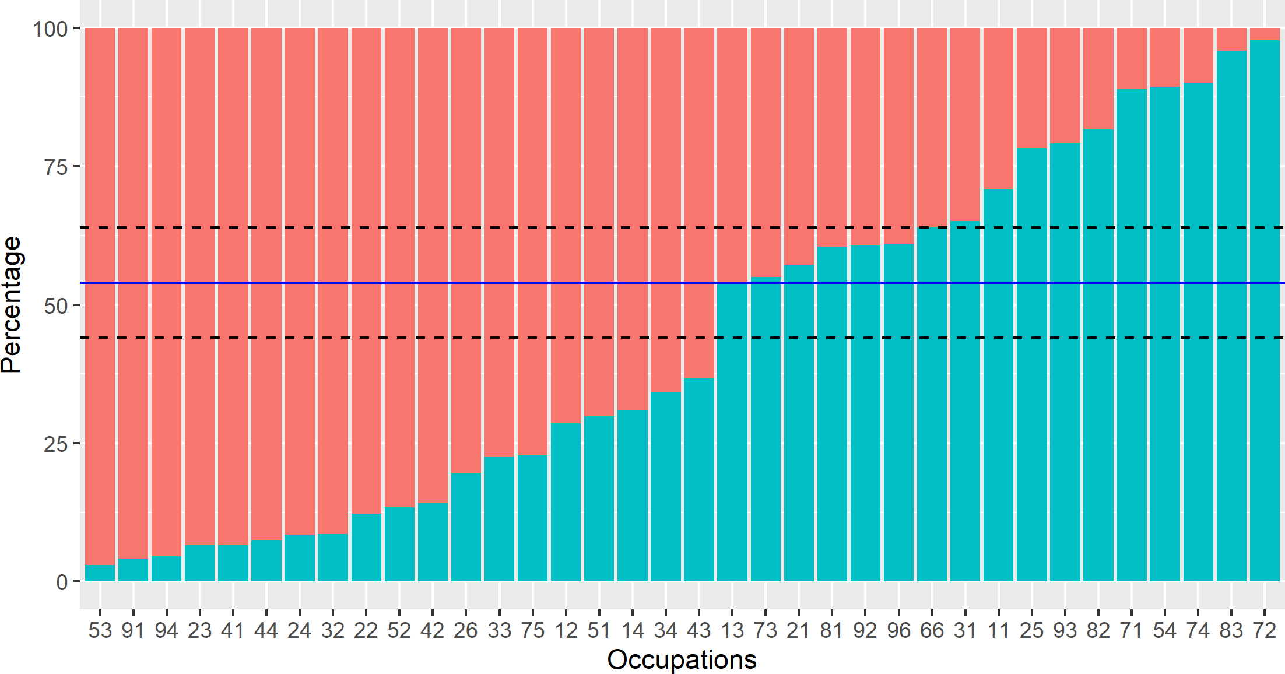

**Figure 6:** Distribution of Employment in RLMS 2018 by Industry and Gender

# References in Russian

This is a Russian reference. )J, OCJJI)J, aum-1

Now I cite (Carnoy et al., 2012).

And now Russian (Au,LpyllfaK m HaTxOJJ, 2010).

References

Au,LpyllfaK, fpmrOpmi- BmKTOpOJJmY m TmMyp Bia,LmMmpOJJmY HaTxOJJ (2010). "021. 0Km-

,LaeMIe ,LOxO,LI a6mTypmeuTOJJ pOCCmi-CKmx JJy:OJJ". JJ: BO11pOCI O6pa:OJJaum-1 2.

Carnoy, Martin m ,Lp. (2012). "005. The economic returns to higher education in the BRIC countries and their implications for higher education expansion". JJ: Higher School of Economics Research Paper No. WP BRP 2.

Cheidvasser, Sofia m Hugo Ben'1te�-Silva (2007). "006. The educated Russian's curse: Returns to education in the Russian Federation during the 1990s". JJ: Labour 21.1, C. 1-41.

Ko�yreva, Polina m Klara Sabirianova Peter (2015). "081. Economic Change in Russia: Twenty Years of the Russian Longitudinal Monitoring Survey". JJ: Economics of Transition 23.2, C. 293-298.

Mincer, Jacob m Haim Ofek (1982). "175. Interrupted work careers: Depreciation and restoration of human capital". JJ: Journal of human resources, C. 3-24.

Mincer, Jacob A. (1974). "082. Schooling, Experience, and Earnings". JJ: NBER Books. Murillo, Ines P. (2006). "172. Returns to Education and Human Capital Depreciation in

Spain". JJ: Econstor Working Paper.

Neuman, Shoshana m Avi Weiss (1995). "091. On the effects of schooling vintage on experience-earnings profiles: theory and evidence". JJ: European economic review 39.5,  C. 943-955.

Rosen, Sherwin (1976). "176. A theory of life earnings". JJ: Journal of Political Economy 84.4, S45-S67.

# Appendix

|  |  |  |  |
| --- | --- | --- | --- |
| ilab | tfem | pfem | tall |
| 1 Personal Care Workers | 97 | 97.0% | 100 |
| 2 Cleaners and Helpers | 163 | 95.9% | 170 |
| 3 Food Preparation Assistants | 21 | 95.5% | 22 |
| 4 Teaching Professionals | 370 | 93.4% | 396 |
| 5 General and Keyboard Clerks | 71 | 93.4% | 76 |
| 6 Other Clerical Support Workers | 25 | 92.6% | 27 |
| 7 Business and Administration Professionals | 97 | 91.5% | 106 |
| 8 Health Associate Professionals | 192 | 91.4% | 210 |
| 9 Health Professionals | 79 | 87.8% | 90 |
| 10 Sales Workers | 350 | 86.6% | 404 |
| 11 Customer Services Clerks | 67 | 85.9% | 78 |
| 12 Legal, Social and Cultural Professionals | 169 | 80.5% | 210 |
| 13 Business and Administration Associate Profes- | 517 | 77.4% | 668 |
| sionals |  |  |  |
| 14 Food Processing, Woodworking, Garment and | 51 | 77.3% | 66 |
| Other Craft and Related Trades Workers |  |  |  |
| 15 Administrative and Commercial Managers | 25 | 71.4% | 35 |
| 16 Personal Services Workers | 172 | 70.5% | 244 |
| 17 Hospitality, Retail and Other Services Managers | 38 | 69.1% | 55 |
| 18 Legal, Social, Cultural and Related Associate | 69 | 65.7% | 105 |
| Professionals |  |  |  |
| 19 Numerical and Material Recording Clerks | 100 | 63.3% | 158 |
| 20 Production and Specialized Services Managers | 139 | 46.0% | 302 |
| 21 Handicraft and Printing Workers | 9 | 45.0% | 20 |
| 22 Science and Engineering Professionals | 101 | 42.8% | 236 |
| 23 Stationary Plant and Machine Operators | 72 | 39.6% | 182 |
| 24 Agricultural, Forestry and Fishery Labourers | 11 | 39.3% | 28 |
| 25 Refuse Workers and Other Elementary Workers | 30 | 39.0% | 77 |
| 26 Miscellaneous non-ISCO | 9 | 36.0% | 25 |
| 27 Science and Engineering Associate Professionals | 120 | 34.9% | 344 |
| 28 Chief Executives, Senior Officials and Legisla- | 7 | 29.2% | 24 |
| tors |  |  |  |
| 29 Information and Communications Technology | 15 | 21.7% | 69 |
| Professionals |  |  |  |
| 30 Labourers in Mining, Construction, Manufac- | 24 | 20.9% | 115 |
| turing and Transport |  |  |  |
| 31 Assemblers | 11 | 18.3% | 60 |
| 32 Building and Related Trades Workers (excluding | 23 | 11.1% | 207 |
| Electricians) |  |  |  |
| 33 Protective Services Workers | 23 | 10.7% | 215 |
| 34 Electrical and Electronic Trades Workers | 16 | 9.9% | 162 |
| 35 Drivers and Mobile Plant Operators | 23 | 4.1% | 558 |
| 36 Metal, Machinery and Related Trades Workers | 6 | 2.2% | 267 |

**Table 3:** Results of Mincer Analysis, RLMS 1994

|  |  |  |  |  |  |  |
| --- | --- | --- | --- | --- | --- | --- |
|  | | Total Sample | Males | Females | Russians | Non-Russians |
| (1) | (2) | (3) | (4) | (5) |
| Vocational education | | 0.141∗∗∗ | 0.126∗∗ | 0.149∗∗∗ | 0.153∗∗∗ | 0.085 |
|  | | (0.042) | (0.064) | (0.055) | (0.046) | (0.102) |
| Higher education | | 0.498∗∗∗ | 0.544∗∗∗ | 0.455∗∗∗ | 0.522∗∗∗ | 0.370∗∗∗ |
|  | | (0.047) | (0.072) | (0.062) | (0.051) | (0.121) |
| Experience | | 0.007 | 0.008 | 0.004 | 0.001 | 0.036∗∗∗ |
|  | | (0.005) | (0.008) | (0.007) | (0.006) | (0.013) |
| Experience squared | | −0.0002 | −0.0004 | 0.0001  (0.0002) | 0.00000  (0.0002) | −0.001∗∗  (0.0004) |
| Non-Russian | | −0.004 | −0.056 | 0.042  (0.059) |  |  |
| Female | | −0.499∗∗∗ |  |  | −0.513∗∗∗ | −0.438∗∗∗  (0.085) |
| Constant | | 12.104∗∗∗ | 12.132∗∗∗ | 11.588∗∗∗ | 12.128∗∗∗ | 11.979∗∗∗ |
|  | | (0.046) | (0.065) | (0.059) | (0.050) | (0.110) |
| Observations | | 3,041 | 1,394 | 1,647 | 2,564 | 477 |
| R2 | | 0.103 | 0.049 | 0.041 | 0.109 | 0.083 |
| Adjusted R2 |  | 0.101 | 0.045 | 0.038 | 0.108 | 0.073 |
| Residual Std. | Error | 0.906 | 0.957 | 0.858 | 0.905 | 0.906 |
| F Statistic |  | 57.786∗∗∗ | 14.271∗∗∗ | 14.057∗∗∗ | 62.886∗∗∗ | 8.534∗∗∗ |
| *Note:* | ∗p*<*0.1; ∗∗p*<*0.05; ∗∗∗p*<*0.01 | | | | | |

(0.0002) (0.0003)

(0.045) (0.069)

(0.033) (0.036)

**Table 4:** Results of Mincer Analysis, RLMS 1995

|  |  |  |  |  |  |  |
| --- | --- | --- | --- | --- | --- | --- |
|  | | Total Sample | Males | Females | Russians | Non-Russians |
|  | | (1) | (2) | (3) | (4) | (5) |
| Vocational education | | 0.081∗ | 0.060 | 0.101∗ | 0.092∗ | 0.023 |
|  | | (0.044) | (0.066) | (0.060) | (0.049) | (0.109) |
| Higher education | | 0.421∗∗∗ | 0.392∗∗∗ | 0.447∗∗∗ | 0.402∗∗∗ | 0.549∗∗∗ |
|  | | (0.048) | (0.072) | (0.066) | (0.053) | (0.127) |
| Experience | | 0.002  (0.006) | −0.002 | 0.006  (0.008) | 0.002  (0.006) | 0.004  (0.015) |
| Experience squared | | −0.0001 | −0.00004 | −0.0001 | −0.0001 | −0.00005  (0.001) |
| Non-Russian | | −0.041 | −0.061 | −0.021 |  |  |
| Female | | −0.431∗∗∗ |  |  | −0.437∗∗∗ | −0.386∗∗∗  (0.090) |
| Constant | | 12.882∗∗∗ | 12.936∗∗∗ | 12.400∗∗∗ | 12.893∗∗∗ | 12.790∗∗∗ |
|  | | (0.049) | (0.067) | (0.064) | (0.052) | (0.118) |
| Observations | | 2,690 | 1,235 | 1,455 | 2,262 | 428 |
| R2 | | 0.085 | 0.032 | 0.040 | 0.082 | 0.105 |
| Adjusted R2 |  | 0.083 | 0.028 | 0.037 | 0.080 | 0.094 |
| Residual Std. | Error | 0.897 | 0.923 | 0.875 | 0.891 | 0.925 |
| F Statistic |  | 41.523∗∗∗ | 8.181∗∗∗ | 12.128∗∗∗ | 40.396∗∗∗ | 9.873∗∗∗ |
| *Note:* | ∗p*<*0.1; ∗∗p*<*0.05; ∗∗∗p*<*0.01 | | | | | |

(0.009)

(0.0002) (0.0003) (0.0002) (0.0002)

(0.047) (0.070) (0.064)

(0.035) (0.038)

**Table 5:** Results of Mincer Analysis, RLMS 1996

|  |  |  |  |  |  |  |
| --- | --- | --- | --- | --- | --- | --- |
|  | | Total Sample | Males | Females | Russians | Non-Russians |
|  | | (1) | (2) | (3) | (4) | (5) |
| Vocational education | | 0.134∗∗ | 0.138∗ | 0.129∗ | 0.134∗∗ | 0.145 |
|  | | (0.052) | (0.080) | (0.069) | (0.058) | (0.118) |
| Higher education | | 0.417∗∗∗ | 0.421∗∗∗ | 0.408∗∗∗ | 0.423∗∗∗ | 0.381∗∗∗ |
|  | | (0.056) | (0.086) | (0.074) | (0.062) | (0.133) |
| Experience | | 0.008 | 0.008 | 0.007 | 0.007 | 0.019 |
|  | | (0.006) | (0.010) | (0.008) | (0.007) | (0.018) |
| Experience squared | | −0.0004∗ | −0.001∗ | −0.0002 | −0.0003 | −0.001  (0.001) |
| Non-Russian | | 0.039  (0.055) | 0.043  (0.083) | 0.034  (0.074) |  |  |
| Female | | −0.477∗∗∗ |  |  | −0.475∗∗∗ | −0.499∗∗∗  (0.100) |
| Constant | | 13.208∗∗∗ | 13.230∗∗∗ | 12.713∗∗∗ | 13.205∗∗∗ | 13.245∗∗∗ |
|  | | (0.059) | (0.084) | (0.075) | (0.064) | (0.130) |
| Observations | | 2,281 | 1,033 | 1,248 | 1,941 | 340 |
| R2 | | 0.087 | 0.036 | 0.029 | 0.084 | 0.104 |
| Adjusted R2 |  | 0.084 | 0.031 | 0.025 | 0.082 | 0.091 |
| Residual Std. | Error | 0.929 | 0.976 | 0.888 | 0.934 | 0.906 |
| F Statistic |  | 35.992∗∗∗ | 7.709∗∗∗ | 7.501∗∗∗ | 35.671∗∗∗ | 7.774∗∗∗ |
| *Note:* | ∗p*<*0.1; ∗∗p*<*0.05; ∗∗∗p*<*0.01 | | | | | |

(0.0002) (0.0003) (0.0003) (0.0002)

(0.039) (0.043)

**Table 6:** Results of Mincer Analysis, RLMS 1998

|  |  |  |  |  |  |  |
| --- | --- | --- | --- | --- | --- | --- |
|  | | Total Sample | Males | Females | Russians | Non-Russians |
|  | | (1) | (2) | (3) | (4) | (5) |
| Vocational education | | 0.217∗∗∗ | 0.176∗∗∗ | 0.253∗∗∗ | 0.236∗∗∗ | 0.108 |
|  | | (0.037) | (0.054) | (0.050) | (0.040) | (0.093) |
| Higher education | | 0.571∗∗∗ | 0.559∗∗∗ | 0.586∗∗∗ | 0.608∗∗∗ | 0.360∗∗∗ |
|  | | (0.041) | (0.061) | (0.054) | (0.044) | (0.106) |
| Experience | | 0.015∗∗∗ | 0.010 | 0.020∗∗∗ | 0.014∗∗∗ | 0.022∗ |
|  | | (0.005) | (0.007) | (0.006) | (0.005) | (0.011) |
| Experience squared | | −0.0004∗∗∗ | −0.0004∗ | −0.0004∗∗ | −0.0004∗∗ | −0.001∗  (0.0003) |
| Non-Russian | | −0.032 | −0.073 | −0.0004 |  |  |
| Female | | −0.470∗∗∗ |  |  | −0.483∗∗∗ | −0.406∗∗∗  (0.071) |
| Constant | | 6.364∗∗∗ | 6.447∗∗∗ | 5.817∗∗∗ | 6.358∗∗∗ | 6.373∗∗∗ |
|  | | (0.043) | (0.061) | (0.057) | (0.046) | (0.107) |
| Observations | | 3,101 | 1,434 | 1,667 | 2,614 | 487 |
| R2 | | 0.133 | 0.064 | 0.079 | 0.141 | 0.095 |
| Adjusted R2 |  | 0.131 | 0.061 | 0.076 | 0.140 | 0.086 |
| Residual Std. | Error | 0.768 | 0.806 | 0.733 | 0.767 | 0.770 |
| F Statistic |  | 79.074∗∗∗ | 19.512∗∗∗ | 28.374∗∗∗ | 85.755∗∗∗ | 10.119∗∗∗ |
| *Note:* | ∗p*<*0.1; ∗∗p*<*0.05; ∗∗∗p*<*0.01 | | | | | |

(0.0002) (0.0002) (0.0002) (0.0002)

(0.038) (0.059) (0.049)

(0.028) (0.030)

**Table 7:** Results of Mincer Analysis, RLMS 2000

|  |  |  |  |  |  |  |
| --- | --- | --- | --- | --- | --- | --- |
|  | | Total Sample | Males | Females | Russians | Non-Russians |
|  | | (1) | (2) | (3) | (4) | (5) |
| Vocational education | | 0.205∗∗∗ | 0.131∗∗ | 0.285∗∗∗ | 0.222∗∗∗ | 0.110 |
|  | | (0.039) | (0.056) | (0.053) | (0.042) | (0.101) |
| Higher education | | 0.551∗∗∗ | 0.469∗∗∗ | 0.630∗∗∗ | 0.576∗∗∗ | 0.413∗∗∗ |
|  | | (0.043) | (0.064) | (0.057) | (0.046) | (0.113) |
| Experience | | 0.009∗ | 0.001 | 0.016∗∗ | 0.008 | 0.014 |
|  | | (0.005) | (0.008) | (0.007) | (0.006) | (0.016) |
| Experience squared | | −0.0002 | −0.0002 | −0.0002 | −0.0002 | −0.0004  (0.001) |
| Non-Russian | | −0.001 | −0.016 | 0.002  (0.055) |  |  |
| Female | | −0.534∗∗∗ |  |  | −0.536∗∗∗ | −0.511∗∗∗  (0.081) |
| Constant | | 7.071∗∗∗ | 7.207∗∗∗ | 6.398∗∗∗ | 7.059∗∗∗ | 7.120∗∗∗ |
|  | | (0.046) | (0.065) | (0.062) | (0.049) | (0.123) |
| Observations | | 3,213 | 1,475 | 1,738 | 2,765 | 448 |
| R2 | | 0.128 | 0.042 | 0.078 | 0.133 | 0.104 |
| Adjusted R2 |  | 0.127 | 0.038 | 0.075 | 0.131 | 0.094 |
| Residual Std. | Error | 0.830 | 0.861 | 0.799 | 0.829 | 0.835 |
| F Statistic |  | 78.748∗∗∗ | 12.777∗∗∗ | 29.233∗∗∗ | 84.557∗∗∗ | 10.307∗∗∗ |
| *Note:* | ∗p*<*0.1; ∗∗p*<*0.05; ∗∗∗p*<*0.01 | | | | | |

(0.0002) (0.0003) (0.0002) (0.0002)

(0.042) (0.065)

(0.030) (0.032)

**Table 8:** Results of Mincer Analysis, RLMS 2001

|  |  |  |  |  |  |  |
| --- | --- | --- | --- | --- | --- | --- |
|  | | Total Sample | Males | Females | Russians | Non-Russians |
|  | | (1) | (2) | (3) | (4) | (5) |
| Vocational education | | 0.196∗∗∗ | 0.113∗∗ | 0.289∗∗∗ | 0.204∗∗∗ | 0.140 |
|  | | (0.036) | (0.052) | (0.050) | (0.039) | (0.101) |
| Higher education | | 0.594∗∗∗ | 0.508∗∗∗ | 0.688∗∗∗ | 0.619∗∗∗ | 0.423∗∗∗ |
|  | | (0.039) | (0.059) | (0.053) | (0.042) | (0.110) |
| Experience | | 0.0002  (0.005) | −0.0004 | −0.0002 | −0.002 | 0.017  (0.015) |
| Experience squared | | −0.00001 | −0.0001 | 0.0001  (0.0002) | 0.00004  (0.0001) | −0.0004  (0.0005) |
| Non-Russian | | −0.027 | −0.103∗ | 0.025  (0.051) |  |  |
| Female | | −0.463∗∗∗ |  |  | −0.478∗∗∗ | −0.361∗∗∗  (0.081) |
| Constant | | 7.491∗∗∗ | 7.591∗∗∗ | 6.921∗∗∗ | 7.501∗∗∗ | 7.383∗∗∗ |
|  | | (0.041) | (0.058) | (0.057) | (0.044) | (0.116) |
| Observations | | 3,604 | 1,673 | 1,931 | 3,128 | 476 |
| R2 | | 0.125 | 0.056 | 0.091 | 0.136 | 0.066 |
| Adjusted R2 |  | 0.124 | 0.053 | 0.089 | 0.135 | 0.056 |
| Residual Std. | Error | 0.813 | 0.853 | 0.774 | 0.805 | 0.858 |
| F Statistic |  | 85.935∗∗∗ | 19.738∗∗∗ | 38.626∗∗∗ | 98.701∗∗∗ | 6.661∗∗∗ |
| *Note:* | ∗p*<*0.1; ∗∗p*<*0.05; ∗∗∗p*<*0.01 | | | | | |

(0.007) (0.006) (0.005)

(0.0001) (0.0002)

(0.040) (0.063)

(0.027) (0.029)

**Table 9:** Results of Mincer Analysis, RLMS 2002

|  |  |  |  |  |  |  |
| --- | --- | --- | --- | --- | --- | --- |
|  | | Total Sample | Males | Females | Russians | Non-Russians |
|  | | (1) | (2) | (3) | (4) | (5) |
| Vocational education | | 0.203∗∗∗ | 0.140∗∗∗ | 0.280∗∗∗ | 0.215∗∗∗ | 0.150∗ |
|  | | (0.033) | (0.047) | (0.046) | (0.036) | (0.082) |
| Higher education | | 0.581∗∗∗ | 0.518∗∗∗ | 0.652∗∗∗ | 0.595∗∗∗ | 0.504∗∗∗ |
|  | | (0.035) | (0.052) | (0.049) | (0.039) | (0.092) |
| Experience | | 0.008∗ | 0.001 | 0.013∗∗ | 0.006 | 0.019 |
|  | | (0.004) | (0.007) | (0.006) | (0.005) | (0.013) |
| Experience squared | | −0.0001 | −0.0001 | −0.0002 | −0.0001 | −0.0004  (0.0004) |
| Non-Russian | | 0.069∗  (0.035) | 0.066  (0.055) | 0.062  (0.046) |  |  |
| Female | | −0.444∗∗∗ |  |  | −0.441∗∗∗ | −0.459∗∗∗  (0.068) |
| Constant | | 7.755∗∗∗ | 7.863∗∗∗ | 7.193∗∗∗ | 7.753∗∗∗ | 7.815∗∗∗ |
|  | | (0.038) | (0.053) | (0.052) | (0.041) | (0.097) |
| Observations | | 3,803 | 1,748 | 2,055 | 3,286 | 517 |
| R2 | | 0.133 | 0.062 | 0.098 | 0.134 | 0.125 |
| Adjusted R2 |  | 0.131 | 0.059 | 0.096 | 0.133 | 0.116 |
| Residual Std. | Error | 0.748 | 0.774 | 0.722 | 0.748 | 0.749 |
| F Statistic |  | 96.883∗∗∗ | 22.835∗∗∗ | 44.584∗∗∗ | 101.827∗∗∗ | 14.558∗∗∗ |
| *Note:* | ∗p*<*0.1; ∗∗p*<*0.05; ∗∗∗p*<*0.01 | | | | | |

(0.0001) (0.0002) (0.0002) (0.0001)

(0.025) (0.026)

**Table 10:** Results of Mincer Analysis, RLMS 2003

|  |  |  |  |  |  |  |
| --- | --- | --- | --- | --- | --- | --- |
|  | | Total Sample | Males | Females | Russians | Non-Russians |
|  | | (1) | (2) | (3) | (4) | (5) |
| Vocational education | | 0.229∗∗∗ | 0.136∗∗∗ | 0.328∗∗∗ | 0.224∗∗∗ | 0.271∗∗∗ |
|  | | (0.033) | (0.046) | (0.046) | (0.035) | (0.083) |
| Higher education | | 0.604∗∗∗ | 0.485∗∗∗ | 0.717∗∗∗ | 0.623∗∗∗ | 0.483∗∗∗ |
|  | | (0.035) | (0.052) | (0.048) | (0.038) | (0.090) |
| Experience | | 0.008∗∗ | 0.008 | 0.009∗ | 0.009∗∗ | 0.006 |
|  | | (0.004) | (0.007) | (0.006) | (0.005) | (0.012) |
| Experience squared | | −0.0002 | −0.0004∗ | −0.0001 | −0.0002 | −0.0002  (0.0004) |
| Non-Russian | | 0.066∗  (0.035) | 0.049  (0.053) | 0.075  (0.047) |  |  |
| Female | | −0.491∗∗∗ |  |  | −0.495∗∗∗ | −0.468∗∗∗  (0.066) |
| Constant | | 7.970∗∗∗ | 8.086∗∗∗ | 7.359∗∗∗ | 7.963∗∗∗ | 8.078∗∗∗ |
|  | | (0.038) | (0.054) | (0.052) | (0.041) | (0.099) |
| Observations | | 3,857 | 1,765 | 2,092 | 3,335 | 522 |
| R2 | | 0.151 | 0.060 | 0.110 | 0.154 | 0.137 |
| Adjusted R2 |  | 0.150 | 0.057 | 0.108 | 0.153 | 0.129 |
| Residual Std. | Error | 0.747 | 0.761 | 0.731 | 0.749 | 0.731 |
| F Statistic |  | 114.015∗∗∗ | 22.345∗∗∗ | 51.464∗∗∗ | 121.088∗∗∗ | 16.378∗∗∗ |
| *Note:* | ∗p*<*0.1; ∗∗p*<*0.05; ∗∗∗p*<*0.01 | | | | | |

(0.0001) (0.0002) (0.0002) (0.0001)

(0.024) (0.026)

**Table 11:** Results of Mincer Analysis, RLMS 2004

|  |  |  |  |  |  |  |
| --- | --- | --- | --- | --- | --- | --- |
|  | | Total Sample | Males | Females | Russians | Non-Russians |
|  | | (1) | (2) | (3) | (4) | (5) |
| Vocational education | | 0.181∗∗∗ | 0.161∗∗∗ | 0.207∗∗∗ | 0.181∗∗∗ | 0.189∗∗ |
|  | | (0.031) | (0.044) | (0.044) | (0.034) | (0.080) |
| Higher education | | 0.554∗∗∗ | 0.486∗∗∗ | 0.617∗∗∗ | 0.570∗∗∗ | 0.467∗∗∗ |
|  | | (0.033) | (0.049) | (0.046) | (0.036) | (0.086) |
| Experience | | 0.0001  (0.004) | −0.006 | 0.005  (0.005) | 0.001  (0.004) | −0.009  (0.011) |
| Experience squared | | 0.00003  (0.0001) | 0.00002  (0.0002) | 0.00001  (0.0002) | −0.00002 | 0.0004  (0.0003) |
| Non-Russian | | 0.039  (0.033) | 0.037  (0.050) | 0.036  (0.044) |  |  |
| Female | | −0.497∗∗∗ |  |  | −0.497∗∗∗ | −0.505∗∗∗  (0.063) |
| Constant | | 8.294∗∗∗ | 8.380∗∗∗ | 7.708∗∗∗ | 8.284∗∗∗ | 8.393∗∗∗ |
|  | | (0.036) | (0.050) | (0.049) | (0.039) | (0.089) |
| Observations | | 3,967 | 1,824 | 2,143 | 3,439 | 528 |
| R2 | | 0.157 | 0.061 | 0.101 | 0.159 | 0.151 |
| Adjusted R2 |  | 0.156 | 0.058 | 0.099 | 0.158 | 0.143 |
| Residual Std. | Error | 0.711 | 0.730 | 0.692 | 0.712 | 0.707 |
| F Statistic |  | 123.291∗∗∗ | 23.549∗∗∗ | 48.085∗∗∗ | 129.807∗∗∗ | 18.629∗∗∗ |
| *Note:* | ∗p*<*0.1; ∗∗p*<*0.05; ∗∗∗p*<*0.01 | | | | | |

(0.006)

(0.0001)

(0.023) (0.025)

**Table 12:** Results of Mincer Analysis, RLMS 2005

(0.004) (0.006) (0.004)

|  |  |  |  |  |  |  |
| --- | --- | --- | --- | --- | --- | --- |
|  | | Total Sample | Males | Females | Russians | Non-Russians |
|  | | (1) | (2) | (3) | (4) | (5) |
| Vocational education | | 0.163∗∗∗ | 0.129∗∗∗ | 0.212∗∗∗ | 0.167∗∗∗ | 0.154∗ |
|  | | (0.031) | (0.043) | (0.044) | (0.034) | (0.079) |
| Higher education | | 0.547∗∗∗ | 0.430∗∗∗ | 0.657∗∗∗ | 0.567∗∗∗ | 0.442∗∗∗ |
|  | | (0.033) | (0.048) | (0.046) | (0.036) | (0.085) |
| Experience | | −0.003 | −0.007 | 0.001  (0.005) | −0.002 | −0.008  (0.011) |
| Experience squared | | 0.0001  (0.0001) | 0.00002  (0.0002) | 0.0001  (0.0002) | 0.0001  (0.0001) | 0.0002  (0.0003) |
| Non-Russian | | 0.063∗  (0.033) | 0.016  (0.049) | 0.109∗∗  (0.044) |  |  |
| Female | | −0.503∗∗∗ |  |  | −0.517∗∗∗ | −0.427∗∗∗  (0.064) |
| Constant | | 8.532∗∗∗ | 8.644∗∗∗ | 7.906∗∗∗ | 8.524∗∗∗ | 8.633∗∗∗ |
|  | | (0.036) | (0.050) | (0.051) | (0.039) | (0.092) |
| Observations | | 3,913 | 1,801 | 2,112 | 3,367 | 546 |
| R2 | | 0.162 | 0.053 | 0.120 | 0.169 | 0.124 |
| Adjusted R2 |  | 0.160 | 0.050 | 0.118 | 0.167 | 0.116 |
| Residual Std. | Error | 0.704 | 0.723 | 0.684 | 0.700 | 0.733 |
| F Statistic |  | 125.554∗∗∗ | 20.059∗∗∗ | 57.218∗∗∗ | 136.313∗∗∗ | 15.263∗∗∗ |
| *Note:* | ∗p*<*0.1; ∗∗p*<*0.05; ∗∗∗p*<*0.01 | | | | | |

(0.023) (0.025)

**Table 13:** Results of Mincer Analysis, RLMS 2006

(0.003) (0.004) (0.004)

|  |  |  |  |  |  |  |
| --- | --- | --- | --- | --- | --- | --- |
|  | | Total Sample | Males | Females | Russians | Non-Russians |
|  | | (1) | (2) | (3) | (4) | (5) |
| Vocational education | | 0.161∗∗∗ | 0.114∗∗∗ | 0.227∗∗∗ | 0.155∗∗∗ | 0.198∗∗∗ |
|  | | (0.027) | (0.038) | (0.039) | (0.029) | (0.069) |
| Higher education | | 0.572∗∗∗ | 0.436∗∗∗ | 0.696∗∗∗ | 0.580∗∗∗ | 0.518∗∗∗ |
|  | | (0.029) | (0.043) | (0.041) | (0.032) | (0.075) |
| Experience | | −0.003 | 0.002  (0.005) | −0.006 | −0.002 | −0.005  (0.009) |
| Experience squared | | 0.00003  (0.0001) | −0.0002 | 0.0002  (0.0001) | 0.00002  (0.0001) | 0.0001  (0.0003) |
| Non-Russian | | 0.092∗∗∗  (0.029) | 0.066  (0.044) | 0.117∗∗∗  (0.039) |  |  |
| Female | | −0.456∗∗∗ |  |  | −0.463∗∗∗ | −0.411∗∗∗  (0.054) |
| Constant | | 8.733∗∗∗ | 8.791∗∗∗ | 8.200∗∗∗ | 8.735∗∗∗ | 8.819∗∗∗ |
|  | | (0.031) | (0.042) | (0.043) | (0.033) | (0.078) |
| Observations | | 4,804 | 2,172 | 2,632 | 4,179 | 625 |
| R2 | | 0.163 | 0.059 | 0.133 | 0.164 | 0.151 |
| Adjusted R2 |  | 0.162 | 0.057 | 0.131 | 0.163 | 0.144 |
| Residual Std. | Error | 0.681 | 0.694 | 0.667 | 0.684 | 0.659 |
| F Statistic |  | 156.012∗∗∗ | 27.246∗∗∗ | 80.635∗∗∗ | 163.550∗∗∗ | 22.059∗∗∗ |
| *Note:* | ∗p*<*0.1; ∗∗p*<*0.05; ∗∗∗p*<*0.01 | | | | | |

(0.0002)

(0.020) (0.022)

**Table 14:** Results of Mincer Analysis, RLMS 2007

(0.003) (0.004) (0.003)

|  |  |  |  |  |  |  |
| --- | --- | --- | --- | --- | --- | --- |
|  | | Total Sample | Males | Females | Russians | Non-Russians |
|  | | (1) | (2) | (3) | (4) | (5) |
| Vocational education | | 0.158∗∗∗ | 0.155∗∗∗ | 0.174∗∗∗ | 0.179∗∗∗ | 0.054 |
|  | | (0.026) | (0.035) | (0.037) | (0.028) | (0.066) |
| Higher education | | 0.495∗∗∗ | 0.378∗∗∗ | 0.593∗∗∗ | 0.530∗∗∗ | 0.298∗∗∗ |
|  | | (0.028) | (0.039) | (0.039) | (0.030) | (0.072) |
| Experience | | −0.001 | 0.002  (0.005) | −0.003 | −0.003 | 0.011  (0.009) |
| Experience squared | | −0.00005 | −0.0002∗ | 0.0001  (0.0001) | 0.00000  (0.0001) | −0.0004  (0.0003) |
| Non-Russian | | 0.045  (0.028) | −0.019 | 0.110∗∗∗  (0.038) |  |  |
| Female | | −0.429∗∗∗ |  |  | −0.447∗∗∗ | −0.318∗∗∗  (0.053) |
| Constant | | 8.955∗∗∗ | 9.000∗∗∗ | 8.476∗∗∗ | 8.953∗∗∗ | 8.996∗∗∗ |
|  | | (0.029) | (0.040) | (0.040) | (0.031) | (0.076) |
| Observations | | 4,726 | 2,153 | 2,573 | 4,136 | 590 |
| R2 | | 0.152 | 0.050 | 0.113 | 0.161 | 0.097 |
| Adjusted R2 |  | 0.150 | 0.048 | 0.111 | 0.160 | 0.089 |
| Residual Std. | Error | 0.640 | 0.641 | 0.636 | 0.641 | 0.631 |
| F Statistic |  | 140.495∗∗∗ | 22.629∗∗∗ | 65.411∗∗∗ | 158.888∗∗∗ | 12.539∗∗∗ |
| *Note:* | ∗p*<*0.1; ∗∗p*<*0.05; ∗∗∗p*<*0.01 | | | | | |

(0.0001) (0.0001)

(0.041)

(0.019) (0.020)

**Table 15:** Results of Mincer Analysis, RLMS 2008

(0.003) (0.005) (0.004)

|  |  |  |  |  |  |  |
| --- | --- | --- | --- | --- | --- | --- |
|  | | Total Sample | Males | Females | Russians | Non-Russians |
|  | | (1) | (2) | (3) | (4) | (5) |
| Vocational education | | 0.175∗∗∗ | 0.151∗∗∗ | 0.209∗∗∗ | 0.189∗∗∗ | 0.120∗ |
|  | | (0.027) | (0.037) | (0.040) | (0.030) | (0.069) |
| Higher education | | 0.567∗∗∗ | 0.488∗∗∗ | 0.640∗∗∗ | 0.599∗∗∗ | 0.412∗∗∗ |
|  | | (0.029) | (0.041) | (0.041) | (0.032) | (0.072) |
| Experience | | −0.0002 | −0.001 | 0.0001  (0.005) | −0.001 | 0.002  (0.009) |
| Experience squared | | −0.0001 | −0.0002 | −0.00000 | −0.0001 | −0.0002  (0.0003) |
| Non-Russian | | 0.043  (0.028) | −0.031 | 0.116∗∗∗  (0.039) |  |  |
| Female | | −0.453∗∗∗ |  |  | −0.476∗∗∗ | −0.322∗∗∗  (0.053) |
| Constant | | 9.176∗∗∗ | 9.249∗∗∗ | 8.650∗∗∗ | 9.173∗∗∗ | 9.235∗∗∗ |
|  | | (0.032) | (0.043) | (0.044) | (0.034) | (0.081) |
| Observations | | 4,827 | 2,170 | 2,657 | 4,140 | 687 |
| R2 | | 0.162 | 0.079 | 0.114 | 0.172 | 0.107 |
| Adjusted R2 |  | 0.161 | 0.077 | 0.112 | 0.171 | 0.101 |
| Residual Std. | Error | 0.683 | 0.680 | 0.683 | 0.681 | 0.689 |
| F Statistic |  | 155.203∗∗∗ | 37.314∗∗∗ | 68.048∗∗∗ | 172.104∗∗∗ | 16.395∗∗∗ |
| *Note:* | ∗p*<*0.1; ∗∗p*<*0.05; ∗∗∗p*<*0.01 | | | | | |

(0.0001) (0.0002) (0.0001) (0.0001)

(0.040)

(0.020) (0.022)

**Table 16:** Results of Mincer Analysis, RLMS 2009

|  |  |  |  |  |  |  |
| --- | --- | --- | --- | --- | --- | --- |
|  | | Total Sample | Males | Females | Russians | Non-Russians |
|  | | (1) | (2) | (3) | (4) | (5) |
| Vocational education | | 0.143∗∗∗ | 0.109∗∗∗ | 0.181∗∗∗ | 0.155∗∗∗ | 0.075 |
|  | | (0.027) | (0.037) | (0.040) | (0.029) | (0.071) |
| Higher education | | 0.517∗∗∗ | 0.431∗∗∗ | 0.587∗∗∗ | 0.534∗∗∗ | 0.406∗∗∗ |
|  | | (0.028) | (0.040) | (0.040) | (0.030) | (0.076) |
| Experience | | 0.012∗∗∗ | 0.008 | 0.016∗∗∗ | 0.011∗∗∗ | 0.021∗∗ |
|  | | (0.003) | (0.005) | (0.004) | (0.003) | (0.010) |
| Experience squared | | −0.0004∗∗∗ | −0.0003∗∗ | −0.0004∗∗∗ | −0.0003∗∗∗ | −0.001∗∗  (0.0003) |
| Non-Russian | | 0.054∗  (0.030) | 0.036  (0.044) | 0.066  (0.041) |  |  |
| Female | | −0.436∗∗∗ |  |  | −0.439∗∗∗ | −0.409∗∗∗  (0.055) |
| Constant | | 9.174∗∗∗ | 9.263∗∗∗ | 8.659∗∗∗ | 9.172∗∗∗ | 9.234∗∗∗ |
|  | | (0.031) | (0.042) | (0.043) | (0.033) | (0.082) |
| Observations | | 4,803 | 2,146 | 2,657 | 4,267 | 536 |
| R2 | | 0.159 | 0.069 | 0.112 | 0.161 | 0.147 |
| Adjusted R2 |  | 0.158 | 0.067 | 0.110 | 0.160 | 0.139 |
| Residual Std. | Error | 0.650 | 0.640 | 0.657 | 0.654 | 0.621 |
| F Statistic |  | 151.376∗∗∗ | 31.959∗∗∗ | 66.940∗∗∗ | 163.424∗∗∗ | 18.259∗∗∗ |
| *Note:* | ∗p*<*0.1; ∗∗p*<*0.05; ∗∗∗p*<*0.01 | | | | | |

(0.0001) (0.0001) (0.0001) (0.0001)

(0.019) (0.020)

**Table 17:** Results of Mincer Analysis, RLMS 2010

|  |  |  |  |  |  |  |
| --- | --- | --- | --- | --- | --- | --- |
|  | | Total Sample | Males | Females | Russians | Non-Russians |
|  | | (1) | (2) | (3) | (4) | (5) |
| Vocational education | | 0.124∗∗∗ | 0.121∗∗∗ | 0.133∗∗∗ | 0.131∗∗∗ | 0.094 |
|  | | (0.021) | (0.030) | (0.031) | (0.023) | (0.062) |
| Higher education | | 0.492∗∗∗ | 0.444∗∗∗ | 0.535∗∗∗ | 0.506∗∗∗ | 0.398∗∗∗ |
|  | | (0.023) | (0.032) | (0.032) | (0.024) | (0.066) |
| Experience | | 0.007∗∗∗ | 0.009∗∗ | 0.004 | 0.005∗ | 0.019∗∗ |
|  | | (0.002) | (0.004) | (0.003) | (0.003) | (0.008) |
| Experience squared | | −0.0002∗∗∗ | −0.0004∗∗∗ | −0.0001 | −0.0002∗∗∗ | −0.001∗∗  (0.0002) |
| Non-Russian | | 0.083∗∗∗  (0.024) | 0.072∗∗  (0.036) | 0.095∗∗∗  (0.033) |  |  |
| Female | | −0.405∗∗∗ |  |  | −0.408∗∗∗ | −0.392∗∗∗  (0.049) |
| Constant | | 9.315∗∗∗ | 9.333∗∗∗ | 8.889∗∗∗ | 9.318∗∗∗ | 9.361∗∗∗ |
|  | | (0.023) | (0.032) | (0.033) | (0.025) | (0.067) |
| Observations | | 7,325 | 3,318 | 4,007 | 6,532 | 793 |
| R2 | | 0.149 | 0.071 | 0.104 | 0.153 | 0.124 |
| Adjusted R2 |  | 0.149 | 0.069 | 0.103 | 0.152 | 0.119 |
| Residual Std. | Error | 0.645 | 0.659 | 0.633 | 0.641 | 0.675 |
| F Statistic |  | 214.077∗∗∗ | 50.335∗∗∗ | 93.184∗∗∗ | 234.981∗∗∗ | 22.323∗∗∗ |
| *Note:* | ∗p*<*0.1; ∗∗p*<*0.05; ∗∗∗p*<*0.01 | | | | | |

(0.0001) (0.0001) (0.0001) (0.0001)

(0.015) (0.016)

**Table 18:** Results of Mincer Analysis, RLMS 2011

|  |  |  |  |  |  |  |
| --- | --- | --- | --- | --- | --- | --- |
|  | | Total Sample | Males | Females | Russians | Non-Russians |
|  | | (1) | (2) | (3) | (4) | (5) |
| Vocational education | | 0.082∗∗∗ (0.020) | 0.102∗∗∗ (0.027) | 0.059∗ (0.031) | 0.097∗∗∗ (0.022) | −0.011  (0.059) |
| Higher education | | 0.462∗∗∗ (0.021) | 0.446∗∗∗ (0.030) | 0.465∗∗∗ (0.031) | 0.479∗∗∗ (0.023) | 0.350∗∗∗ (0.061) |
| Experience | | 0.005∗ (0.002) | 0.003  (0.004) | 0.006∗ (0.003) | 0.004  (0.003) | 0.007  (0.008) |
| Experience squared | | −0.0002∗∗∗ | −0.0003∗∗ | −0.0002∗∗ | −0.0002∗∗∗ | −0.0003  (0.0002) |
| Non-Russian | | 0.050∗∗  (0.024) | 0.047  (0.034) | 0.054  (0.033) |  |  |
| Female | | −0.443∗∗∗ |  |  | −0.445∗∗∗ | −0.425∗∗∗  (0.046) |
| Constant | | 9.492∗∗∗ | 9.512∗∗∗ | 9.035∗∗∗ | 9.483∗∗∗ | 9.590∗∗∗ |
|  | | (0.022) | (0.029) | (0.032) | (0.023) | (0.065) |
| Observations | | 7,166 | 3,270 | 3,896 | 6,415 | 751 |
| R2 | | 0.174 | 0.088 | 0.100 | 0.176 | 0.158 |
| Adjusted R2 |  | 0.173 | 0.087 | 0.099 | 0.175 | 0.152 |
| Residual Std. | Error | 0.617 | 0.608 | 0.624 | 0.616 | 0.629 |
| F Statistic |  | 250.624∗∗∗ | 63.004∗∗∗ | 86.557∗∗∗ | 272.876∗∗∗ | 27.904∗∗∗ |
| *Note:* | ∗p*<*0.1; ∗∗p*<*0.05; ∗∗∗p*<*0.01 | | | | | |

(0.0001) (0.0001) (0.0001) (0.0001)

(0.015) (0.016)

**Table 19:** Results of Mincer Analysis, RLMS 2012

|  |  |  |  |  |  |  |
| --- | --- | --- | --- | --- | --- | --- |
|  | | Total Sample | Males | Females | Russians | Non-Russians |
|  | | (1) | (2) | (3) | (4) | (5) |
| Vocational education | | 0.064∗∗∗ | 0.094∗∗∗ | 0.031 | 0.059∗∗∗ | 0.102∗ |
|  | | (0.021) | (0.027) | (0.031) | (0.022) | (0.057) |
| Higher education | | 0.440∗∗∗ | 0.434∗∗∗ | 0.433∗∗∗ | 0.440∗∗∗ | 0.441∗∗∗ |
|  | | (0.021) | (0.030) | (0.031) | (0.023) | (0.059) |
| Experience | | 0.008∗∗∗ | 0.011∗∗∗ | 0.006∗ | 0.006∗∗ | 0.021∗∗∗ |
|  | | (0.002) | (0.004) | (0.003) | (0.003) | (0.008) |
| Experience squared | | −0.0003∗∗∗ | −0.0005∗∗∗ | −0.0002∗ | −0.0003∗∗∗ | −0.001∗∗∗  (0.0002) |
| Non-Russian | | 0.041∗  (0.023) | 0.042  (0.033) | 0.038  (0.033) |  |  |
| Female | | −0.462∗∗∗ |  |  | −0.461∗∗∗ | −0.470∗∗∗  (0.045) |
| Constant | | 9.643∗∗∗ | 9.637∗∗∗ | 9.195∗∗∗ | 9.655∗∗∗ | 9.596∗∗∗ |
|  | | (0.022) | (0.029) | (0.033) | (0.024) | (0.062) |
| Observations | | 7,427 | 3,366 | 4,061 | 6,603 | 824 |
| R2 | | 0.171 | 0.088 | 0.090 | 0.169 | 0.183 |
| Adjusted R2 |  | 0.170 | 0.086 | 0.089 | 0.169 | 0.178 |
| Residual Std. | Error | 0.635 | 0.621 | 0.645 | 0.635 | 0.633 |
| F Statistic |  | 254.601∗∗∗ | 64.701∗∗∗ | 80.544∗∗∗ | 269.058∗∗∗ | 36.546∗∗∗ |
| *Note:* | ∗p*<*0.1; ∗∗p*<*0.05; ∗∗∗p*<*0.01 | | | | | |

(0.0001) (0.0001) (0.0001) (0.0001)

(0.015) (0.016)

**Table 20:** Results of Mincer Analysis, RLMS 2013

|  |  |  |  |  |  |  |
| --- | --- | --- | --- | --- | --- | --- |
|  | | Total Sample | Males | Females | Russians | Non-Russians |
|  | | (1) | (2) | (3) | (4) | (5) |
| Vocational education | | 0.078∗∗∗ | 0.076∗∗∗ | 0.083∗∗∗ | 0.083∗∗∗ | 0.062 |
|  | | (0.021) | (0.028) | (0.032) | (0.023) | (0.058) |
| Higher education | | 0.470∗∗∗ | 0.424∗∗∗ | 0.504∗∗∗ | 0.480∗∗∗ | 0.409∗∗∗ |
|  | | (0.022) | (0.030) | (0.032) | (0.024) | (0.061) |
| Experience | | 0.011∗∗∗ | 0.010∗∗∗ | 0.012∗∗∗ | 0.008∗∗∗ | 0.029∗∗∗ |
|  | | (0.002) | (0.004) | (0.003) | (0.003) | (0.008) |
| Experience squared | | −0.0003∗∗∗ | −0.0005∗∗∗ | −0.0003∗∗∗ | −0.0003∗∗∗ | −0.001∗∗∗  (0.0002) |
| Non-Russian | | −0.045∗∗ | −0.043 | −0.049 |  |  |
| Female | | −0.432∗∗∗ |  |  | −0.431∗∗∗ | −0.436∗∗∗  (0.045) |
| Constant | | 9.684∗∗∗ | 9.724∗∗∗ | 9.211∗∗∗ | 9.693∗∗∗ | 9.559∗∗∗ |
|  | | (0.023) | (0.031) | (0.033) | (0.025) | (0.063) |
| Observations | | 7,324 | 3,359 | 3,965 | 6,440 | 884 |
| R2 | | 0.165 | 0.082 | 0.111 | 0.167 | 0.154 |
| Adjusted R2 |  | 0.164 | 0.081 | 0.110 | 0.166 | 0.149 |
| Residual Std. | Error | 0.629 | 0.625 | 0.631 | 0.625 | 0.659 |
| F Statistic |  | 240.156∗∗∗ | 59.946∗∗∗ | 99.247∗∗∗ | 258.110∗∗∗ | 31.873∗∗∗ |
| *Note:* | ∗p*<*0.1; ∗∗p*<*0.05; ∗∗∗p*<*0.01 | | | | | |

(0.0001) (0.0001) (0.0001) (0.0001)

(0.023) (0.032) (0.032)

(0.015) (0.016)

**Table 21:** Results of Mincer Analysis, RLMS 2014

|  |  |  |  |  |  |  |
| --- | --- | --- | --- | --- | --- | --- |
|  | | Total Sample | Males | Females | Russians | Non-Russians |
|  | | (1) | (2) | (3) | (4) | (5) |
| Vocational education | | 0.080∗∗∗ | 0.089∗∗∗ | 0.067∗∗ | 0.088∗∗∗ | 0.050 |
|  | | (0.023) | (0.031) | (0.034) | (0.024) | (0.065) |
| Higher education | | 0.473∗∗∗ | 0.440∗∗∗ | 0.492∗∗∗ | 0.495∗∗∗ | 0.333∗∗∗ |
|  | | (0.024) | (0.033) | (0.034) | (0.025) | (0.067) |
| Experience | | 0.008∗∗∗ | 0.011∗∗ | 0.007∗∗ | 0.005∗ | 0.037∗∗∗ |
|  | | (0.003) | (0.004) | (0.004) | (0.003) | (0.009) |
| Experience squared | | −0.0002∗∗∗ | −0.0004∗∗∗ | −0.0002 | −0.0002∗ | −0.001∗∗∗  (0.0003) |
| Non-Russian | | −0.018 | −0.040 | 0.002  (0.034) |  |  |
| Female | | −0.409∗∗∗ |  |  | −0.416∗∗∗ | −0.363∗∗∗  (0.051) |
| Constant | | 9.780∗∗∗ | 9.793∗∗∗ | 9.359∗∗∗ | 9.794∗∗∗ | 9.632∗∗∗ |
|  | | (0.025) | (0.035) | (0.036) | (0.027) | (0.073) |
| Observations | | 6,147 | 2,794 | 3,353 | 5,449 | 698 |
| R2 | | 0.160 | 0.081 | 0.117 | 0.168 | 0.128 |
| Adjusted R2 |  | 0.160 | 0.080 | 0.116 | 0.167 | 0.121 |
| Residual Std. | Error | 0.616 | 0.627 | 0.606 | 0.611 | 0.652 |
| F Statistic |  | 195.451∗∗∗ | 49.417∗∗∗ | 88.665∗∗∗ | 220.189∗∗∗ | 20.278∗∗∗ |
| *Note:* | ∗p*<*0.1; ∗∗p*<*0.05; ∗∗∗p*<*0.01 | | | | | |

(0.0001) (0.0001) (0.0001) (0.0001)

(0.025) (0.037)

(0.016) (0.017)

**Table 22:** Results of Mincer Analysis, RLMS 2015

|  |  |  |  |  |  |  |
| --- | --- | --- | --- | --- | --- | --- |
|  | | Total Sample | Males | Females | Russians | Non-Russians |
|  | | (1) | (2) | (3) | (4) | (5) |
| Vocational education | | 0.091∗∗∗ | 0.117∗∗∗ | 0.050 | 0.091∗∗∗ | 0.093 |
|  | | (0.023) | (0.029) | (0.036) | (0.024) | (0.063) |
| Higher education | | 0.443∗∗∗ | 0.442∗∗∗ | 0.425∗∗∗ | 0.449∗∗∗ | 0.401∗∗∗ |
|  | | (0.023) | (0.031) | (0.036) | (0.025) | (0.064) |
| Experience | | 0.010∗∗∗ | 0.016∗∗∗ | 0.007∗ | 0.006∗∗ | 0.036∗∗∗ |
|  | | (0.003) | (0.004) | (0.004) | (0.003) | (0.008) |
| Experience squared | | −0.0003∗∗∗ | −0.001∗∗∗ | −0.0001 | −0.0002∗∗ | −0.001∗∗∗  (0.0002) |
| Non-Russian | | −0.039 | −0.056∗ | −0.024 |  |  |
| Female | | −0.422∗∗∗ |  |  | −0.426∗∗∗ | −0.391∗∗∗  (0.047) |
| Constant | | 9.818∗∗∗ | 9.794∗∗∗ | 9.426∗∗∗ | 9.838∗∗∗ | 9.627∗∗∗ |
|  | | (0.025) | (0.033) | (0.038) | (0.027) | (0.070) |
| Observations | | 6,230 | 2,844 | 3,386 | 5,515 | 715 |
| R2 | | 0.163 | 0.093 | 0.093 | 0.165 | 0.167 |
| Adjusted R2 |  | 0.162 | 0.091 | 0.091 | 0.164 | 0.161 |
| Residual Std. | Error | 0.599 | 0.587 | 0.607 | 0.597 | 0.613 |
| F Statistic |  | 202.247∗∗∗ | 58.161∗∗∗ | 69.116∗∗∗ | 217.040∗∗∗ | 28.468∗∗∗ |
| *Note:* | ∗p*<*0.1; ∗∗p*<*0.05; ∗∗∗p*<*0.01 | | | | | |

(0.0001) (0.0001) (0.0001) (0.0001)

(0.024) (0.033) (0.034)

(0.016) (0.016)

**Table 23:** Results of Mincer Analysis, RLMS 2016

|  |  |  |  |  |  |  |
| --- | --- | --- | --- | --- | --- | --- |
|  | | Total Sample | Males | Females | Russians | Non-Russians |
|  | | (1) | (2) | (3) | (4) | (5) |
| Vocational education | | 0.052∗∗ | 0.064∗∗ | 0.036 | 0.058∗∗ | 0.023 |
|  | | (0.024) | (0.030) | (0.038) | (0.026) | (0.063) |
| Higher education | | 0.403∗∗∗ | 0.396∗∗∗ | 0.403∗∗∗ | 0.414∗∗∗ | 0.336∗∗∗ |
|  | | (0.024) | (0.031) | (0.037) | (0.026) | (0.064) |
| Experience | | 0.011∗∗∗ | 0.017∗∗∗ | 0.007∗ | 0.009∗∗∗ | 0.032∗∗∗ |
|  | | (0.003) | (0.004) | (0.004) | (0.003) | (0.008) |
| Experience squared | | −0.0003∗∗∗ | −0.001∗∗∗ | −0.0001 | −0.0002∗∗∗ | −0.001∗∗∗  (0.0002) |
| Non-Russian | | 0.013  (0.025) | 0.016  (0.035) | 0.011  (0.036) |  |  |
| Female | | −0.406∗∗∗ |  |  | −0.406∗∗∗ | −0.404∗∗∗  (0.046) |
| Constant | | 9.872∗∗∗ | 9.849∗∗∗ | 9.489∗∗∗ | 9.881∗∗∗ | 9.800∗∗∗ |
|  | | (0.027) | (0.034) | (0.040) | (0.028) | (0.074) |
| Observations | | 6,296 | 2,905 | 3,391 | 5,611 | 685 |
| R2 | | 0.146 | 0.083 | 0.080 | 0.145 | 0.167 |
| Adjusted R2 |  | 0.145 | 0.081 | 0.079 | 0.144 | 0.161 |
| Residual Std. | Error | 0.619 | 0.592 | 0.641 | 0.621 | 0.598 |
| F Statistic |  | 179.466∗∗∗ | 52.260∗∗∗ | 58.799∗∗∗ | 190.040∗∗∗ | 27.237∗∗∗ |
| *Note:* | ∗p*<*0.1; ∗∗p*<*0.05; ∗∗∗p*<*0.01 | | | | | |

(0.0001) (0.0001) (0.0001) (0.0001)

(0.016) (0.017)

**Table 24:** Results of Mincer Analysis, RLMS 2017

|  |  |  |  |  |  |  |
| --- | --- | --- | --- | --- | --- | --- |
|  | | Total Sample | Males | Females | Russians | Non-Russians |
|  | | (1) | (2) | (3) | (4) | (5) |
| Vocational education | | 0.074∗∗∗ | 0.083∗∗∗ | 0.062 | 0.080∗∗∗ | 0.040 |
|  | | (0.024) | (0.029) | (0.040) | (0.026) | (0.061) |
| Higher education | | 0.404∗∗∗ | 0.404∗∗∗ | 0.398∗∗∗ | 0.411∗∗∗ | 0.354∗∗∗ |
|  | | (0.025) | (0.031) | (0.040) | (0.027) | (0.062) |
| Experience | | 0.013∗∗∗ | 0.019∗∗∗ | 0.009∗∗ | 0.013∗∗∗ | 0.020∗∗∗ |
|  | | (0.003) | (0.004) | (0.004) | (0.003) | (0.008) |
| Experience squared | | −0.0004∗∗∗ | −0.001∗∗∗ | −0.0002∗∗ | −0.0004∗∗∗ | −0.001∗∗  (0.0002) |
| Non-Russian | | 0.061∗∗  (0.026) | 0.058∗  (0.035) | 0.063  (0.038) |  |  |
| Female | | −0.442∗∗∗ |  |  | −0.443∗∗∗ | −0.432∗∗∗  (0.044) |
| Constant | | 9.920∗∗∗ | 9.890∗∗∗ | 9.506∗∗∗ | 9.919∗∗∗ | 9.973∗∗∗ |
|  | | (0.027) | (0.034) | (0.043) | (0.029) | (0.072) |
| Observations | | 6,355 | 2,945 | 3,410 | 5,715 | 640 |
| R2 | | 0.153 | 0.089 | 0.066 | 0.149 | 0.201 |
| Adjusted R2 |  | 0.152 | 0.087 | 0.065 | 0.148 | 0.195 |
| Residual Std. | Error | 0.628 | 0.578 | 0.668 | 0.636 | 0.550 |
| F Statistic |  | 191.331∗∗∗ | 57.371∗∗∗ | 48.265∗∗∗ | 199.302∗∗∗ | 31.864∗∗∗ |
| *Note:* | ∗p*<*0.1; ∗∗p*<*0.05; ∗∗∗p*<*0.01 | | | | | |

(0.0001) (0.0001) (0.0001) (0.0001)

(0.016) (0.017)

**Table 25:** Results of Mincer Analysis, RLMS 2018

|  |  |  |  |  |  |  |
| --- | --- | --- | --- | --- | --- | --- |
|  | | Total Sample | Males | Females | Russians | Non-Russians |
|  | | (1) | (2) | (3) | (4) | (5) |
| Vocational education | | 0.077∗∗∗ | 0.070∗∗ | 0.085∗∗ | 0.082∗∗∗ | 0.063 |
|  | | (0.023) | (0.031) | (0.036) | (0.025) | (0.067) |
| Higher education | | 0.386∗∗∗ | 0.370∗∗∗ | 0.400∗∗∗ | 0.394∗∗∗ | 0.345∗∗∗ |
|  | | (0.024) | (0.032) | (0.036) | (0.025) | (0.069) |
| Experience | | 0.013∗∗∗ | 0.015∗∗∗ | 0.013∗∗∗ | 0.012∗∗∗ | 0.022∗∗∗ |
|  | | (0.003) | (0.004) | (0.004) | (0.003) | (0.008) |
| Experience squared | | −0.0004∗∗∗ | −0.0005∗∗∗ | −0.0003∗∗∗ | −0.0003∗∗∗ | −0.001∗∗  (0.0002) |
| Non-Russian | | 0.004  (0.025) | −0.019 | 0.025  (0.035) |  |  |
| Female | | −0.393∗∗∗ |  |  | −0.398∗∗∗ | −0.354∗∗∗  (0.048) |
| Constant | | 9.993∗∗∗ | 10.007∗∗∗ | 9.582∗∗∗ | 10.000∗∗∗ | 9.930∗∗∗ |
|  | | (0.027) | (0.036) | (0.039) | (0.028) | (0.079) |
| Observations | | 6,120 | 2,806 | 3,314 | 5,468 | 652 |
| R2 | | 0.144 | 0.073 | 0.077 | 0.147 | 0.126 |
| Adjusted R2 |  | 0.143 | 0.072 | 0.075 | 0.146 | 0.119 |
| Residual Std. | Error | 0.593 | 0.581 | 0.602 | 0.591 | 0.610 |
| F Statistic |  | 171.170∗∗∗ | 44.408∗∗∗ | 55.095∗∗∗ | 187.836∗∗∗ | 18.631∗∗∗ |
| *Note:* | ∗p*<*0.1; ∗∗p*<*0.05; ∗∗∗p*<*0.01 | | | | | |

(0.0001) (0.0001) (0.0001) (0.0001)

(0.035)

(0.015) (0.016)