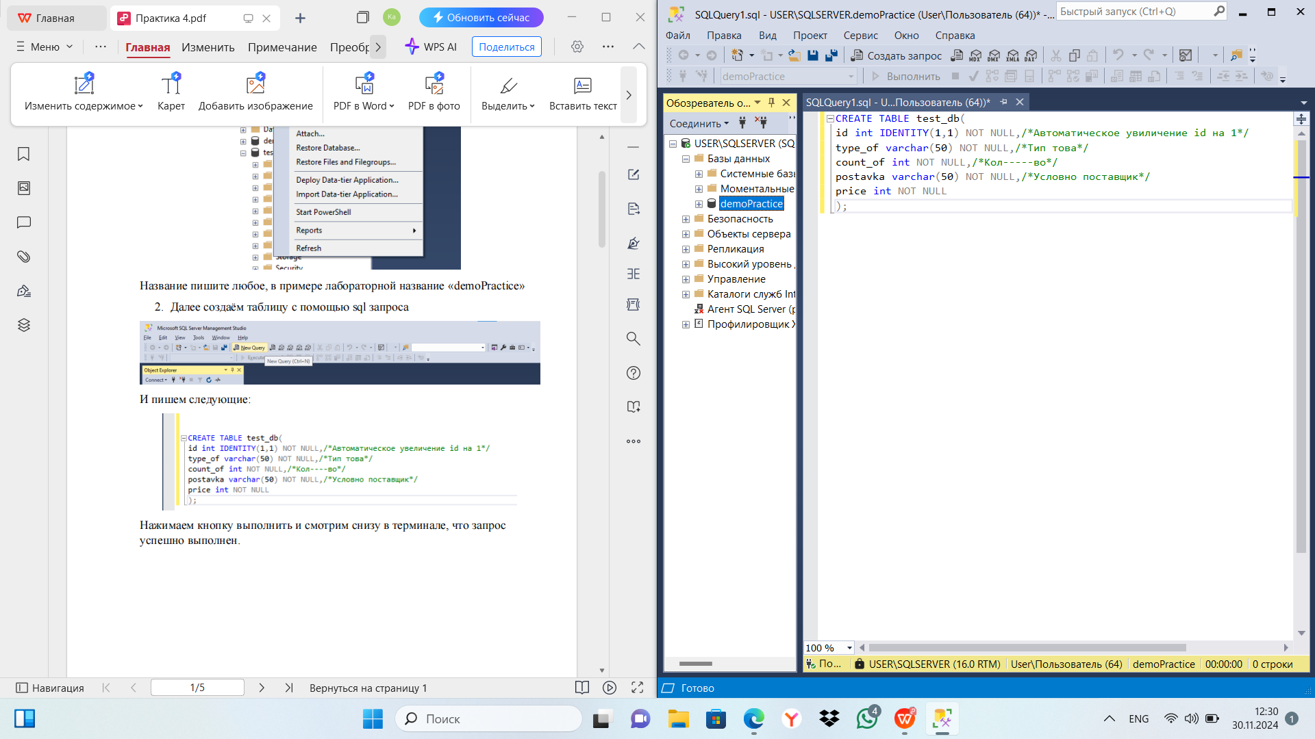Практическая 4

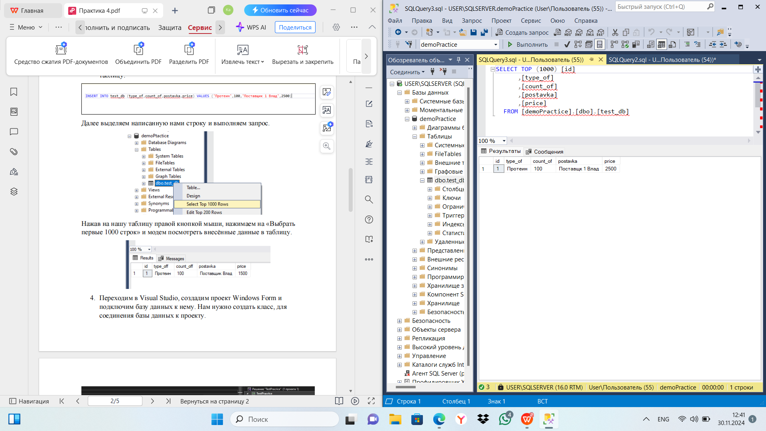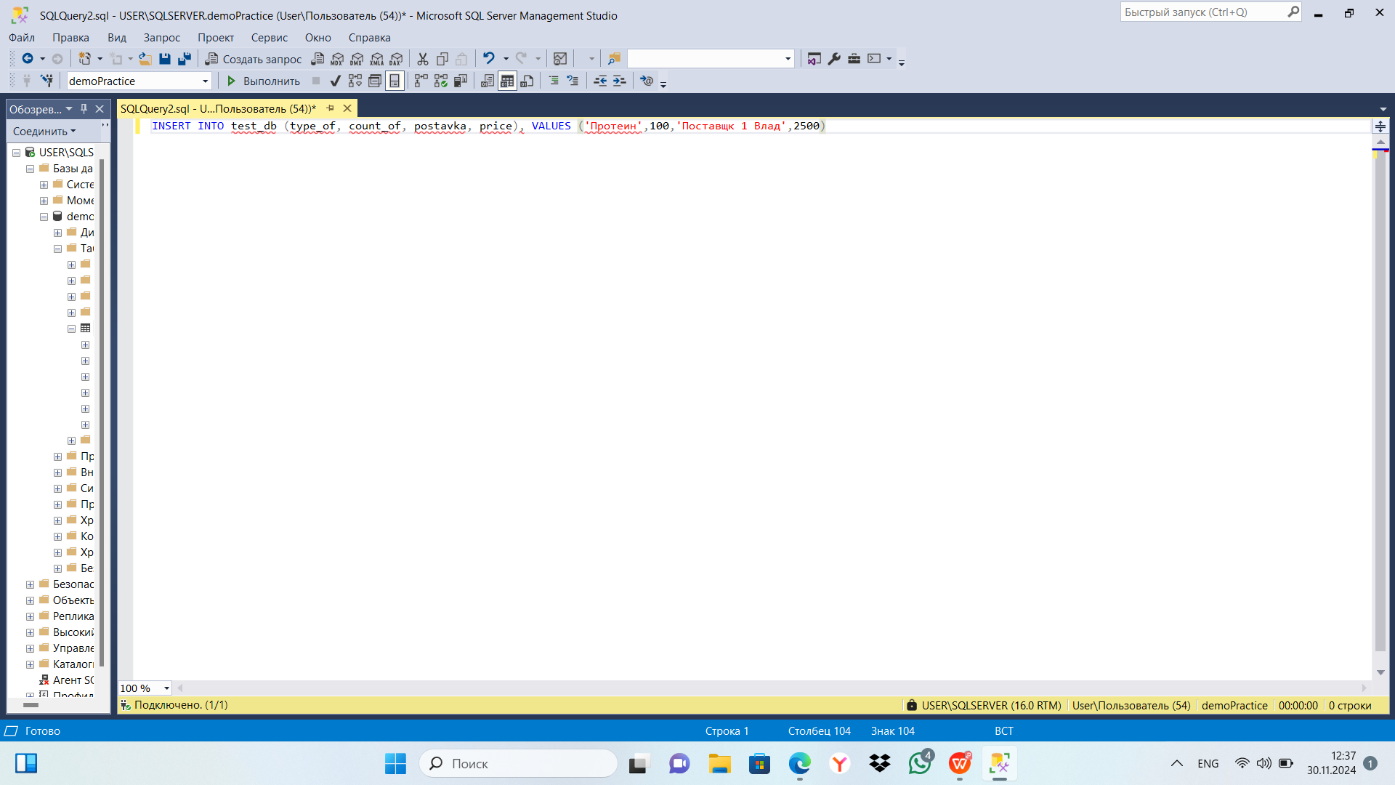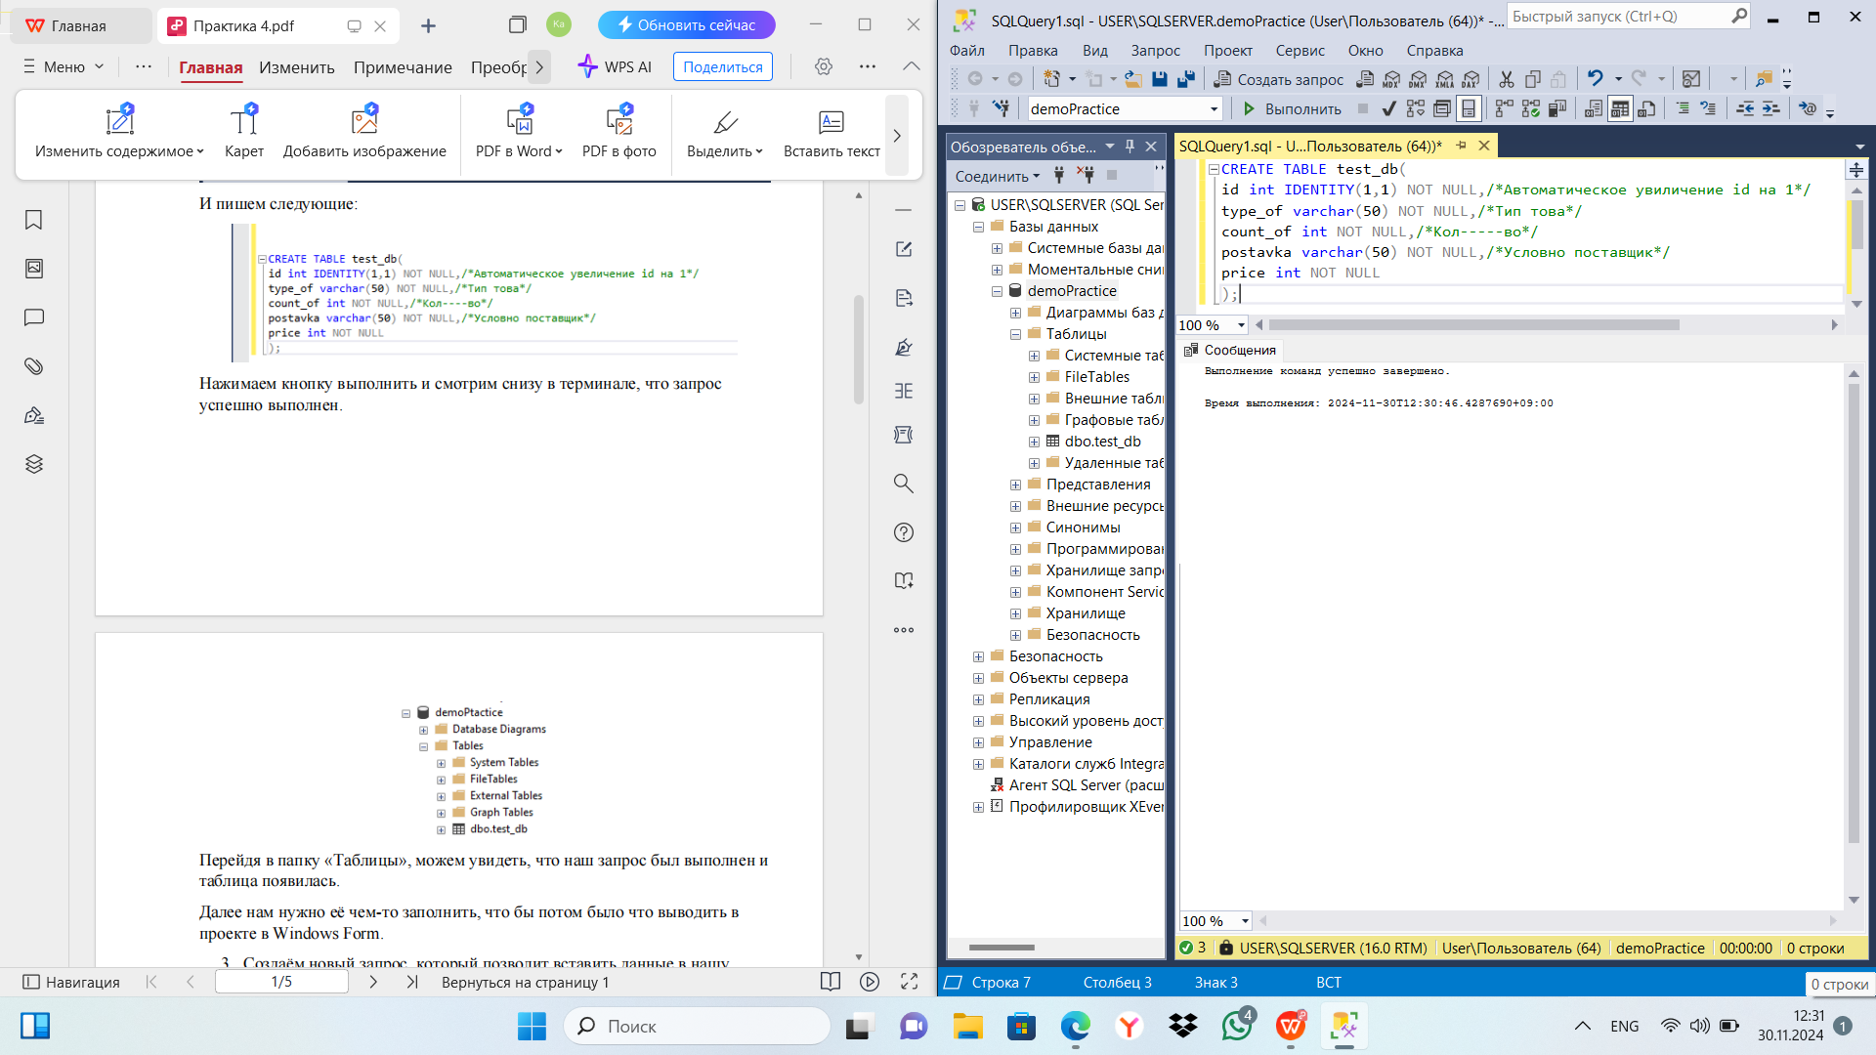

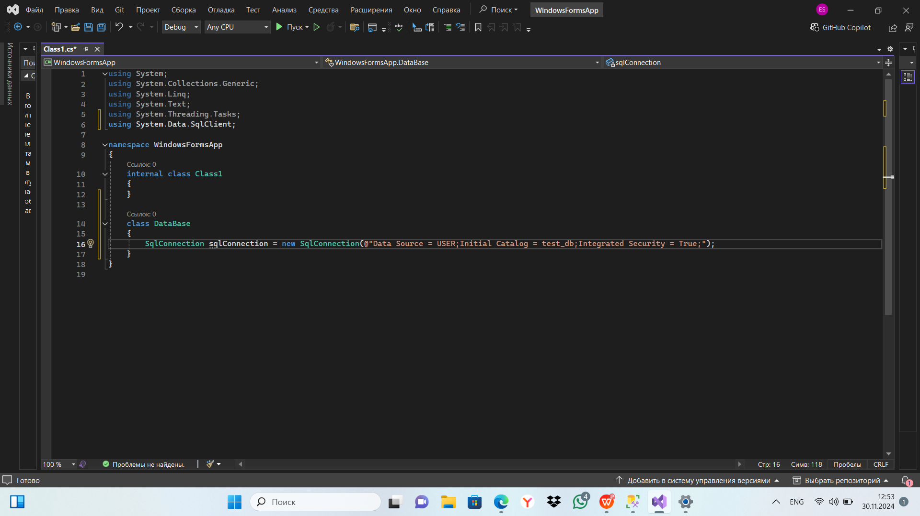

using System;

using System.Collections.Generic;

using System.Linq;

using System.Text;

using System.Threading.Tasks;

using System.Data.SqlClient;

namespace WindowsFormsApp

{

internal class Class1

{

}

class DataBase

{

SqlConnection sqlConnection = new SqlConnection(@"Data Source = USER;Initial Catalog = test_db;Integrated Security = True;");

}

public void openConnection()

{

if (sqlConnection.State == System.Data.ConnectionState.Closed) { SqlConnection.Open(); }

}

public void closeConnection()

{

if (SqlConnection.State == System.Data.ConnectionState.Open) { SqlConnection.Close(); }

}

public SqlConnection getConnection()

{

return SqlConnection;

}

public partial class Form1 : Form

{

DataBase dataBase = new DataBase(); //Экземпляр класса "Вашего класса"

public Form1()

{

InitializeComponent();

}

private void Form1_Load(object sender, EventArgs e)

{

}

}

}

Практическая 5

