## **Function for simulator**

The funsction is used to simalate crasher/aviator game

x = floor(RTP * 100 / (1 - random()))/100

x = max(x, 1)

For each game Crasher 96.5, Crasher 98 and Aviator I compare results provicec in files with my simulator.

## **Crasher RTP 96.5 (size=20 000)**

Randomly select 20000 lines from provided file and compare the sample with simulator.

**Conclusion**: no signifiicant differences are found.

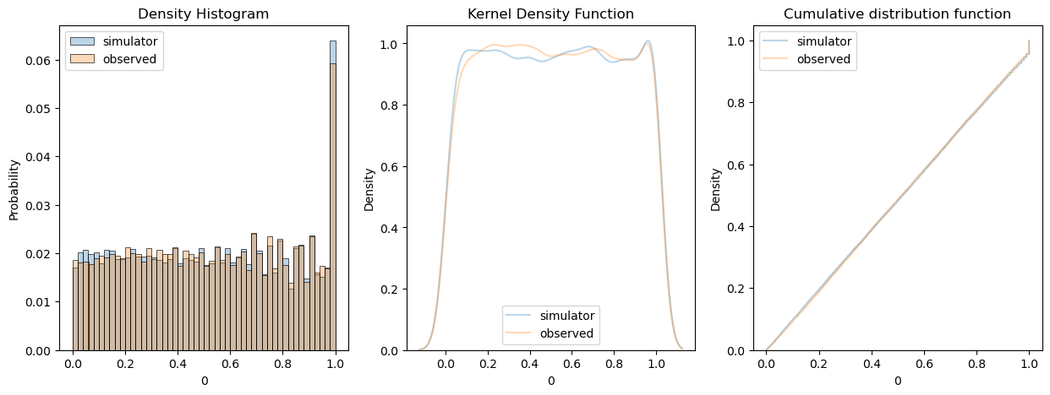

Perform comparisons for 100 times and evaluate 50% confident intervals for p_values.

|  |  |  |
| --- | --- | --- |
| **Test (100 simulations)** | **P_value Q1** | **P_value Q3** |
| Mann–Whitney U Test | 0.215516 | 0.780917 |
| Chi-Squared Test | 0.006875 | 0.228765 |
| Kolmogorov-Smirnov Test | 0.236380 | 0.759756 |

## **Crasher RTP 98.0 (size=20 000)**

Randomly select 20000 lines from provided file and compare the sample with simulator.

**Conclusion**: no signifiicant differences are found.

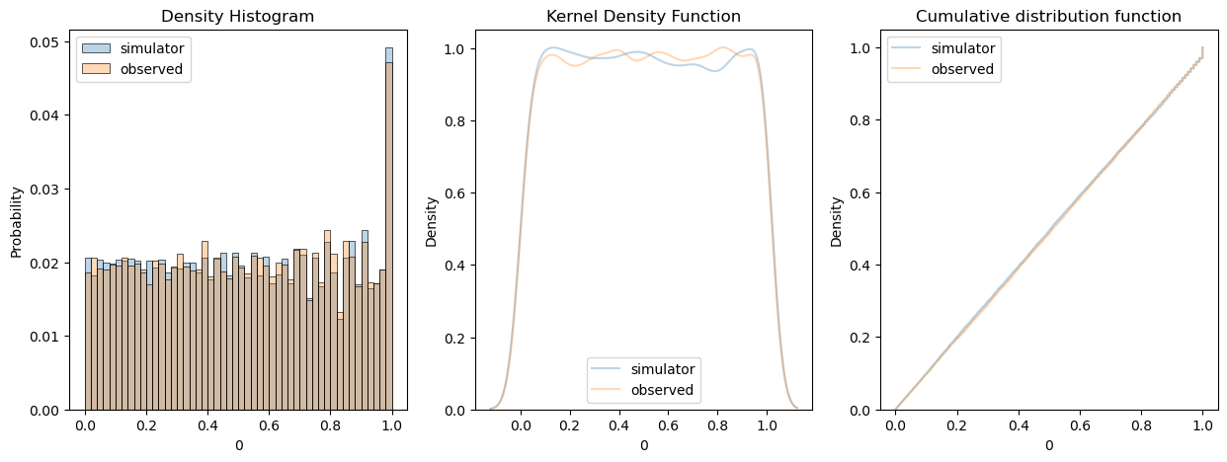

Perform comparisons for 100 times and evaluate 50% confident intervals for p_values.

|  |  |  |
| --- | --- | --- |
| **Test (100 simulations)** | **P_value Q1** | **P_value Q3** |
| Mann–Whitney U Test | 0.238595 | 0.746206 |
| Chi-Squared Test | 0.038300 | 0.610640 |
| Kolmogorov-Smirnov Test | 0.223403 | 0.791374 |

## **Aviator RTP 96.0 (size = 21 231)**

Merge all aviators files and got 21 000 samples. Evaluate RTP as 96% based on observation then compare data with the simulation.

**Conclusion**: no signifiicant differences are found.

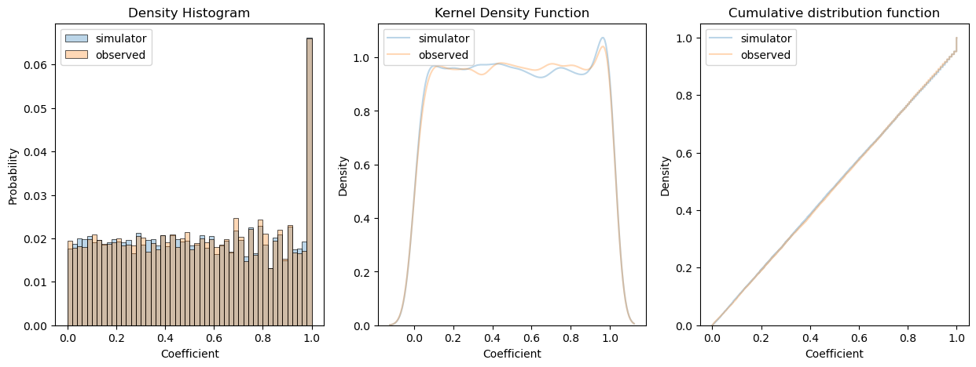

Perform comparisons for 100 times and evaluate 50% confident intervals for p_values.

|  |  |  |
| --- | --- | --- |
| **Test (100 simulations)** | **P_value Q1** | **P_value Q3** |
| Mann–Whitney U Test | 0.382666 | 0.783951 |
| Chi-Squared Test | 0.236057 | 0.717094 |
| Kolmogorov-Smirnov Test | 0.315294 | 0.790925 |

**RTP estimator:**

## 

[0.9715, 0.9598, 0.9548, 0.9576, 0.9628, 0.9607] – estimated RTP for provided files

## **AA test RTP 96.0 (size=10 000)**

Compare two equal simulations to show the power of tests

For 2 samples with equal distributions tests results are compared to results above. Here «observed» is the result of first simulator.

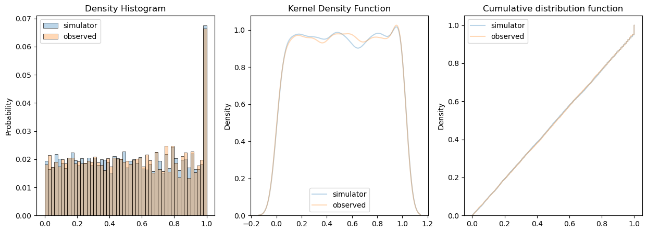

|  |  |  |
| --- | --- | --- |
| **Test (100 simulations)** | **P_value Q1** | **P_value Q3** |
| Mann–Whitney U Test | 0.345362 | 0.755933 |
| Chi-Squared Test | 0.127428 | 0.643547 |
| Kolmogorov-Smirnov Test | 0.522888 | 0.900204 |