## **Function for simulation**

I used the following function to simulate crasher/aviator game

x = floor(RTP * 100 / (1 - RANDOM))/100 (RANDOM is uniformly distributed between 0 and 1)

x = max(x, 1)

## In each game, I conducted a comparison between the results obtained from the files and those generated by my simulator.

## **Crasher RTP 96.5 (size=20 000)**

I chose 20,000 lines from the provided file and proceeded to compare them with the results from the simulator.

**Conclusion**: Based on the comparison, it can be concluded that there are no significant differences between the results from the provided file and the simulator.

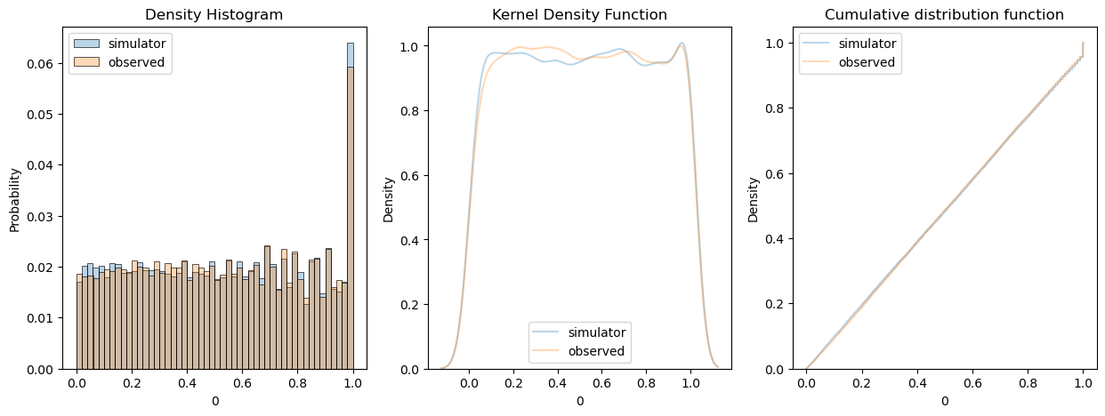

After repeating the comparison 100 times, I evaluated 50% confidence intervals for the p-values obtained. This allowed for a statistical assessment of the significance of the differences between the results from the provided file and the simulator across multiple iterations.

|  |  |  |
| --- | --- | --- |
| **Test (100 simulations)** | **P_value Q1 (25%)** | **P_value Q3 (25%)** |
| Mann–Whitney U Test | 0.215516 | 0.780917 |
| Chi-Squared Test | 0.006875 | 0.228765 |
| Kolmogorov-Smirnov Test | 0.236380 | 0.759756 |

## **Crasher RTP 98.0 (size=20 000)**

I chose 20,000 lines from the provided file and proceeded to compare them with the results from the simulator.

**Conclusion**: Based on the comparison, it can be concluded that there are no significant differences between the results from the provided file and the simulator.

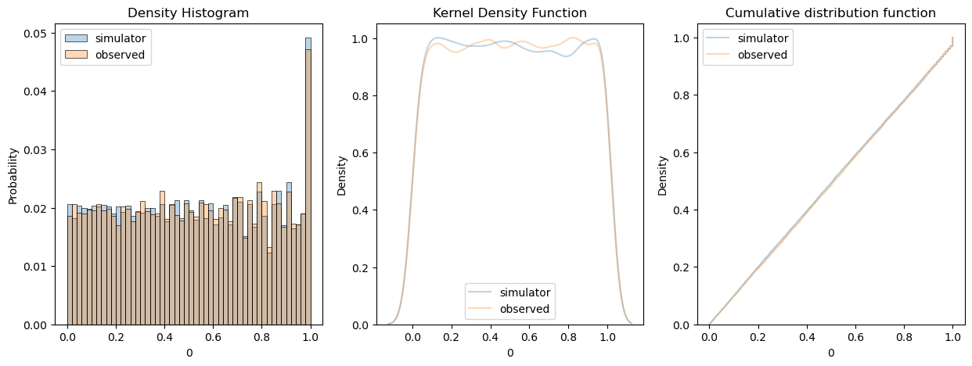

After repeating the comparison 100 times, I evaluated 50% confidence intervals for the p-values obtained. This allowed for a statistical assessment of the significance of the differences between the results from the provided file and the simulator across multiple iterations.

|  |  |  |
| --- | --- | --- |
| **Test (100 simulations)** | **P_value Q1** | **P_value Q3** |
| Mann–Whitney U Test | 0.238595 | 0.746206 |
| Chi-Squared Test | 0.038300 | 0.610640 |
| Kolmogorov-Smirnov Test | 0.223403 | 0.791374 |

## **Aviator RTP 96.0 (size = 21 231)**

After merging all the aviator files, I obtained a dataset of 21,000 samples. I estimated the Return to Player (RTP) as 96% based on observations. Using this estimated RTP, I then proceeded to compare the data from the merged files with the results from the simulation. By doing so, I could assess how well the simulator replicates the observed RTP in the actual data.

**Conclusion**: Based on the comparison, it can be concluded that there are no significant differences between the results from the provided file and the simulator.

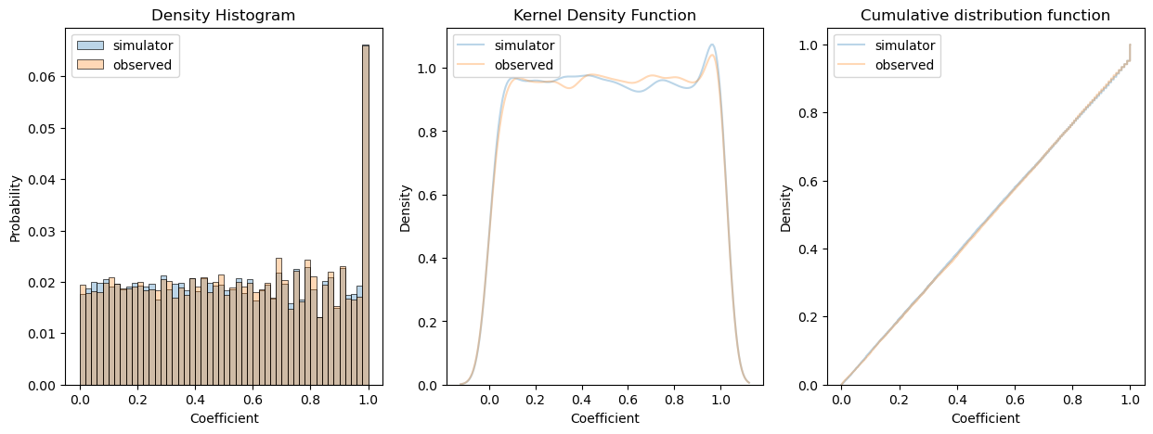

After repeating the comparison 100 times, I evaluated 50% confidence intervals for the p-values obtained. This allowed for a statistical assessment of the significance of the differences between the results from the provided file and the simulator across multiple iterations.

|  |  |  |
| --- | --- | --- |
| **Test (100 simulations)** | **P_value Q1** | **P_value Q3** |
| Mann–Whitney U Test | 0.382666 | 0.783951 |
| Chi-Squared Test | 0.236057 | 0.717094 |
| Kolmogorov-Smirnov Test | 0.315294 | 0.790925 |

**RTP estimator:**

## 

[0.9715, 0.9598, 0.9548, 0.9576, 0.9628, 0.9607] – estimated RTP for aviator’s files

## **AA test RTP 96.0 (size=10 000)**

To demonstrate the power of statistical tests, I performed two equal simulations. In this scenario, both simulations were conducted under the same conditions, assuming equal parameters and inputs. By comparing the results of these simulations, we can evaluate the sensitivity and effectiveness of the statistical tests in detecting any potential differences or discrepancies between the two sets of data. This comparison helps to showcase the ability of the tests to distinguish between outcomes and identify any significant variations, despite the underlying similarity of the simulations.

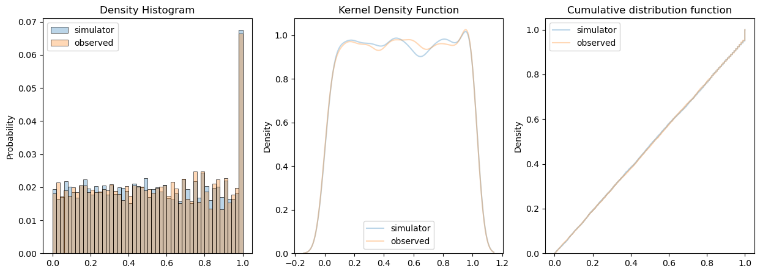

|  |  |  |
| --- | --- | --- |
| **Test (100 simulations)** | **P_value Q1** | **P_value Q3** |
| Mann–Whitney U Test | 0.345362 | 0.755933 |
| Chi-Squared Test | 0.127428 | 0.643547 |
| Kolmogorov-Smirnov Test | 0.522888 | 0.900204 |