**Application “Глючный калькулятор”**

**Test Result Report**

*Created by:* Volchok Artsiom

*Reported period:* 02.03-11.03.2023

*Signed of by:* Leshko Vladislav

**Testing team**

|  |  |  |
| --- | --- | --- |
| **Full name** | **Role** | **Responsibility** |
| Volchok Artsiom | Test-lead | 1. Coordination of the team's work 2. Test plan 3. Test-runs execution 4. Bug reporting 5. Test result reporting |
| Kurnosova Ekaterina | QA engineer | 1. Test-runs execution 2. Bug reporting 3. Test result reporting |
| Tolstik Marina | QA engineer | 1. Test-runs execution 2. Bug reporting 3. Test result reporting |

**Testing process description**

The Calculator application was tested under Windows 10 21H2. Testing of the application took place as exploratory testing, because there are no requirements for the application. The smoke test, the critical path test and the extended test were performed manually. Each team member tested the application independently. Then all the results were summed up and entered into a common table in this report.

**Summary**

Build was installed under the platform (Windows 10 21H2). A security error appears before installation. The smoke tests, critical path tests failed. The application is unstable, the main functionality is partially functional. The existing problems are related to functionality, with the lack of functionality according to the calc_7 requirement.2/3, as well as a flaw in the interface according to the calc_7.1/1 requirement. Most of the errors found earlier have not been eliminated. There is no progress in the quality of the application. Currently, scheduled tests have been completed. 9 errors with the importance of "Major" and “Critical” were found. “Critical” and “Major” bugs are more than 20% each.

|  |  |  |  |  |
| --- | --- | --- | --- | --- |
| **Severity** | **Minor** | **Medium** | **Major** | **Critical** |
| **Quantity** | **1** | **8** | **5** | **4** |
| **Total** | **18** | | | |

**Testing timetable**

|  |  |  |  |
| --- | --- | --- | --- |
| **Full name** | **Date** | **Description** | **Testing timetable, h** |
| Kurnosova Ekaterina | 04.03.2023 | Preparing the test environment | 0.5 |
| Kurnosova Ekaterina | 04.03.2023 | Performing a smoke test under Windows 10 | 3 |
| Kurnosova Ekaterina | 04.03.2023 | Writing a bug report | 1 |
| Kurnosova Ekaterina | 05.03.2023 | Performing a Critical path test under Windows 10 | 2 |
| Kurnosova Ekaterina | 05.03.2023 | Writing a bug report | 1 |
| Kurnosova Ekaterina | 05.03.2023 | Communication with the team leader on project issues | 1,5 |
| Kurnosova Ekaterina | 08.03.2023 | Writing a test result report | 2 |
| Tolstik Marina | 04.03.2023 | Preparing the test environment (downloading and installing the application) | 0.5 |
| Tolstik Marina | 04.03.2023 | Performing the tests as exploratory testing | 1 |
| Tolstik Marina | 04.03.2023 | Writing a bug report | 2 |
| Tolstik Marina | 08.03.2023 | Writing a test result report | 3 |
| Cat Tihon | 08.03.2023 | Psychological support of the team and motivation | 2 |
| Volchok Artsiom | 02-03.03.2023 | Making a test plan | 5 |
| Volchok Artsiom | 04.03.2023 | Preparing the test environment | 0.33 |
| Volchok Artsiom | 04.03.2023 | Testing the app | 2.5 |
| Volchok Artsiom | 04.03.2023 | Writing the bug-report | 2 |
| Volchok Artsiom | 05.03.2023 | Communication with the team on project issues | 1.5 |
| Volchok Artsiom | 10.03.2023 | Writing a test result report | 2.5 |
| Volchok Artsiom | 10.03.2023 | Communication with the team | 2 |
| Volchok Artsiom | 10.03.23 | Rest | 0.0000001 |

**All bugs statistics**

|  |  |  |  |
| --- | --- | --- | --- |
| **ID** | **Severity** | **Summary** | **Found by** |
| AA-01-01 | Critical | When installing the application, a security error appears. | Volchok Artsiom |
| AA-01-02 | Medium | Button "2" is visually different in font. | Volchok Artsiom |
| AA-01-03 | Medium | Button "9" is visually different in font and it doesn't work. | Volchok Artsiom |
| AA-01-04 | Medium | Button "0" is visually different in font. | Volchok Artsiom |
| AA-01-05 | Medium | The difference between the "опрограмме" button and the "О программе" window. | Volchok Artsiom |
| AA-01-06 | Major | Left-click on an empty space, it gives the error "623453245". Then click on the cross in the error window, the application closes. | Volchok Artsiom |
| AA-01-07 | Medium | When tabbing an application, the buttons are switched out of order. | Volchok Artsiom |
| AA-01-08 | Medium | When switching from a regular calculator to the engineering background of the application, except for the number buttons, it turns red. | Volchok Artsiom |
| AA-01-09 | Major | Entering Latin and Cyrillic letters is not allowed in an empty calculator field. | Volchok Artsiom |
| AA-01-10 | Minor | When the application is minimized to the taskbar, the name shows incorrectly. | Volchok Artsiom |
| AA-01-11 | Critical | The text above the input field is displayed with "question mark" characters | Kurnosova Ekaterina |
| AA-01-12 | Critical | Incorrect calculation result when performing more than one action | Kurnosova Ekaterina |
| AA-01-13 | Critical | Error "Is not a valid floating point value" when calculating decimal numbers | Kurnosova Ekaterina |
| AA-01-14 | Major | Throws it out of the application after the error "exception occurred" | Kurnosova Ekaterina |
| AA-01-15 | medium | the background color of the buttons becomes red on the main page when you select the Normal view of calculator | Tolstik Marina |
| AA-01-16 | major | if you enter more than 9 digits from the keyboard into the input field, an error "Unable to enter so many digits, sorry :(" appears | Tolstik Marina |
| AA-01-17 | medium | the input field becomes empty after pressing the symbols of the arithmetic operations (+. -. *. /) | Tolstik Marina |
| AA-01-18 | major | arithmetic operation cannot be performed with the result of the calculation. an error "+ы¦ȳэvщ ъры№ъϵы ϵюё" appears | Tolstik Marina |
| AA-01-19 | medium | "0" remains before the number in the input field | Tolstik Marina |

**Bug statistics.**

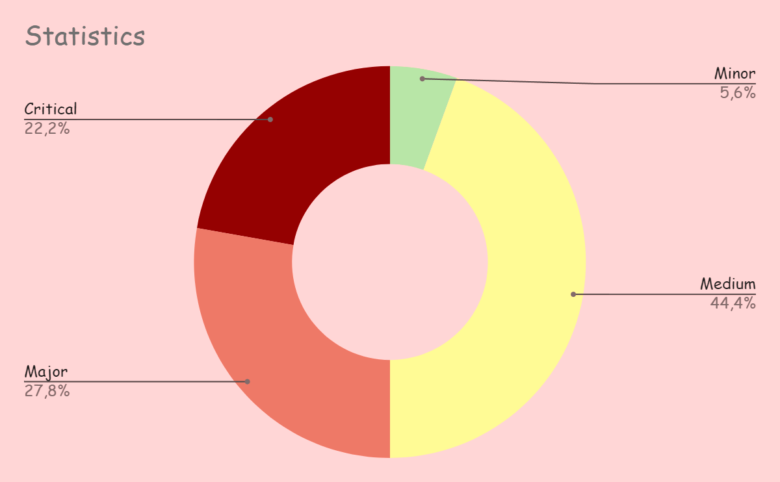

**Conclusion**

Build **can’t be recommended** for production deployment. Opened bugs are planned to be fixed in the following releases.