Grid-DRI is an ImageJ macro that facilitates the process of counting the petrographic features for determining the Damage Rating Index (DRI). Grid-DRI requires a high resolution image of the polished slab prepared for analysis. In its present form, the Damage Rating Index (as a formal methodology) is performed directly on a polished slab using a zoom stereo microscope at a magnification of 16x. Alternatively, Grid-DRI can be used in instances where direct access to the polished slab is not possible, but access to a high resolution image of the polished slab is available. For instance, a flatbed scanner or digital microscope could be used to record an image of the entire polished slab, and the image analyzed using Grid-DRI. By default the petrographic features and their weighting factors are set to the proposed values by Sanchez et al. (2015), but can be modified as necessary within the macro by the user.

Further information about the DRI can be found here:

Sanchez, L.F.M.; Fournier, B.; Jolin, M.; Bedoya, M.A.B.; Bastien, J.; Duchesne, J. “Use of Damage Rating Index to quantify alkali-silica reaction damage in concrete: Fine versus coarse aggregate” ACI Materials Journal, v 113, n 4, p 395-407, July-August 2016.

Sanchez, L.F.M.; Fournier, B.; Jolin, M.; Duchesne, Josée “Reliable quantification of AAR damage through assessment of the Damage Rating Index (DRI)” Cement and Concrete Research, v 67, p 74-92, January 2015.

Rivard, Patrice; Fournier, Benoit; Ballivy, Gérard “The Damage Rating Index Method for ASR Affected Concrete - A Critical Review of Petrographic Features of Deterioration and Evaluation Criteria” Cement, Concrete and Aggregates, v 24, n 2, p 81-91, December 2002

Grattan-Bellew, P.E. “Laboratory evaluation of alkali-silica reaction in concrete from Saunders generating station” ACI Materials Journal, v 92, n 2, p 126-134, Mar-Apr 1995

1. **Damage Rating Index (DRI) Analyses**

* Open your image in ImageJ or FIJI. Use the rectangular area selection tool to select the area you wish to perform the DRI analyses on. Select *Plugins>Macros>Run…* and navigate to directory containing “Grid-DRI.txt”.
* A new window will appear, prompting you to provide:

1. The screen-height. Enter the height of your display screen in cm. If you don’t know the height of your screen, measure it with a ruler.

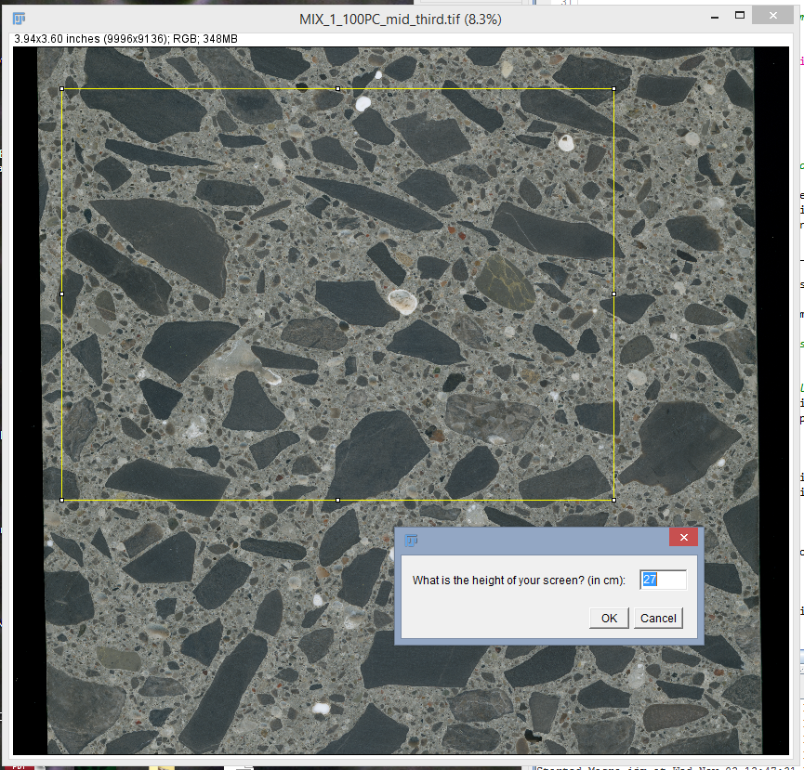

1. Number of pixels per cm. Enter the number of pixels representing 1 cm on your image. If you don’t know or can’t otherwise determine the resolution of your image, you will need to photograph/capture an image of a ruler or other reference material under the same conditions at which you collected the image of your sample.

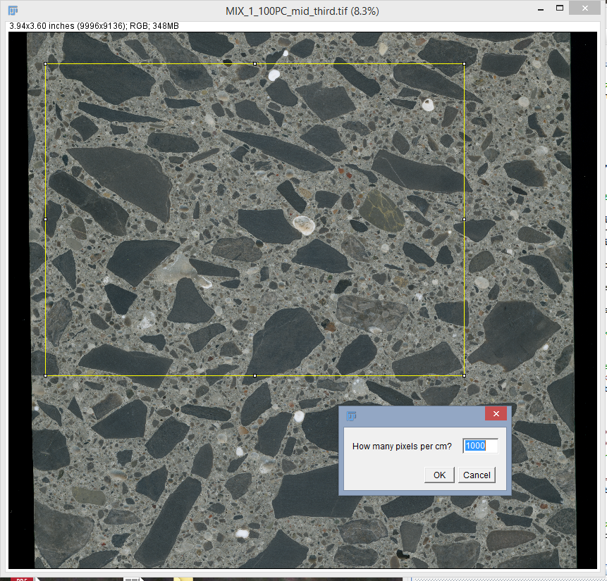

* A window will appear informing you of the number of 1cm*1cm frames that fit within your selected area. Press “OK”.
* Next, the first 1cm*1cm frame will be opened and displayed at a magnification of 16x (if the previous steps were executed correctly, the frame should appear on the display monitor with the dimensions 16cm*16cm). A window will appear to inform you that the program is paused. While the program is paused it is possible to zoom in/out , look at surrounding areas, etc. To begin the analysis, select “OK” on the window.

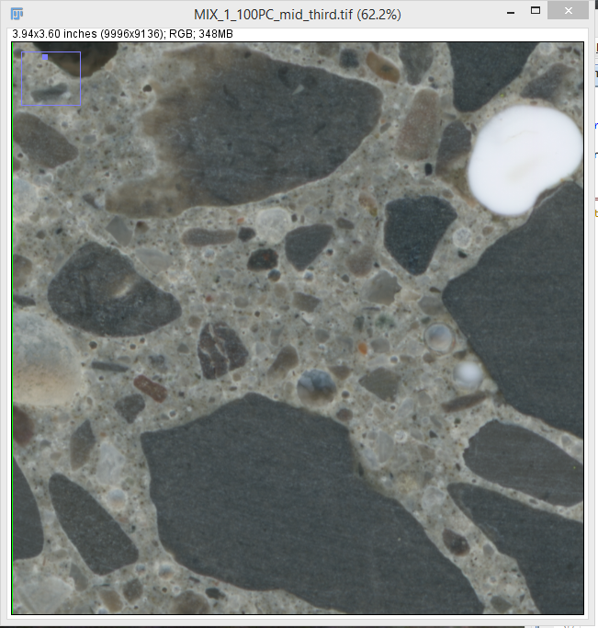

* A window appears, informing you of the frame number and total number of frames. You are asked to provide:

1. Number of observed features. For each of the 7 DRI features of interest enter the appropriate number of observed occurrences. This information is saved for each frame and written to a text-file with “*_DRIcount.txt” appended to the original image name.

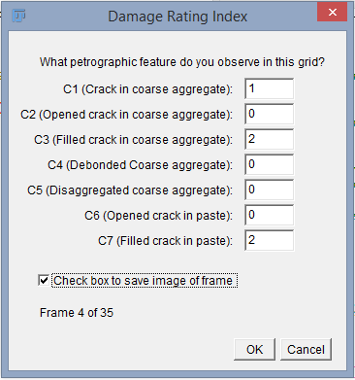

1. Save frame picture option. If you wish to save an image of the frame, check the box at the bottom of the menu. The image frame will be saved to the same file as the original image, with “*_square*A*.tif” appended to the original image name, where *A* represents the frame number.

* When finished with the analysis menu, press ‘enter’. The program will move to the next frame with the same “Pause” menu appearing again.
* In the same manner, proceed through all frames.
* After inputting information on the final frame, a menu appears informing you the program is finished running, with the number of frames that were analyzed. Press “OK”.
* A second “Results Summary” window appears, listing the final DRI value, as well as the factored feature counts for each of 7 types.
* After the program has analyzed all frames it creates an overlaid grid, where each square represents 1 cm2 that was a frame analyzed by the program.
* When the program finishes running, the results text-file is saved in the same folder as the original image. Information within this text-file includes:

1. Frame number.
2. Number of each feature-type per frame.
3. Pixel-coordinates of top-left corner of each frame.
4. Total number of features observed for all frames.
5. Normalized (to 100 cm2 grid) total number of features observed for all frames.
6. Standard DRI factors.
7. Factored DRI feature count values for each feature type. This is the product of standard DRI and normalized total number of features.
8. DRI value. This is the sum of all factored DRI feature count values.