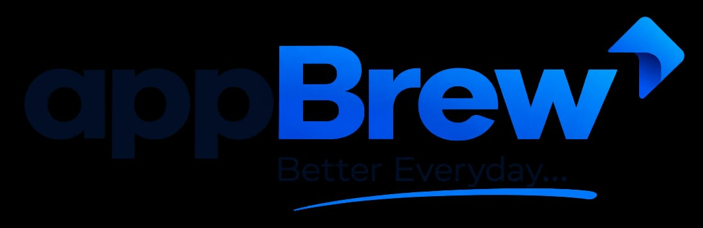
Python Programming Course
A 12-Week Curriculum · From Absolute Beginner to Confident Python Developer
TARGET AUDIENCE  Absolute beginners — no prior coding experience | DURATION  12 Weeks (3 Months) | PREREQUISITES  Basic computer literacy + a computer for Python/IDE setup | PRIMARY GOAL  Build strong Python fundamentals and apply them to real projects, automation and data analysis

MONTH 1  Fundamentals & Core Concepts  W1 Intro to Programming  Python overview & setup, choosing an IDE (VS Code/PyCharm), first program, syntax, variables & data types, input/output.  W2 Operators & Control Flow  Arithmetic, relational & logical operators; if/elif/else; for & while loops; break & continue.  W3 Functions  Defining & calling functions, parameters & arguments, return statement, variable scope, lambda functions.  W4 Core Data Structures  Lists, tuples, dictionaries, sets, and list comprehensions. | MONTH 2  Intermediate Python & Problem-Solving  W5 File Handling  Reading/writing text files, working with CSV files, working with JSON files.  W6 Errors & Exceptions  Understanding exceptions, try/except/else/finally, raising exceptions, debugging techniques.  W7 Object-Oriented Programming  Classes & objects, the __init__ constructor, attributes & methods, inheritance, encapsulation & polymorphism.  W8 Modules, Packages & Standard Library  Importing & creating modules, key standard libraries (datetime, math, random, os, sys), virtual environments. | MONTH 3  Advanced Topics & Practical Application  W9 Data & Essential Libraries  pip & external packages, NumPy arrays, Pandas DataFrames, basic data cleaning & analysis.  W10 APIs & Databases  Consuming APIs with requests, handling JSON responses, SQLite basics, CRUD operations.  W11 Mini Projects (incl. Automation)  To-Do List app · Weather App (API) · Automation Suite — scheduled file/folder organizer & auto email/report sender · Expense Tracker.  W12 Capstone Project & Wrap-up  End-to-end build (data dashboard, web scraper or automation bot), final presentation, course recap & next steps.

ASSESSMENT METHODS  ▸ Weekly Assignments & Quizzes: Reinforce topics covered each week  ▸ Hands-on Labs: Practical in-class exercises  ▸ Mini-Projects: Applied projects at the end of each month  ▸ Final Capstone Project: Comprehensive evaluation of all skills learned | SUGGESTED SPECIALIZATION TRACKS (MONTH 3)  ▸ Data Science: Deeper NumPy/Pandas, Matplotlib/Seaborn visualization, basic statistics  ▸ Web Development: Flask or Django, HTML/CSS basics, deploying a simple web app  ▸ Automation: File/OS scripting, task scheduling, email & report automation, browser automation (Selenium)

