Did the SFPSP Increase Contraceptive Uptake?
A Difference-in-Differences Evaluation of a Nigerian Family Planning Programme
Research report · Synthetic DHS-style dataset, 2018–2022 · Northern Nigeria

Executive Summary
This report evaluates whether the State Family Planning Support Programme (SFPSP), rolled out in four Northern Nigerian states between 2019 and 2020, increased modern contraceptive use among women aged 15–49. Using a Difference-in-Differences (DiD) design comparing four treatment states against four comparable control states across a 2018 baseline and a 2022 endline survey, we find a robust, statistically significant increase in modern contraceptive prevalence attributable to the programme: approximately 11.4 percentage points (95% CI: 8.4–14.3), holding across a simple model and a fully adjusted model with individual covariates and state fixed effects. The effect is consistent across all four treatment states and extends to any-method contraceptive use. A placebo check confirms no significant baseline gap between treatment and control groups, supporting the plausibility of the design's parallel-trends assumption. The full analysis pipeline data simulation, cleaning, descriptive statistics, and regression is implemented entirely in R (base R, dplyr, ggplot2, sandwich/lmtest, openxlsx); the complete, reproducible source code is available in the accompanying GitHub repository. This analysis uses a synthetic dataset built for methods-training purposes and should be read as a demonstration of evaluation method rather than a finding about a real programme.

1. Introduction
Modern contraceptive prevalence in Northern Nigeria remains well below national targets, driven by limited service access, low awareness, and sociocultural barriers. The SFPSP combined community mobilisation and messaging with supply-side investment in four states (Kaduna, Kano, Bauchi, Gombe), leaving four comparable states (Katsina, Jigawa, Yobe, Adamawa) unexposed. This report asks: did the programme increase modern contraceptive uptake among women of reproductive age in the states where it operated?

2. Data and Methods
The analysis uses a synthetic, DHS-style dataset of 14,923 women aged 15–49 (after cleaning), split across 8 states and 2 survey waves (2018 baseline, 2022 endline), constructed because real programme-linked microdata meeting the design's requirements is not publicly available. The dataset was built with realistic data-quality issues (inconsistent state-name spelling, missing values, duplicate entries) and then cleaned through a documented pipeline: standardising categorical text, correcting or dropping implausible values, removing true duplicate entries by respondent ID, and explicitly flagging (rather than silently imputing) missing data. Full details are in the accompanying data dictionary and cleaning log.
The evaluation uses a Difference-in-Differences design: Yᵢₛₜ = β₀ + β₁Treatₛ + β₂Postₜ + β₃(Treatₛ×Postₜ) + Xᵢₛₜ'γ + δₛ + εᵢₛₜ, where the coefficient of interest, β₃, captures the programme's effect on the treated group's outcome trend relative to the control group's trend. The model is estimated in R with lm(), and standard errors are clustered by state using the sandwich and lmtest packages (the R equivalent of Stata's cluster() option). Three models are estimated: a simple 2x2 comparison, a covariate-adjusted model with state fixed effects, and a version using any-method contraceptive use as the outcome.

3. Descriptive Findings
Modern contraceptive prevalence was nearly identical between treatment and control states at baseline (18.0% vs. 17.3%), and this gap was not statistically significant (p = 0.46) a reassuring precondition for the DiD design. By the 2022 endline, treatment states had risen to 32.2% while control states had only reached 20.2%.
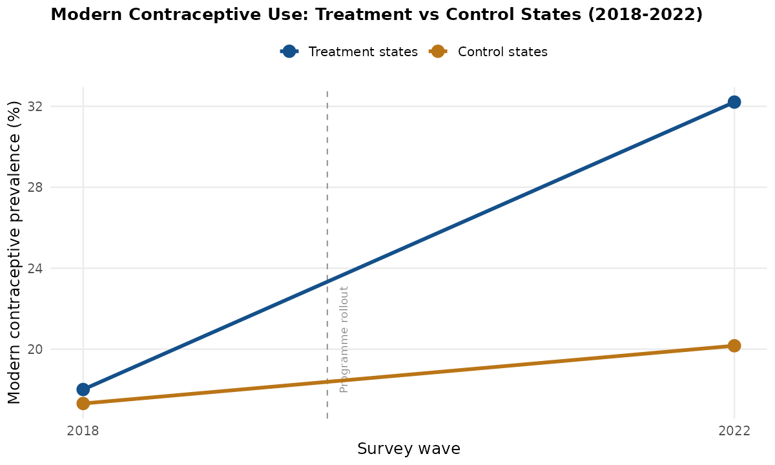
Figure 1. Modern contraceptive prevalence, treatment vs. control states, 2018–2022.
This pattern held consistently across every individual treatment state, and was absent in every control state, indicating the effect is not driven by a single outlier location.
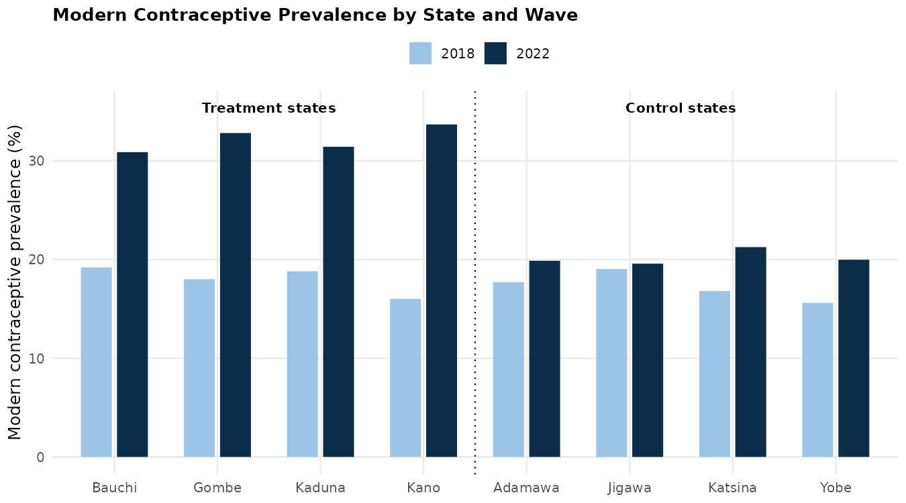
Figure 2. Modern contraceptive prevalence by state and survey wave.
As expected, modern contraceptive use rises with education and household wealth, and is higher in urban areas patterns consistent with the broader family planning literature and accounted for in the adjusted regression model.
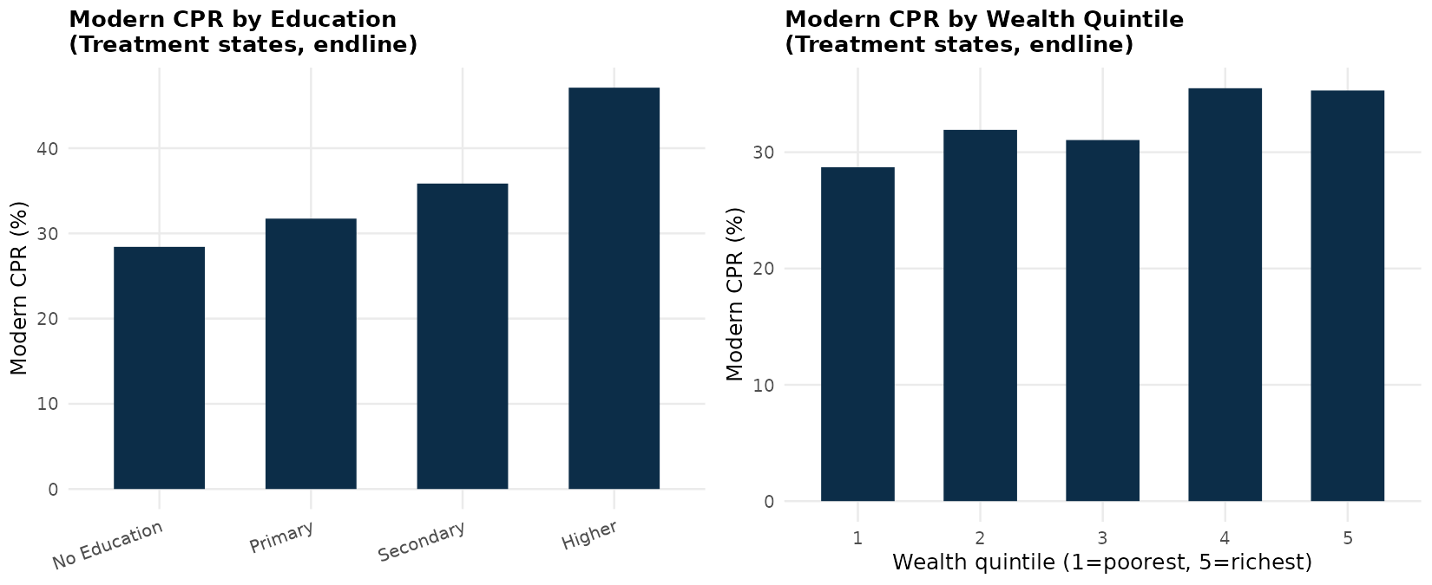
Figure 3. Modern contraceptive use by education and wealth quintile (treatment states, 2022 endline).

4. Difference-in-Differences Results
Table 1 summarises the DiD coefficient (the estimated programme effect, in percentage points) across the three model specifications. The estimate is stable at roughly 11-12 percentage points and highly statistically significant in every specification, whether or not individual covariates and state fixed effects are included.
Model | Effect (pp) | Std. error | 95% CI | p-value
1. Simple DiD (no controls) | +11.35 | 1.51 | [8.39, 14.31] | <0.001
2. DiD + covariates + state FE (modern method) | +11.64 | 1.46 | [8.78, 14.51] | <0.001
3. DiD + covariates + state FE (any method) | +10.43 | 1.44 | [7.61, 13.25] | <0.001

As a robustness check for the parallel-trends assumption, we compared treatment and control states using only the 2018 baseline data. The estimated gap was small (0.7 percentage points) and statistically insignificant (p = 0.46), consistent with the two groups being on comparable footing before the programme began.

5. Discussion and Limitations
The consistency of the estimated effect across specifications, its uniform presence across all treatment states, and the absence of a significant baseline gap together support a causal interpretation: the programme is associated with a substantial increase in modern contraceptive uptake. That said, several limitations temper this conclusion. With only two survey waves, a full pre-trend test (as in an event-study design with 3+ periods) is not possible, so the parallel-trends assumption rests on contextual judgement rather than direct statistical evidence. Because states were not randomly assigned to the programme, unobserved time-varying confounders such as a concurrent state-level health initiative cannot be fully ruled out. Self-reported contraceptive use is also subject to social desirability and recall bias. Finally, this report uses a synthetic dataset constructed for methods demonstration; the specific effect size should not be read as an empirical finding about any real programme. The full R source code, including the random seed used to generate the synthetic data, is available in the GitHub repository for exact replication.

6. Recommendations
- If replicated with real programme data, priorities collecting at least one additional pre-programme wave to allow a formal pre-trend (event-study) test.
- Pair the quantitative evaluation with qualitative work (e.g., focus groups) to help explain the mechanism behind the uptake increase, especially the role of the 'heard of programme exposure channel.
- Given the larger gains observed among more educated and wealthier women in the descriptive analysis, consider whether programme messaging and service delivery are reaching lower-education, lower-wealth, and rural populations equally, and adjust targeting if not.
- Track any-method use alongside modern-method use to ensure gains are not simply a substitution from traditional to modern methods within a stable overall total, though in this data both outcomes moved together.

7. Conclusion
This evaluation finds a large, robust, and statistically significant association between the SFPSP and increased modern contraceptive uptake among women of reproductive age in the states where it was implemented, on the order of 11-12 percentage points above what would be expected from national trends alone. The finding is consistent across model specifications and across every treatment state individually, and baseline balance between treatment and control groups supports the credibility of the Difference-in-Differences design. As with any non-experimental evaluation, causal claims should be made with appropriate caution, and this analysis built on a synthetic dataset should be treated as a demonstration of evaluation methodology rather than a definitive real-world result.

