Group Coursework Assignment

Dave Matt

Table of Contents

# Tasks:1

Read and inspect the data set. Provide a descriptive analysis for each of the variables in the data set.

* **Anwser**

# Load packages  
library("plotly")

## Loading required package: ggplot2

##   
## Attaching package: 'plotly'

## The following object is masked from 'package:ggplot2':  
##   
## last_plot

## The following object is masked from 'package:stats':  
##   
## filter

## The following object is masked from 'package:graphics':  
##   
## layout

library("tidyverse")

## -- Attaching packages --------------------------------------- tidyverse 1.3.1 --

## v tibble 3.1.6 v dplyr 1.0.8  
## v tidyr 1.1.4 v stringr 1.4.0  
## v readr 2.1.1 v forcats 0.5.1  
## v purrr 0.3.4

## -- Conflicts ------------------------------------------ tidyverse_conflicts() --  
## x dplyr::filter() masks plotly::filter(), stats::filter()  
## x dplyr::lag() masks stats::lag()

library("data.table")

##   
## Attaching package: 'data.table'

## The following objects are masked from 'package:dplyr':  
##   
## between, first, last

## The following object is masked from 'package:purrr':  
##   
## transpose

library("dplyr")  
library("gridExtra")

##   
## Attaching package: 'gridExtra'

## The following object is masked from 'package:dplyr':  
##   
## combine

library("knitr")  
library("scales")

##   
## Attaching package: 'scales'

## The following object is masked from 'package:purrr':  
##   
## discard

## The following object is masked from 'package:readr':  
##   
## col_factor

# Load Cloud Data  
df.office <- read_csv("office.csv")

## Rows: 200 Columns: 10

## -- Column specification --------------------------------------------------------  
## Delimiter: ","  
## chr (1): professional  
## dbl (9): respondent_id, variety_of_choice, electronics, furniture, quality_o...  
##   
## i Use `spec()` to retrieve the full column specification for this data.  
## i Specify the column types or set `show_col_types = FALSE` to quiet this message.

# view first 6 rows of cloud.csv  
head(df.office)

## # A tibble: 6 x 10  
## respondent_id variety_of_choice electronics furniture quality_of_service  
## <dbl> <dbl> <dbl> <dbl> <dbl>  
## 1 1 8 3 6 3  
## 2 2 6 3 1 4  
## 3 3 6 1 2 4  
## 4 4 8 3 3 4  
## 5 5 4 6 3 4  
## 6 6 8 4 3 5  
## # ... with 5 more variables: low_prices <dbl>, return_policy <dbl>,  
## # professional <chr>, income <dbl>, age <dbl>

# reveal cloud.csv data analysis  
str(df.office)

## spec_tbl_df [200 x 10] (S3: spec_tbl_df/tbl_df/tbl/data.frame)  
## $ respondent_id : num [1:200] 1 2 3 4 5 6 7 8 9 10 ...  
## $ variety_of_choice : num [1:200] 8 6 6 8 4 8 7 7 10 8 ...  
## $ electronics : num [1:200] 3 3 1 3 6 4 2 5 7 4 ...  
## $ furniture : num [1:200] 6 1 2 3 3 3 2 3 5 0 ...  
## $ quality_of_service: num [1:200] 3 4 4 4 4 5 2 2 1 4 ...  
## $ low_prices : num [1:200] 2 7 9 8 2 10 8 2 5 9 ...  
## $ return_policy : num [1:200] 2 1 6 7 5 6 7 3 4 1 ...  
## $ professional : chr [1:200] "non-professional" "non-professional" "non-professional" "non-professional" ...  
## $ income : num [1:200] 16 22 18 18 35 13 22 19 14 16 ...  
## $ age : num [1:200] 28 27 22 29 51 24 27 26 27 28 ...  
## - attr(*, "spec")=  
## .. cols(  
## .. respondent_id = col_double(),  
## .. variety_of_choice = col_double(),  
## .. electronics = col_double(),  
## .. furniture = col_double(),  
## .. quality_of_service = col_double(),  
## .. low_prices = col_double(),  
## .. return_policy = col_double(),  
## .. professional = col_character(),  
## .. income = col_double(),  
## .. age = col_double()  
## .. )  
## - attr(*, "problems")=<externalptr>

# descriptive analysis of cloud.csv  
summary(df.office)

## respondent_id variety_of_choice electronics furniture   
## Min. : 1.00 Min. : 4.000 Min. : 1.00 Min. :0.00   
## 1st Qu.: 50.75 1st Qu.: 6.000 1st Qu.: 3.00 1st Qu.:1.00   
## Median :100.50 Median : 8.000 Median : 4.50 Median :2.00   
## Mean :100.50 Mean : 7.565 Mean : 4.45 Mean :3.27   
## 3rd Qu.:150.25 3rd Qu.:10.000 3rd Qu.: 6.00 3rd Qu.:6.00   
## Max. :200.00 Max. :10.000 Max. :10.00 Max. :7.00   
## quality_of_service low_prices return_policy professional   
## Min. :1.00 Min. : 1.000 Min. : 1.00 Length:200   
## 1st Qu.:2.00 1st Qu.: 2.000 1st Qu.: 3.00 Class :character   
## Median :3.00 Median : 5.000 Median : 4.00 Mode :character   
## Mean :3.53 Mean : 4.795 Mean : 4.25   
## 3rd Qu.:4.00 3rd Qu.: 7.000 3rd Qu.: 6.00   
## Max. :9.00 Max. :10.000 Max. :10.00   
## income age   
## Min. :13.00 Min. :21.00   
## 1st Qu.:15.00 1st Qu.:24.00   
## Median :19.50 Median :27.00   
## Mean :32.17 Mean :32.52   
## 3rd Qu.:54.25 3rd Qu.:38.00   
## Max. :95.00 Max. :68.00

# Tasks:2

Make a new data object (e.g., a data.frame or tibble) for clustering that includes only the attitudinal variables from the original data set. Then normalise (use z-score standardisation) all variables in this new data object. Which variable has the smallest minimum value and which variable has the largest maximum value in the normalized data set?

* **Anwser**

# make a new data frame with only attitudinal varibales  
df.officen <- df.office[,2:7]  
head(df.officen)

## # A tibble: 6 x 6  
## variety_of_choice electronics furniture quality_of_service low_prices  
## <dbl> <dbl> <dbl> <dbl> <dbl>  
## 1 8 3 6 3 2  
## 2 6 3 1 4 7  
## 3 6 1 2 4 9  
## 4 8 3 3 4 8  
## 5 4 6 3 4 2  
## 6 8 4 3 5 10  
## # ... with 1 more variable: return_policy <dbl>

# Then normalise (use z-score standardisation)  
df.officen<-scale(df.officen, center = TRUE, scale = FALSE)  
summary(df.officen)

## variety_of_choice electronics furniture quality_of_service  
## Min. :-3.565 Min. :-3.45 Min. :-3.27 Min. :-2.53   
## 1st Qu.:-1.565 1st Qu.:-1.45 1st Qu.:-2.27 1st Qu.:-1.53   
## Median : 0.435 Median : 0.05 Median :-1.27 Median :-0.53   
## Mean : 0.000 Mean : 0.00 Mean : 0.00 Mean : 0.00   
## 3rd Qu.: 2.435 3rd Qu.: 1.55 3rd Qu.: 2.73 3rd Qu.: 0.47   
## Max. : 2.435 Max. : 5.55 Max. : 3.73 Max. : 5.47   
## low_prices return_policy   
## Min. :-3.795 Min. :-3.25   
## 1st Qu.:-2.795 1st Qu.:-1.25   
## Median : 0.205 Median :-0.25   
## Mean : 0.000 Mean : 0.00   
## 3rd Qu.: 2.205 3rd Qu.: 1.75   
## Max. : 5.205 Max. : 5.75

low_prices has the smallest min value of -3.795 electronics has the largest maximum value of 5.55

# Tasks:3

Run the hierarchical clustering algorithm using method = “ward.D2” on the normalised data and use set.seed(123)for reproducibility. Plot the dendogram.

* **Anwser**

set.seed(123) # Setting seed  
Hierar_office <- hclust(dist(df.officen),method = "ward.D2")  
Hierar_office

##   
## Call:  
## hclust(d = dist(df.officen), method = "ward.D2")  
##   
## Cluster method : ward.D2   
## Distance : euclidean   
## Number of objects: 200

# Plott dendrogram  
plot(Hierar_office)

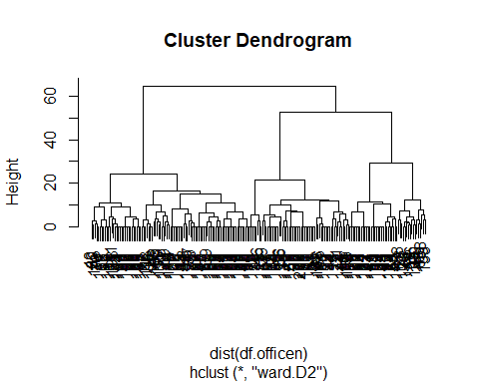

# Tasks:4

Suppose that after looking at the dendrogram and discussing with the marketing department, you decide to proceed with a 6-cluster solution. Divide the data points into 6 clusters. How many observations are assigned to each cluster?

* **Anwser**

# 6-cluster solution  
Hierar_office_6 <- cutree(Hierar_office, k = 6 )  
  
# display 6-cluster solution  
Hierar_office_6

## [1] 1 2 3 3 4 3 3 1 5 2 5 6 1 4 3 1 1 3 1 6 6 5 3 6 1 1 1 4 3 5 3 1 5 1 3 3 3  
## [38] 6 1 5 3 1 4 6 5 2 6 1 1 1 6 1 5 1 3 3 3 6 1 5 3 1 4 6 5 3 6 1 1 1 4 3 5 3  
## [75] 1 5 3 3 1 5 3 5 6 1 4 3 1 1 3 1 6 6 5 3 3 3 1 5 2 5 6 1 4 3 1 1 3 1 4 6 5  
## [112] 3 1 1 2 3 3 4 3 3 1 5 2 5 6 1 6 3 1 1 3 1 4 6 5 3 6 1 1 1 6 3 5 3 3 1 5 3  
## [149] 5 6 1 4 3 1 1 3 1 4 6 5 3 6 1 1 1 4 3 1 5 2 5 6 1 6 3 1 1 3 1 4 6 5 3 6 1  
## [186] 1 1 4 3 1 5 2 5 6 1 4 3 1 1 3

table(Hierar_office_6)

## Hierar_office_6  
## 1 2 3 4 5 6   
## 64 8 52 17 30 29

plot.new()  
plot(Hierar_office_6)

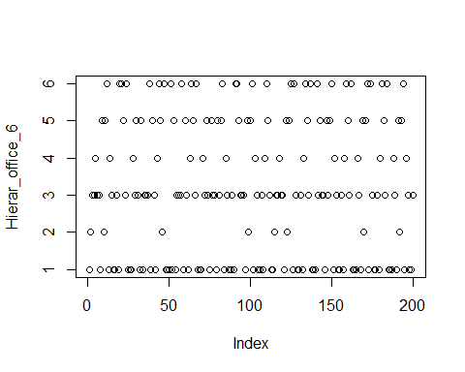

# Tasks:5

Use the normalised data to calculate the means for each of the attitudinal variables per cluster. Use the flexclust package to generate a segment profile plot. Comment on whether any cluster memberships have changed, if any. Check the concordance between the hclust and as.kcca procedures.

* **Anwser**

# library flexclust  
library(flexclust)

## Warning: package 'flexclust' was built under R version 4.1.3

## Loading required package: grid

## Loading required package: lattice

## Loading required package: modeltools

## Loading required package: stats4

# means for each of the attitudinal variables per cluster  
k2 <- kmeans(df.officen, centers = 6, nstart = 20)  
str(k2)

## List of 9  
## $ cluster : int [1:200] 4 2 1 1 5 1 1 6 6 2 ...  
## $ centers : num [1:6, 1:6] -0.738 -0.065 -2.393 2.022 -2.624 ...  
## ..- attr(*, "dimnames")=List of 2  
## .. ..$ : chr [1:6] "1" "2" "3" "4" ...  
## .. ..$ : chr [1:6] "variety_of_choice" "electronics" "furniture" "quality_of_service" ...  
## $ totss : num 5856  
## $ withinss : num [1:6] 346.8 16.9 162.2 523.4 178 ...  
## $ tot.withinss: num 1427  
## $ betweenss : num 4429  
## $ size : int [1:6] 52 8 29 63 17 31  
## $ iter : int 2  
## $ ifault : int 0  
## - attr(*, "class")= chr "kmeans"

k2

## K-means clustering with 6 clusters of sizes 52, 8, 29, 63, 17, 31  
##   
## Cluster means:  
## variety_of_choice electronics furniture quality_of_service low_prices  
## 1 -0.7380769 -1.68076923 -1.9430769 -0.6069231 3.33961538  
## 2 -0.0650000 -0.70000000 -2.8950000 0.4700000 3.45500000  
## 3 -2.3925862 -0.72586207 -1.9596552 4.7458621 -2.65706897  
## 4 2.0223016 0.02619048 2.7141270 -0.9903175 -1.44579365  
## 5 -2.6238235 2.02058824 -1.1523529 0.1758824 -2.03029412  
## 6 0.8220968 2.51774194 0.9558065 -1.6267742 0.04370968  
## return_policy  
## 1 2.2115385  
## 2 -3.2500000  
## 3 -0.6293103  
## 4 -1.4880952  
## 5 2.5735294  
## 6 -0.6693548  
##   
## Clustering vector:  
## [1] 4 2 1 1 5 1 1 6 6 2 6 3 4 5 1 4 4 1 4 3 3 6 1 3 4 4 4 5 1 6 1 4 6 4 1 1 1  
## [38] 3 4 6 1 4 5 3 6 2 3 4 4 4 3 4 6 4 1 1 1 3 4 6 1 4 5 3 6 1 3 4 4 4 5 1 6 1  
## [75] 4 6 1 1 4 6 1 6 3 4 5 1 4 4 1 4 3 3 6 1 1 1 4 6 2 6 3 4 5 1 4 4 1 4 5 3 6  
## [112] 1 4 4 2 1 1 5 1 1 4 6 2 6 3 4 3 1 4 4 1 4 5 3 6 1 3 4 4 4 3 1 6 1 1 4 6 1  
## [149] 6 3 4 5 1 4 4 1 4 5 3 6 1 3 4 4 4 5 1 4 6 2 6 3 4 3 1 4 4 1 4 5 3 6 1 3 4  
## [186] 4 4 5 1 4 6 2 6 3 4 5 1 4 4 1  
##   
## Within cluster sum of squares by cluster:  
## [1] 346.7885 16.8750 162.2069 523.3651 178.0000 200.1935  
## (between_SS / total_SS = 75.6 %)  
##   
## Available components:  
##   
## [1] "cluster" "centers" "totss" "withinss" "tot.withinss"  
## [6] "betweenss" "size" "iter" "ifault"

k2$size

## [1] 52 8 29 63 17 31

cl1 <- kcca(df.officen, k=6)  
cl1

## kcca object of family 'kmeans'   
##   
## call:  
## kcca(x = df.officen, k = 6)  
##   
## cluster sizes:  
##   
## 1 2 3 4 5 6   
## 17 37 42 52 8 44

plot.new()  
image(cl1)  
points(df.officen)

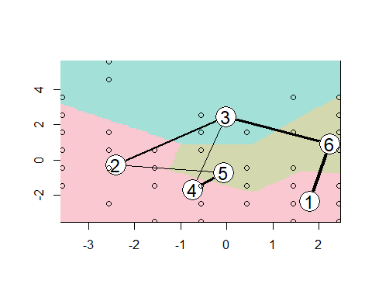

barplot(cl1)

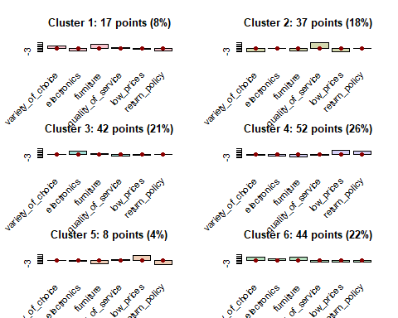

cl2 <- kcca(df.officen, k=6, family=kccaFamily("kmedians"),  
 control=list(initcent="kmeanspp"))  
cl2

## kcca object of family 'kmedians'   
##   
## call:  
## kcca(x = df.officen, k = 6, family = kccaFamily("kmedians"),   
## control = list(initcent = "kmeanspp"))  
##   
## cluster sizes:  
##   
## 1 2 3 4 5 6   
## 62 24 32 60 13 9

image(cl2)  
points(df.officen)

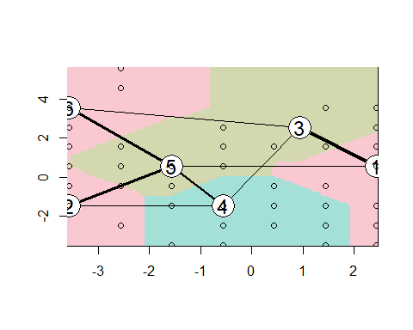

k2a <- as.kcca(k2, df.officen)  
k2a

## kcca object of family 'kmeans'   
##   
## call:  
## as.kcca(object = k2, data = df.officen)  
##   
## cluster sizes:  
##   
## 1 2 3 4 5 6   
## 52 8 29 63 17 31

k2b <- as(k2a, "kmeans")  
k2b

## K-means clustering with 6 clusters of sizes 52, 8, 29, 63, 17, 31  
##   
## Cluster means:  
## variety_of_choice electronics furniture quality_of_service low_prices  
## 1 -0.7380769 -1.68076923 -1.9430769 -0.6069231 3.33961538  
## 2 -0.0650000 -0.70000000 -2.8950000 0.4700000 3.45500000  
## 3 -2.3925862 -0.72586207 -1.9596552 4.7458621 -2.65706897  
## 4 2.0223016 0.02619048 2.7141270 -0.9903175 -1.44579365  
## 5 -2.6238235 2.02058824 -1.1523529 0.1758824 -2.03029412  
## 6 0.8220968 2.51774194 0.9558065 -1.6267742 0.04370968  
## return_policy  
## 1 2.2115385  
## 2 -3.2500000  
## 3 -0.6293103  
## 4 -1.4880952  
## 5 2.5735294  
## 6 -0.6693548  
##   
## Clustering vector:  
## [1] 4 2 1 1 5 1 1 6 6 2 6 3 4 5 1 4 4 1 4 3 3 6 1 3 4 4 4 5 1 6 1 4 6 4 1 1 1  
## [38] 3 4 6 1 4 5 3 6 2 3 4 4 4 3 4 6 4 1 1 1 3 4 6 1 4 5 3 6 1 3 4 4 4 5 1 6 1  
## [75] 4 6 1 1 4 6 1 6 3 4 5 1 4 4 1 4 3 3 6 1 1 1 4 6 2 6 3 4 5 1 4 4 1 4 5 3 6  
## [112] 1 4 4 2 1 1 5 1 1 4 6 2 6 3 4 3 1 4 4 1 4 5 3 6 1 3 4 4 4 3 1 6 1 1 4 6 1  
## [149] 6 3 4 5 1 4 4 1 4 5 3 6 1 3 4 4 4 5 1 4 6 2 6 3 4 3 1 4 4 1 4 5 3 6 1 3 4  
## [186] 4 4 5 1 4 6 2 6 3 4 5 1 4 4 1  
##   
## Within cluster sum of squares by cluster:  
## [1] 346.7885 16.8750 162.2069 523.3651 178.0000 200.1935  
##   
## Available components:  
##   
## [1] "cluster" "centers" "size" "withinss"

All concordance changed

# Tasks:6

Describe the 6-cluster solution using the cluster numbers corresponding to the hierarchical clustering procedure.

* **Anwser**
* The 6-Cluster Solution visually differentiated the 6 clusters in groups while th heirarchical clustering procedure was clumsy.

# Tasks:7

Comment on why you may decide to NOT proceed with this 6-cluster solution.

* **Anwser**
* The accuracy and qaulity of clustering of the 6-Clustered Solution is impaired after then we may decide not to proceed with the 6-Cluster solutions

# Tasks:8

Generate a 5-cluster solution. How many observations are assigned to each cluster?

* **Anwser**

# 5-cluster solution  
Hierar_office_5 <- cutree(Hierar_office, k = 5 )  
  
# display 5-cluster solution  
Hierar_office_5

## [1] 1 2 2 2 3 2 2 1 4 2 4 5 1 3 2 1 1 2 1 5 5 4 2 5 1 1 1 3 2 4 2 1 4 1 2 2 2  
## [38] 5 1 4 2 1 3 5 4 2 5 1 1 1 5 1 4 1 2 2 2 5 1 4 2 1 3 5 4 2 5 1 1 1 3 2 4 2  
## [75] 1 4 2 2 1 4 2 4 5 1 3 2 1 1 2 1 5 5 4 2 2 2 1 4 2 4 5 1 3 2 1 1 2 1 3 5 4  
## [112] 2 1 1 2 2 2 3 2 2 1 4 2 4 5 1 5 2 1 1 2 1 3 5 4 2 5 1 1 1 5 2 4 2 2 1 4 2  
## [149] 4 5 1 3 2 1 1 2 1 3 5 4 2 5 1 1 1 3 2 1 4 2 4 5 1 5 2 1 1 2 1 3 5 4 2 5 1  
## [186] 1 1 3 2 1 4 2 4 5 1 3 2 1 1 2

table(Hierar_office_5)

## Hierar_office_5  
## 1 2 3 4 5   
## 64 60 17 30 29

# Tasks:9

Repeat the steps performed previously to describe the clusters for the 5-cluster solution (i.e., calculate cluster means and segmentation plot). Describe the 5-cluster solution using the cluster numbers corresponding to the hierarchical clustering procedure. Give “expressive” labels to the clusters.

* **Anwser**

k3 <- kmeans(df.officen, centers = 5, nstart = 20)  
str(k3)

## List of 9  
## $ cluster : int [1:200] 1 2 2 2 3 2 2 5 5 2 ...  
## $ centers : num [1:5, 1:6] 2.022 -0.648 -2.624 -2.393 0.822 ...  
## ..- attr(*, "dimnames")=List of 2  
## .. ..$ : chr [1:5] "1" "2" "3" "4" ...  
## .. ..$ : chr [1:6] "variety_of_choice" "electronics" "furniture" "quality_of_service" ...  
## $ totss : num 5856  
## $ withinss : num [1:5] 523 595 178 162 200  
## $ tot.withinss: num 1658  
## $ betweenss : num 4198  
## $ size : int [1:5] 63 60 17 29 31  
## $ iter : int 2  
## $ ifault : int 0  
## - attr(*, "class")= chr "kmeans"

k3

## K-means clustering with 5 clusters of sizes 63, 60, 17, 29, 31  
##   
## Cluster means:  
## variety_of_choice electronics furniture quality_of_service low_prices  
## 1 2.0223016 0.02619048 2.7141270 -0.9903175 -1.44579365  
## 2 -0.6483333 -1.55000000 -2.0700000 -0.4633333 3.35500000  
## 3 -2.6238235 2.02058824 -1.1523529 0.1758824 -2.03029412  
## 4 -2.3925862 -0.72586207 -1.9596552 4.7458621 -2.65706897  
## 5 0.8220968 2.51774194 0.9558065 -1.6267742 0.04370968  
## return_policy  
## 1 -1.4880952  
## 2 1.4833333  
## 3 2.5735294  
## 4 -0.6293103  
## 5 -0.6693548  
##   
## Clustering vector:  
## [1] 1 2 2 2 3 2 2 5 5 2 5 4 1 3 2 1 1 2 1 4 4 5 2 4 1 1 1 3 2 5 2 1 5 1 2 2 2  
## [38] 4 1 5 2 1 3 4 5 2 4 1 1 1 4 1 5 1 2 2 2 4 1 5 2 1 3 4 5 2 4 1 1 1 3 2 5 2  
## [75] 1 5 2 2 1 5 2 5 4 1 3 2 1 1 2 1 4 4 5 2 2 2 1 5 2 5 4 1 3 2 1 1 2 1 3 4 5  
## [112] 2 1 1 2 2 2 3 2 2 1 5 2 5 4 1 4 2 1 1 2 1 3 4 5 2 4 1 1 1 4 2 5 2 2 1 5 2  
## [149] 5 4 1 3 2 1 1 2 1 3 4 5 2 4 1 1 1 3 2 1 5 2 5 4 1 4 2 1 1 2 1 3 4 5 2 4 1  
## [186] 1 1 3 2 1 5 2 5 4 1 3 2 1 1 2  
##   
## Within cluster sum of squares by cluster:  
## [1] 523.3651 594.7000 178.0000 162.2069 200.1935  
## (between_SS / total_SS = 71.7 %)  
##   
## Available components:  
##   
## [1] "cluster" "centers" "totss" "withinss" "tot.withinss"  
## [6] "betweenss" "size" "iter" "ifault"

k3$centers

## variety_of_choice electronics furniture quality_of_service low_prices  
## 1 2.0223016 0.02619048 2.7141270 -0.9903175 -1.44579365  
## 2 -0.6483333 -1.55000000 -2.0700000 -0.4633333 3.35500000  
## 3 -2.6238235 2.02058824 -1.1523529 0.1758824 -2.03029412  
## 4 -2.3925862 -0.72586207 -1.9596552 4.7458621 -2.65706897  
## 5 0.8220968 2.51774194 0.9558065 -1.6267742 0.04370968  
## return_policy  
## 1 -1.4880952  
## 2 1.4833333  
## 3 2.5735294  
## 4 -0.6293103  
## 5 -0.6693548

cl3 <- kcca(df.officen, k=5)  
cl3

## kcca object of family 'kmeans'   
##   
## call:  
## kcca(x = df.officen, k = 5)  
##   
## cluster sizes:  
##   
## 1 2 3 4 5   
## 43 17 78 17 45

plot.new()  
image(cl3)  
points(df.officen)

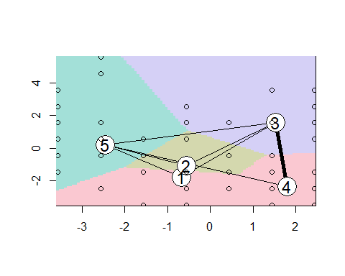

barplot(cl3)

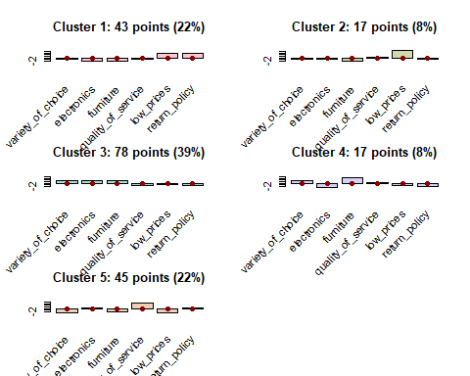

cl4 <- kcca(df.officen, k=5, family=kccaFamily("kmedians"),  
 control=list(initcent="kmeanspp"))  
cl4

## kcca object of family 'kmedians'   
##   
## call:  
## kcca(x = df.officen, k = 5, family = kccaFamily("kmedians"),   
## control = list(initcent = "kmeanspp"))  
##   
## cluster sizes:  
##   
## 1 2 3 4 5   
## 35 23 62 57 23

image(cl4)  
points(df.officen)

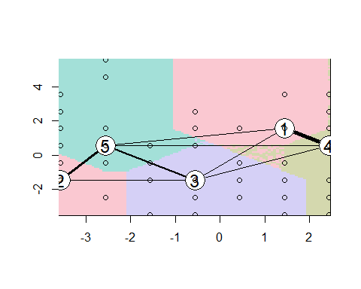

k3a <- as.kcca(k3, df.officen)  
k3a

## kcca object of family 'kmeans'   
##   
## call:  
## as.kcca(object = k3, data = df.officen)  
##   
## cluster sizes:  
##   
## 1 2 3 4 5   
## 63 60 17 29 31

k3b <- as(k3a, "kmeans")  
k3b

## K-means clustering with 5 clusters of sizes 63, 60, 17, 29, 31  
##   
## Cluster means:  
## variety_of_choice electronics furniture quality_of_service low_prices  
## 1 2.0223016 0.02619048 2.7141270 -0.9903175 -1.44579365  
## 2 -0.6483333 -1.55000000 -2.0700000 -0.4633333 3.35500000  
## 3 -2.6238235 2.02058824 -1.1523529 0.1758824 -2.03029412  
## 4 -2.3925862 -0.72586207 -1.9596552 4.7458621 -2.65706897  
## 5 0.8220968 2.51774194 0.9558065 -1.6267742 0.04370968  
## return_policy  
## 1 -1.4880952  
## 2 1.4833333  
## 3 2.5735294  
## 4 -0.6293103  
## 5 -0.6693548  
##   
## Clustering vector:  
## [1] 1 2 2 2 3 2 2 5 5 2 5 4 1 3 2 1 1 2 1 4 4 5 2 4 1 1 1 3 2 5 2 1 5 1 2 2 2  
## [38] 4 1 5 2 1 3 4 5 2 4 1 1 1 4 1 5 1 2 2 2 4 1 5 2 1 3 4 5 2 4 1 1 1 3 2 5 2  
## [75] 1 5 2 2 1 5 2 5 4 1 3 2 1 1 2 1 4 4 5 2 2 2 1 5 2 5 4 1 3 2 1 1 2 1 3 4 5  
## [112] 2 1 1 2 2 2 3 2 2 1 5 2 5 4 1 4 2 1 1 2 1 3 4 5 2 4 1 1 1 4 2 5 2 2 1 5 2  
## [149] 5 4 1 3 2 1 1 2 1 3 4 5 2 4 1 1 1 3 2 1 5 2 5 4 1 4 2 1 1 2 1 3 4 5 2 4 1  
## [186] 1 1 3 2 1 5 2 5 4 1 3 2 1 1 2  
##   
## Within cluster sum of squares by cluster:  
## [1] 523.3651 594.7000 178.0000 162.2069 200.1935  
##   
## Available components:  
##   
## [1] "cluster" "centers" "size" "withinss"

# Tasks:10

Comment on why you may find this 5-cluster solution better than the previous 6-cluster solution..

* **Anwser**
* The 5-Cluster Solution shows more accuracy and detects the similarity better closer to the center

# Tasks:11

Use all the variables not included in the clustering procedure to evaluate whether the 5-cluster solution is meaningful. Generate ideas on how to target each segment (at least one idea per segment).

* **Anwser**

library(clValid)

## Warning: package 'clValid' was built under R version 4.1.3

## Loading required package: cluster

##   
## Attaching package: 'clValid'

## The following object is masked from 'package:flexclust':  
##   
## clusters

## The following object is masked from 'package:modeltools':  
##   
## clusters

rownames(df.officen) <- 1:nrow( df.officen)  
stab <- clValid(df.officen, 2:6, clMethods=c("hierarchical","kmeans"),validation="stability")  
plot(stab)

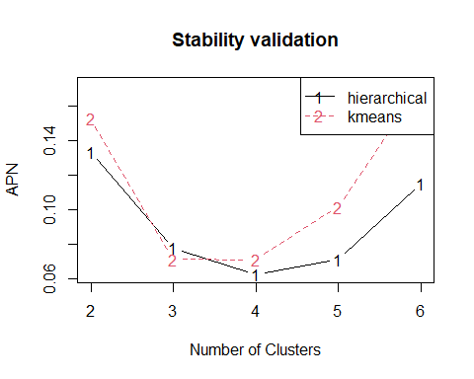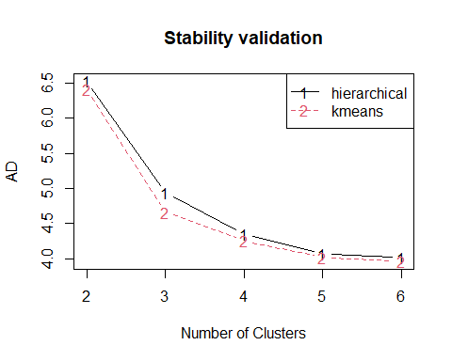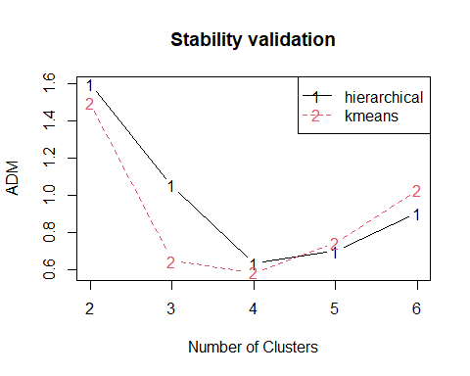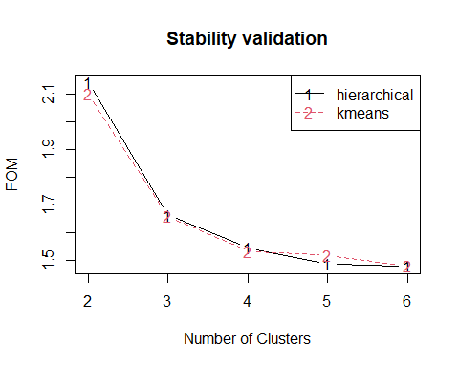

intern <- clValid(df.officen, 2:6, clMethods=c("hierarchical","kmeans"),validation="internal")  
plot(intern)

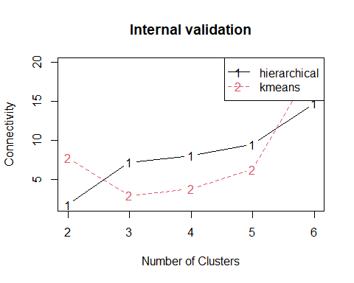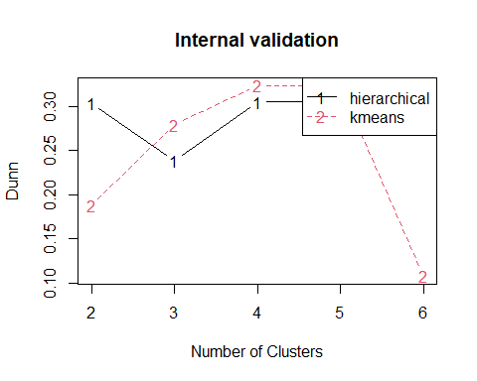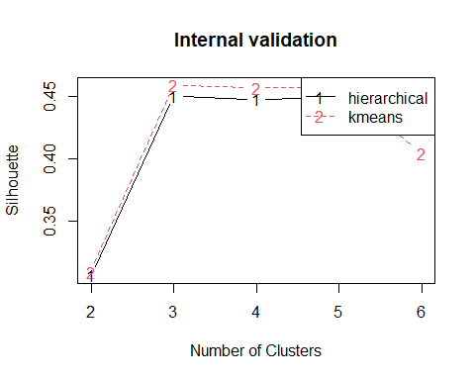

summary(intern)

##   
## Clustering Methods:  
## hierarchical kmeans   
##   
## Cluster sizes:  
## 2 3 4 5 6   
##   
## Validation Measures:  
## 2 3 4 5 6  
##   
## hierarchical Connectivity 1.7095 7.1786 8.0242 9.5020 14.7433  
## Dunn 0.3036 0.2382 0.3050 0.3050 0.3050  
## Silhouette 0.3067 0.4503 0.4477 0.4491 0.4285  
## kmeans Connectivity 7.7456 2.9492 3.7948 6.2726 19.7937  
## Dunn 0.1883 0.2793 0.3235 0.3235 0.1078  
## Silhouette 0.3097 0.4588 0.4569 0.4567 0.4048  
##   
## Optimal Scores:  
##   
## Score Method Clusters  
## Connectivity 1.7095 hierarchical 2   
## Dunn 0.3235 kmeans 4   
## Silhouette 0.4588 kmeans 3

optimalScores(stab)

## Score Method Clusters  
## APN 0.06215602 hierarchical 4  
## AD 3.95702148 kmeans 6  
## ADM 0.58420959 kmeans 4  
## FOM 1.47797553 hierarchical 6

# Tasks:12

Run the k-means clustering algorithm on the normalised data, creating 5 clusters. Use iter.max = 1000 and nstart = 100 and set.seed(123)for reproducibility. How many observations are assigned to each cluster?

* **Anwser**

set.seed(123)  
k5 <- kmeans(df.officen, centers = 5, nstart = 100,iter.max = 1000)  
k5

## K-means clustering with 5 clusters of sizes 60, 17, 34, 29, 60  
##   
## Cluster means:  
## variety_of_choice electronics furniture quality_of_service low_prices  
## 1 -0.6483333 -1.550000e+00 -2.0700000 -0.4633333 3.3550000  
## 2 -2.6238235 2.020588e+00 -1.1523529 0.1758824 -2.0302941  
## 3 0.7879412 2.344118e+00 0.8770588 -1.6182353 -0.2067647  
## 4 -2.3925862 -7.258621e-01 -1.9596552 4.7458621 -2.6570690  
## 5 2.1016667 -1.184238e-16 2.8466667 -0.9633333 -1.3783333  
## return_policy  
## 1 1.4833333  
## 2 2.5735294  
## 3 -0.7205882  
## 4 -0.6293103  
## 5 -1.5000000  
##   
## Clustering vector:  
## 1 2 3 4 5 6 7 8 9 10 11 12 13 14 15 16 17 18 19 20   
## 5 1 1 1 2 1 1 3 3 1 3 4 5 2 1 5 5 1 5 4   
## 21 22 23 24 25 26 27 28 29 30 31 32 33 34 35 36 37 38 39 40   
## 4 3 1 4 5 5 5 2 1 3 1 5 3 5 1 1 1 4 5 3   
## 41 42 43 44 45 46 47 48 49 50 51 52 53 54 55 56 57 58 59 60   
## 1 5 2 4 3 1 4 5 5 5 4 5 3 5 1 1 1 4 5 3   
## 61 62 63 64 65 66 67 68 69 70 71 72 73 74 75 76 77 78 79 80   
## 1 5 2 4 3 1 4 5 5 5 2 1 3 1 5 3 1 1 5 3   
## 81 82 83 84 85 86 87 88 89 90 91 92 93 94 95 96 97 98 99 100   
## 1 3 4 5 2 1 5 5 1 5 4 4 3 1 1 1 3 3 1 3   
## 101 102 103 104 105 106 107 108 109 110 111 112 113 114 115 116 117 118 119 120   
## 4 5 2 1 5 5 1 5 2 4 3 1 5 5 1 1 1 2 1 1   
## 121 122 123 124 125 126 127 128 129 130 131 132 133 134 135 136 137 138 139 140   
## 5 3 1 3 4 5 4 1 5 5 1 5 2 4 3 1 4 5 5 5   
## 141 142 143 144 145 146 147 148 149 150 151 152 153 154 155 156 157 158 159 160   
## 4 1 3 1 1 3 3 1 3 4 5 2 1 5 5 1 5 2 4 3   
## 161 162 163 164 165 166 167 168 169 170 171 172 173 174 175 176 177 178 179 180   
## 1 4 5 5 5 2 1 3 3 1 3 4 5 4 1 5 5 1 5 2   
## 181 182 183 184 185 186 187 188 189 190 191 192 193 194 195 196 197 198 199 200   
## 4 3 1 4 5 5 5 2 1 5 3 1 3 4 5 2 1 5 5 1   
##   
## Within cluster sum of squares by cluster:  
## [1] 594.7000 178.0000 245.0294 162.2069 476.9333  
## (between_SS / total_SS = 71.7 %)  
##   
## Available components:  
##   
## [1] "cluster" "centers" "totss" "withinss" "tot.withinss"  
## [6] "betweenss" "size" "iter" "ifault"

k5$size

## [1] 60 17 34 29 60

# Tasks:13

Check the concordance between the hclust and kmeans procedures. What is the Hit Rate?

* **Anwser**

k2$clusters

## NULL

Hierar_office_6

## [1] 1 2 3 3 4 3 3 1 5 2 5 6 1 4 3 1 1 3 1 6 6 5 3 6 1 1 1 4 3 5 3 1 5 1 3 3 3  
## [38] 6 1 5 3 1 4 6 5 2 6 1 1 1 6 1 5 1 3 3 3 6 1 5 3 1 4 6 5 3 6 1 1 1 4 3 5 3  
## [75] 1 5 3 3 1 5 3 5 6 1 4 3 1 1 3 1 6 6 5 3 3 3 1 5 2 5 6 1 4 3 1 1 3 1 4 6 5  
## [112] 3 1 1 2 3 3 4 3 3 1 5 2 5 6 1 6 3 1 1 3 1 4 6 5 3 6 1 1 1 6 3 5 3 3 1 5 3  
## [149] 5 6 1 4 3 1 1 3 1 4 6 5 3 6 1 1 1 4 3 1 5 2 5 6 1 6 3 1 1 3 1 4 6 5 3 6 1  
## [186] 1 1 4 3 1 5 2 5 6 1 4 3 1 1 3

cor.test(k2$cluster,Hierar_office_6)

##   
## Pearson's product-moment correlation  
##   
## data: k2$cluster and Hierar_office_6  
## t = 1.7918, df = 198, p-value = 0.0747  
## alternative hypothesis: true correlation is not equal to 0  
## 95 percent confidence interval:  
## -0.01264698 0.26049154  
## sample estimates:  
## cor   
## 0.1263157

print(cor.test(k2$cluster,Hierar_office_6))

##   
## Pearson's product-moment correlation  
##   
## data: k2$cluster and Hierar_office_6  
## t = 1.7918, df = 198, p-value = 0.0747  
## alternative hypothesis: true correlation is not equal to 0  
## 95 percent confidence interval:  
## -0.01264698 0.26049154  
## sample estimates:  
## cor   
## 0.1263157