Requirements and Analysis Document for the Vanaheim
project (RAD)

1 Introduction
1.1 Purpose of application
The purpose of the game is to create a fun environment for the player. By using text to perform things, we hope to help people become better at typing.

1.2 General characteristics of application
The Vanaheim application is a single-player application with a graphical user interface (GUI) for Windows/Mac/Linux platforms.

The player will navigate through a 2-dimensional world. Navigation is made using the arrow keys. When navigating around the world, the player may be blocked by certain objects such as trees, water etc. Every interaction is made by typing commands. For example if the player wishes to equip his axe in inventory he type ”equip crude axe”.
The game won't have an end.

1.3 Scope of application
It is only possible to play the game alone. That is, there's no multiplayer option. There is no option to save a game and there is no saved statistics for player level, quests completed etc.

1.4 Objectives and success criteria of the project
- It should be possible to accept and complete a quest. A quest can for example be to kill five spiders.
- It should be possible to use commands to invoke actions in the game.

1.5 Definitions, acronyms and abbreviations
- GUI, graphical user interface
- FPS, frames per second
- Java, platform independent programming language.
- JRE, Java Runtime Environment. Additional software needed to run a Java application.
- Host, a computer where the game will run.
- NPC, non-player character
- Loot, pick up items from killed enemies.
- Quest, a player accepts a quest, performs it and then finishes it to gain a reward.

2 Requirements
2.1 Functional requirements
The player should be able to:
*Move around the world
*Attack monsters
*Kill monsters
*Loot monsters
*Start game from welcome screen
*End game to welcome screen
*Equip items
*Unequip items
*Use items
*Receive quest from NPC
*Complete quest
*Be able to change world, for examle enter a house

2.2 Non-functional requirements
2.2.1 Usability
*Get response from NPC in a resonable amount of time
*Not too high latency that disturb the player
2.2.2 Reliability
NA
2.2.3 Performance
*FPS at 120
2.2.4 Supportability
NA
2.2.5 Implementation
To achieve platform independence, the application will use the Java environment. We use Slick2D library so we can focus on other implementation details.
2.2.6 Packaging and installation
*JAR-files
2.2.7 Legal
*Only use openSource sprites and music. Also some sprites and music are made by us.
2.3 Application models
2.3.1 Use case model
See APPENDIX for UML diagram.

2.3.2 Use cases priority
1. Start game
2. Move around the map
3. Enter houses
4. Use simple command tasks
  - Open/Close inventory
  - Show questbook
  - Hide questbook
  - Equip an item
  - Unequip item
  - Use item
5. Fight monsters
6. Use more advanced command tasks
  - Open console window
  - Hit monster
  - Talk to NPC
  - Loot items
7. Win against monster
8. Loose against monster
9. Receive quest from NPC
10. Finish quest
11. End game

2.3.3 Analysis model
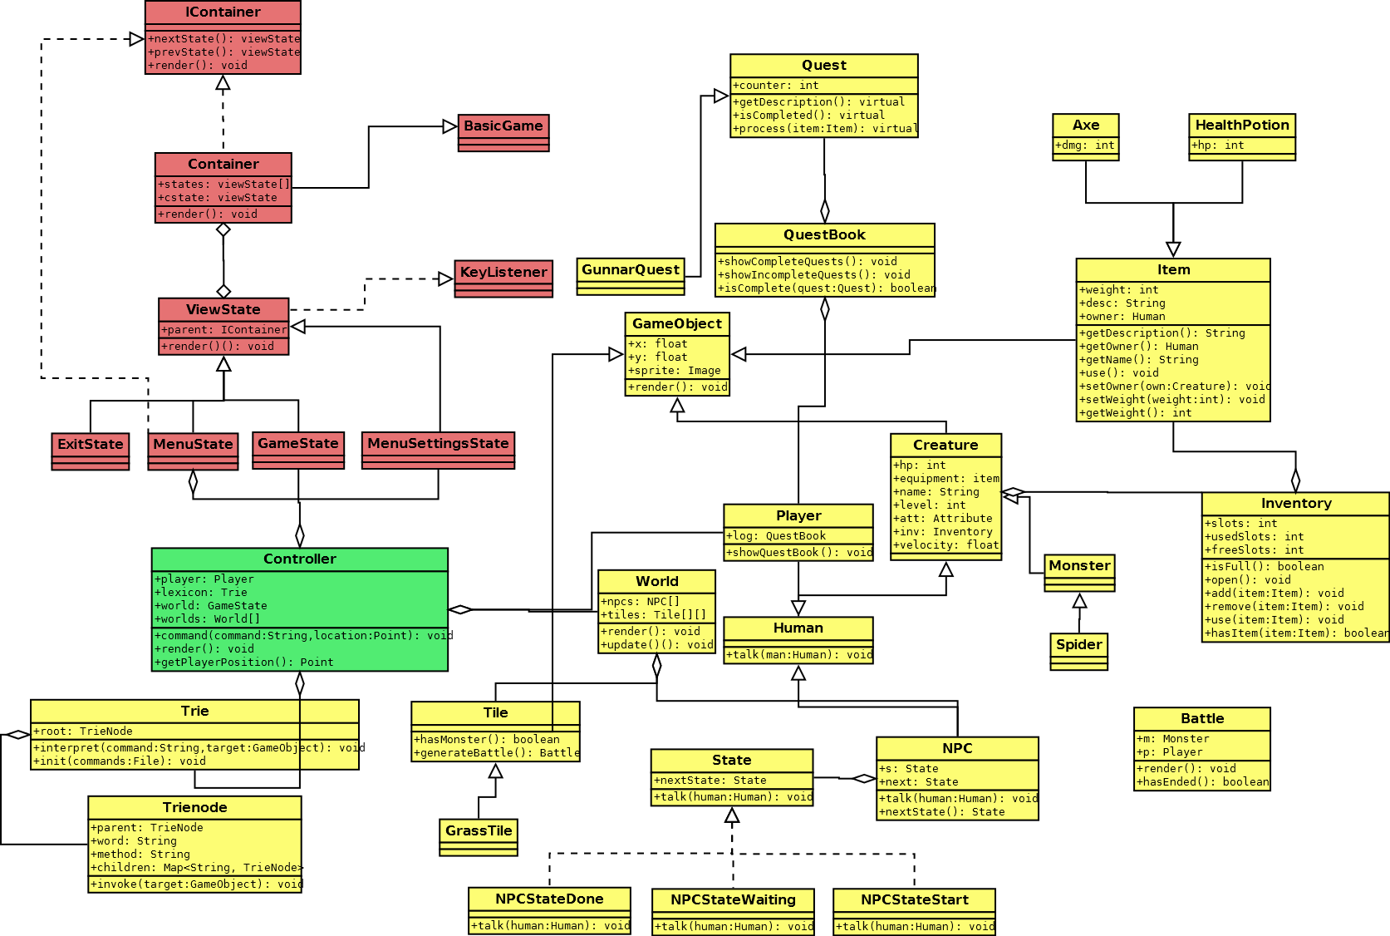
2.3.4 User interface

2.4 References

APPENDIX
Use case model

