ISMS Scope Document
ISO/IEC 27001:2022 — Clause 4.3
Field | Value
Document owner | GRC Analyst (ISMS Implementation Project)
Organization | NRW Logistics GmbH (fictional entity — portfolio project)
Version | 1.0
Status | Draft for management approval
Classification | Internal
Related clauses | ISO/IEC 27001:2022 §4.1, §4.2, §4.3, §4.4

1. Purpose
This document defines the scope of the Information Security Management System (ISMS) for NRW Logistics GmbH, in accordance with ISO/IEC 27001:2022 Clause 4.3. It establishes the boundaries and applicability of the ISMS by identifying the organizational units, locations, assets, and technologies included, and by documenting exclusions with justification.
Why this matters: Scope is the foundation, not paperwork
Every later ISMS artifact inherits its boundaries from this document. If a risk register includes an asset the scope document didn't cover, or the Statement of Applicability justifies a control by referencing an out-of-scope system, an auditor will flag the inconsistency immediately. Getting scope right first prevents rework across every downstream deliverable.

2. Organizational Context (Clause 4.1)
NRW Logistics GmbH is a road freight and warehousing company headquartered in Dortmund, Germany, with a distribution center in Witten. The company provides regional freight transport, warehousing, and fleet management services to industrial and retail clients across North Rhine-Westphalia.
Internal issues relevant to the ISMS include: reliance on a small internal IT team, use of an outsourced cloud ERP platform, and a fleet telematics system operated by internal staff. External issues include increasing customer contractual requirements for information security assurance, GDPR obligations as a processor of customer shipment and location data, and sector-wide pressure from insurers requiring demonstrable cyber risk management.

3. Interested Parties (Clause 4.2)
The following interested parties, and their security-related requirements, were considered in determining ISMS scope:
Interested party | Requirement / expectation
Customers | Confidentiality of shipment data; contractual security clauses; incident notification
Employees | Protection of personal data; clear acceptable use expectations
Regulators (GDPR / BSI) | Lawful processing of personal data; breach notification within statutory timeframes
Cyber insurer | Evidence of baseline security controls to maintain coverage terms
Cloud ERP provider (Microsoft Azure) | Shared responsibility model — customer-managed configuration and access control

Why this matters: Interested parties drive scope, not the other way around
A common mistake is scoping the ISMS around convenient IT boundaries (e.g. 'just the servers we manage') rather than around what interested parties actually need protected. Auditors check that Clause 4.2 requirements are traceable into the scope statement — if a customer requires shipment data confidentiality, the systems that hold shipment data must be in scope, regardless of who technically administers them.

4. ISMS Scope Statement
The ISMS covers the information, information systems, and business processes involved in the receipt, storage, transport, and delivery of customer freight, and the internal IT infrastructure that supports these operations, specifically:
- HQ network — Dortmund office, including internal administrative systems and end-user devices
- Warehouse Management System (WMS) — Witten distribution center
- Fleet telematics — vehicle tracking and route management systems
- Cloud ERP — Azure-hosted platform supporting finance and operations

5. Scope Boundary Diagram
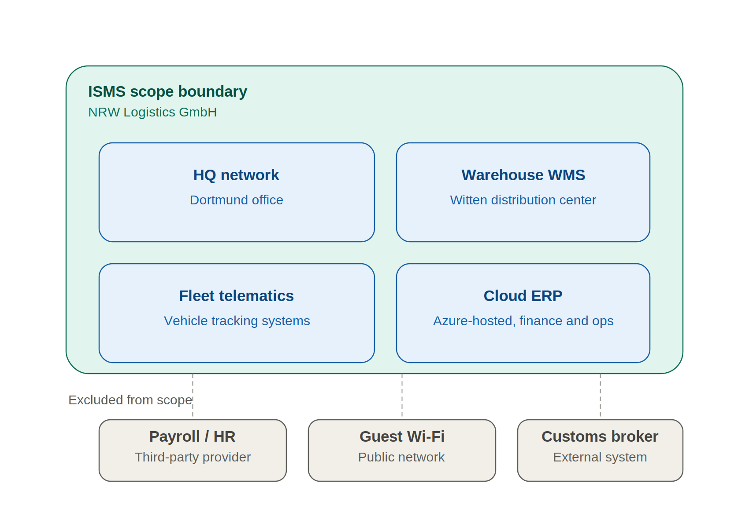

6. Exclusions and Justification
Excluded item | Justification
Payroll / HR system | Fully outsourced to a third-party provider holding its own ISO 27001 certification; NRW Logistics has no administrative control over the system
Guest Wi-Fi | Logically segmented from all corporate and operational networks; carries no company or customer data
Customs broker system | External system operated by a third-party customs agent; NRW Logistics only exchanges data via a defined API interface, which is itself in scope as a data flow

Why this matters: Exclusions must be justified, not just declared
ISO 27001 explicitly requires (Clause 4.3) that exclusions be documented with reasoning — you can't simply omit something inconvenient. A weak justification (e.g. 'not relevant') is a common audit nonconformity. The strongest justifications point to either genuine lack of control (fully outsourced, separately certified) or a defined, monitorable boundary (network segmentation, a scoped API interface) — both of which this table demonstrates.

7. Approval
Role | Name | Date
ISMS Owner / GRC Analyst
Management representative

