**Assessing the trajectories of local plant community change: a literature review**

Ekin Kaplan1,2,*, Bernd Lenzner1, Stefan Dullinger3, Franz Essl1

1 Division of BioInvasions, Global Change & Macroecology, Department of Botany and Biodiversity Research, University of Vienna, Austria

2 Vienna Doctoral School of Ecology and Evolution, University of Vienna, Vienna, Austria

3 Division of Biodiversity Dynamics and Conservation, Department of Botany and Biodiversity Research, University of Vienna, Austria

*corresponding author: ekin.kaplan@univie.ac.at

**ORCID-IDs**

Ekin Kaplan: 0000-0002-7303-5883

Bernd Lenzner: 0000-0002-2616-3479

Stefan Dullinger: 0000-0003-3919-0887

Franz Essl: 0000-0001-8253-2112

Target Journals: Global Ecology and Biogeography, Global Change Biology, Ecography

**Abstract**

**Aim**

We conducted a comprehensive review of the literature on studies on local scale plant community change. The focus of this review is to examine the key findings and conclusions derived from these studies, specifically in terms of changes in species richness and diversity. Furthermore, this review aims to analyze the regional and habitat-specific variations in these changes and identify the primary drivers associated with them. By incorporating these findings, this manuscript will contribute to the current understanding of global plant diversity and propose avenues for future research.

**Location**

Global

**Time Period**

1827-2022

**Taxon**

Plants

**Methods**

A global systematic literature review was conducted to identify literature on plant community change worldwide. Relevant studies were extracted from Web of Science and Scopus, focusing on English studies only. Duplicates were removed, and a two-step screening process was applied, based on three criteria: (i) a focus on plant community data, (ii) inclusion of two temporally separate assessments of plant communities, and (iii) coverage of diversity metrics (species richness and composition). Studies meeting all criteria underwent a full review using a 22 category template. Review papers and meta-analyses were excluded, resulting in a total of 865 studies included in the review.

**Results**

Our study reviewed 4,983 papers, identifying 865 meeting inclusion criteria, with 594 based on permanent plots and 266 on resurveys. Geographically, most studies were from Europe (469), followed by North America (206), South America (77), and Asia (67), with fewer from Oceania (22) and Africa (23). In terms of habitats, 39.4 % focused on forests, 27.2 % on grasslands, and the remaining on diverse habitats. Our dataset included 649 studies on vascular plants. Among the drivers of change, land-use change was the most prevalent, followed by succession, climate change, biological invasions, pollution, and resource extraction, with some studies considering multiple drivers. Species composition changed in 801 studies, species richness exhibited increasing or not changing trends over time.

**Conclusions**

Our review reveals significant deviations from the "no net change" hypothesis in local plant community diversity. We observed more frequent increases in species richness and diversity, particularly across specific habitats and under certain drivers of change. These findings challenge previous assumptions and highlight the importance of considering regional and habitat-specific variations. The results emphasize the need for continued research to address gaps, particularly in underrepresented regions, to better understand global plant biodiversity dynamics and inform conservation efforts.

**Keywords**

biodiversity change, drivers, habitats, resurvey, species composition, species richness, vascular plants, vegetation change

**1 INTRODUCTION**

The decline of many species has become a hallmark of the Anthropocene (IPBES, 2019). Current anthropogenically accelerated extinction rates are exceeding historic ones by several orders of magnitude(Ceballos et al., 2015; Ceballos & Ehrlich, 2023), and, consequently, one million species are estimated to head towards extinction(Díaz et al., 2019; IPBES, 2019).

While global trends of widespread species decline are undisputed, there is considerable debate on the prevailing trends of species richness changes at local scale (Cardinale et al., 2018; Dornelas et al., 2014; Vellend et al., 2013, 2017). Several large studies and meta-analyses based on data from different realms and taxonomic groups have reported diverging patterns of species richness changes, sparking a no net loss of species richness at local scale-debate (Blowes et al., 2019; Hillebrand et al., 2018; Vellend et al., 2017). A number of reasons have been brought forward that may contribute to these unexpected and controversial findings, including biases and gaps in data, opposing trends in different regions or among underlying drivers of change, and the offsetting role of expanding alien species compensating for native species declines(Cardinale et al., 2018; Gonzalez et al., 2016; Primack et al., 2018).

In contrast, a consenus has emerged that considerable species turnover over time is the norm at local scale (Blowes et al., 2019; Dornelas et al., 2014; Jandt et al., 2022; Vellend et al., 2017). Studies have shown that signals of species turnover are particularly strong for mobile taxonomic groups and in the open oceans, probably because these communities are dominated by mostly rather short-lived organisms, and the environment is highly spatio-temporarily volatile (Blowes et al., 2019; Hillebrand et al., 2018).

For terrestrial plants, resurveying historic vegetation plots has become an essential resource for analysing temporal community trends at small scale(Kapfer et al., 2017; Knollová et al., 2024). Starting in the late 19th century, vegetation scientists started to study local plant diversity through establishing plots or relevés that document community composition (Jandt et al., 2022). Over time, an increasing number of these plots have been established, and in recent decades, an increasing subset of historic plots has been revisited (Jandt et al., 2022). The location of historic vegetation plots was often not sufficiently georeferenced to guarantee their unambiguous retrieval. Thus, more recently, permanent plots have been increasingly established to monitor plant community change over time in a systematic fashion, e.g. by repeated sampling of well-located plots (Knollová et al., 2024).

Understanding the dynamics of local plant community change is also essential for conservation policy and management. Such applied research questions include the assessment of the distribution and increase of alien plant species (Hédl et al., 2017), the conservation status of species across various habitats and climatic zones (Litza & Diekmann, 2017), or the effectiveness of protected areas (Feary et al., 2015).

A first comprehensive meta-analysis on local plant biodiversity change over time was done by Vellend et al. (2013). Their analysis was based on the then available literature of 148 studies published by July 2012, and with the vast majority of studies from Europe and North America. However, since then, resurveyed vegetation plot data have been strongly expanded and so has the literature based on this data. These substantial advances allow for an assessment of progress in knowledge made and remaining gaps and biases.

Here, we provide a global review of the literature on vegetation resurvey studies, extending the study of Vellend et al. (2013), and expanding it in several aspects. To this end, we study the following research questions: 1) What is the spatial distribution of resurvey studies and what is the increase of these studies in different continents during the last decade? 2) What is the coverage of different habitats and protected areas and do habitats and protected areas (versus non-protected areas) differ in observed changes in plant richness and composition? 3) Which underlying drivers have been studied and how do they relate to observed changes in plant richness and composition? 4) Do trajectories of plant diversity change differ for different metrics, i.e. species richness versus diversity?

**METHODS**

*Literature review protocol*

We conducted a systematic literature review to identify the body of literature on local scale plant community change. We screened the relevant peer reviewed literature available in Web of Science (https://www.webofscience.com/wos) and Scopus (https://www.scopus.com). We built out search string on the keywords used by Vellend et al. (2013), but extended it to include additional terms related to diversity measures and sampling schemes (see Figure S1 for the search string and for the full workflow). The search in both databases was performed on 5th August 2022 with a focus on English studies only. After removing duplicates, we did a two-step assessment of the remaining 7,398 studies. First, we screened all studies by title, abstract and keywords, retaining those studies that fulfilled three selection criteria: (i) the study focuses on plant communities, (ii) it includes at least two temporally separate assessments, and (iii) it addresses diversity aspects such as species richness or species composition. After this step, 2,330 studies were retained and underwent a full review. To do so, we developed a template to extract relevant information for further analyses (Table S1). The template contained information on i) geographic location, ii) habitats, iii) number and georeferencing of plots, iv) start and end year of sampling, v) studied drivers of change, vi) located inside or outside protected areas, vii) taxonomic groups included, and viii) diversity aspects studied. Publications that did not fulfil the three criteria were dropped, as were reviews and meta-analyses to avoid replication of individual studies. Further, authors also screened datasets that were known (such as Dornelas et al., 2014; Jandt et al., 2022; Richner et al., 2015; Vellend et al., 2013) that resulted in 144 new papers. A data set of 816 papers (also 865 sub-studies, which derived from the accepted and collected papers) were retained for full analyses.

We assigned studies to countries, geographic continents, biogeographic continents of the Biodiversity Information Standards (TDWG) classification (Brummitt et al., 2001) and ecoregions (Dinerstein et al., 2017). For assigning plots to habitats, we used a slightly modified version of the first order classification of the EUNIS habitat classification (Table S1.A) (*EUNIS Habitat Classification*, 2021). For classification of the studied drivers, we applied the classification scheme developed by the IPBES Global Assessment (IPBES, 2019). We modified it according to the needs of our study by eliminating the category “Governance, Economy, Demographics, Technology, and Values” which was not applicable in the context of this study, and by adding the categories of “Disturbance” (namely; natural continuous pressure, mid-disturbance and postdisturbance) to capture studies that focus on succession after or during disturbances (e.g. fires, storms, floods), also the land-use categories split into three based on the time and the manner of their impact (namely; land-use change, land-use cessation and ongoing land-use) (Table S1.B).

Based on the information provided in the studies, we distinguished between experimental plots (i.e. plots with manipulated and designed species composition) and non-experimental plots; plots have been further sub-divided into permanent plots (i.e. accurately geolocated plots) and quasi-permanent plots (i.e. plots that have not been exactly geolocated in at least one survey, usually the first one) (Kapfer et al. 2017).

*Statistical analyses*

We analysed the retrieved data to provide an assessment of the published knowledge of local-scale plant community changes. We analysed the geographic distribution of studies (countries, continents, ecoregions), the distribution across habitats, the distribution of studies inside and outside of protected areas, and the studied drivers. To analyse the increase in publications during the last decade, we analysed the number of studies for each continent according to their publication dates relative to the number of studies included by Vellend at al. (2013). We assessed reported trends in species richness and composition for the full data set, for different habitats, and for different drivers.

We applied Chi²-Tests against an even probability of studies showing an increase, no change, or decrease in the dataset to test for significant trends different from zero, i.e. a no net change over time; also to test if trends in the habitats with most studies (forests, grassland) changed when accounting for different drivers as compared to the overall trend in these habitats. We only considered forests and grasslands, as sample sizes for the other habitats were too small to obtain meaningful results. We also used Chi-squared tests to assess if trends in species richness and diversity differ between studies located inside and outside protected areas. Along with these, we ran another chi-squared test to concur the direction of the richness and species diversity changes, using bonferonni correction. Finally, we tested if reported trends of species richness and diversity changed with study duration, i.e. number of years between first and last survey. To do so, we ran generalized linear models (GLMs) with the number of publications as dependent and the timespan as independent variable. Models followed a Poisson error distribution and we run separate modes for species richness and diversity change as well as for each change direction, resulting in six individual models.

All analyses and visualizations were conducted in R version 4.1.3 (R Core Team, 2023) using the packages *tidyverse* (Wickham, 2016), *ggplot2* (Wickham et al., 2007), *cowplot* (Wilke, 2015), *countrycode* (Arel-Bundock, 2009) and *sf* (Pebesma, 2016).

**RESULTS**

*Spatial distribution and temporal increase of studies*

Of the 865 sub-studies retained in the final data set, 469 were from Europe (54 %), followed by North America (206 sub-studies; 24%), South America (77; 9%) and Asia (67; 8%) (Figure 1). The fewest sub-studies are reported from Africa (23; 3 %) and Oceania (22; 2 %). At the country-scale, we found sub-studies from 78 different countries with the USA contributing most individual studies (178), followed by Germany (59), the United Kingdom (50), and Brazil (42). Some regions of the globe such as Africa, western and Central Asia are poorly represented.

We have extracted specific sampling localities for the studies which we mapped on the global ecoregions (Dinerstein et al., 2017). Most studies were conducted in temperate ecoregions such as temperate broadleaf & mixed forests (446 studies; 50 %), followed by temperate conifer forests (117; 13 %). The ecoregions with the fewest studies were located in tropical & subtropical coniferous forests (1; 0.1 %) and Montane Grasslands & Shrubland (1; 0.1 %) ranking last (Table S6). The vast majority of sub-studies (814, 94%) are located in the Northern Hemisphere. The majority of studies studied vascular plants (649), followed by studies considering trees only (98), macrophytes (18), bryophytes (18), and lichens (10). In 97 publications, all above mentioned taxonomic groups were included.

Since the search performed in July 2012 for the meta-analysis of Vellend et al. (2013), the number of studies included here has immensely increased within a decade (Figure 2). The strongest increase was for Africa (800%), followed by South America (592%), Asia (295%), Europe (250 %), Oceania (244 %), and North America (186 %). Similarly, the number of plots included in the studies also increased from c. 18,139 (Vellend et al., 2013) to 167,240.

*Drivers of change and habitats covered*

The main drivers associated with observed plant diversity changes were ongoing land-use (282 sub-studies), followed by climate change (193), succession after cessation of land use (181), and pollution (164). For 67 studies no driver was identified. Overall, 508 sub-studies were single-driver studies (i.e., only considering one driver), while 290 considered two or more drivers (Figure 1). The most often studies driver combinations were biological invasions and ongoing land-use (28), followed by pollution and ongoing land-use (19).

The most studied habitat were forests (384, 39%) concerning forests, followed by grasslands (265, 27%), wetlands (98, 10%), alpine/arctic grasslands (85, 9%) coastal habitats (69, 8%), man-made habitats (33, 3%), barren/inland habitats (21, 2%), and aquatic habitats (18, 2%) (Figure 1). A total of 370 studies (43 %) were conducted within designated protected areas (Figure 5).

*Evidence of species richness and diversity changes*

Species richness changes were reported in 684 sub-studies, of which 352 (52%) reported an increase in species richness, 221 (32%) a decrease, while 111 (16%) studies showed no change. For species diversity change, i.e. information provided by diversity measures (indices such as Shannon-Wiener and Simpson), 154 (50 %) studies showed an increase, 104 (34 %) a decrease, and 50 (16 %) no change (Figure 3). For both, species richness and diversity change, we found a significant deviation from the no net-change assumption (X² = 127.69, p < 0.001; and X² = 52.70, p < 0.001 respectively; Table S4, Table S5). In other words, the studies analysed show a significant increase of species richness and diversity changes over time.

When zooming in on reported changes across habitats, we found significant deviations from equal distribution pattern for species richness change in alpine/arctic grasslands (X² = 24.6, p < 0.001), barren/inland (X² = 14.6, p < 0.001), coastal (X² = 16.4, p = 0.001), forest (X² = 34.2, p < 0.001), grassland (X² = 46.7, p < 0.001), man-made (X² = 12.8, p = 0.002), and wetland (X² = 18.8, p < 0.001) habitats; these significant deviations also appear for diversity change in barren/inland (X² = 10, p = 0.014), forest (X² = 15.1, p = 0.0015), grassland (X² = 25.4, p < 0.001) and wetland (X² = 8.96, p = 0.012) habitats (Figure 3, Table S4).

We also tested how the reported changes differed when considering habitat-driver interactions for those habitats with sufficient studies in our dataset (i.e., forests and grasslands). We found significant differences for forest habitats (Figure 4, Table S4). Species richness change significantly differed when considering alien species (X² = 10.1, p = 0.007), ongoing land-use (X² = 15.8, p < 0.001), land-use change (X² = 8.19, p = 0.017), and postdisturbance (X² = 38, p < 0.001); diversity change significantly differed in climate change (X² = 6.08, p = 0.045), alien species (X² = 10.6, p = 0.08), ongoing land-use (X² = 8.85, p = 0.015), and land-use change (X² = 11.4, p = 0.004) (Figure 4, Table S5). In grasslands, species richness varied significantly in response to climate change (X² = 7.32, p = 0.023), ongoing land-use (X² = 12.8, p = 0.002), land-use cessation (X² = 20.0, p < 0.001), land-use change (X² = 10.8, p = 0.006), and postdisturbance (X² = 16.4, p < 0.001). Additionally, species diversity showed significant differences in ongoing land-use (X² = 8.71, p = 0.015) and postdisturbance scenarios (X² = 9.5, p = 0.013).

Finally, we compared the reported trends for studies within and outside protected areas.Analyses did not show any significant differences for both species’ richness and diversity changes (X² = 1.37, p = 0.6 and X² = 3114, p = 0.712) (Tables S4, S5).

*Length of study duration and reported changes in species richness and diversity*

The mean study duration was 26.64 years, with a minimum of 1 year, and a maximum of 180 years. The earliest study has started in 1827, followed by 1834 (Figure S4). All studies starting early are located in Europe and North America. When testing for the role of study duration – i.e. the time elapsed between first and last survey – the GLM analyses revealed significant negative relationships for both species richness and diversity change with study duration (Figure 6); in other words, studies over longer time periods showed more negative and less positive changes in species richness and diversity. For species richness change, studies that reported increases declined most strongly in studies covering extended time periods (estimate = -0.031, p < 0.001), followed by reported decreases (estimate = -0.016, p < 0.001), and reported no changes (estimate = -0.015, p < 0.001). The same trend was observed for diversity change with a less stronger deviation between the declines (increase: estimate = -0.024, p < 0.001; decrease: estimate = -0.018, p < 0.001; no change: estimate = -0.020, p < 0.001).

*Direction of the change in species richness and diversity*

The overall trends for species richness and diversity, as determined by chi-squared tests, significantly diverge from an equal distribution, with a significant tendency toward increases when the "no change" variable is excluded (richness: X² = 29.949, p < 0.001; diversity: X² = 9.69, p = 0.002). Habitats that exhibited a significant deviation from equal distribution in species richness showed a significant trend toward increases in alpine/arctic grasslands (adjusted p = 0.012) and forests (adjusted p = 0.004) after applying the Bonferroni correction. Among the drivers, ongoing land use (adjusted p = 0.049) and post-disturbance drivers (adjusted p = 0.004) also showed a significant directional increase in species richness. For diversity, only the post-disturbance driver (adjusted p = 0.049) exhibited a significant increase. Additionally, species richness change in forest habitats with post-disturbance driver (adjusted p = 0.004) showed a significant trend toward increases.

**DISCUSSION**

Our assessment of the published literature on temporal plant community changes revealed significant deviations of reported global species richness and diversity trends from the net-zero change assumption reported in previous studies (e.g., Blowes et al., 2019; Hillebrand et al., 2018; Vellend et al., 2017). Substantially more studies in our dataset report an increase in both species richness and diversity change than a decrease. The global patterns significantly deviate across different habitats and drivers with more pronounced changes seen for species richness change compared to diversity change. For species richness, apart from aquatic habitats, all habitats differ from the expected equal proportions. For diversity; barren/inland, forest, grassland and wetland habitats differ from equal proportions.

With increasing time between the first and last observation, reported increases decline slightly faster than reported decreases, especially for diversity change studies indicating a pattern shift over time. Whether the studies were conducted in a protected area or outside did not have any significant affect on the reported trend.

*No support for no-net change theory but indications for habitat and driver specific trends*

By postulating the idea of no-net change of species richness within available time-series data, Vellend et al. (2013) have sparked a lively debate on the validity of these findings and the restriction of existing time-series data for analysing such trends. Major critical voices argued that these observed global trends were masking smaller scale patterns related to specific habitats, the timing of and time between the observations, potential different effects of different drivers of change and the absence of common baselines as reference levels (Cardinale et al., 2018; Gonzalez et al., 2016). Interestingly, our data already reject the no-net change assumption, showing that in the literature more instances of increases in species richness and diversity change have been reported to date. However, supporting the critical voices, we also found significant differences in the reported patterns across habitats and drivers of change.

The proportionately higher reported increases in species richness in forests stronger proportional increase in species richness is in line with recent findings. For example in Germany, native and exotic forest species are found to increase their cover (Jandt et al., 2022) and we are also observing a thermophilization in forest understory communities (Zellweger et al., 2020), likely resulting in higher species numbers following range expansion of warm adapted species. Then looking more closely in species richness and diversity dynamics in forest habitats, we again observe strong higher proportionate increases in reported changes and less decreases under succession dynamics.

We also observed a trend change in man-made habitats towards near equal reported decreases and increases in species richness, however, this result needs to be adressed with caution given the low sample size within this habitat. Nevertheless, this trend pattern is not unexpected, as such man-made habitats are characterized by high intensity use, reseeding, or high levels of fertilization (*EUNIS Habitat Classification*, 2021). Such practices have been shown to strongly reduce species richness and shift communities towards species poor assemblages with few dominant species (Boch et al., 2021; McKinney, 2002; Zechmeister et al., 2003). In addition, human-dominated landscape often also hold larger numbers of alien species, which have been reported to reduce native species richness and lead to the homogenization of communities with fewer overall species richness (Bauer, 2012; MacDougall & Turkington, 2005; Rojas‐Sandoval et al., 2022).

*No effect of protected areas on reported richness and diversity changes*

Surprisingly we did not find a significant effect of protected areas on the distribution or reported changes in species richness or diversity change. In the literature we find ample evidence that protected areas reduce the extinction risk of threatened species (Feary et al., 2015). Consequently, we would have expected significantly less reported decreases in species richness. We were not able to distinguish the type of protected area, the studies were conducted in. However, protection status associated with different protected area types significantly affect changes in plant species richness and diversity as they are related to different degrees of human interaction with the environment, from extensive farming to full exclusion of people (Locke & Dearden, 2005). Hence, we caution for taking our reported results at face value and call for a more in depth and nuanced follow up assessment of the effect of protected areas on species richness and diversity changes.

*Species richness and diversity change trends change over time*

Overall trends for species richness and diversity change show a clear increase for both metrics in our analysis, contrary to the no change trend reported by Vellend (2013), but in line with Dornelas (2014) study which reported a positive slope for terrestrial plants exclusively (Figure 3). This can be interpreted in numerous ways, including the effect of the limitations of the study. Biases for resurvey time span, time-series baselines, habitats, drivers and regions were discussed extensively by Gonzalez (2016) study, which our review is not exempt from. As mentioned before in the discussion, as we attempt to account for these biases (such as in the case of resurvey time span), the proportion of increasing species richness and diversity change instances decreases (Figure 6). Furthermore, cases such as the overrepresentation of forest habitats should be accounted for in the case of interpreting the results.

*Limitations, data biases and gaps*

While the published literature on temporal trends of species richness and diversity of plant communities has increased strongly over the last decade, and studies from some underreported regions had increased more strongly than well-studied regions, many gaps and biases in the literature remain. For instance, there are 20.3 times more studies from Europe, and 8.9 times more publications from North America than from Africa. Further, tropical and subtropical regions which include the vast majority of plant biodiversity hotspots (Cai et al., 2023), and which are facing particularly rapidly rising anthropogenic pressures to plant biodiversity due to land use change, habitat destruction and modification, increasing population and urbanization (Newbold et al., 2014; Ruas et al., 2022) are severely underrepresented. Thus, the findings reported here characterize the state of the published evidence in the field, but extreme caution is required for extrapolating these trends beyond the studies.

Several studies (Cardinale et al., 2018; Gonzalez et al., 2016) have shown that some of the most pervasive human impacts on plant biodiversity such as the conversion of remaining natural habitats to agricultural or other uses is severely underrepresented. Similarly, parts of North America and Europe, the continents with the highest numbers of studies, are characterized by declining land use intensity trends in peripheral regions and marginal lands, which tend to contribute to increasing species richness on local scale; as protected areas and study sites tend to be located on such sites, the reported trends may not by representative for average landscapes.

Further, some drivers are predominantly studied in specific contexts, as they are more amenable for scientific study than other contexts. For instance, climate change impacts on plant communities on local scale cold environments such as mountains have been studied by a substantial number of studies (e.g. Gottfried et al., 2012; Pauli et al., 2012), as mountain floras are rather species poor, and there are few other confounding anthropogenic pressures. The majority of these studies have reported increases in plant species richness (Cannone & Piccinelli, 2021; Hamid et al., 2020; Moret et al., 2021; Willard et al., 2007), as mountain floras are limited by the harsh climate, and, thus, a warming climate allows the upward spread of lowland species. However, it is undisputed that these well-documented responses to global warming are context-dependent, and in other contexts (e.g. in semi-arid or warm regions), responses of plant communities to climate warming may be different, but are much less studied.

**CONCLUSIONS**

We provide a baseline assessment on the published evidence of changes in plant communities on small scale over time. We show that there was a pronounced increase in studies in recent years, substantially advancing the understanding of the trajectories of changes in different contexts. This increase in research effort was likely driven by several studies reporting a no net change of species richness at the local scale, and studies from other taxonomic groups such as invertebrates (e.g. Hallmann et al., 2017; Seibold et al., 2019) and vertebrates (e.g. McRae et al., 2022) that have shown prevailing drastic population declines at local scale. The recent compilation and integration of many individual studies in large repositories such as ForestRePlot (<https://forestreplot.ugent.be>) and ReSurveyEurope (Knollová et al., 2024) establish a basis for future robust analyses of different aspects of plant community change.

**ACKNOWLEDGEMENTS**

FE and BL appreciate funding by the Austrian Science Foundation FWF (grant I 5825-B).

**CONFLICT OF INTEREST STATEMENT**

Authors declare no competing interests for this study.

**DATA AVAILABILITY STATEMENT**

#add

**BIOSKETCHES**

Ekin Kaplan is a PhD student at the University of Vienna. He is interested in temporal trends and drivers of plant invasions and biodiversity change of plant communities.

**REFERENCES**

Almond, R.E.A., Grooten, M., Juffe Bignoli, D. & Petersen, T. (2022). *Living Planet Report 2022 – Building a nature-positive society.* WWF.

Bello, F. de, Valencia, E., Ward, D., & Hallett, L. (2020). Why we still need permanent plots for vegetation science. *Journal of Vegetation Science*, *31*(5), 679–685. https://doi.org/10.1111/JVS.12928

Blowes, S. A., Supp, S. R., Antão, L. H., Bates, A., Bruelheide, H., Chase, J. M., Moyes, F., Magurran, A., McGill, B., Myers-Smith, I. H., Winter, M., Bjorkman, A. D., Bowler, D. E., Byrnes, J. E. K., Gonzalez, A., Hines, J., Isbell, F., Jones, H. P., Navarro, L. M., … Dornelas, M. (2019). The geography of biodiversity change in marine and terrestrial assemblages. *Science*, *366*(6463), 339–345. https://doi.org/10.1126/SCIENCE.AAW1620/SUPPL_FILE/AAW1620-BLOWES-SM.PDF

Cardinale, B. J., Gonzalez, A., Allington, G. R. H., & Loreau, M. (2018). Is local biodiversity declining or not? A summary of the debate over analysis of species richness time trends. *Biological Conservation*, *219*, 175–183. https://doi.org/10.1016/j.biocon.2017.12.021

Ceballos, G., Ehrlich, P. R., Barnosky, A. D., García, A., Pringle, R. M., & Palmer, T. M. (2015). Accelerated modern human-induced species losses: Entering the sixth mass extinction. *Science Advances*, *1*(5). https://doi.org/10.1126/sciadv.1400253

Coetzee, B. W. T., Gaston, K. J., & Chown, S. L. (2014). Local Scale Comparisons of Biodiversity as a Test for Global Protected Area Ecological Performance: A Meta-Analysis. *PLOS ONE*, *9*(8), e105824. https://doi.org/10.1371/journal.pone.0105824

Díaz, S., Settele, J., Brondízio, E. S., Ngo, H. T., Agard, J., Arneth, A., Balvanera, P., Brauman, K. A., Butchart, S. H. M., Chan, K. M. A., Lucas, A. G., Ichii, K., Liu, J., Subramanian, S. M., Midgley, G. F., Miloslavich, P., Molnár, Z., Obura, D., Pfaff, A., … Zayas, C. N. (2019). Pervasive human-driven decline of life on Earth points to the need for transformative change. *Science*, *366*(6471). https://doi.org/10.1126/SCIENCE.AAX3100/SUPPL_FILE/AAX3100-DIAZ-SM.PDF

Dornelas, M., Antão, L. H., Moyes, F., Bates, A. E., Magurran, A. E., Adam, D., Akhmetzhanova, A. A., Appeltans, W., Arcos, J. M., Arnold, H., Ayyappan, N., Badihi, G., Baird, A. H., Barbosa, M., Barreto, T. E., Bässler, C., Bellgrove, A., Belmaker, J., Benedetti-Cecchi, L., … Zettler, M. L. (2018). BioTIME: A database of biodiversity time series for the Anthropocene. *Global Ecology and Biogeography*, *27*(7), 760–786. https://doi.org/10.1111/GEB.12729

Dornelas, M., Gotelli, N. J., McGill, B., Shimadzu, H., Moyes, F., Sievers, C., & Magurran, A. E. (2014). Assemblage Time Series Reveal Biodiversity Change but Not Systematic Loss. *Science*, *344*(6181), 296–299. https://doi.org/10.1126/science.1248484

European Environment Agency (2021) EUNIS Habitat Classification. https://www.eea.europa.eu/data-and-maps/data/eunis-habitat-classification-1

Gonzalez, A., Cardinale, B. J., Allington, G. R. H., Byrnes, J., Arthur Endsley, K., Brown, D. G., Hooper, D. U., Isbell, F., O’Connor, M. I., & Loreau, M. (2016). Estimating local biodiversity change: A critique of papers claiming no net loss of local diversity. *Ecology*, *97*(8), 1949–1960. https://doi.org/10.1890/15-1759.1

Gray, C. L., Hill, S. L. L., Newbold, T., Hudson, L. N., Börger, L., Contu, S., Hoskins, A. J., Ferrier, S., Purvis, A., & Scharlemann, J. P. W. (2016). Local biodiversity is higher inside than outside terrestrial protected areas worldwide. *Nature Communications*, *7*(1), Article 1. https://doi.org/10.1038/ncomms12306

Hédl, R., Bernhardt-Römermann, M., Grytnes, J. A., Jurasinski, G., & Ewald, J. (2017). Resurvey of historical vegetation plots: A tool for understanding long-term dynamics of plant communities. *Applied Vegetation Science*, *20*(2), 161–163. https://doi.org/10.1111/AVSC.12307

Hillebrand, H., Blasius, B., Borer, E. T., Chase, J. M., Downing, J. A., Eriksson, B. K., Filstrup, C. T., Harpole, W. S., Hodapp, D., Larsen, S., Lewandowska, A. M., Seabloom, E. W., Waal, D. B. V. de, & Ryabov, A. B. (2018). Biodiversity change is uncoupled from species richness trends: Consequences for conservation and monitoring. *Journal of Applied Ecology*, *55*(1), 169–184. https://doi.org/10.1111/1365-2664.12959

IPBES. (2019). *Summary for policymakers of the global assessment report on biodiversity and ecosystem services*. Zenodo. https://doi.org/10.5281/zenodo.3553579

Jandt, U., Bruelheide, H., Berg, C., Bernhardt-Römermann, M., Blüml, V., Bode, F., Dengler, J., Diekmann, M., Dierschke, H., Doerfler, I., Döring, U., Dullinger, S., Härdtle, W., Haider, S., Heinken, T., Horchler, P., Jansen, F., Kudernatsch, T., Kuhn, G., … Wulf, M. (2022). ReSurveyGermany: Vegetation-plot time-series over the past hundred years in Germany. *Scientific Data*, *9*(1). https://doi.org/10.1038/s41597-022-01688-6

Jandt, U., Bruelheide, H., Jansen, F., Bonn, A., Grescho, V., Klenke, R. A., Sabatini, F. M., Bernhardt-Römermann, M., Blüml, V., Dengler, J., Diekmann, M., Doerfler, I., Döring, U., Dullinger, S., Haider, S., Heinken, T., Horchler, P., Kuhn, G., Lindner, M., … Wulf, M. (2022). More losses than gains during one century of plant biodiversity change in Germany. *Nature 2022 611:7936*, *611*(7936), 512–518. https://doi.org/10.1038/s41586-022-05320-w

Kapfer, J., Hédl, R., Jurasinski, G., Kopecký, M., Schei, F. H., & Grytnes, J.-A. (2017). *Resurveying historical vegetation data – opportunities and challenges*. https://doi.org/10.1111/avsc.12269

Ledger, S. E. H., Loh, J., Almond, R., Böhm, M., Clements, C. F., Currie, J., Deinet, S., Galewski, T., Grooten, M., Jenkins, M., Marconi, V., Painter, B., Scott-Gatty, K., Young, L., Hoffmann, M., Freeman, R., & McRae, L. (2023). Past, present, and future of the Living Planet Index. *Npj Biodiversity*, *2*(1), Article 1. https://doi.org/10.1038/s44185-023-00017-3

Litza, K., & Diekmann, M. (2017). *Resurveying hedgerows in Northern Germany: Plant community shifts over the past 50 years*. https://doi.org/10.1016/j.biocon.2016.12.003

McRae, L., Freeman, R., Geldmann, J., Moss, G. B., Kjær-Hansen, L., & Burgess, N. D. (2022). A global indicator of utilized wildlife populations: Regional trends and the impact of management. *One Earth*, *5*(4), 422–433. https://doi.org/10.1016/j.oneear.2022.03.014

Odland, A., Høitomt, T., & Olsen, S. L. (2010). Increasing Vascular Plant Richness on 13 High Mountain Summits in Southern Norway since the Early 1970s. *Arctic, Antarctic, and Alpine Research*, *42*(4), 458–470. https://doi.org/10.1657/1938-4246-42.4.458

Pauli, H., Gottfried, M., Dullinger, S., Abdaladze, O., Akhalkatsi, M., Alonso, J. L. B., Coldea, G., Dick, J., Erschbamer, B., Calzado, R. F., Ghosn, D., Holten, J. I., Kanka, R., Kazakis, G., Kollár, J., Larsson, P., Moiseev, P., Moiseev, D., Molau, U., … Grabherr, G. (2012). Recent Plant Diversity Changes on Europe’s Mountain Summits. *Science*, *336*(6079), 353–355. https://doi.org/10.1126/science.1219033

Primack, R. B., Miller-Rushing, A. J., Corlett, R. T., Devictor, V., Johns, D. M., Loyola, R., Maas, B., Pakeman, R. J., & Pejchar, L. (2018). Biodiversity gains? The debate on changes in local- vs global-scale species richness. *Biological Conservation*, *219*, A1–A3. https://doi.org/10.1016/j.biocon.2017.12.023

Thuiller, W., Albert, C., Araújo, M. B., Berry, P. M., Cabeza, M., Guisan, A., Hickler, T., Midgley, G. F., Paterson, J., Schurr, F. M., Sykes, M. T., & Zimmermann, N. E. (2008). Predicting global change impacts on plant species’ distributions: Future challenges. *Perspectives in Plant Ecology, Evolution and Systematics*, *9*(3–4), 137–152. https://doi.org/10.1016/J.PPEES.2007.09.004

Vellend, M., Baeten, L., Becker-Scarpitta, A., Boucher-Lalonde, V., McCune, J. L., Messier, J., Myers-Smith, I. H., & Sax, D. F. (2017a). Plant Biodiversity Change Across Scales During the Anthropocene. *Annual Review of Plant Biology*, *68*(1), 563–586. https://doi.org/10.1146/annurev-arplant-042916-040949

Vellend, M., Baeten, L., Becker-Scarpitta, A., Boucher-Lalonde, V., McCune, J. L., Messier, J., Myers-Smith, I. H., & Sax, D. F. (2017b). Plant Biodiversity Change Across Scales During the Anthropocene. *Https://Doi.Org/10.1146/Annurev-Arplant-042916-040949*, *68*, 563–586. https://doi.org/10.1146/ANNUREV-ARPLANT-042916-040949

Vellend, M., Baeten, L., Myers-Smith, I. H., Elmendorf, S. C., Beauséjour, R., Brown, C. D., Frenne, P. D., Verheyen, K., & Wipf, S. (2013). Global meta-analysis reveals no net change in local-scale plant biodiversity over time. *Proceedings of the National Academy of Sciences*, *110*(48), 19456–19459. https://doi.org/10.1073/pnas.1312779110

Verheyen, K., Baeten, L., De Frenne, P., Bernhardt-Römermann, M., Brunet, J., Cornelis, J., Decocq, G., Dierschke, H., Eriksson, O., Hédl, R., Heinken, T., Hermy, M., Hommel, P., Kirby, K., Naaf, T., Peterken, G., Petřík, P., Pfadenhauer, J., Van Calster, H., … Verstraeten, G. (2012). *Driving factors behind the eutrophication signal in understorey plant communities of deciduous temperate forests*. https://doi.org/10.1111/j.1365-2745.2011.01928.x

**Figures**

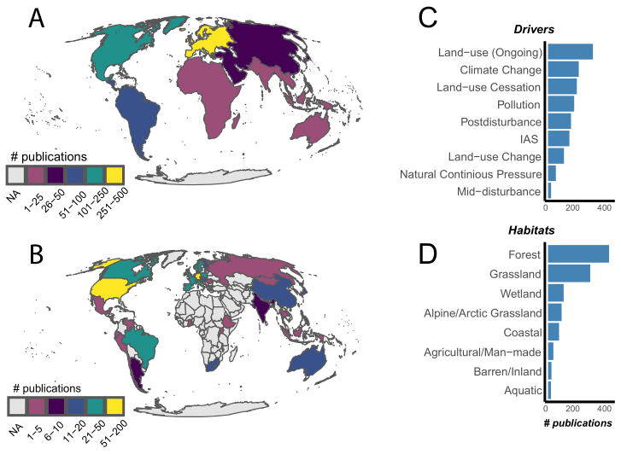

Figure 1: The distribution of studies across countries (A) and continents (B), the different drivers of change covered (C), and the distribution across habitats (D).

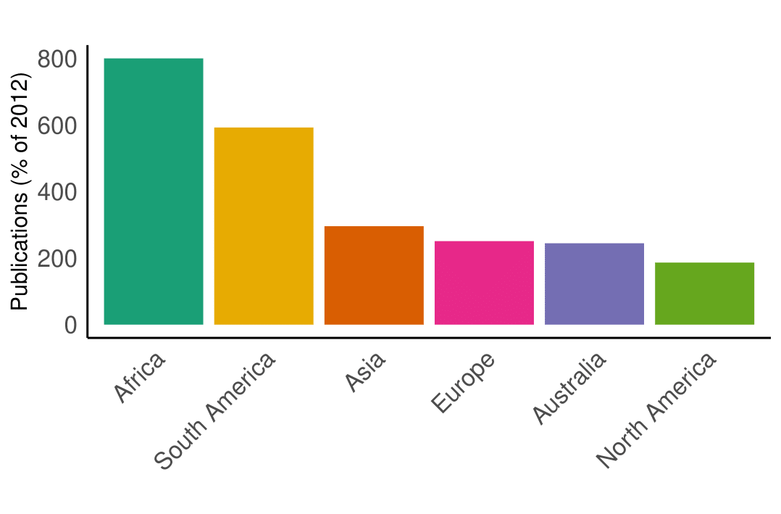

Figure 2: The increase in the numbers of published studies per geographic continents relative to the number of publications included in the meta-analysis of Vellend et al. (2013).

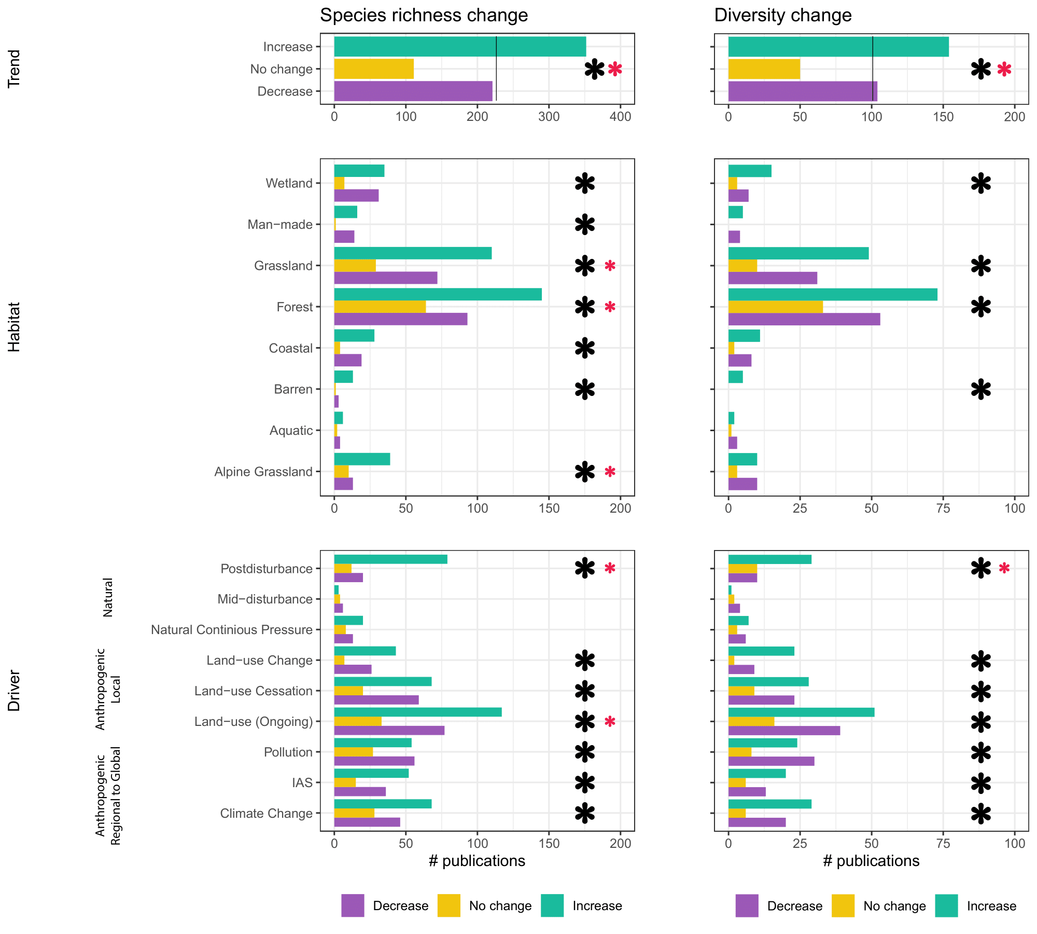

Figure 3: Reported changes in species richness (i.e. number of species recorded) and diversity (i.e. reported change in diversity indices) in 607 and 420 sub-studies, respectively. Shown is the overall trend across all studies, and the trends for different habitats and studied drivers (black asterisk: chi-squared test p < 0.05; red asterisk: chi-squared test p < 0.05 without no change variable, with bonferonni correction).

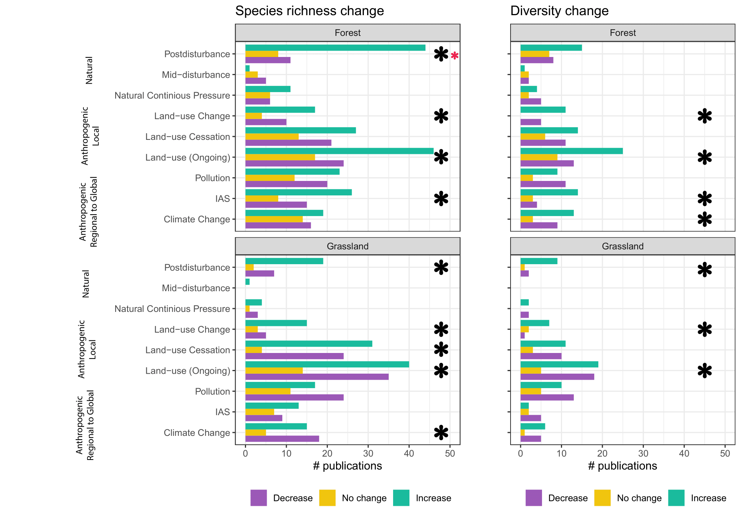

Figure 4: Reported changes in species richness (i.e. number of species recorded) and species diversity (i.e. reported change in diversity indices) in studies on forest (n = 384) and grassland habitats (n = 265). Shown is the overall trend across all studies, and the trends for different habitats and studied drivers (black asterisk: chi-squared test p < 0.05; red asterisk: chi-squared test p < 0.05 without no change variable, with bonferonni correction).

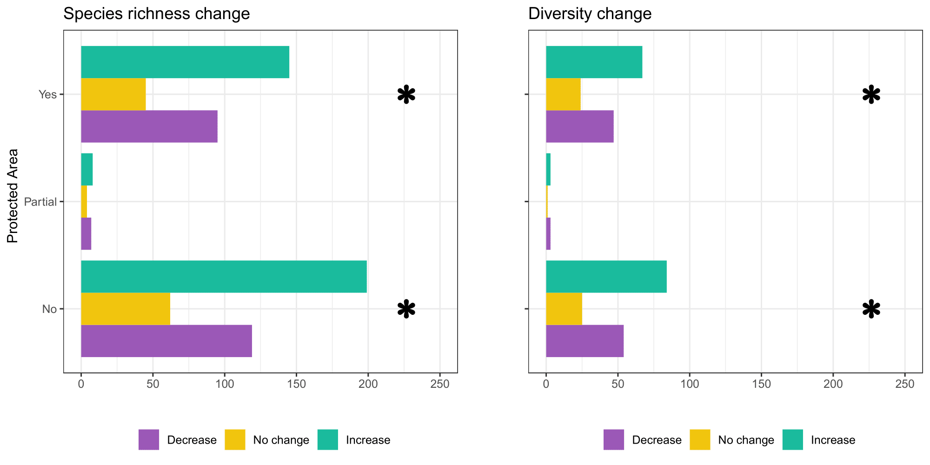

Figure 5: Reported changes in species richness (i.e. number of species recorded) and species diversity (i.e. reported change in diversity indices) in studies within (n = 370) and outside of designated protected areas (n = 470) (black asterisk: chi-squared test p < 0.05.

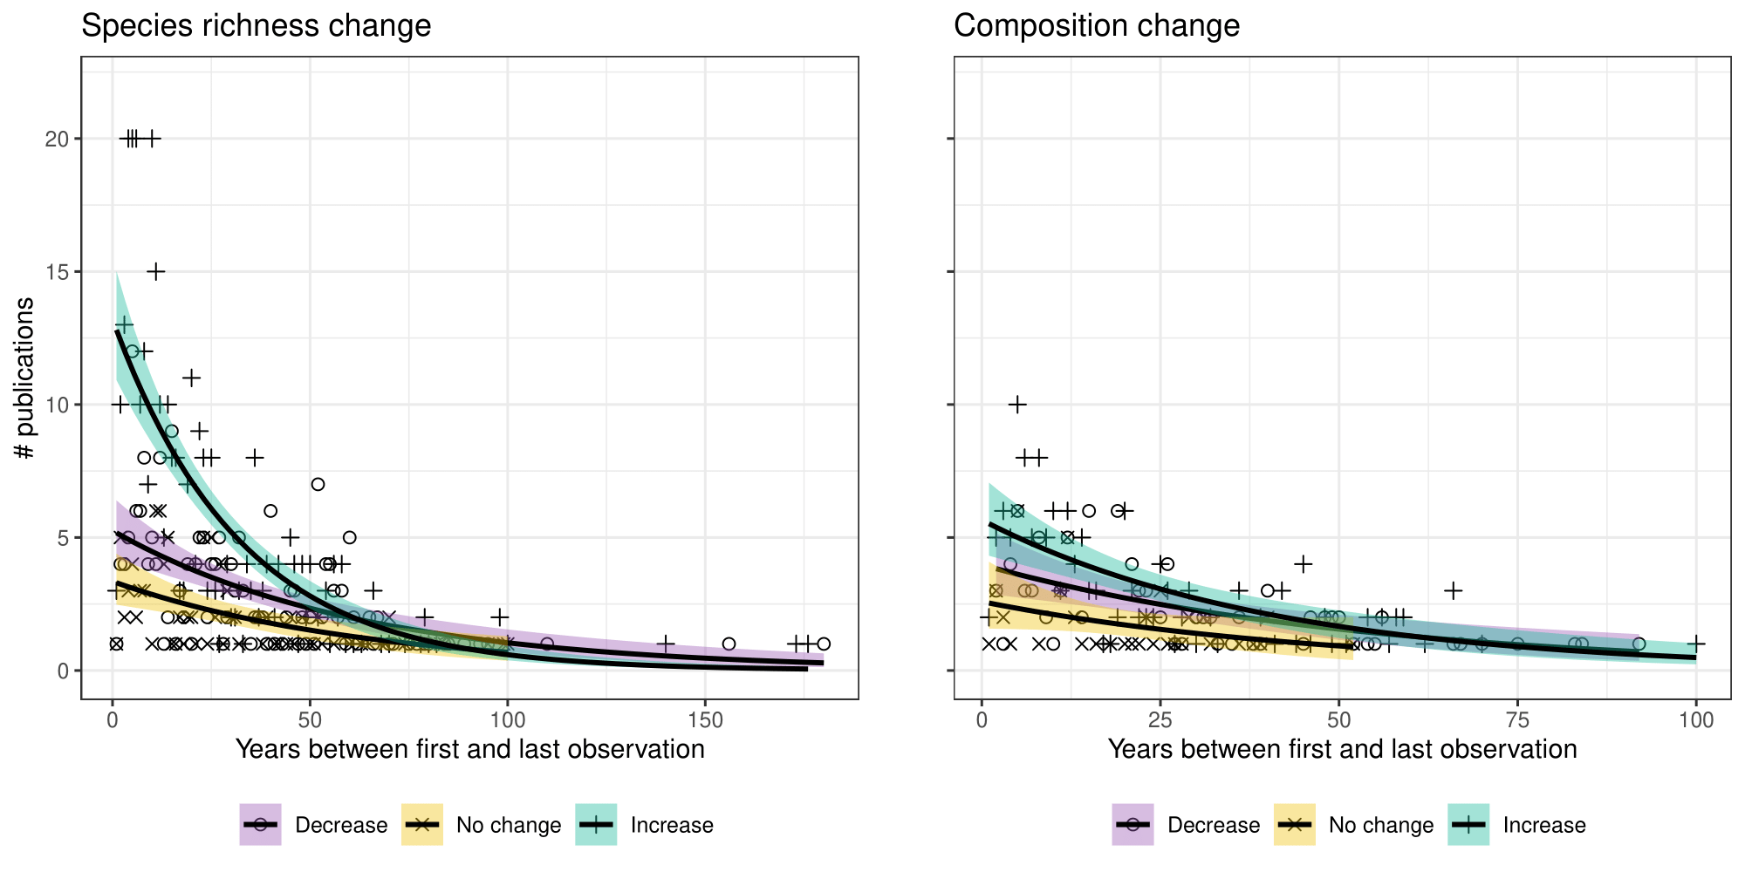

Figure 6: Reported changes in species richness (i.e. number of species recorded) and species diversity (i.e. reported change in diversity indices) in 684 and 308 sub-studies respectively, in relation to the length of the time span of the studies.