**Supporting Information**

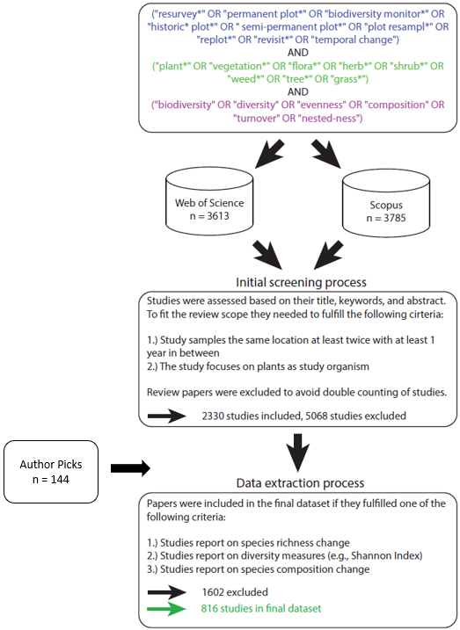

Figure S1: Workflow showing the major steps of the systematic review, including data collection, cleaning, and extraction. Search string coloration refers to the three domains keywords that were identified focusing on re-survey (blue), flora and vegetation (green), and diversity measures (violet).

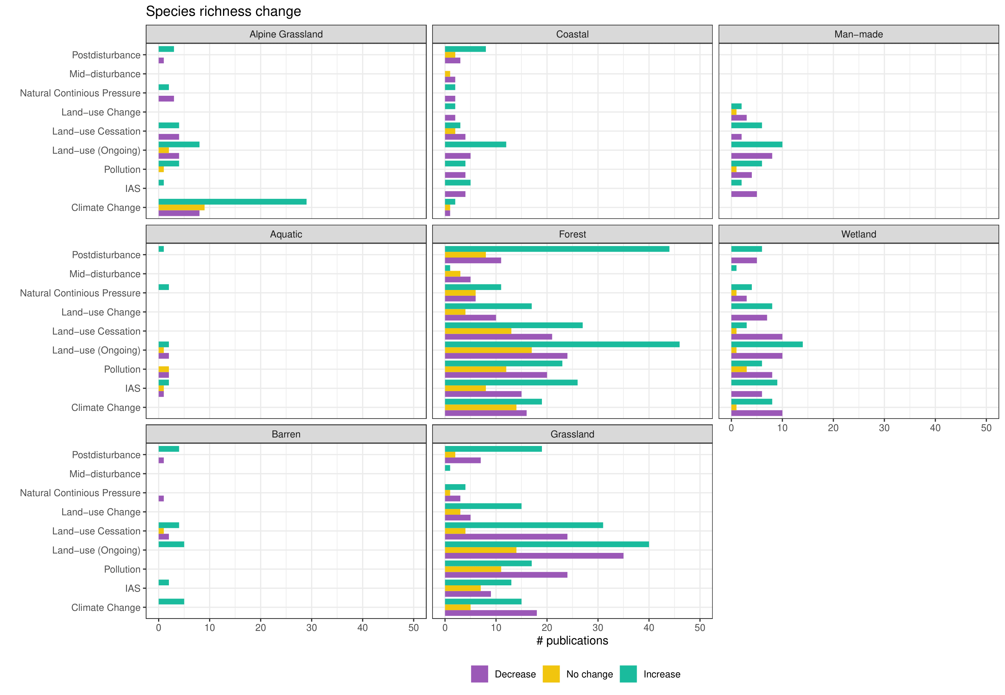

Figure S2: Interaction plots between all habitat and driver combinations for studies that reported species richness changes (n = 684).

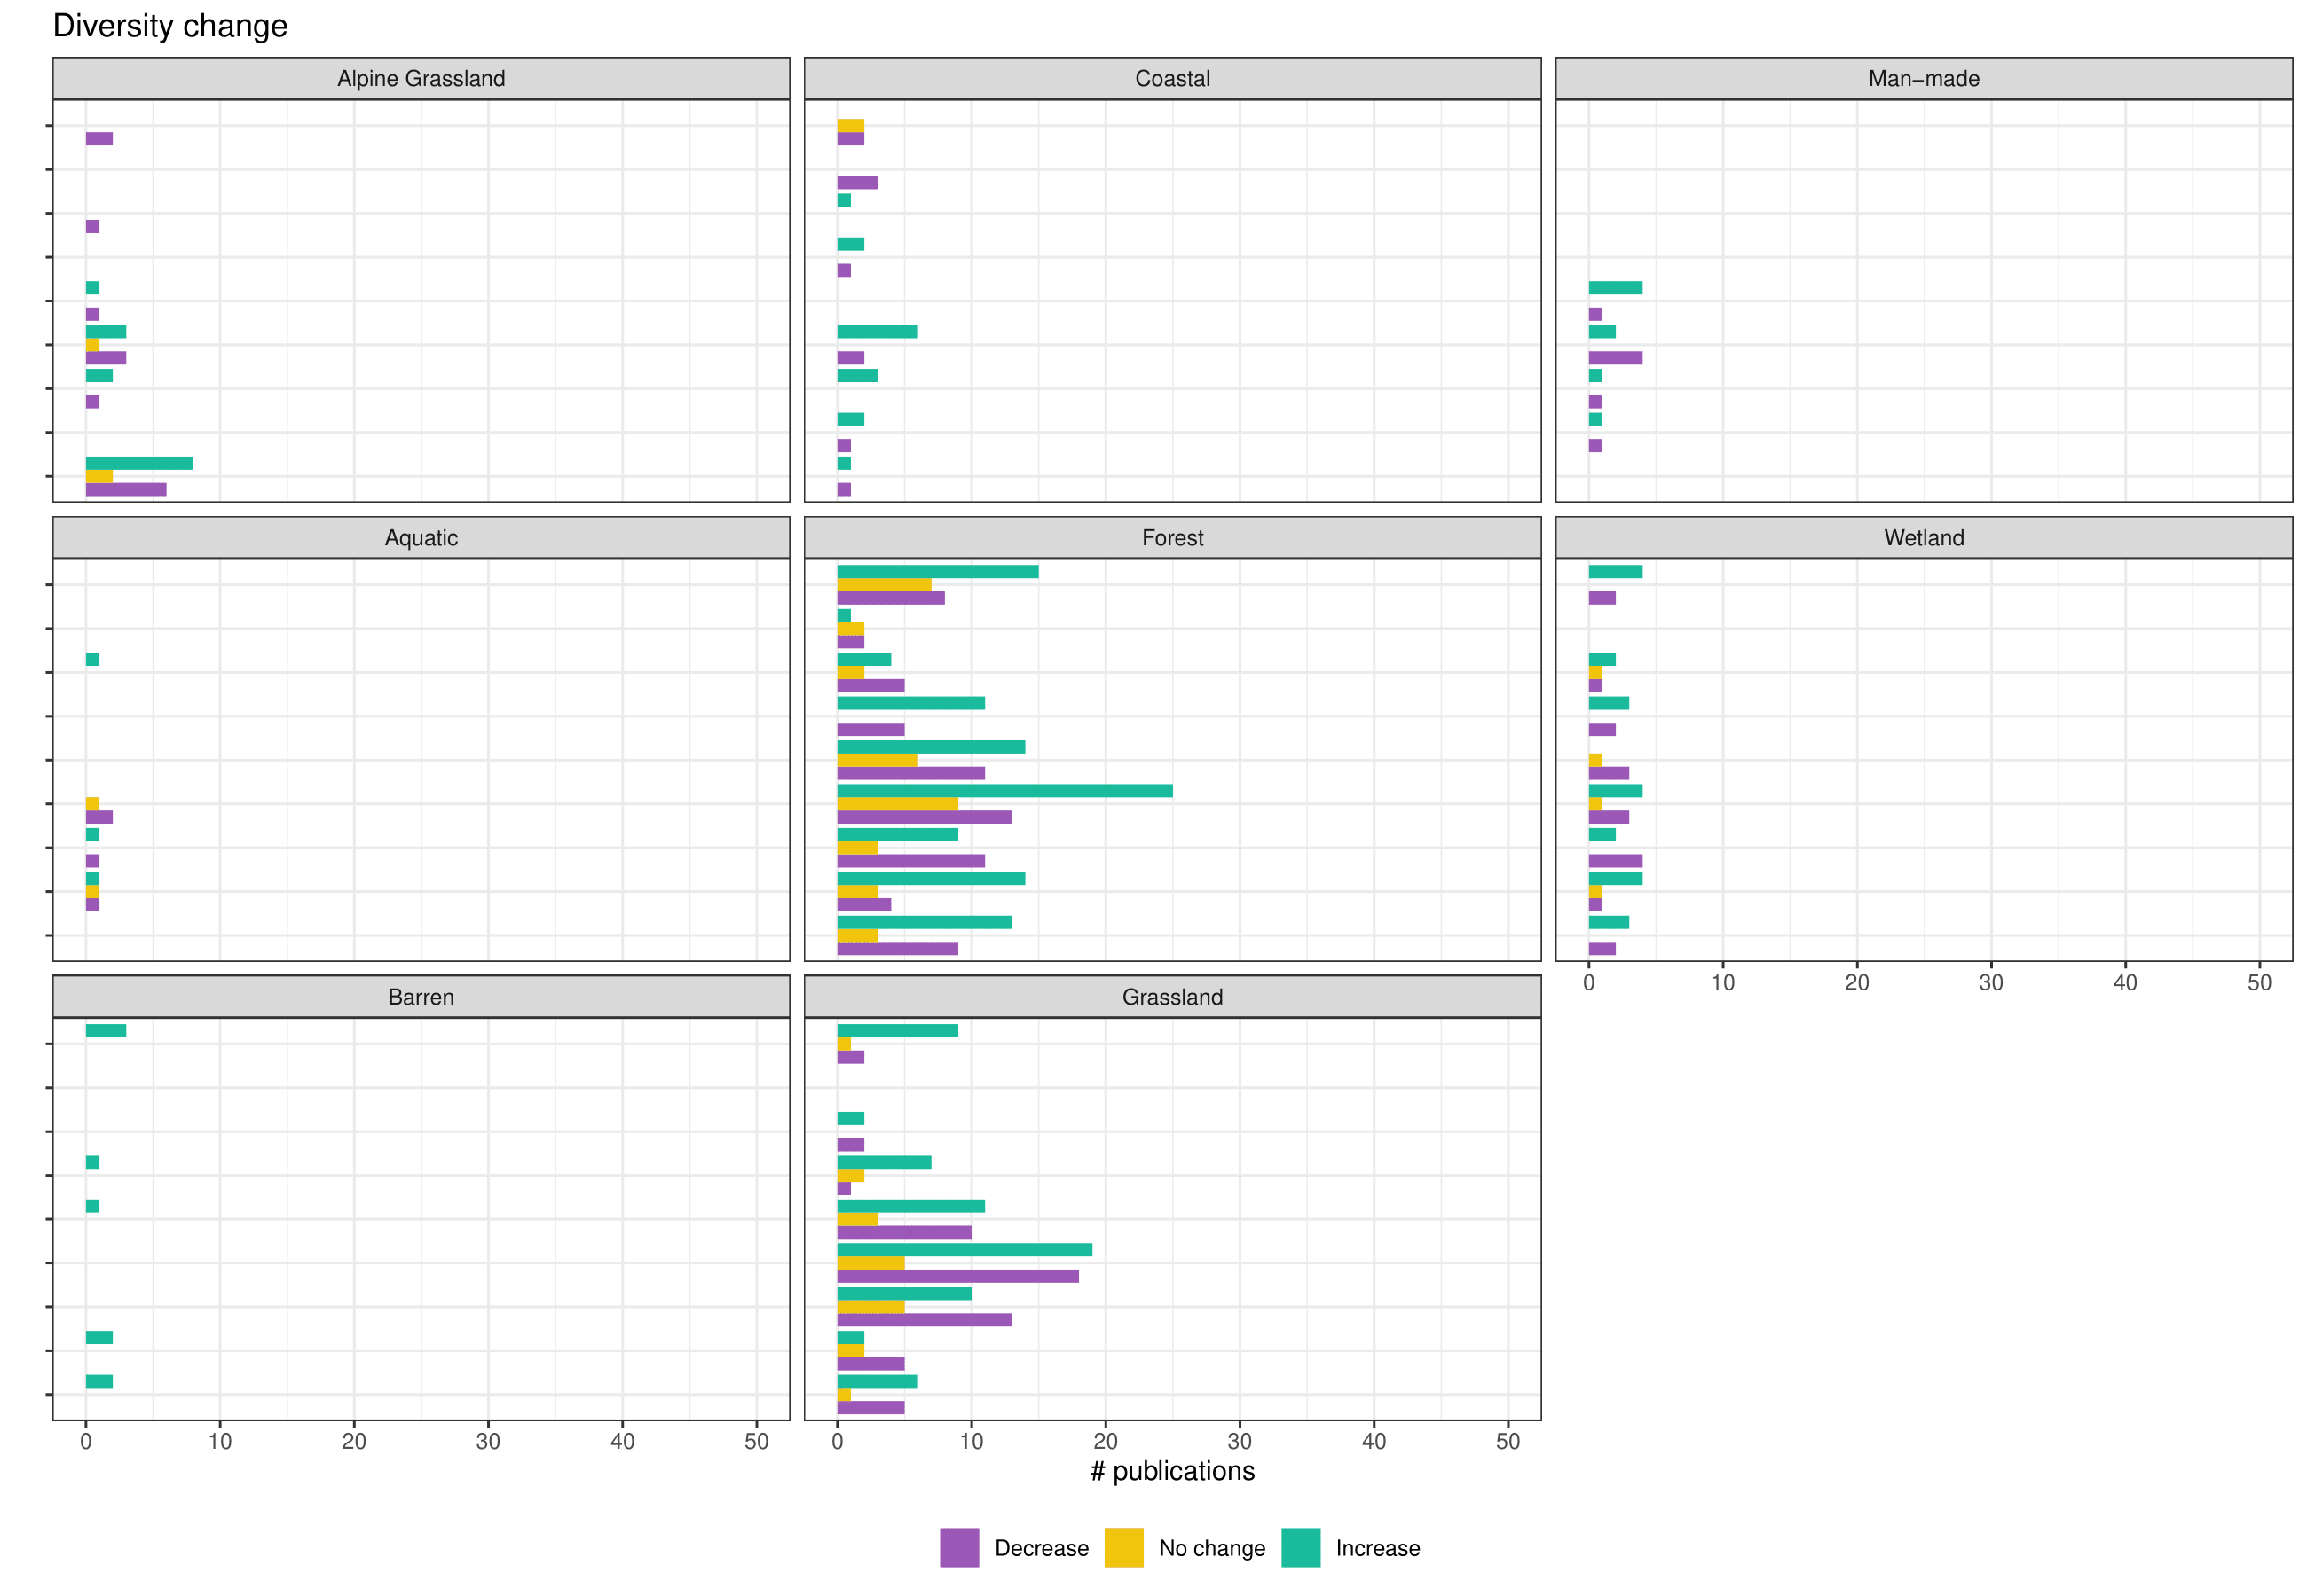

Figure S3: Interaction plots between all habitat and driver combinations for studies that reported species diversity changes (n = 308).

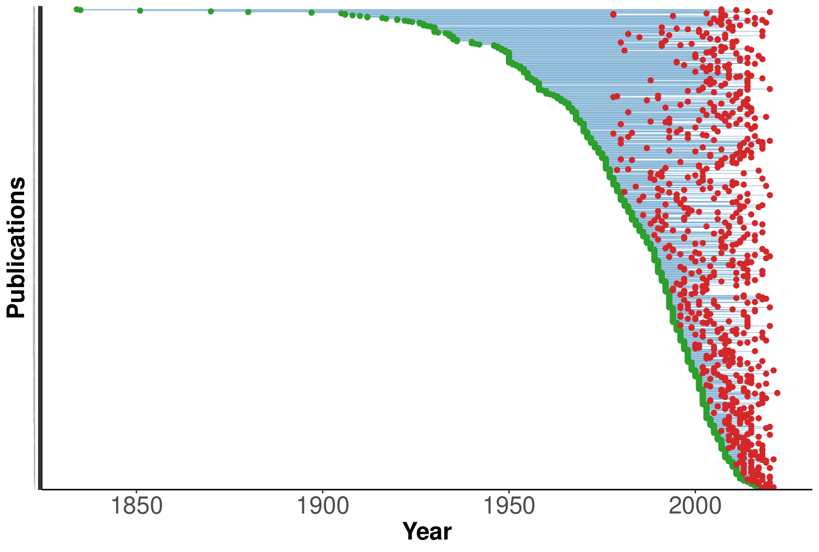Figure S4: Timespan between first and last surveys for all studies (n = 865) included in the literature review.

Table S1.A: The template used to extract relevant information from the 865 studies retained in the final data set. Shown are the categories, and short description of the rationale and content included.

|  |  |
| --- | --- |
| **Category** | **Description** |
| Ref_ID | Unique identifier for each study. The identifier consists of the name of the database (Web of Science = WoS, Scopus = SCO) and a number. |
|
| Habitat_I | Habitat classification for the study site based on the EUNIS classification by the European Environment Agency (EUNIS Terrestrial Habitat Classification 2021).  Link: https://www.eea.europa.eu/data-and-maps/data/eunis-habitat-classification-1  Categories are as follows: Aquatic = Aquatic habitats covered by water Coastal = Coastal habitats Grassland = Grasslands and lands dominated by forbs, mosses or lichens Alpine/Arctic Grasslands (Tundra) = Heathland, scrubs and tundra Forest = Forest and other wooded land Barren/Inland = Inland habitats with no or little soil mostly with sparse vegetation Man-made = Vegetated man-made habitats  Wetland = Mires, bogs and fens |
| Countries | Country where the study took place. When a study took place in several countries, each country was selected. |
| Locality | The local region of the study area. |
| Ecoregions | Assignment to ecoregions of localities (Dinerstein et al., 2017) |
| Taxonomic_Group | Identification of the taxonomic groups covered in the study. |
| Start_year | Year when the first survey/sampling was conducted. |
| End_year | Year when the last survey/sampling was conducted. |
| SSD | The drivers studied by a study based on IPBES (2019, <https://doi.org/10.5281/zenodo.6417333>). When several drives were studied, then each of these drivers was selected.  Refer to Table S1.B for further information |
|
|
|
|
|
|
|
| Conservation | Indication if the study area is located in a protected area. |
| No_of_Observations | Number of observations/surveys that are used by the study. |
| Plot_Size | Size of the sampling site/plot used in the study standardized to square meters. |
| No_of_Surveys | Number of surveys that have been conducted |
| Permanent_Plots | Indication if study plots are permanently marked |
| Experimental_Plots | Indication if study plots are experimentally manipulated |
| Diversity_Change_Direction (alpha) | Identifies if the study includes information on alpha diversity change over time. |
| Composition_Change (beta) | Reported direction of species composition change. |
| Diversity_Change_Ind (alpha) | Information on which indicators are used for reporting diversity change.   Multiple answers are possible |
| SR_Change_Direction | Indication of the direction of the reported species richness change. |
|
|
| Species_List_Available | Indicates if the publication provides the primary plant data used for analyses |
| Paper_Included | Indication if the study qualifies for the meta-analyses. |
| Publication Year | The year study was published. |
| Biogeographic Continent | Assignment to biogeographically defined continent based on the delineation of the Biodiversity Information Standards (TDWG) classification (Brummitt et al., 2001) |
| Geographic Continent | Assignment to geographically defined continent. |

Table S1.B: Descriptions of study system drivers which was utilized to categorize 865 sub-studies.

|  |  |
| --- | --- |
| **Name** | **Description** |
| Climate Change | Direct effects of long-term shift in weather patterns on biodiversity (including fluctuations in temperatures, precipitation, humidity, extreme weather events and more). Only recorded if the study specifically points out the direct effect of climate change on the resurvey plots. |
| IAS (Invasive Alien Species) | Living organisms that are non-native to an ecosystem, and which threaten native species and ecosystems. Any occurrence of invasive alien species found in the resurvey plots are recorded and native expansive species are not included. |
| Land-use (Ongoing) | Continuous utilization and management of land for specific human activities, such as agriculture, forestry, urban development, or industrial operations. This term encompasses the active processes and practices that maintain the land's current state and function, including cultivation, construction, resource extraction, and infrastructure maintenance. |
| Land-use Cessation | The discontinuation or significant reduction of human activities that modify the natural landscape, such as agriculture, forestry, urbanization, or industrial practices. This process typically results in the abandonment of previously managed or cultivated land, allowing natural processes to resume, often leading to ecological succession and the gradual restoration of native vegetation and wildlife habitats. |
| Land-use Change | Alteration or transformation of the natural landscape due to human activities, resulting in the modification of land cover and the ecological processes that occur on that land. This change can involve the conversion of natural ecosystems into agricultural fields, urban areas, industrial sites, or other forms of land use, as well as the intensification or modification of existing land uses. |
| Natural Continious Pressure | Any natural pressure or disturbance that continues throughout the first and last survey, most examples are due to natural herbivory pressure (such as deer grazing). |
| Mid-disturbance | Any natural disturbance event (just as in the case of postdisturbance category) that occured between the first and last survey. |
| Postdisturbance | Succession after any disturbance event that occured in the habitat which are caused by natural causes and not human activities. Some examples include wildfires, volcanic eruptions, hurricanes and floodings. This category is utilized when the natural disturbance occured before the first survey |
| Pollution | Direct effects of the pollutant release into the atmosphere, water, and land from human activities (urban, agricultural or industrial pollution) on biodiversity (such as atmospheric nitrogen deposition, heavy metals, coal deposition, fertilization and more). |

Table S2: Distribution of studies across geographic (A) and biogeographic continents of the Biodiversity Information Standards (TDWG) classification.

1. TDWG continents

|  |  |
| --- | --- |
| Europe | 469 |
| Africa | 23 |
| Asia-Temperate | 37 |
| Asia-Tropical | 30 |
| Australasia | 22 |
| Northern America | 206 |
| Southern America | 77 |

1. Geographic continents

|  |  |
| --- | --- |
| Africa | 23 |
| Americas | 283 |
| Asia | 67 |
| Europe | 469 |
| Oceania | 22 |

Table S3: Overview on th number of studies per country and the geographic continent the country belongs to. Also shown are the years of first and last survey in the country.

|  |  |  |  |  |  |
| --- | --- | --- | --- | --- | --- |
| **Countries** | **Continent** | **ISO_Code_3** | **Count** | **Min_Start_Year** | **Max_End_Year** |
| Argentina | Americas | ARG | 6 | 1968 | 2017 |
| Australia | Oceania | AUS | 15 | 1963 | 2016 |
| Austria | Europe | AUT | 16 | 1980 | 2019 |
| Belgium | Europe | BEL | 13 | 1953 | 2015 |
| Brazil | Americas | BRA | 42 | 1981 | 2019 |
| Burkina Faso | Africa | BFA | 1 | 1990 | 2013 |
| Canada | Americas | CAN | 25 | 1870 | 2022 |
| Central African Republic | Africa | CAF | 1 | 1982 | 2002 |
| Chile | Americas | CHL | 2 | 2000 | 2016 |
| China | Asia | CHN | 18 | 1955 | 2020 |
| Costa Rica | Americas | CRI | 3 | 1976 | 2015 |
| Croatia | Europe | HRV | 1 | 2007 | 2010 |
| Cuba | Americas | CUB | 1 | 2001 | 2003 |
| Czech Republic | Europe | CZE | 32 | 1926 | 2021 |
| Denmark | Europe | DNK | 7 | 1967 | 2016 |
| Ecuador | Americas | ECU | 2 | 1880 | 2020 |
| Estonia | Europe | EST | 5 | 1954 | 2018 |
| Ethiopia | Africa | ETH | 2 | 2000 | 2021 |
| Finland | Europe | FIN | 15 | 1933 | 2019 |
| France | Europe | FRA | 25 | 1948 | 2019 |
| French Guiana | Americas | GUF | 1 | 1984 | 2016 |
| Georgia | Asia | GEO | 1 | 2001 | 2008 |
| Germany | Europe | DEU | 58 | 1936 | 2020 |
| Ghana | Africa | GHA | 2 | 1968 | 2020 |
| Gibraltar | Europe | GIB | 1 | 1991 | 1995 |
| Greece | Europe | GRC | 1 | 2001 | 2008 |
| Greenland | Americas | GRL | 1 | 1968 | 2007 |
| Hungary | Europe | HUN | 18 | 1942 | 2020 |
| Iceland | Europe | ISL | 1 | 1990 | 2013 |
| India | Asia | IND | 6 | 1992 | 2018 |
| Indonesia | Asia | IDN | 5 | 1930 | 2015 |
| Ireland | Europe | IRL | 2 | 1961 | 1998 |
| Israel | Asia | ISR | 2 | 1990 | 1997 |
| Italy | Europe | ITA | 23 | 1930 | 2020 |
| Jamaica | Americas | JAM | 2 | 1974 | 2014 |
| Japan | Asia | JPN | 12 | 1956 | 2014 |
| Kenya | Africa | KEN | 1 | 1977 | 2017 |
| Kyrgyzstan | Asia | KGZ | 1 | 1973 | 2015 |
| Latvia | Europe | LVA | 1 | 1912 | 2011 |
| Luxembourg | Europe | LUX | 2 | 2005 | 2007 |
| Mexico | Americas | MEX | 2 | 1991 | 2016 |
| Mongolia | Asia | MNG | 3 | 1966 | 2010 |
| Nepal | Asia | NPL | 5 | 1950 | 2014 |
| Netherlands | Europe | NLD | 28 | 1950 | 2018 |
| New Zealand | Oceania | NZL | 7 | 1969 | 2020 |
| Nicaragua | Americas | NIC | 2 | 1999 | 2002 |
| Norway | Europe | NOR | 22 | 1924 | 2015 |
| Panama | Americas | PAN | 1 | 1999 | 2012 |
| Peru | Americas | PER | 3 | 2009 | 2017 |
| Philippines | Asia | PHL | 3 | 1994 | 2013 |
| Poland | Europe | POL | 25 | 1920 | 2020 |
| Portugal | Europe | PRT | 1 | 2003 | 2008 |
| Puerto Rico | Americas | PRI | 4 | 1989 | 2010 |
| Réunion | Africa | REU | 1 | 1995 | 2011 |
| Romania | Europe | ROU | 2 | 2004 | 2021 |
| Russian Federation | Europe | RUS | 3 | 1927 | 2016 |
| Serbia | Europe | SRB | 1 | 1998 | 2010 |
| Seychelles | Africa | SYC | 1 | 1985 | 1998 |
| Singapore | Asia | SGP | 1 | 2011 | 2015 |
| Slovakia | Europe | SVK | 13 | 1949 | 2015 |
| Slovenia | Europe | SVN | 8 | 1939 | 2019 |
| South Africa | Africa | ZAF | 11 | 1946 | 2019 |
| South Korea | Asia | KOR | 4 | 1995 | 2020 |
| Spain | Europe | ESP | 23 | 1962 | 2020 |
| Sri Lanka | Asia | LKA | 1 | 1978 | 2018 |
| Sweden | Europe | SWE | 28 | 1897 | 2019 |
| Switzerland | Europe | CHE | 36 | 1835 | 2020 |
| Thailand | Asia | THA | 3 | 2002 | 2018 |
| Uganda | Africa | UGA | 3 | 1958 | 2006 |
| Ukraine | Europe | UKR | 1 | 1934 | 2006 |
| United Kingdom | Europe | GBR | 50 | 1930 | 2018 |
| United States | Americas | USA | 178 | 1827 | 2020 |
| Uruguay | Americas | URY | 1 | 1995 | 1999 |
| Venezuela | Americas | VEN | 2 | 1965 | 2012 |

Table S4: Analysis results related to studies on species richness change. (A) Chi² test results to test distribution of reported trends against the net-zero change assumption (i.e., equal proportion of studies reporting increases, no change, or decrease in species richness. (B) Chi² test results to test change in the reported trends across habitats against the equal distribution. (C) Chi² test results to test change in the reported trends across drivers against the equal distribution. (D) Chi² test results to test change in the reported trends across forest habitat x driver combinations against the equal distribution. (E) Chi² test results to test change in the reported trends across grassland habitat x driver combinations against the equal distribution. (F) Chi² test results to test change in the reported trends across studies within and outside protected areas against the equal distribution.

|  |  |  |  |
| --- | --- | --- | --- |
| (A) |  |  |  |
|  | **X.squared** | **df** | **p.value** |
| ***Species richness change*** | ***127.69*** | ***2*** | ***< 0.001*** |
|  |  |  |  |
| (B) |  |  |  |
| **Habitat** | **X.squared** | **p.value** |  |
| ***Alpine/Arctic*** | ***24.6*** | ***0.0005*** |  |
| Aquatic | 2 | 0.425 |  |
| ***Barren/Inland*** | ***14.6*** | ***0.0005*** |  |
| ***Coastal*** | ***16.4*** | ***0.0005*** |  |
| ***Forest*** | ***34.2*** | ***0.0005*** |  |
| ***Grassland*** | ***46.7*** | ***0.0005*** |  |
| ***Man-made*** | ***12.8*** | ***0.0030*** |  |
| ***Wetland*** | ***18.8*** | ***0.0005*** |  |
|  |  |  |  |
| (C) |  |  |  |
| **Driver** | **X.squared** | **p.value** |  |
| ***Climate Change*** | ***17.0*** | ***0.0005*** |  |
| ***IAS*** | ***20.1*** | ***0.0010*** |  |
| ***Land-use (Ongoing)*** | ***46.7*** | ***0.0005*** |  |
| ***Land-use Cessation*** | ***26.6*** | ***0.0005*** |  |
| ***Land-use Change*** | ***25.6*** | ***0.0005*** |  |
| Mid-disturbance | 1.08 | 0.695 |  |
| Natural Continious Pressure | 5.32 | 0.0765 |  |
| ***Pollution*** | ***11.5*** | ***0.0055*** |  |
| ***Postdisturbance*** | ***72.4*** | ***0.0005*** |  |
|  |  |  |  |
|  |  |  |  |
|  |  |  |  |
| (D) |  |  |  |
| **Driver** | **Habitat** | **X.squared** | **p.value** |
| Climate Change | Forest | 0.776 | 0.709 |
| ***IAS*** | ***Forest*** | ***10.1*** | ***0.00600*** |
| ***Land-use (Ongoing)*** | ***Forest*** | ***15.8*** | ***0.00150*** |
| Land-use Cessation | Forest | 4.85 | 0.100 |
| ***Land-use Change*** | ***Forest*** | ***8.19*** | ***0.0240*** |
| Mid-disturbance | Forest | 2.67 | 0.316 |
| Natural Continious Pressure | Forest | 2.17 | 0.374 |
| Pollution | *Forest* | 3.53 | 0.200 |
| ***Postdisturbance*** | ***Forest*** | ***38*** | ***0.000500*** |
|  |  |  |  |
| (E) |  |  |  |
| **Driver** | **Habitat** | **X.squared** | **p.value** |
| ***Climate Change*** | ***Grassland*** | ***7.32*** | ***0.0235*** |
| IAS | Grassland | 1.93 | 0.430 |
| ***Land-use (Ongoing)*** | ***Grassland*** | ***12.8*** | ***0.002*** |
| ***Land-use Cessation*** | ***Grassland*** | ***20.0*** | ***0.0005*** |
| ***Land-use Change*** | ***Grassland*** | ***10.8*** | ***0.006*** |
| Mid-disturbance | Grassland | 2 | 1 |
| Natural Continious Pressure | Grassland | 1.75 | 0.554 |
| Pollution | Grassland | 4.88 | 0.095 |
| **Postdisturbance** | **Grassland** | **16.4** | **0.0005** |
|  |  |  |  |
| (F) |  |  |  |
| **Protected area** | **X.squared** | **p.value** |  |
| ***Yes*** | ***52.63*** | ***0.0005*** |  |
| ***No*** | ***20.126*** | ***0.0005*** |  |

Table S5: Analysis results related to studies on species composition change. (A) Chi² test results to test distribution of reported trends against the net-zero change assumption (i.e., equal proportion of studies reporting increases, no change, or decrease in species richness. (B) Chi² test results to test change in the reported trends across habitats against the equal distribution. (C) Chi² test results to test change in the reported trends across drivers against the equal distribution. (D) Chi² test results to test change in the reported trends across forest habitat x driver combinations against the equal distribution. (E) Chi² test results to test change in the reported trends across grassland habitat x driver combinations against the equal distribution. (F Chi² test results to test change in the reported trends across studies within and outside protected areas against the equal distribution.

|  |  |  |  |
| --- | --- | --- | --- |
| (A) |  |  |  |
|  | **X.squared** | **df** | **p.value** |
| ***Diversity change*** | ***52.70*** | ***2*** | ***< 0.001*** |
|  |  |  |  |
| (B) |  |  |  |
| **Habitat** | **X.squared** | **p.value** |  |
| Alpine/Arctic | 4.26 | 0.144 |  |
| Aquatic | 1 | 0.892 |  |
| ***Barren/Inland*** | ***10*** | ***0.0135*** |  |
| Coastal | 6 | 0.0555 |  |
| ***Forest*** | ***15.1*** | ***0.00100*** |  |
| ***Grassland*** | ***25.4*** | ***0.000500*** |  |
| Man-made | 4.67 | 0.171 |  |
| ***Wetland*** | ***8.96*** | ***0.0125*** |  |
|  |  |  |  |
| (C) |  |  |  |
| **Driver** | **X.squared** | **p.value** |  |
| Climate Change | 1.65 | 0.249 |  |
| IAS | 1.48 | 0.302 |  |
| Land-use (Ongoing) | 1.6 | 0.249 |  |
| Land-use Cessation | 0.490 | 0.593 |  |
| ***Land-use Change*** | ***6.12*** | ***0.0230*** |  |
| Mid-disturbance | 1.8 | 0.375 |  |
| Natural Continious Pressure | 0.0769 | 1 |  |
| Pollution | 0.667 | 0.502 |  |
| ***Postdisturbance*** | ***9.26*** | ***0.00150*** |  |
|  |  |  |  |
| (D) |  |  |  |
| **Driver** | **Habitat** | **X.squared** | **p.value** |
| ***Climate Change*** | ***Forest*** | ***6.08*** | ***0.0455*** |
| ***IAS*** | ***Forest*** | ***10.6*** | ***0.00850*** |
| ***Land-use (Ongoing)*** | ***Forest*** | ***8.85*** | ***0.0155*** |
| Land-use Cessation | Forest | 3.16 | 0.226 |
| ***Land-use Change*** | ***Forest*** | ***11.4*** | ***0.00400*** |
| Mid-disturbance | Forest | 0.4 | 1 |
| Natural Continious Pressure | Forest | 1.27 | 0.653 |
| Pollution | Forest | 4.52 | 0.105 |
| Postdisturbance | Forest | 3.8 | 0.185 |
|  |  |  |  |
| (E) |  |  |  |
| **Driver** | **Habitat** | **X.squared** | **p.value** |
| Climate Change | Grassland | 3.5 | 0.272 |
| IAS | Grassland | 2 | 0.529 |
| ***Land-use (Ongoing)*** | ***Grassland*** | ***8.71*** | ***0.0155*** |
| Land-use Cessation | Grassland | 4.75 | 0.115 |
| ***Land-use Change*** | ***Grassland*** | ***6.2*** | ***0.0510*** |
| Natural Continious Pressure | Grassland | 2 | 0.560 |
| Pollution | Grassland | 3.5 | 0.188 |
| ***Postdisturbance*** | ***Grassland*** | ***9.5*** | ***0.0135*** |
|  |  |  |  |
| (F) |  |  |  |
| **Protected areas** | **X.squared** | **p.value** |  |
| Yes | 3.5 | 0.072 |  |
| ***No*** | ***6.5*** | ***0.01*** |  |

Table S6: Distribution of studies across ecoregions (Dinerstein et al., 2017). A total of 628 studies could be located sufficiently to assign them to ecoregions.

|  |  |  |
| --- | --- | --- |
| **Ecoregions** | **# publications** | **% publications** |
| Temperate Broadleaf & Mixed Forests | 446 | 50.2 |
| Temperate Conifer Forests | 117 | 13.2 |
| Tropical & Subtropical Moist Broadleaf Forests | 63 | 7.0 |
| Mediterranean Forests, Woodlands & Scrub | 56 | 6.3 |
| Temperate Grasslands, Savannas & Shrubland | 55 | 6.2 |
| Boreal Forests/Taiga | 38 | 4.3 |
| Tropical & Subtropical Grasslands, Savannas & Shrubland | 27 | 3.1 |
| Tundra | 26 | 2.9 |
| Deserts & Xeric Shrublands | 21 | 2.5 |
| Tropical & Subtropical Dry Broadleaf Forests | 17 | 1.9 |
| Montane Grasslands & Shrublands | 15 | 1.6 |
| Mangroves | 4 | 0.5 |
| Flooded Grasslands & Savannas | 2 | 0.2 |
| Tropical & Subtropical Coniferous Forests | 1 | 0.1 |