Ekkaphume prasert

643040546-2

Web:<https://www.behance.net/>

1. This website has a pleasing arrangement of all the elements.

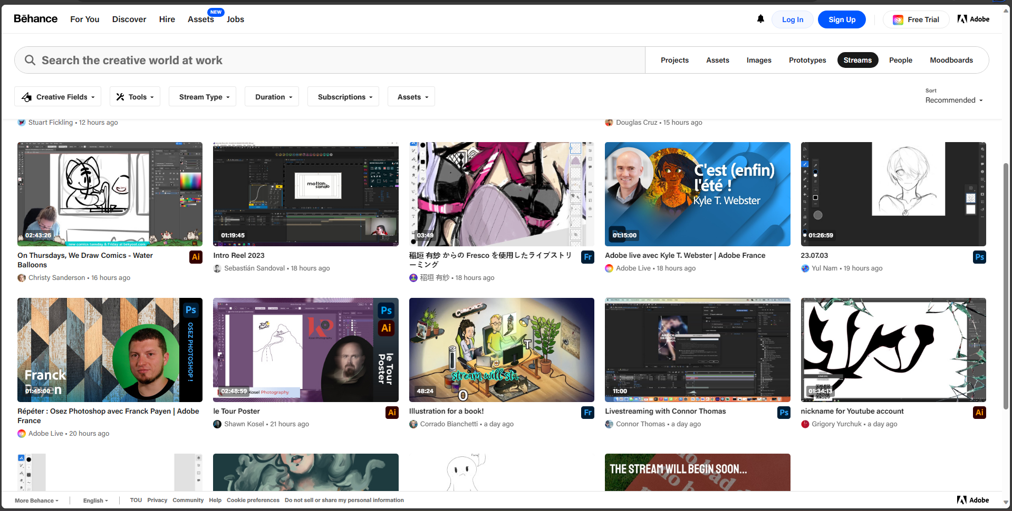

1. They put every tool and function bar on the navigation bar.

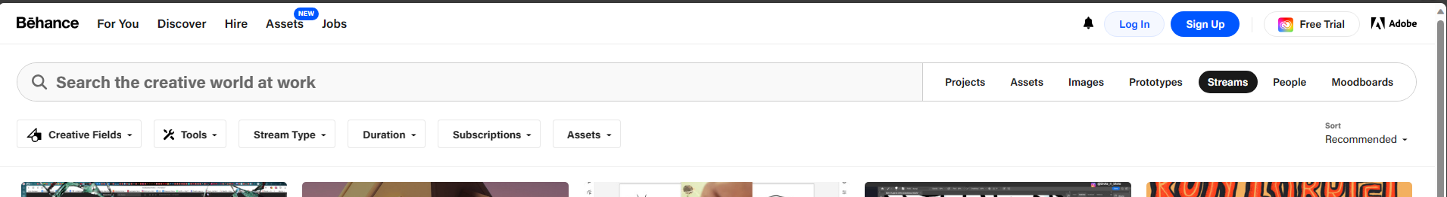

This enhances the user experience on the website.

1. The website boasts an impressive loading speed, allowing users to access its content swiftly and ensuring a seamless browsing experience.
2. The thoughtful selection of color schemes and spacing elements contributes to excellent visual clarity, making it effortless for users to navigate and engage with the website

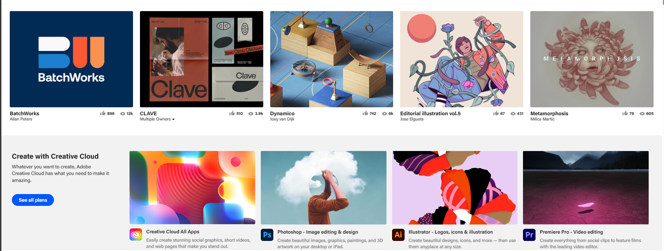

1. The website is meticulously categorized, providing a comprehensive and easily understandable structure that enables users to navigate through a vast array of content effortlessly.

