Ekkaphume Prasert 643040546-2

Website : [Dom Pérignon is vintage only (domperignon.com)](https://www.domperignon.com/)

1. This website shows artistic work. It could be more colorful to show visual art for users

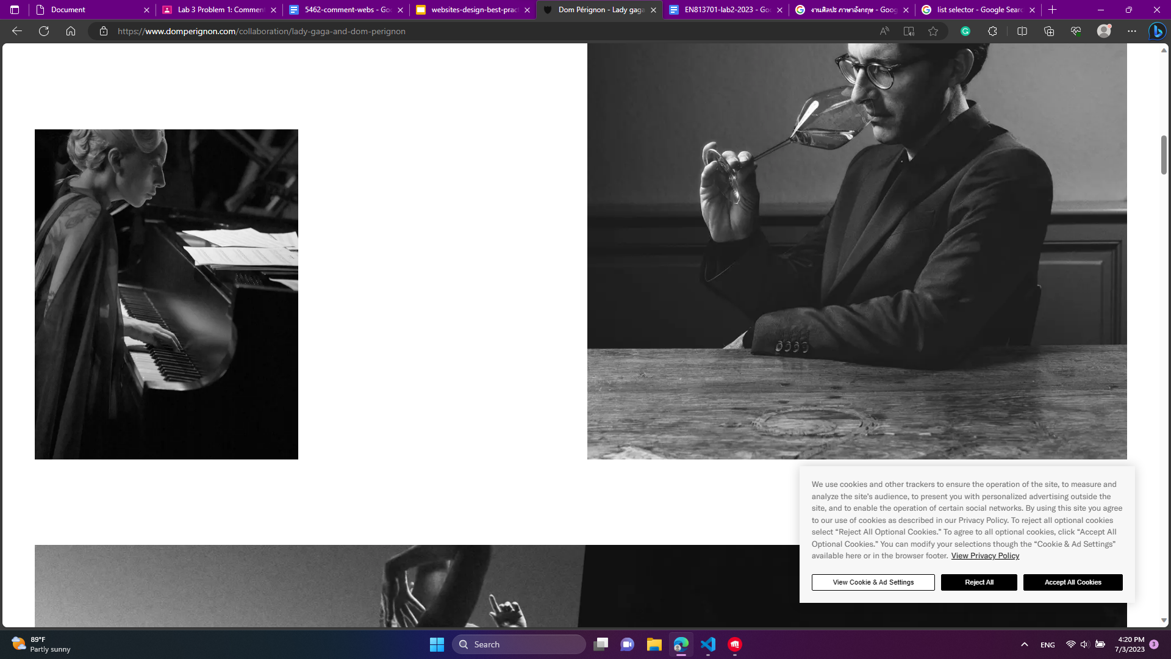

1. The space for entering our birth year is too large on the homepage.

They can do like down drop1999 for easier using the webpage

1. Many gaps between images are wide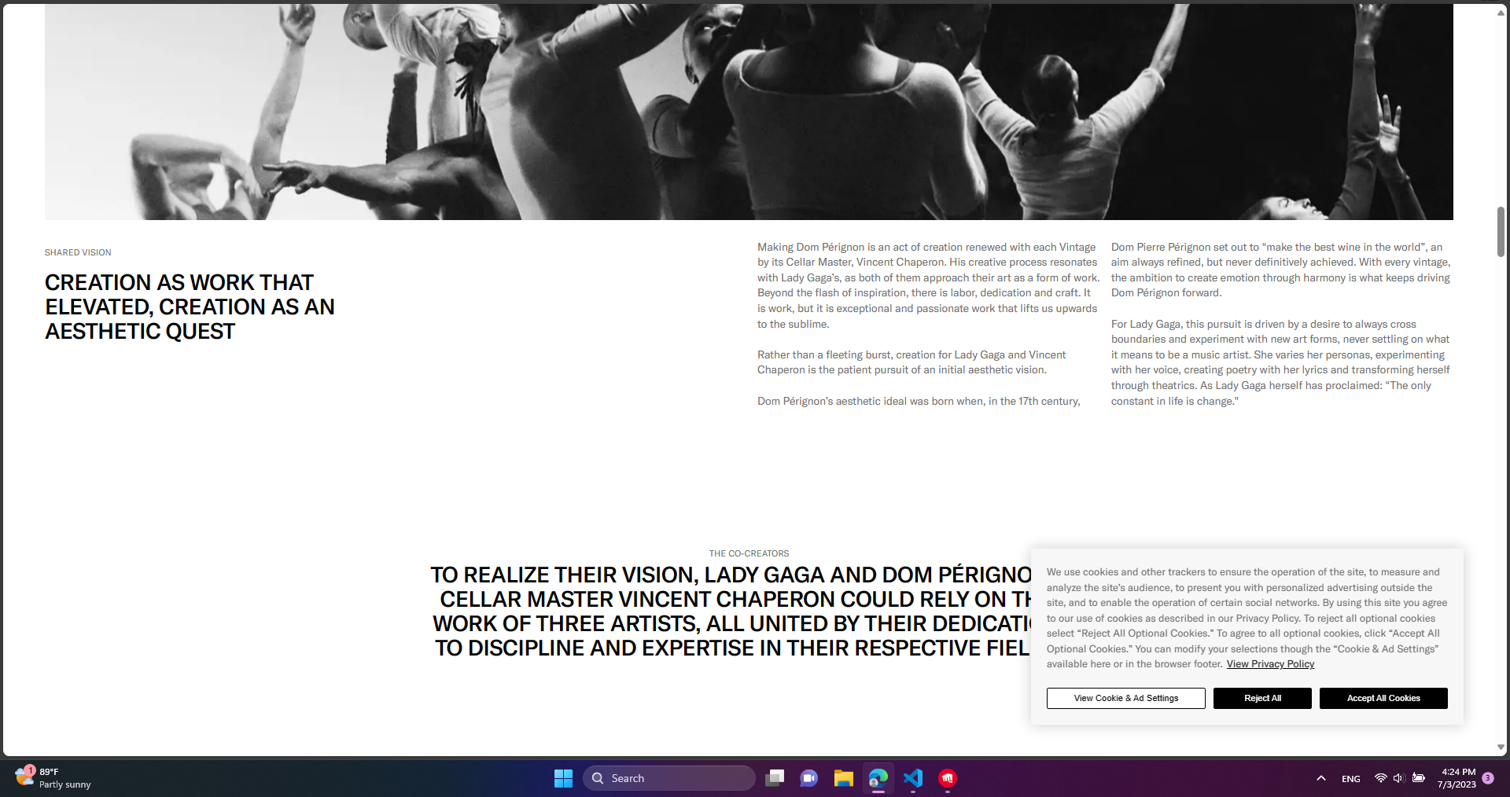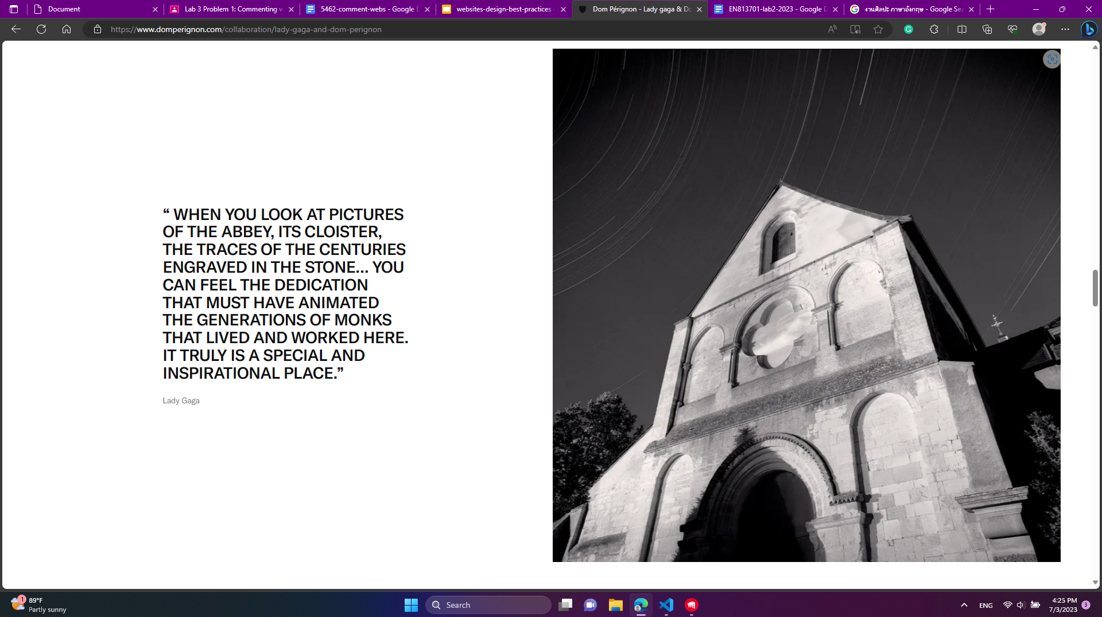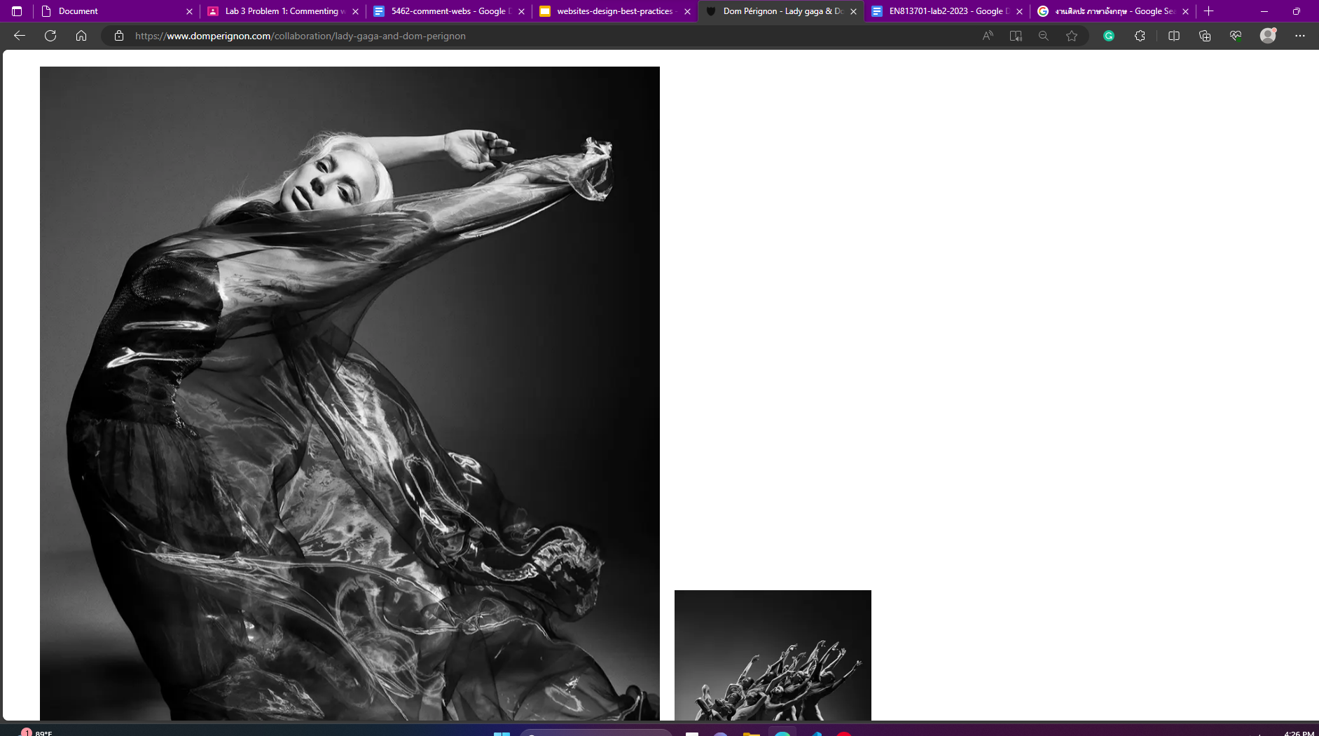
2. All text is upper-character makes it more difficult for a user to read

