**RGG Null Model Graphs**

* Blues

Average Clustering Coefficient: 0.4627823333108821

Average Shortest Path: 3.2282472255704726

* + RGG Null Model

Clustering mean: 0.627781062482125

Clustering standard deviation: 0.006196241687672166

Shortest path length mean: 5.385805873919828

Shortest path length standard deviation: 0.0926639309928226

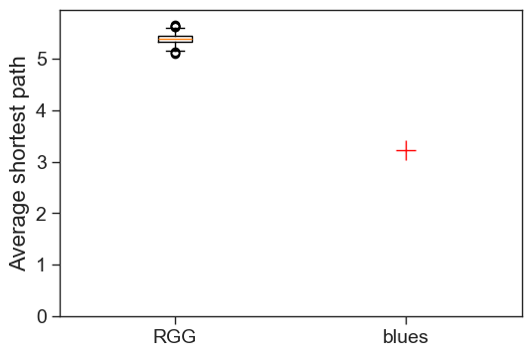

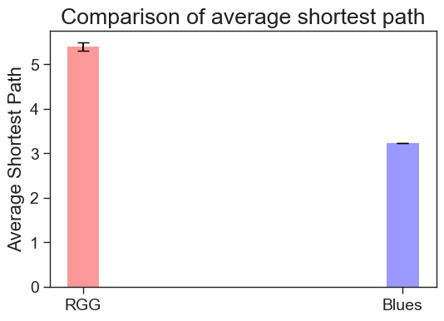

* Classical

Average Clustering Coefficient: 0.45931960915241926

Average Shortest Path: 3.396951123683797

* + RGG Null Model

Clustering mean: 0.6270625241500833

Clustering standard deviation: 0.006155847441761408

Shortest path length mean: 5.466928779999229

Shortest path length standard deviation: 0.09121516240350593

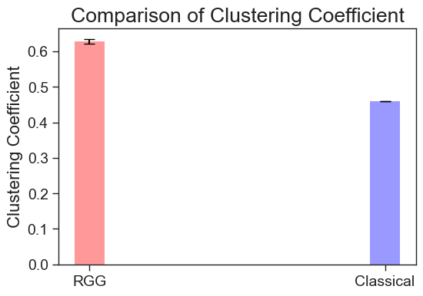

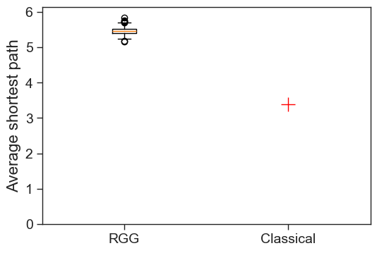

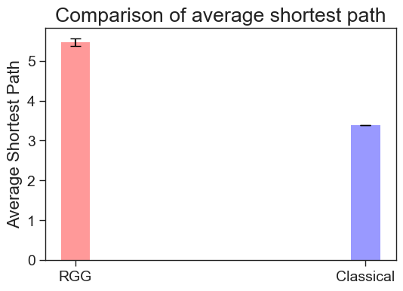

* Country

Average Clustering Coefficient: 0.47067879400894647

Average Shortest Path: 3.376511110615157

* + RGG Null model

Clustering mean: 0.6259609497152872

Clustering standard deviation: 0.0061323500605900624

Shortest path length mean: 5.655690023881501

Shortest path length standard deviation: 0.0905625041389638

* Disco

Average Clustering Coefficient: 0.45671636104030194

Average Shortest Path: 3.2329841525651357

* + RGG Null model

Clustering mean: 0.6260544939047268

Clustering standard deviation: 0.006005192392628449

Shortest path length mean: 5.6021754833227115

Shortest path length standard deviation: 0.09414011161517402

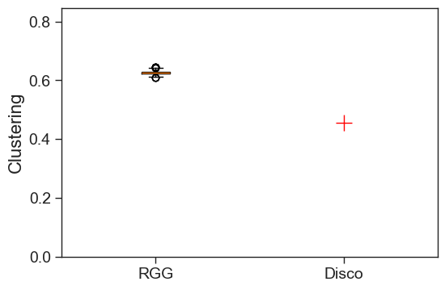

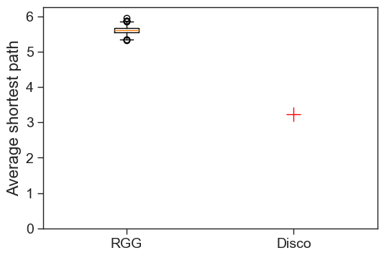

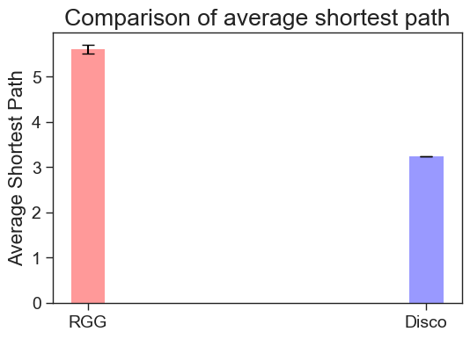

* Hiphop

Average Clustering Coefficient: 0.46409454574976355

Average Shortest Path: 3.2927905551967944

* + RGG Null model

Clustering mean: 0.6275216233302672

Clustering standard deviation: 0.0060419519645763505

Shortest path length mean: 5.430971014492754

Shortest path length standard deviation: 0.09109105026634512

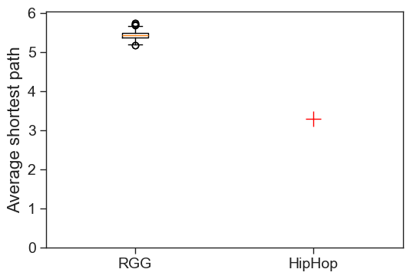

* Jazz

Average Clustering Coefficient: 0.4567310065098232

Average Shortest Path: 3.1312535973293425

* + RGG Null model

* Metal

Average Clustering Coefficient: 0.4530100087996576

Average Shortest Path: 3.1631335282651074

* + RGG Null model

* Pop

Average Clustering Coefficient: 0.47674961107296676

Average Shortest Path: 3.3320958083832335

* + RGG Null model

* Reggae

Average Clustering Coefficient: 0.46990968772089314

Average Shortest Path: 3.3256098330651014

* + RGG Null model

* Rock

Average Clustering Coefficient: 0.4359610497692023

Average Shortest Path: 3.455956950402649

* + RGG Null model

