Game Design Document

Fill up the Following document

1. Write the title of your project.

The Knight Runner

1. What is the goal of the game?

The goal of the Game is to fight against monsters and collect treasure .

1. Write a brief story of your game?

In this game there are many monsters who try to kill the knight (hero), and Knight has to defeat them and has to reach to the end and collect treasure .

1. Which are the playing characters of this game?

* Playing characters are the ones which respond to the user based on the input from the user
* Cars, monkeys, dinos, wizards etc, are the playing characters in the game.

|  |  |  |
| --- | --- | --- |
| Number | Character Name | What can this character do? |
| 1 | The Knight (Hero) | He can kill monsters by throwing fireballs . |
| 2 |  |  |
| 3 |  |  |
| 4 |  |  |
| 5 |  |  |
| 6 |  |  |
| 7 |  |  |
| 8 |  |  |

1. Which are the Non Playing Characters of this game?

* Non Playing characters are the ones which don't have an action or a behaviour when the user interacts with the game.
* Hurdles, stones, bananas, coins, etc are non playing characters in the game.

|  |  |  |
| --- | --- | --- |
| Number | Character Name | What can this character do? |
| 1 | Enemy1 | This character comes from ground and can kill the Knight. |
| 2 | Enemy2 | This character comes flying and tries to kill the Knight . |
| 3 |  |  |
| 4 |  |  |
| 5 |  |  |
| 6 |  |  |
| 7 |  |  |
| 8 |  |  |

Draw your imagination of this game. What does this game look like?

* Draw the game either on your computer or on paper,
* Add images of scenes of the game to show each of the playing and non-playing characters at least once.

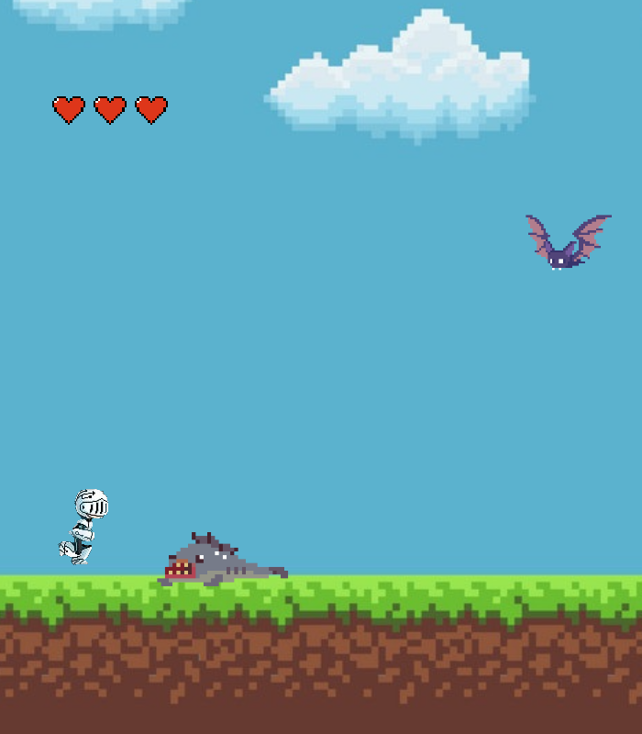

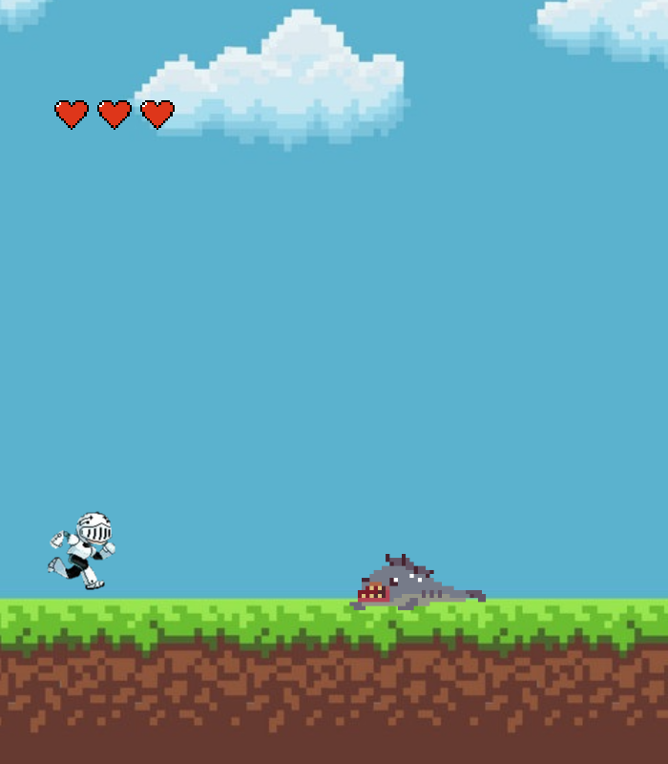

How do you plan to make your game engaging?

In my Game there are 3 lives (Hearts) given to the Hero , and if he touches the monster he loses his 1 heart and so on. I had also put some lucky blocks , If the player jumps and collect s the block the will stop coming to attack him for 10 seconds .