TeamName : Undone Team Mobile / Tablet computer POS System Date: 16 / 9 / 2013
Plan for <Iteration> Page 1

Mobile / Tablet computer POS System
Iteration Plan for The Inventory System

1.Milestones

Milestone | Description, Criteria, and Work Products
Detail of Implements the Inventory System | Design the diagram(UML) which relate to inventory system use cases. Analyze the performance of the feature in interaction diagram. Important feature will be implemented first for example add item.

2.Iteration Objectives
UC1 : Add Item to Inventory System
First, a customer touch on add button. Next, he must add products by type products’ details for example name, ID, quantity, and price. After that customer touch on confirm button.

UC2 : Remove Item to Inventory System
A customer open the inventory site in the application, touch on the item that will be removed, confirm box will immediately appear. The customer confirms remove the item, Item is removed from the inventory system.

UC3 : Edit Item to Inventory System
A customer opens the inventory site in the application, touch on the item that will be edited, the selected item in the inventory will be separate by color. The customer touch on the edit button, edit site to show up. The customer edits inventory item detail and touch save to save new details of the item. The inventory item is updated.

UC4 : Searching the Inventory System
When a customer need to find item. He can search it by keying product’s ID or products’ name in a searching bar. Then the inventory will search a product. When the inventory finish searched, product will be showed.

Domain model

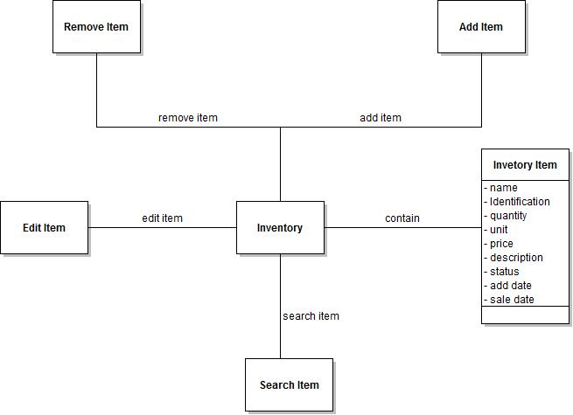

3.Tasks
Design classes component for iteration. First will base on UC1 - UC3 which relate to
UC1 : Add Item to Inventory System , UC2 : Remove Item to Inventory System ,
UC3 : Edit Item to Inventory System. Implement first part of the system. Update design classes component for UC4 and start iteration for UC4. Create wiki page , document and plan for next iteration.

Task Table

Task | Assigned to
Detailed  Design of inventory component classes  (UC1 - UC3) | Suwijak Chaipipat  Eknarin Thirayothin
Detailed
Design of inventory component classes (UC4)

Design  Review of Inventory system component classes | Team
Implement
UC1 : Add Item to Inventory System
UC2 : Remove Item to Inventory System
UC3 : Edit Item to Inventory System

Implement
UC4 : Searching the Inventory System

Detailed
Update design of inventory component classes (UC4)

Address
Add more document to wiki page

Create  Plan for next iteration | Eknarin Thirayothin

4.Issues
Design what user interface of this POS application should be.

5.Evaluation Criteria
- Application can add item to inventory system.
- Application can edit item to inventory system.
- Application can remove item to inventory system.
- Application can search for item to inventory system.

6.System Tests
The test that the inventory system should have. They are added / removed / edited of the inventory system.We test this system by add just few items in inventory and then remove some item out and add another item and choose one item to edit.

