# Lab: Linux and Linux Shell

Lab for the "Containers and Clouds" course @ SoftUni

## Configure Connectivity of the VM

The first step is to open the link – <https://labs.play-with-docker.com/>. 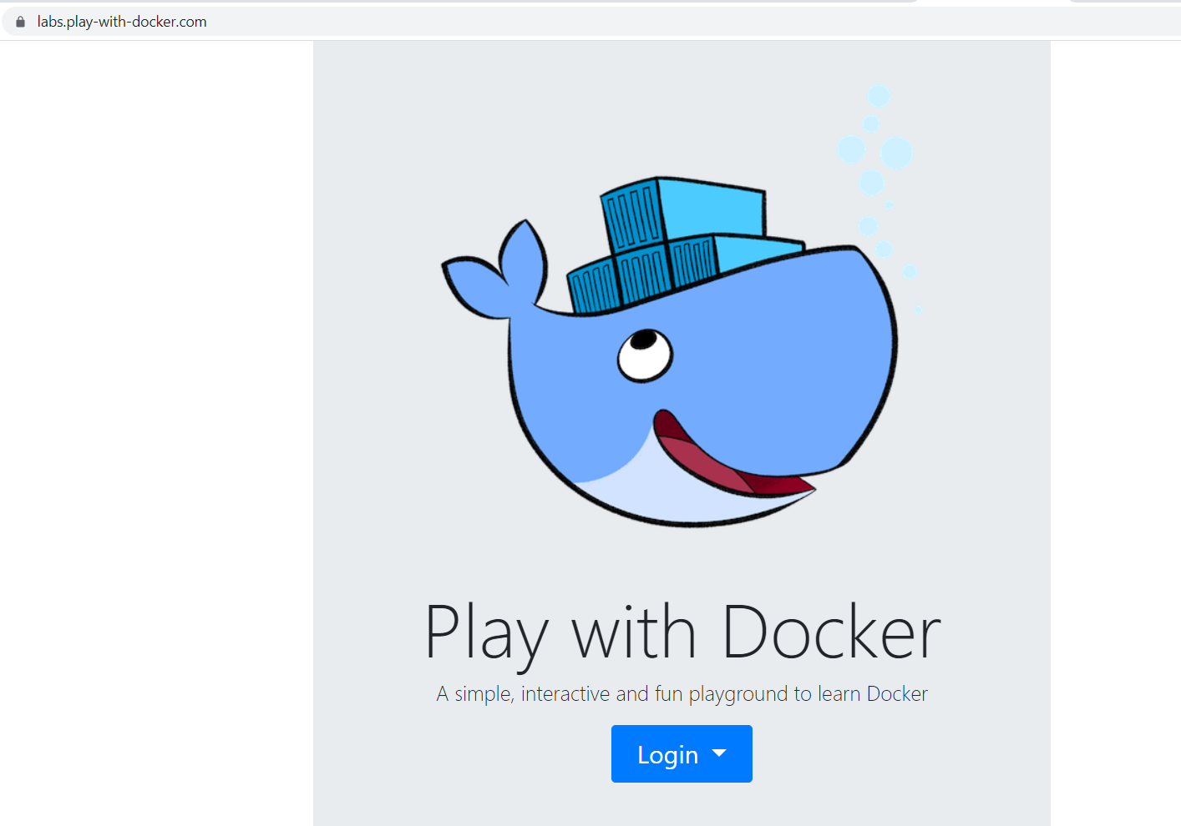

Then press the **[Login]** button and click on "**docker**". A new dialog box opens, which is for **docker registration**. If you don't have a registration click on **[Sign Up]**. You have to create an account with a username, password and email. Then sign in to your account. It takes you to a page to select the plan you want – click on "**Continue to Free**" (Personal plan). Log in to the email you registered with and **confirm your account**. You may need to reload the page until you see this:

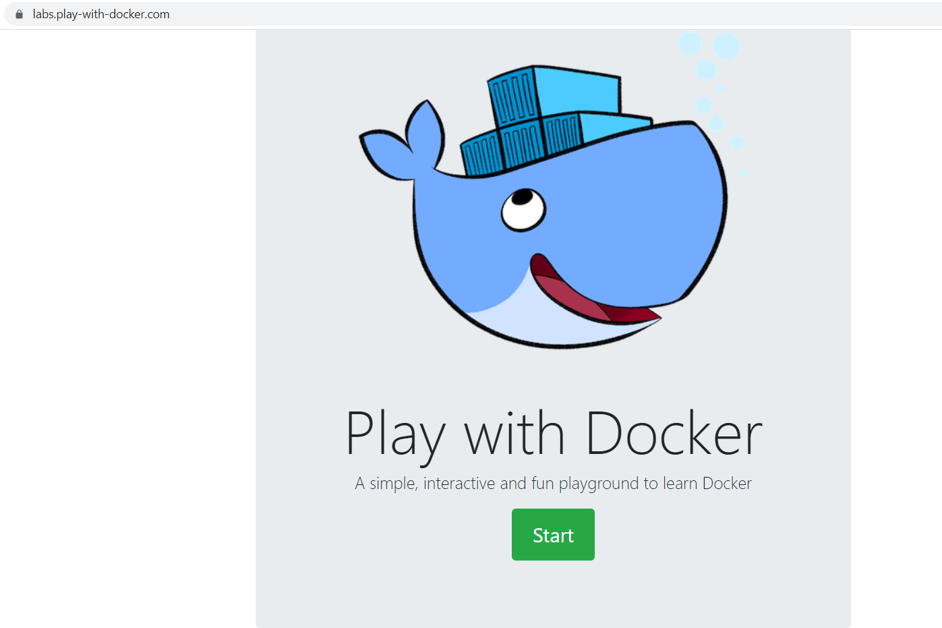

Click on the **[Start]** button.

Картина, която съдържа текст

Описанието е генерирано автоматично

You should see this. Click on **[+ add new instance]**.

Картина, която съдържа текст

Описанието е генерирано автоматично

We are ready for work!

## Getting to Know Environment Variables

Let's start with the **environment exploration process**. Try out the set command and look at its result:



↓

Картина, която съдържа текст

Описанието е генерирано автоматично

When executed **without parameters**, set returns **information about the environment** – **variables** and **functions**. Again, the information will differ from distribution to distribution and between versions of distribution.

We added | less to the set command to **display the command output**, **one page at a time**. It is **optional**, but it's a good idea to use it when the **output is longer**. You can go to the **next pages** with [Enter] or **quit** with [q].

The set command can be used to **modify the parameters** that are driving the environment. In order to see what **parameters** are there, we can execute:

Картина, която съдържа текст

Описанието е генерирано автоматично

We can **see the same information** but prepared for **re-use** with:

Картина, която съдържа текст

Описанието е генерирано автоматично

Let's **change the flag** that **controls the amount of information** shown during commands execution:

Картина, която съдържа текст

Описанието е генерирано автоматично

You should note that the minus ("-") is used to **turn on a flag**, while the plus ("+") is used to **deactivate a flag**. Now, we can execute few more commands:

Картина, която съдържа текст

Описанието е генерирано автоматично

Картина, която съдържа маса

Описанието е генерирано автоматично

We can see that immediately **after each command** there is **information aboutse what is going to be executed**. This way we can see that instead ls, in fact something else is being executed – its **alias** or the statement it specifies.

It is time to **deactivate** the xtrace **mode**:

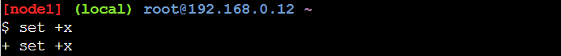

Now you will not be able to see what commands are executed.

## Getting Help

Now it is time to explore ways of **getting help** about different commands.

For the **shell built-in commands**, we can use the **help** command. If we execute it **without parameters**, it will return **all built-in commands**:



↓

Картина, която съдържа текст

Описанието е генерирано автоматично

In order to **ask for a command**, we must execute it like:



↓

Картина, която съдържа текст

Описанието е генерирано автоматично

Most **external commands** offer integrated help. The ways to **ask for this information** vary, but typically we can use:

Картина, която съдържа текст

Описанието е генерирано автоматично

When using man, it is good to know the following **set of keys**:

* Key [h]shows **help information**
* Key [q] either **exits the help mode** or **the man**
* If we want to **search for something** from the current cursor position onwards, then we can press[/], then enter the string and then press the [Enter] key. Once in this mode, we can press [n]key to **move forward** over the matches, or the[N] key to **move backward**
* Searching backwards works the same, but it is initiated with the[?] key

A **quick search** in man can be done on the command line with:

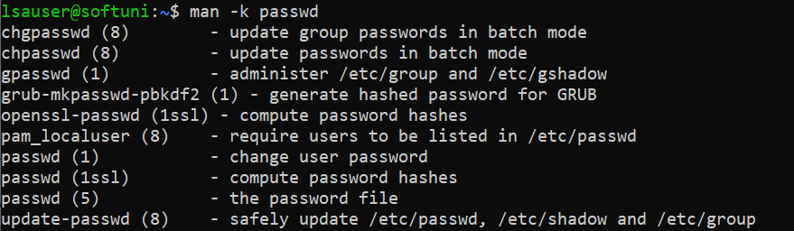

Similar effect can be achieved by using the apropos command:

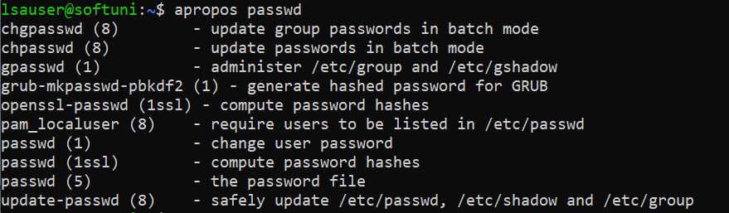

Beside man, usually there is an alternative and modern help system available – info. We can use it the same way:



↓

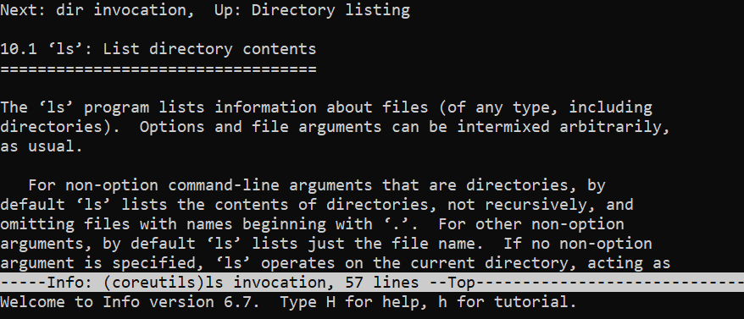

For **help** inside the tool, we can press the [h] key. The help screen can be **closed** with the [x] key. No matter where we are in the tool, we can **exit** with the [q] key.