CONTROL CHECK AI
UI/UX & Frontend Design Specification
Version 0.1 — Mockup-Aligned Product Design Baseline
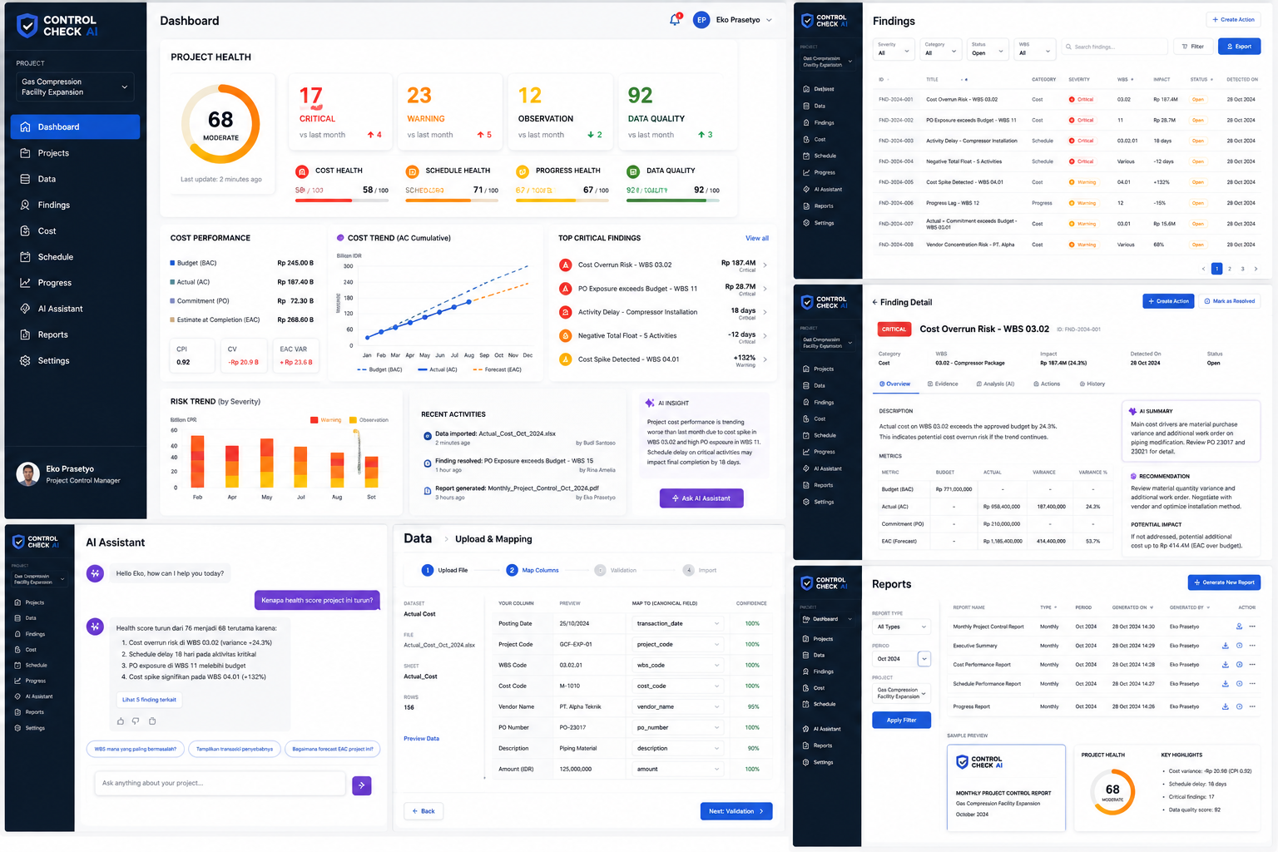
Approved visual reference for the ControlCheck AI web application.

Product | ControlCheck AI
Document | UI/UX & Frontend Design Specification
Version | 0.1
Reference | Approved application mockup
Purpose | Implementation baseline for React frontend and design QA

1. Purpose and Design Intent
This document converts the approved ControlCheck AI mockup into an implementation specification. The objective is to ensure that the production web application preserves the same visual hierarchy, information density, navigation model, dashboard composition, enterprise tone, and interaction patterns shown in the mockup.
- Desktop-first enterprise SaaS interface with responsive behavior for laptop and tablet widths.
- Dark navy navigation rail combined with a bright white/gray workspace.
- Data-dense but calm layout: important findings are visually prioritized without making every element look critical.
- Project-control language must dominate the UI: project health, cost, schedule, progress, evidence, findings, actions, reports.
- AI is positioned as an evidence-based assistant, not as the primary interface.

2. Non-Negotiable Design Principles
ID | Principle | Requirement
P1 | Evidence before explanation | Every risk/finding must have traceable evidence and underlying records.
P2 | Executive clarity | Dashboard must be understandable within 10 seconds by a Project Manager.
P3 | Professional density | Use compact tables/cards, not oversized consumer-style components.
P4 | Severity consistency | Critical, Warning and Observation colors behave consistently across all pages.
P5 | One project context | Current project selector remains visible in the navigation/header context.
P6 | Actionable findings | Every material finding can lead to evidence review, AI analysis, action creation or resolution.
P7 | No decorative AI | AI-generated output must be grounded in findings/evidence and clearly distinguish reasoning from calculated metrics.

3. Visual Design System

3.1 Color Tokens
Token | Hex | Usage
navy-950 | #07192D | Main sidebar / dark navigation
navy-900 | #0F2742 | Dark panels / selected context
blue-600 | #1769E8 | Primary action / active nav
blue-500 | #2B79F7 | Links / secondary blue
slate-900 | #111827 | Primary text
slate-600 | #667085 | Secondary text
slate-200 | #E5E7EB | Borders/dividers
slate-50 | #F8FAFC | Workspace background
critical | #EF4444 | Critical finding / severe cost risk
warning | #F59E0B | Warning / schedule risk
observation | #EAB308 | Observation / moderate risk
success | #2E8B57 | Good data quality / positive delta
ai | #7C3AED | AI assistant / reasoning accents

3.2 Typography
Role | Specification | Usage
Page title | Aptos/Inter Semibold 20–24 px | Dashboard, Findings, Reports
Section title | Semibold 14–16 px | Card and panel headings
Body | Regular 13–14 px | Descriptions, AI narrative
Table | Regular/Medium 12–13 px | Dense enterprise tables
KPI | Semibold/Bold 24–36 px | Health score, counts, key values
Microcopy | Regular 11–12 px | Timestamps, hints, confidence, metadata

3.3 Geometry and Surfaces
- Card radius: 10–14 px. Avoid excessive pill-shaped containers.
- Card border: 1 px neutral slate; shadow must be subtle and optional.
- Workspace grid: 12-column desktop grid; 20–24 px page padding; 16–20 px inter-card gaps.
- Sidebar width: approximately 220–240 px desktop; collapsible to icon rail at narrower widths.
- Primary buttons: blue. AI actions: purple. Destructive actions: red only where necessary.

4. Application Shell and Information Architecture
Order | Navigation item | Purpose
1 | Dashboard | Project health and executive overview
2 | Projects | Project portfolio and project creation
3 | Data | Uploads, mapping, validation, imports
4 | Findings | Central risk/finding register
5 | Cost | Cost performance and exposure analysis
6 | Schedule | Activity delay, float and slippage analysis
7 | Progress | Planned vs actual progress and variance
8 | AI Assistant | Evidence-grounded project Q&A
9 | Reports | Monthly and analytical reports
10 | Settings | Organization, thresholds, roles, integrations

4.1 Persistent Sidebar
- Top area contains ControlCheck AI logo and current project selector.
- Selected navigation item uses bright blue fill with white icon/text.
- User identity stays anchored at the lower part of the sidebar.
- Sidebar remains visually stable between pages to preserve project context.

5. Dashboard — Primary Screen
The dashboard shown in the mockup is the canonical landing page after project selection. It combines executive health, cost status, risk trends, critical findings and AI insight.
Zone | Component | Required behavior
Top KPI | Project Health ring | 0–100 score; label such as Good / Moderate / High Risk; timestamp below.
Top KPI | Critical / Warning / Observation cards | Large count, month-on-month delta, severity color.
Top KPI | Data Quality | Score 0–100, positive/negative delta.
Health strip | Cost / Schedule / Progress / Data Quality | Small horizontal score bars, each independently clickable.
Cost panel | Cost Performance | BAC, AC, Commitment, EAC, CPI/CV/EAC variance.
Trend panel | Cost Trend | Monthly cumulative BAC/AC/forecast chart.
Findings panel | Top Critical Findings | 5 highest-priority findings with impact and drill-down affordance.
Risk panel | Risk Trend by Severity | Stacked monthly trend of warning/observation/critical events.
Activity panel | Recent Activities | Imports, resolved findings, reports generated.
AI panel | AI Insight | Short evidence-grounded summary + Ask AI Assistant button.

5.1 Dashboard Acceptance Criteria
- At 1440 px width, all major dashboard cards fit without horizontal scrolling.
- Project Health and the three domain health scores are visible above the fold.
- Critical findings show numeric impact and severity, not only titles.
- All monetary values use configured project currency and compact formatting.
- AI Insight never invents numeric values; metrics must come from backend-calculated data.
- Clicking a finding opens the Finding Detail view with evidence context.

6. Findings Register
Area | Specification
Header | Page title + Create Action button.
Filters | Severity, Category, Status, WBS, search, advanced filter.
Table columns | ID, Title, Category, Severity, WBS, Impact, Status, Detected On.
Severity chips | Critical = red, Warning = orange, Observation = yellow.
Status chips | Open, In Review, Resolved, Dismissed.
Export | Export current filtered result to Excel/CSV/PDF as permitted.
Row action | Click row to open Finding Detail. Secondary quick actions may appear in overflow menu.

7. Finding Detail
Section | Required content
Header | Severity badge, finding title, ID, category, WBS, impact, detected date, status.
Tabs | Overview, Evidence, Analysis (AI), Actions, History.
Overview | Human-readable description and calculated metrics.
Metrics table | Budget, Actual, Commitment, EAC/Forecast, variance, variance % as relevant.
AI Summary | Compact explanation using finding + evidence context.
Recommendation | Specific corrective/review action; avoid generic advice.
Potential Impact | Separate calculated or scenario-based impact with provenance.
Evidence | Source dataset, row/entity references, supporting values/calculation.
Actions | Create Action, assign owner/due date/priority, status tracking.
Resolution | Mark as Resolved requires optional resolution note and audit history.

8. Data Upload & Mapping
The mockup defines a four-step import experience. This flow should feel controlled and transparent because source Excel layouts will vary between organizations.
Step | Screen behavior
1 Upload File | Drag/drop or file picker; show file name, sheet list, row count and detected dataset type.
2 Map Columns | Display source column, sample preview, canonical destination field and confidence.
3 Validation | Run data-quality validation; block critical schema errors and display warnings.
4 Import | Persist normalized records, provenance and import summary; then optionally run Control Check.

- Mapping confidence >=95% may be preselected, but the user must be able to override it.
- Low-confidence mappings must be visually highlighted.
- Never discard source column names or source row references; preserve lineage for evidence.

9. AI Assistant
Element | Specification
Conversation panel | Clean chat layout with white surface and limited purple accents.
User prompts | Project-control questions such as health drop, highest-risk WBS, cost exposure, delayed critical work.
Answer structure | Direct answer → supporting reasons → referenced findings/evidence → optional next actions.
Suggested prompts | Context-aware prompt chips below the current answer.
Evidence action | Provide “View related findings/evidence” when available.
Input | Single composer at bottom; support concise questions without requiring prompt engineering.
Guardrail | If evidence is insufficient, answer that evidence is insufficient rather than estimating facts.

10. Reports
Area | Specification
Filters | Report type, period, project.
Report table | Report name, type, period, generated on, generated by, actions.
Actions | Generate report, download, regenerate, optional share based on RBAC.
Preview | Card preview showing logo, report title, health score and key highlights.
Core report types | Monthly Project Control, Executive Summary, Cost Performance, Schedule Performance, Progress Report, Findings Summary.

11. Additional Page Specifications

11.1 Projects
- Portfolio cards/table show project name, client, status, health score, open critical findings, latest data date.
- Create Project wizard asks only essential metadata first; detailed configuration can follow.

11.2 Cost
- BAC/AC/Commitment/EAC summary, CPI/CV, cost trend, top WBS variance, top vendors, cost findings.

11.3 Schedule
- Overall schedule health, delayed activities, critical path risk, negative float, baseline slippage, progress lag.

11.4 Progress
- Planned vs actual trend, S-curve-ready chart, WBS variance table, progress anomaly findings.

11.5 Settings
- Organization profile, roles, rule thresholds, severity settings, currency/date formats, AI configuration, integration settings.

12. Component Inventory for React
Component | Suggested responsibility
AppShell | Sidebar + top bar + content frame
ProjectSelector | Current project context
NavItem | Sidebar navigation state
MetricCard | KPI value, delta, label
HealthGauge | 0–100 project score ring
DomainHealthBar | Cost/schedule/progress/data quality score
SeverityBadge | Critical/warning/observation
StatusBadge | Open/in review/resolved/dismissed
FindingTable | Filterable/paginated findings register
FindingCard | Compact critical finding display
EvidenceTable | Source record/evidence table
CostTrendChart | BAC/AC/EAC trend
RiskTrendChart | Severity trend
UploadStepper | 4-step ingestion workflow
ColumnMapper | Source-to-canonical field mapping
AIInsightCard | Short AI summary
AIChat | Evidence-grounded assistant
ReportPreview | Report thumbnail/summary
EmptyState | Contextual empty-data guidance
SkeletonState | Loading placeholders

13. Responsive Behavior
Viewport | Behavior
>=1440 px | Full sidebar, 12-column dashboard, dense tables, multi-card overview.
1024–1439 px | Sidebar may collapse; dashboard cards reduce columns; tables remain scrollable within panel.
768–1023 px | Tablet layout: stacked charts, compact filters, drawer navigation.
<768 px | Not a primary MVP target; support safe responsive reading, but do not redesign as mobile-first.

14. Interaction and State Model
State | UI expectation
Loading | Skeletons for cards/tables; avoid full-page spinner.
Empty | Explain what data is missing and offer the next valid action.
Validation error | Inline field/mapping error with human-readable reason.
API error | Non-destructive toast/banner; keep user context.
Permission denied | Explain access restriction without exposing sensitive metadata.
No evidence | Finding/AI panel explicitly states insufficient evidence.
Success | Use restrained green confirmation; do not interrupt workflow.
Unsaved changes | Warn before leaving settings/mapping forms.

15. Accessibility and Usability Requirements
- Contrast must remain readable for all text and severity states; color cannot be the only severity signal.
- All interactive controls need visible focus state and keyboard navigation.
- Charts require text summaries/tooltips and should not be the sole source of critical numeric information.
- Tables must retain meaningful headers and accessible sorting/filter labels.
- Icons should include accessible labels where their meaning is not obvious from adjacent text.
- Critical data values should use monospaced/tabular-number behavior where feasible to improve scanning.

16. Frontend Technical Baseline
Layer | Recommended baseline
Framework | React + TypeScript
Styling | Tailwind CSS
Components | shadcn/ui or equivalent accessible primitives
Data fetching | TanStack Query
Tables | TanStack Table
Charts | Recharts
Forms | React Hook Form + Zod
Routing | React Router or framework-native router
Icons | Lucide
State | Local/component state first; lightweight global state only where needed
API | FastAPI REST endpoints with typed response models

17. Backend Data Contracts Needed by the UI
Contract | Minimum fields
Project summary | project_id, name, data_date, health_score, health_band
Health domains | cost_score, schedule_score, progress_score, data_quality_score
Finding list | id, title, category, severity, wbs, impact, status, detected_at
Finding detail | description, metrics, recommendation, potential_impact, evidence_count, history
Evidence | source_dataset, source_record_id, source_row, field/value snapshot, calculation reference
Dashboard cost | BAC, AC, commitment, EAC, CPI, CV, EAC variance
AI answer | answer, cited_finding_ids, cited_evidence_ids, confidence/grounding metadata
Report | id, type, period, generated_at, generated_by, download status

18. Mockup-to-Implementation Mapping
Mockup area | Frontend route / component
Main Dashboard | /projects/:id/dashboard → ProjectDashboard
Findings table | /projects/:id/findings → FindingsPage
Finding detail | /projects/:id/findings/:findingId → FindingDetailPage
AI Assistant | /projects/:id/assistant → AIAssistantPage
Upload & Mapping | /projects/:id/data/import → DataImportWizard
Reports | /projects/:id/reports → ReportsPage

19. Definition of Done — Visual Fidelity
- Sidebar structure, project selector, active navigation treatment and overall workspace contrast match the approved mockup.
- Dashboard information hierarchy matches the mockup: health first, domain health second, analytical panels below.
- Findings register and Finding Detail maintain the same density and severity hierarchy shown in the reference.
- AI Assistant uses purple as a secondary accent and does not visually compete with core project-control metrics.
- Data Mapping follows the 4-step flow and includes confidence values beside mappings.
- Reports page includes filters, report registry and a document preview area.
- No page introduces a conflicting design language without an explicit approved revision to this specification.
- Responsive behavior does not break tables/cards at 1024 px and above.

20. Implementation Priority
Priority | Screen / capability | Reason
P0 | App Shell + Project Selector | Foundation for every route.
P0 | Dashboard | Primary product value and demo screen.
P0 | Findings + Finding Detail | Core ControlCheck workflow.
P0 | Data Upload & Mapping | Required to get user data into the system.
P1 | Cost / Schedule / Progress | Deep analysis after findings workflow.
P1 | AI Assistant | Adds explanatory intelligence after evidence is available.
P1 | Reports | Commercially important for Project Control teams.
P2 | Projects portfolio / advanced Settings | Scale and administration after MVP workflow is stable.

21. Design Governance
This document and the approved mockup form the visual baseline for ControlCheck AI v0.1. Any meaningful change to navigation, severity colors, core dashboard hierarchy, data-ingestion flow, Finding Detail structure, or AI placement should be treated as a design revision rather than an implementation shortcut.
Design baseline: Approved ControlCheck AI mockup included on the cover page
MVP target: Desktop web application
Frontend target: React + TypeScript + Tailwind CSS
Primary QA: Visual comparison against mockup + functional acceptance criteria in this document

