Catch per Unit Effort Candidate Outliers

Table of Contents

# Candidate Outlier Report for Airport

## Data Summary

Airport has 294 catch records for 22 divers during the 2016 season.

## Candidate Outliers

The forest plot identifying candidate outlier divers is shown below. Candidate outliers at the 95% level are shown in light blue, whilst outliers at the 99% level are shown in dark blue.

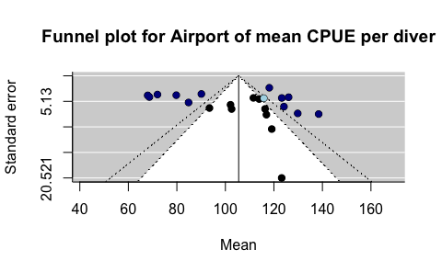

### Candidate Outliers, 95%

The following divers are classified as candidate outliers at the 95% level:

|  |  |  |
| --- | --- | --- |
| Diver | Mean CPUE | Standard Deviation CPUE |
| 12031 | 116 | 17 |

### Candidate Outliers, 99%

The following divers are classified as candidate outliers at the 99% level:

|  |  |  |
| --- | --- | --- |
| Diver | Mean CPUE | Standard Deviation CPUE |
| 8039 | 68 | 8.8 |
| 9630 | 80 | 16.9 |
| 9757 | 69 | 17.0 |
| 10130 | 123 | 17.8 |
| 10275 | 118 | 5.4 |
| 10310 | 72 | 15.5 |
| 10941 | 85 | 15.2 |
| 11095 | 126 | 13.6 |
| 11135 | 138 | 23.0 |
| 11472 | 124 | 20.5 |
| 11757 | 130 | 32.9 |
| 11998 | 90 | 10.3 |

This report template was produced for the Victorian Fisheries Authority by [interadata](https://www.interadata.io/).