OCTOBER 2026 • PRE-DEFENSE DELIVERABLE

ANTHEIA
Architecture & Diagrams
  - Development of an Intelligent Recommendation System for Personal Styling Based on Image Analysis and User Preferences
System Context • UML Use Case • Component Architecture (draft)
Document status: Proposed requirements and architecture — to be reviewed by the supervisor. No implementation, test pass, model quality, or live retailer integration is claimed.
Prepared for: First pre-defense, 24 October 2026
Team members / supervisor: [insert verified names]
Brand concept: personal color guidance, explicit style preferences, complete outfits and multi-retailer shopping comparisons.

Executive architecture summary
The proposed ANTHEIA system is a responsive web recommendation platform with separable photo-based palette guidance, explicit user-preference management, catalog retrieval, outfit compatibility/ranking, hard-constraint verification and explainable retailer-linked results. A native app may be added later using the same API; payment and merchant checkout remain outside the system boundary. The architecture is logical, technology-agnostic and NOT a claim that any component is deployed.

1. Architecture goals and constraints
Principle | Implication in the architecture
Photo-free by default | User preferences + request are sufficient; photo processing is a parallel, explicitly consented branch [S1].
Separation of concerns | Retrieval, compatibility, user ranking, constraint validation and palette estimation are independent evaluation units [S3].
Retailer data provenance | Each integration uses permission-checked adapter(s) plus a normalized versioned snapshot [S2][S3].
Transparent commerce | Offers carry retailer/source/time, size, currency and outbound link; no checkout inside ANTHEIA [S1][S2].
Privacy boundaries | Raw photos live in temporary restricted storage and are not passed to external retailers [S1].
Research reproducibility | Ablation tests use fixed inputs and the same data snapshot, recording versions and hard-constraint pass rates [S3].

2. System Context Diagram — boundary and external actors
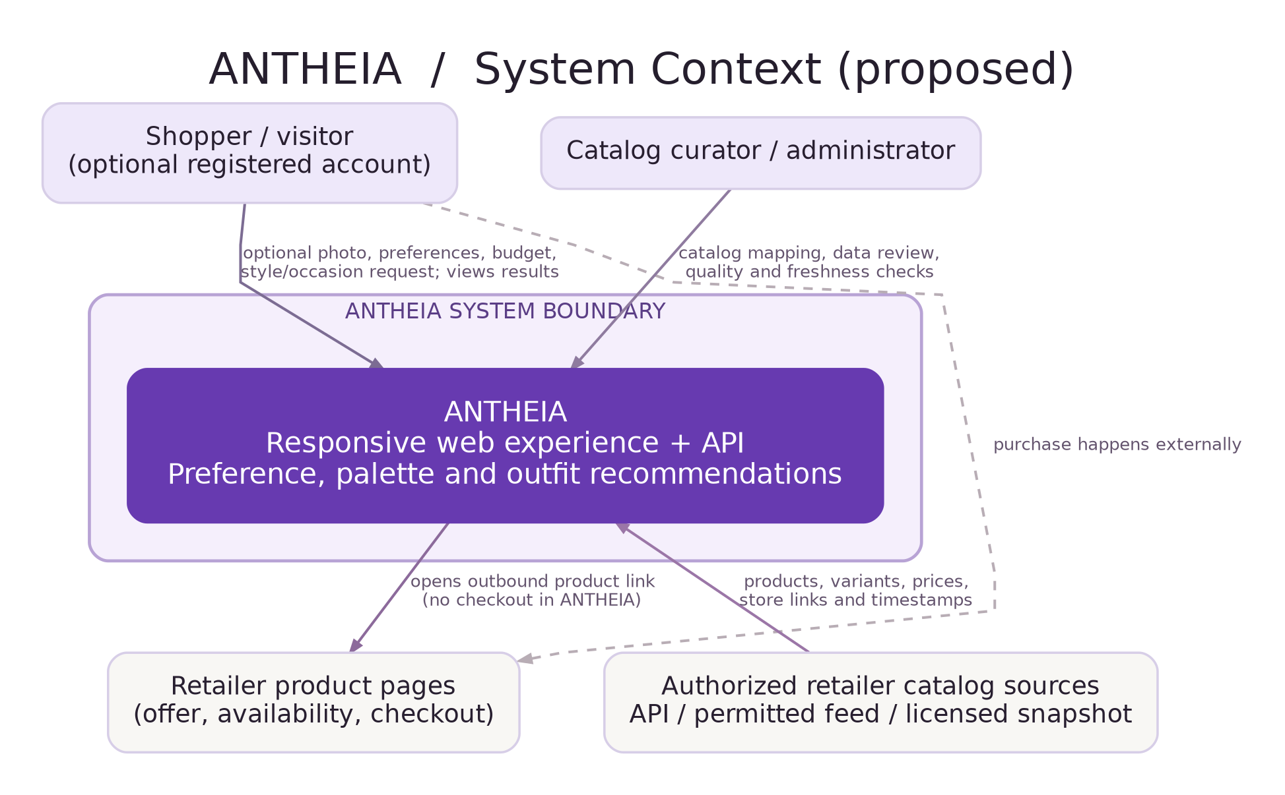
Figure source: diagrams/01_system_context.drawio (fully editable in diagrams.net); diagrams/01_system_context.svg (scalable).
The shopper supplies a profile, optional portrait and shopping constraints and receives outfit comparisons; an administrator manages permitted catalog records. Authorized retailer sources provide product metadata. A merchant website receives an outbound navigation; ANTHEIA never takes payment or places orders. Dotted routes in the drawing represent external shopper checkout or optional paths, not ANTHEIA-managed transactions.
Boundary / relationship | Meaning for requirements
Shopper → ANTHEIA | FR-01–FR-12, FR-19–FR-28: voluntary photo, requests and editable filters.
Administrator → ANTHEIA | FR-29/30: restricted import and data provenance checks.
Catalog sources → ANTHEIA | FR-13–FR-17: only permitted feeds/approved snapshots, with freshness labels.
ANTHEIA → retailer page | FR-26/33: outbound links; merchant remains responsible for checkout and inventory.

3. UML Use Case Diagram — user goals and administrator actions
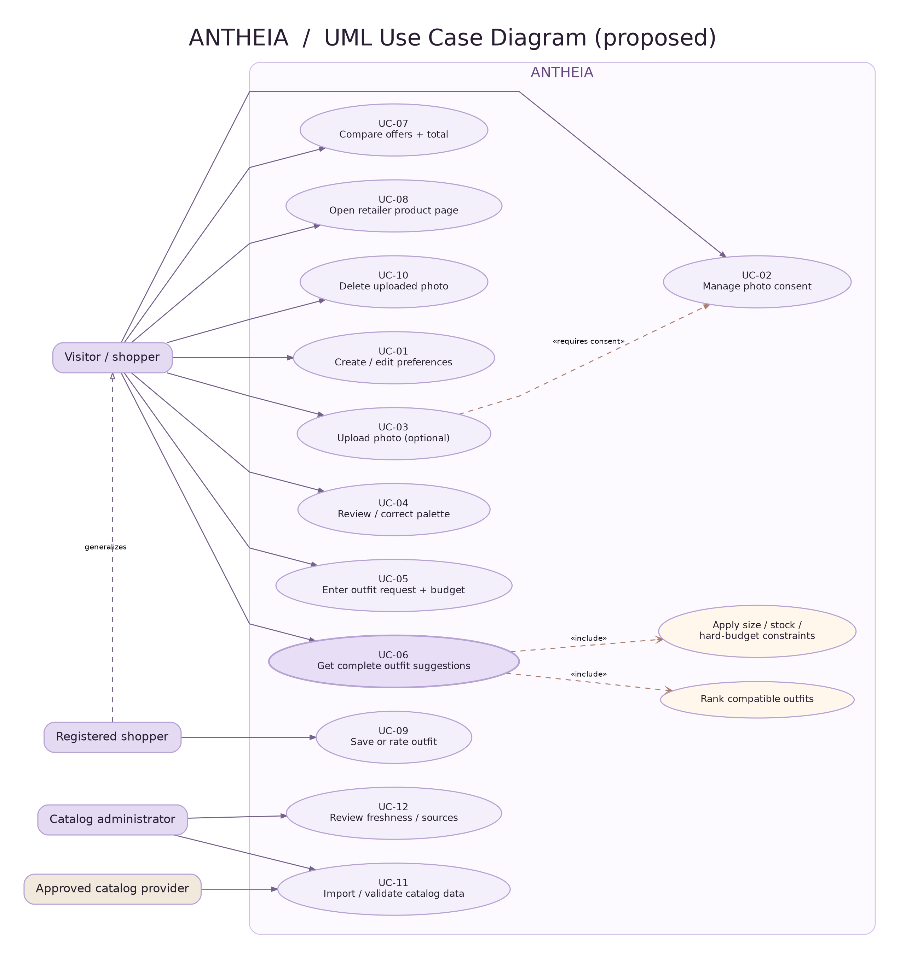
Figure source: diagrams/02_use_case.drawio (fully editable in diagrams.net); diagrams/02_use_case.svg (scalable).
An association shows an actor participating in a use case. The two «include» relations show mandatory filtering and ranking within UC-06. UC-03 is optional; its dashed consent dependency expresses a precondition, not a promise of photo-based accuracy. Registered-shopper-specific persistence is a Should requirement. All use cases correspond to proposed functionality.

3.1 Use case catalogue
ID | Use case | Primary actor | Success boundary | Req.
UC-01 | Create / edit explicit style profile | Visitor | Manual style, color, dislikes, size and region can be edited at any time; no photo required. | FR-01, FR-03
UC-02 | Manage photograph consent | Visitor | Consent is opt-in and granular before image handling; refusal preserves manual flow. | FR-05, FR-31
UC-03 | Upload photograph (optional) | Consenting visitor | Validate image; temporary processing; recover gracefully if poor quality. | FR-05–FR-07
UC-04 | Review / correct palette | Visitor | Uncertainty visible; user selects or modifies palette; does not supersede explicit dislikes. | FR-07–FR-08
UC-05 | Enter outfit request and budget | Visitor | Structured fields or parsed text; explicit budget currency and size/occasion. | FR-04, FR-11–FR-12
UC-06 | Get complete outfit suggestions | Visitor | Retrieve candidates, apply hard filters, rank compatible outfits and explain selections. | FR-19–FR-25
UC-07 | Compare offers and totals | Visitor | Retailer prices, variant availability, item sum and provenance are shown. | FR-16, FR-22–FR-26
UC-08 | Open retailer product page | Visitor | User navigates to recorded store URL; ANTHEIA does not process a purchase. | FR-26, FR-33
UC-09 | Save or rate outfit | Registered shopper | Stored preference or explicit feedback can be reviewed/removed; learning not assumed. | FR-10, FR-27
UC-10 | Delete uploaded photograph | Visitor | Delete active photo and derived file artefacts; confirm outcome. | FR-09, FR-31
UC-11 | Import/validate product data | Admin + approved source | Adapter validates normalized records and rejects malformed source items. | FR-13–FR-15, FR-29–FR-30
UC-12 | Review source and freshness | Admin | Inspect source permissions, timestamps, invalid URLs and review logs. | FR-14, FR-16, FR-29–FR-30

4. Component Diagram (draft) — responsibility boundaries
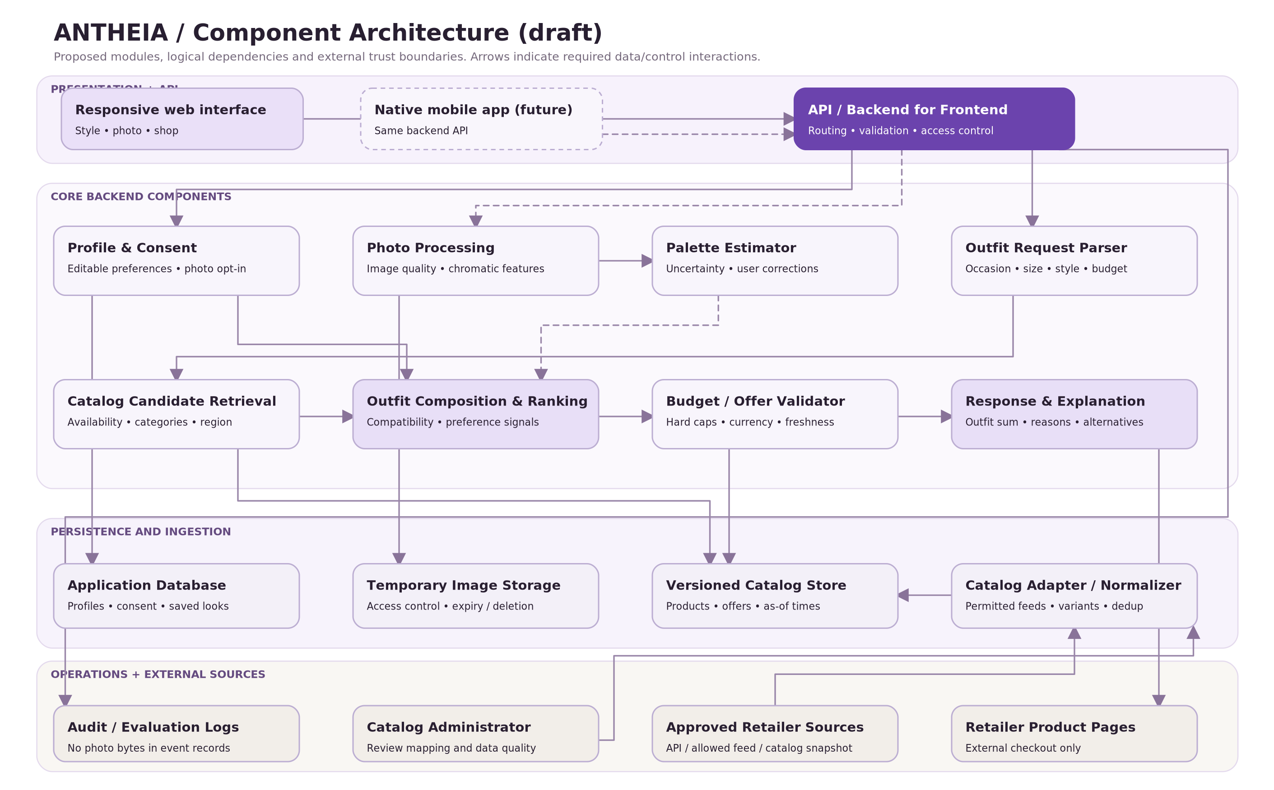
Figure source: diagrams/03_component.drawio (fully editable in diagrams.net); diagrams/03_component.svg (scalable).
Solid connectors depict planned service, storage or retailer-link interaction; dashed connectors denote optional photo signals or a future native client. The catalog adapter is logically independent from the recommender. The budget/offer validator operates after candidate composition and before display. Actual deployment may merge modules without changing their responsibilities.

4.1 Responsibility and interfaces
Component | Inputs | Outputs / obligations | Related req.
Web UI / BFF | Session or guest request, filters, optional photo | Validates input and consent; renders reasons, prices, errors and outbound offers. | FR-01–FR-06; FR-11
Profile & Consent | Explicit color/style/size, privacy actions | Prioritized preference profile; auditable consent/deletion state. | FR-03/05/08/09
Photo processor + palette estimator | Consented photo, quality signals | Tentative palette and uncertainty; does not identify person or guarantee classification. | FR-06–FR-08/28
Request interpreter | Free-text and structured occasion/size/budget | Editable normalized filter object; reject invalid currency or negative budgets. | FR-04/11/12
Catalog adapter / normalized store | Approved source feed / versioned snapshot | Canonical offer, variant, price, currency, retailer, link and timestamp. | FR-13–FR-17/29/30
Candidate retrieval | Filter object, normalized catalog | Eligible candidate subsets with missing-data provenance. | FR-12/18/20
Outfit composition & ranking | Candidate subset + profile + optional palette | Compatible outfit combinations and attributable preference scores. | FR-19–FR-21/25
Budget / offer validator | Outfits, per-variant offers, currency, cap | Subtotal, unknown shipping notices, size/stock/price compliance. | FR-21–FR-24
Recommendation response | Validated ranked outfits + store URLs | Explanations, alternatives, timestamps and safe retailer redirects. | FR-25–FR-26/33
App DB / temp store / logs | User records / temporary bytes / event IDs | Protect storage, version experiments, implement deletion, exclude photo bytes from logs. | FR-09/10/31; NFR-06/09/16

4.2 Suggested service contracts and data records
Contract / entity | Minimum fields or behavior
POST /style-requests | styles[], colorsLiked[], colorsAvoided[], occasion, sizeFilters[], region, strictBudget{amount,currency}, promptText; validate then return interpreted filters.
POST /palette-estimates | Only after consent; ephemeral photo handle, quality flags, suggestedPalette[], optional seasonLabel, explanation and uncertainty.
POST /recommendations | profileOrGuestContext, interpretedFilters, optional palette, catalogSnapshotId; returns outfits[] plus reasons, sourceStatus and warnings.
OutfitRecommendation | outfitId, roleToOfferMap, subtotal{amount,currency}, excludedCostReasons[], explanations[], matchSignals, sourceSnapshotId.
Offer | retailerId, sourceId, productId, variantId, URL, category, size, color, price, currency, stockState, asOf, imageReference/rights.
PreferenceProfile | styleChoices, userColors, avoidedColors, sizes, occasion defaults, region, optional edited palette; distinct from photo-derived inference.
PhotoArtifact | opaque storage reference, consent reference, expiry, deletion state; not embedded into shopping response.
CatalogSnapshot | snapshotId, import time, source permissions and schema version; immutable for controlled experiments.

4.3 Three important interaction sequences
Flow A — Photo-free shopping: Visitor → profile preferences → request parser → catalog retrieval → outfit compatibility/ranking → hard budget/availability validation → explainable comparison → outbound retailer link.
Flow B — Optional color assistance: Consent → temporary photograph → quality checks → palette estimate + uncertainty → user edits palette → optional color feature is merged into ranking. Declining consent returns to Flow A.
Flow C — Catalog preparation: Administrator verifies permissions → approved feed/snapshot → adapter validation + canonical normalization → versioned catalog snapshot → candidate retrieval. Missing live access leads to a labelled reproducible snapshot, not invented fresh stock.

5. Trust boundaries and failure handling
Boundary / risk | Mitigation / failure response | Check
Portrait image and processing | Consent gate, restricted ephemeral storage, no retailer disclosure, delete control and clear policy. | FR-05/09; NFR-06/07
Retailer catalog freshness | Attribution + as-of metadata, unknown stock explicit, stale link checks, labelled snapshot fallback. | FR-13–FR-18
Hard-budget arithmetic | Validate canonical currency and per-variant offer; exclude over-cap outfits and disclose excluded charges. | FR-22–FR-24
Account and admin authorization | Server-side access checks prevent cross-user profile reads and unauthorized ingestion. | FR-29; NFR-05
ML/candidate biases and reproducibility | Keep algorithms modular; compare explicit preferences, compatibility and added palette signal using held-out human judgments. | FR-20; NFR-09/18

6. Diagram-to-requirement mapping
Diagram | Mandatory pre-defense purpose | Direct traceability
Context (Fig. 1) | Clearly separates ANTHEIA from users and external retailer sources / checkout. | FR-01/05/13/14/26/29/33
Use Case (Fig. 2) | Shows user and administrator scenarios, photo consent, shopping, alternatives and deletion. | FR-01–FR-31; UC-01–UC-12
Component (Fig. 3) | Shows independently testable analysis, retrieval, ranking, budgets, adapters, stores and API. | FR-06–FR-30; NFR-03/06/09/14

7. Architecture review checklist / next milestone
- Confirm legal and practical access to at least one retailer-origin data source; define a second independently shaped fixture for adapter contract tests.
- Confirm the color-estimation experiment protocol and ethical/privacy conditions before accepting any personal photos.
- Agree on strict versus flexible budget interface and KZT/other-currency conversion rules.
- Link FR, NFR, UC, diagram and acceptance IDs to YouTrack issues and Git commits/PRs.
- Maintain editable diagram sources (.drawio) and a review log of supervisor feedback; do not imply the first defense requires a complete deployed product.

References and basis
[S1] Evidence of Relevance — four semi-structured interviews; Sections 2.1–2.7, Tables 2.1–2.2 (2026).
[S2] Existing Systems Comparison — Blossom, StyleLab, Stitch Fix and Cladwell; Sections 4.1–4.6 (2026).
[S3] Fashion Recommendation Literature Review — 12 reviewed scientific works; Sections 3.1–3.10 and Table 3.1 (2026).
[S4] First Pre-defense Requirements — "До 24 октября"; items 6–7 and minimum repository deliverables (2026).
Source interpretation: interview-supported needs are distinguished from engineering proposals, technical dependencies and planned acceptance thresholds. Bibliographic citations for scientific claims remain in [S3].

