Database

Tables:

-user

* userID
* Username
* Password
* Favourite game
* Genre1
* Genre2
* Genre3
* Platform

-games

* GameID
* Name
* Release date
* Rating
* Genre1
* Genre1
* Genre2
* Genre3
* gameType(multi,single,coop)
* platform

-recommendations

* recID
* userID
* GameID
* userRating

Web

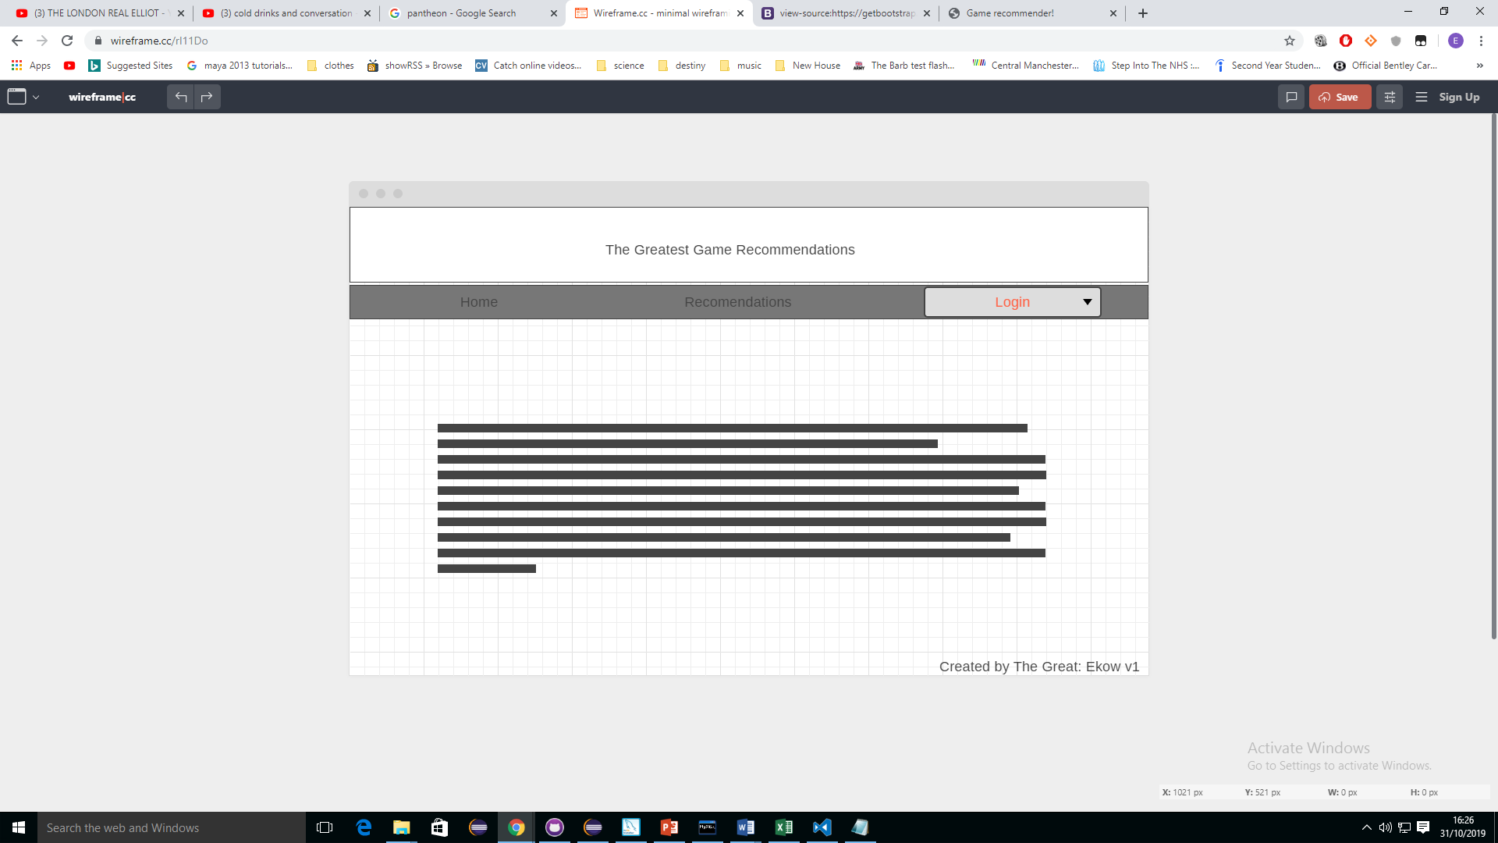

-login/register

-my profile

* Enter preferences

-recommendations

* Generates recommendations based on preferences
* Delete if uninterested or bad recommendation
* Rate recommemdation