Step 1 – Execute the database first

* Execute the table(TranslationWord.sql) in your database
* Seed the data from “DataSeeding.sql”
* Make sure change the connection string as per your data base.

Step 2 – for installing the packages for react :

* Run the command “npm install” in terminal or bash.

Step 3 – Configure the startup project:

* Set a multiple project as start up.
* Set both the projects (TestTranslation,TestTranslation.react) as ‘start without debugging’.

Step 4 – The React project will load on your local host as below:

* Front view:

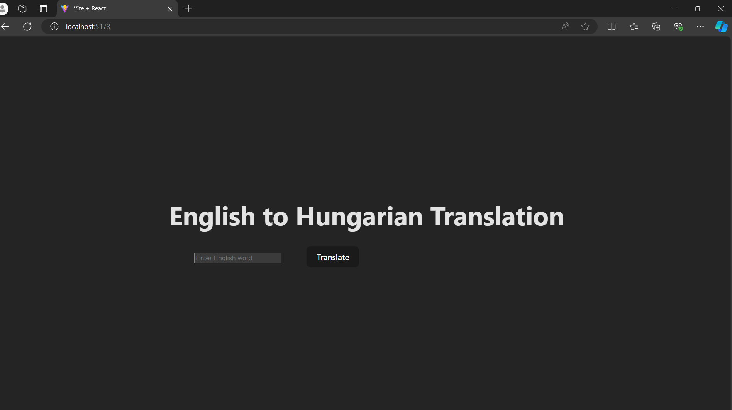

* Searching a phrase:

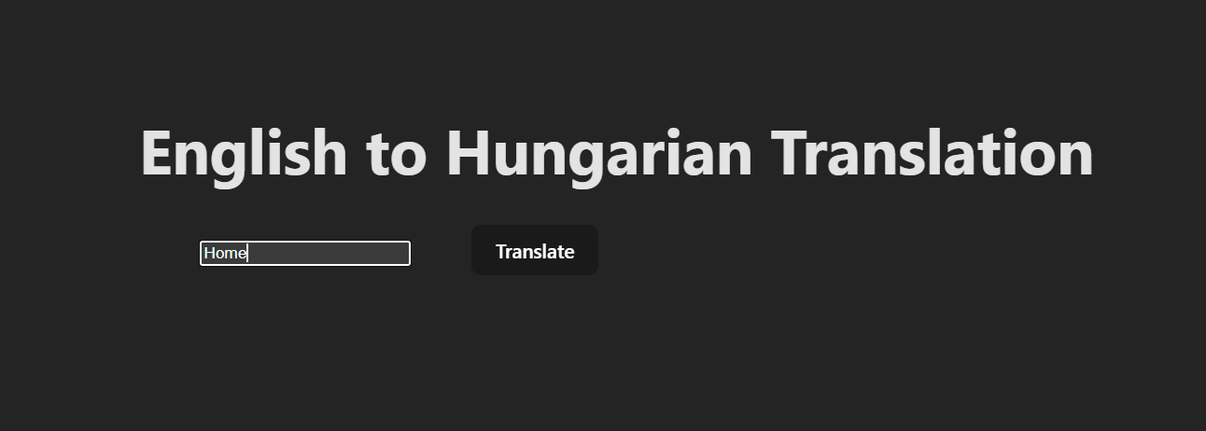

* Hungarian translation of the searched word. 