Simulator:

* + 1. Workflow:
       - It loads a list of customers and cell tower locations from two csv files.
       - Maps the customers and cell tower locations randomly with given time interval of start date time and end date time.
       - The message created is then pushed into a Kafka server at a given range of rates. It maintains feeds of messages in topics.
    2. Structure of the sample data:
       - The customer list has two columns, caller and receiver

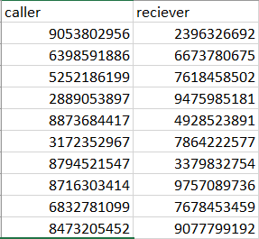

**Figure 1: Sample customer list with caller and receiver numbers**

* + - * The cell tower locations have two columns. ID and latitude/longitude values.

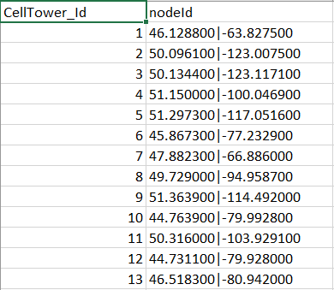

**Figure 2: Sample cell tower locations**

* + 1. Output:
       - The message produced follows the given order:

|  |  |  |  |  |
| --- | --- | --- | --- | --- |
| dateTimeConnect | Start time of call | yyyymmdd hhmmss | 20181101 154530 |  |
| dateTimeDisconnect | End time of call | yyyymmdd hhmmss | 20181101 164530 |  |
| origNodeId | Latitude and longitude of cell tower for caller | Latitude|Longitude | 49.252121 | -122.893949 |  |
| destNodeId | Latitude and longitude of cell tower for reciever | Latitude|Longitude | 49.252814 | -122.896873 |  |
| callingPartyNumber | Mobile number of caller | digits(size -10) – no char | 2365482589 |  |
| originalCalledPartyNumber | Mobile number of reciever | digits(size -10) – no char | 2365694587 |  |
| callStatus | Field for identifying call drop | Boolean (0/1) | 0 | 0 – Normal call 1- call drop |
| eventType | Either voice / Data | Boolean (0/1) | 1 | 0-Voice 1-Data |

**Figure 3: Data format and structure of the message produced**

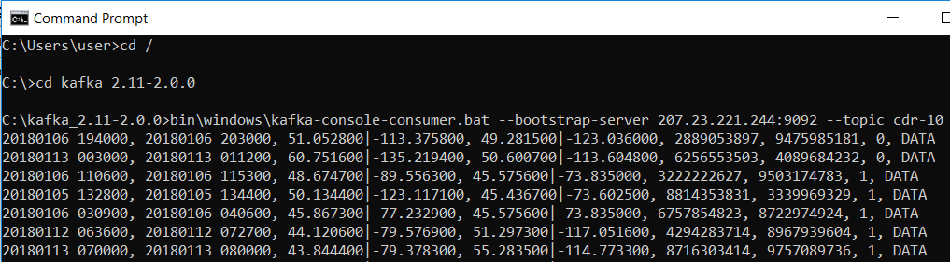

**Figure 4: Sample message generated from the Kafka server**