Tomcat Writeup

First of all I will begin to visit website .The problem is our website port is not 80 or 443 .Because of that I made an nmap scan .
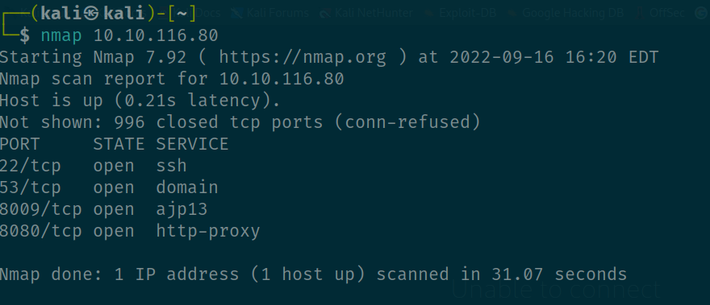
As we see here server has a few services running in the background . First I visited ajp13 but it was dead end then I visited 8080 .It was an apache tomcat server .
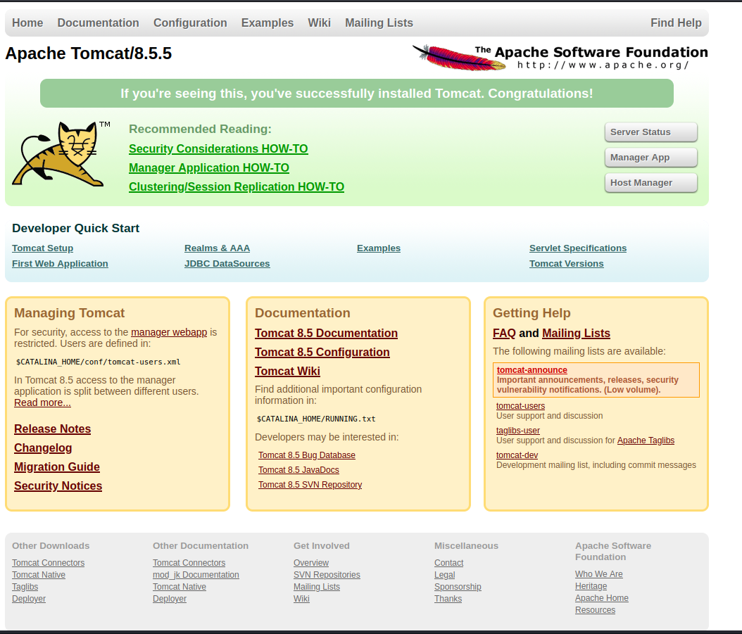
Usualy I should have made an directory scan but ı clicked the manager app and it asked me a username and password.
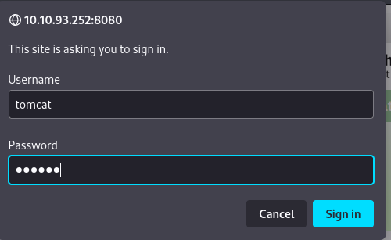

Since I don’t know the password and username I wrote random characters .The problem is server returned me an 403 forbidden message .
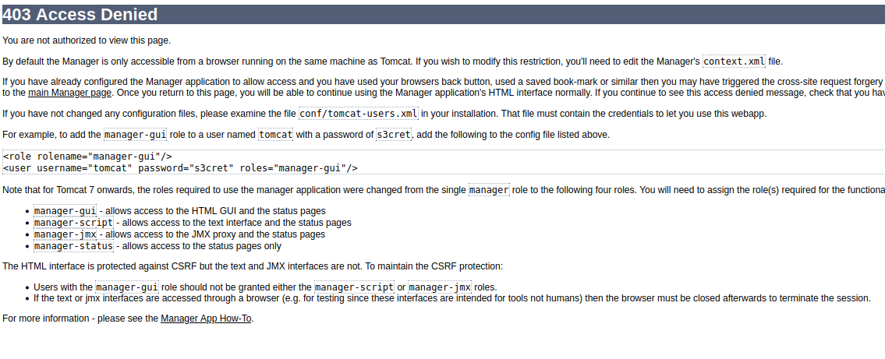
I checked the error messsage and noticed something about username and password .I thought maybe they didn’t change default credentials for server .I went to logins screen and tried default credentials .It worked .
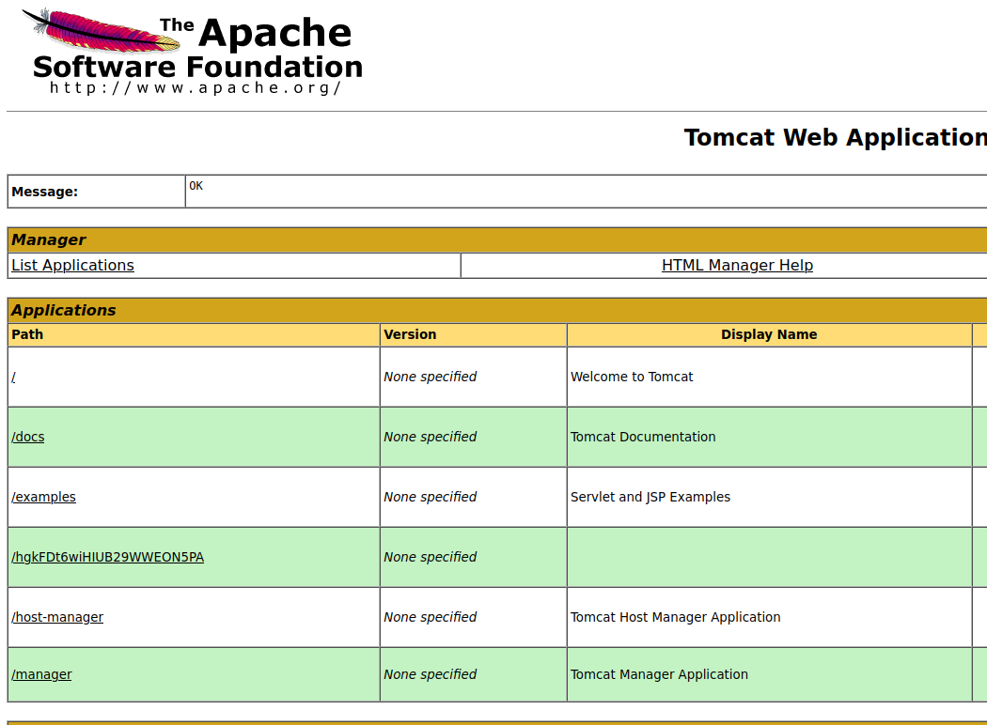
In below I saw I can upload war files .I searched on google and noticed I could have a chance to get a reverse shell via file upload . I created a war file reverse shell by msfvenom and upload to server .

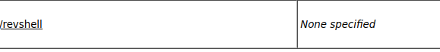

Then I started to listen dedicated port in my local computer .
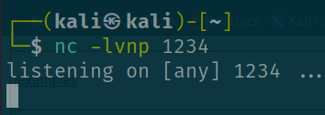

After that I triggered the file and received shell but shell was very uncomfortable .I decided to stabilize shell using python tty module .

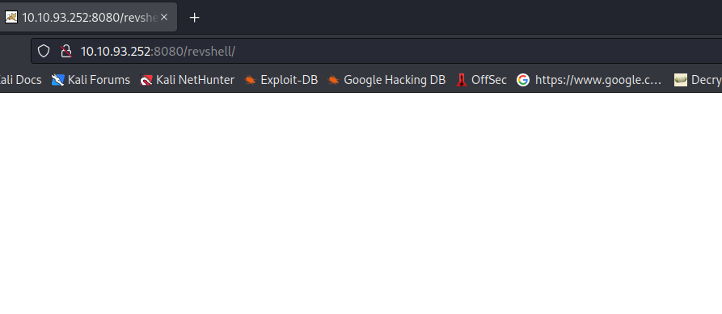

After that I went to home directory and see a user name jack .When I checked in I saw a couple files .
First I received the user flag .

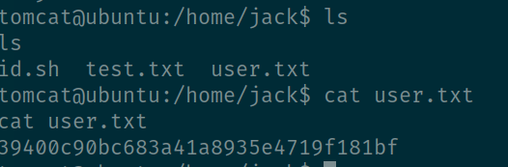

After that I checked other files .When I see id .sh was writable and runs with root privilages I decided to exploit .Biggest problem was the system had no editors avalible .Because of that I used echo command to write id.sh file .
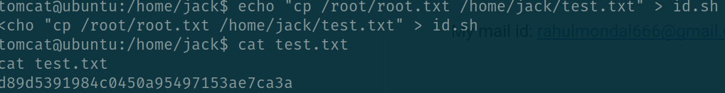
This id.sh file runs in periodic time .After waiting for some time if we check test.txt we can see our root flag .Actually we can receive a root shell but machine was too unstable and I couldn’t do that .

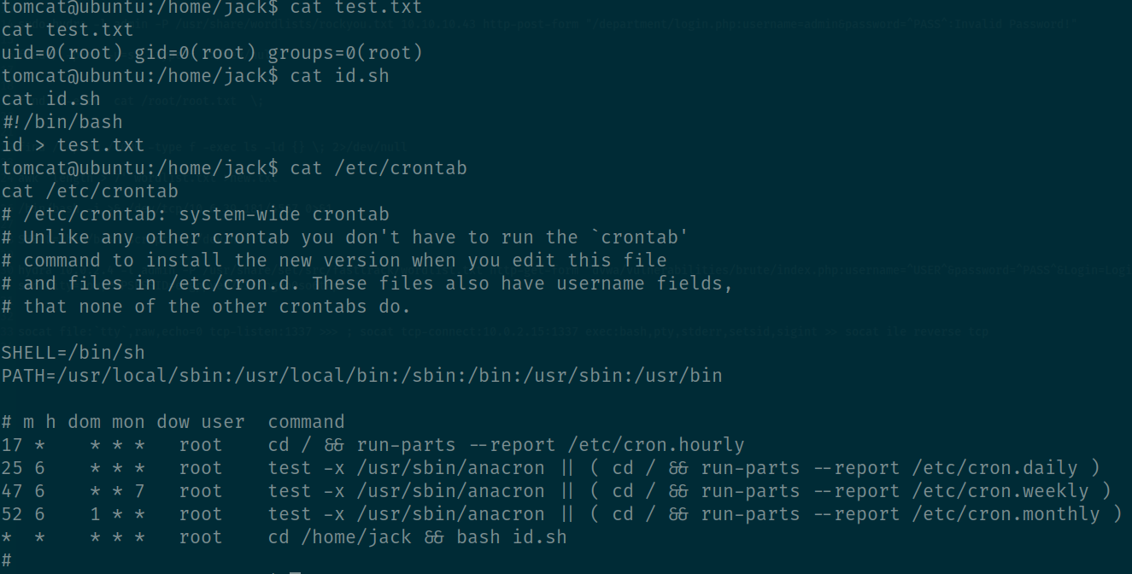
First problem in this situation is why apache server is accessible for casual user ? This is a
misconfiguration vulnerability .

Second problem is Why this system uses default credentials for admin login ?

Third problem is why this system don’t use 2 factor authentication for admin panel ?

Forth problem is why system allows admin to upload a war file that contains a reverse shell codes inside ?

The last problem is why there is a file has root privilages inside of an casual user ?

