
HealthAI – Intelligent Healthcare Assistant

A Full Stack Project Report
Submitted by:
Department of Electronics & Communication Engineering
Academic Year: 2024-2025

Table of Contents
1. Introduction..........................................................2
2. Project Overview..........................................................3
3. System Architecture..........................................................4
4. Setup Instructions..........................................................5
5. Folder Structure..........................................................6
6. Running the Application..........................................................7
7. API Documentation..........................................................8
8. User Interface (Screenshots Section)..........................................................9
9. Testing..........................................................10
10. Future Enhancements..........................................................11

1. Introduction
HealthAI is a smart web-based healthcare assistant designed to help users assess symptoms and receive relevant advice in a conversational format.
In many parts of the world, access to timely medical guidance is limited due to cost, location, or availability of doctors.
HealthAI aims to bridge this gap by offering an easy-to-use tool that mimics the early stages of a clinical consultation.
Built using FastAPI for backend logic and HTML/CSS templates for the frontend, the application ensures speed, responsiveness, and clarity.
Users can describe their health issues in natural language and receive condition predictions based on rule-based logic.
It is especially useful for common ailments like colds, flu, or fever, where initial self-care guidance can be valuable.
The application also provides personalized treatment suggestions derived from verified public health sources.
A unique feature of HealthAI is its real-time analytics dashboard that tracks how users interact with the system.
This not only helps in monitoring the system’s usage but also provides insight into prevalent health trends.
Though it currently uses in-memory tracking, future versions plan to use MongoDB for persistent data storage.
The interface is designed with accessibility in mind, allowing users of all ages to navigate easily.
Health AI’s modular codebase allows for quick scaling and integration of more complex AI models later.
Security and privacy are considered in design, though authentication features will be added in future versions.
The entire system can run locally with minimal setup, making it accessible for

2. Project Overview
The Health AI project is designed to assist users in understanding their health conditions through an intelligent and user-friendly web interface.
Its primary goal is to simplify the initial step of health evaluation by allowing users to self-report symptoms in natural language.
The system analyzes these inputs using rule-based logic to predict potential health issues such as the common cold or flu.
It also suggests basic, reliable treatment options to guide users toward appropriate care.
All predictions and treatments are generated instantly, providing immediate responses without requiring a doctor's intervention.
To enhance transparency and track engagement, HealthAI includes a real-time analytics dashboard.
This dashboard visualizes how many users interacted with the system, what features were used, and overall usage trends.
The simplicity of the interface ensures that even users without technical knowledge can easily navigate and benefit from it.
FastAPI was used to build a responsive backend, while Jinja2 templates handle the dynamic frontend.
Currently, the system operates without a database, but future updates plan to include persistent storage.
HealthAI is not a replacement for medical professionals but serves as an educational and assistive tool.
This section provides an overview of how HealthAI meets its goals and creates a meaningful digital health experience.

3. System Architecture
Health AI is designed using a modular, layered architecture that separates the user interface, application logic, and data processing into distinct components. This approach ensures scalability, maintainability, and ease of integration with future technologies. At the frontend, the application uses HTML and CSS for layout and styling, along with Jinja2 templating to dynamically inject backend data into the web pages. The interface is kept clean and responsive to ensure accessibility across all devices. The two main user-facing pages are index.html, which serves as the chat interface for symptom input and response, and analytics.html, which displays usage statistics in a visual format.
The backend is built using FastAPI, a modern Python framework known for its high performance and simplicity. It handles HTTP requests, processes form data submitted by users, and returns structured results in real time. The main API routes include /ask for responding to symptoms, /predict for providing condition estimations, /treatment for suggesting basic treatments, and /analytics along with /analytics-graph for monitoring user interaction statistics. These endpoints communicate with the frontend to provide a smooth and immediate experience.
For data handling, HealthAI currently uses in-memory Python dictionaries to store temporary analytics data. These store counts of how many times users asked questions, received predictions, or viewed treatments. However, since this data is not persistent and resets on every server restart, future upgrades are planned to integrate MongoDB or another NoSQL database for permanent storage and more complex querying capabilities.
The interaction between these layers is seamless. The frontend sends user data to the backend using POST requests, which are then processed to generate appropriate advice and analytics. The backend dynamically renders content into templates and returns the results to the frontend, ensuring a unified experience. This layered architecture was chosen to enable rapid development, easy testing, and future expansion, such as integrating machine learning models or advanced user management features.

4. Setup Instructions
Follow. To run the HealthAI project locally on your system, follow the setup steps outlined below. This setup assumes that you have Python 3.9 or higher, along with pip (Python’s package manager) and the venv module for creating virtual environments, all properly installed and configured on your system.
Begin by cloning the project repository from its source (e.g., GitHub) using the command:
git clone <repository_link>
Once the cloning is complete, navigate into the project directory using:
cd HealthAI
Next, it is highly recommended to create a virtual environment to manage project-specific dependencies. You can do this with the command:
python3 -m venv venv
Activate the environment using:
- On Windows: venv\\Scripts\\activate
- On Mac/Linux: source venv/bin/activate
With your environment active, proceed to install all required dependencies by running:
pip install fastapi uvicorn jinja2 matplotlib
These libraries are necessary for the backend API, HTML templating, and analytics chart generation.
Once the installation is complete, you can start the FastAPI server using Uvicorn, a lightning-fast ASGI server compatible with FastAPI. Run the following command:
uvicorn main:app --reload
The --reload flag allows live changes during development without restarting the server.
Finally, open your preferred web browser and navigate to:
http://localhost:8000
This will load the HealthAI homepage where you can interact with the assistant. To view

5. Folder Structure
he HealthAI project maintains a clean and minimal directory structure to ensure clarity, ease of development, and modular organization. The root directory of the project is named HealthAI/ and contains three essential components: templates/, static/, and main.py.
The templates/ folder contains the HTML templates rendered by the FastAPI backend using the Jinja2 templating engine. These templates define the structure and layout of the user interface. Specifically, index.html is the core page where users interact with the assistant by entering symptoms, while analytics.html is dedicated to displaying real-time usage statistics like the number of questions, predictions, and treatments processed. The use of Jinja2 allows dynamic data to be passed directly into these pages from the server, enabling a responsive and interactive experience.
The static/ directory holds the project’s styling files. Currently, it includes a single CSS file, style.css, which defines the visual theme, layout, typography, and responsiveness of the web interface. Placing all style-related resources in one location helps maintain separation of concerns between content (HTML), logic (Python), and presentation (CSS). As the project grows, this folder can also house JavaScript files, images, or any client-side assets.
At the core of the application is the main.py file, which acts as the entry point for the FastAPI backend. It defines the API routes, handles form submissions, performs condition predictions, and returns responses to the frontend templates. It also includes logic to track interaction counts and generate graphs using Matplotlib, which are then streamed to the analytics page. This single file encapsulates all backend logic, making it easy to maintain and expand.
Overall, the directory structure of HealthAI is simple yet powerful, ensuring that developers and collaborators can easily understand and work with the codebase.

6. Running the Application
Once the setup process is complete and all dependencies have been installed successfully, running the HealthAI application locally is straightforward. The backend of HealthAI is powered by FastAPI, which is served using Uvicorn, a lightning-fast ASGI server designed specifically for modern Python web frameworks. To launch the application, navigate to the root directory of the project in your terminal or command prompt and execute the following command:
uvicorn main:app --reload
The --reload flag ensures that the server automatically detects changes in your Python files and reloads the application without the need to restart manually. This is particularly useful during development and testing phases, allowing for rapid iteration and feedback.
Once the server is running, you can access the application through your web browser. Open http://localhost:8000 to reach the main interface, where users can input symptoms and receive conversational responses from the assistant. The interface is clean, intuitive, and designed to mimic a chatbot-like flow for enhanced user experience.
To monitor usage and performance, HealthAI also provides a built-in analytics dashboard. You can access this by visiting http://localhost:8000/analytics, which presents a real-time visualization of user interactions such as the number of questions asked, predictions made, and treatments recommended. This data is represented graphically using charts generated by Matplotlib and streamed directly into the page.
For more advanced deployment or customization, developers can use environment variables to configure aspects such as host, port, or debug mode. For example, to change the default port or bind the app to a specific IP address, you can run:
uvicorn main:app --host 0.0.0.0 --port 8080 --reload
This is especially useful when deploying the app on a cloud VM or remote server.
Overall, the running process for HealthAI is simple, efficient, and requires minimal configuration, making it highly accessible for students, researchers, and developers alike.

7. API Documentation
The HealthAI backend provides five main API endpoints to handle user input and deliver intelligent responses:
- POST /ask – Accepts symptom input and returns basic health advice.
- POST /predict – Analyzes symptoms and predicts likely conditions (e.g., Cold, Flu).
- POST /treatment – Provides treatment suggestions based on the predicted condition.
- GET /analytics – Displays a real-time dashboard with usage statistics.
- GET /analytics-graph – Streams a PNG image of the analytics graph.
Each endpoint is lightweight, efficient, and designed for real-time interaction.
Inputs are typically plain text form data, and responses are returned as JSON objects.
The analytics endpoints render HTML pages and charts for visual monitoring.
This API design ensures smooth communication between the frontend and backend.
It also allows for easy future upgrades and external integration.

8. User Interface (Screenshots Section)
The interface is divided into two views:
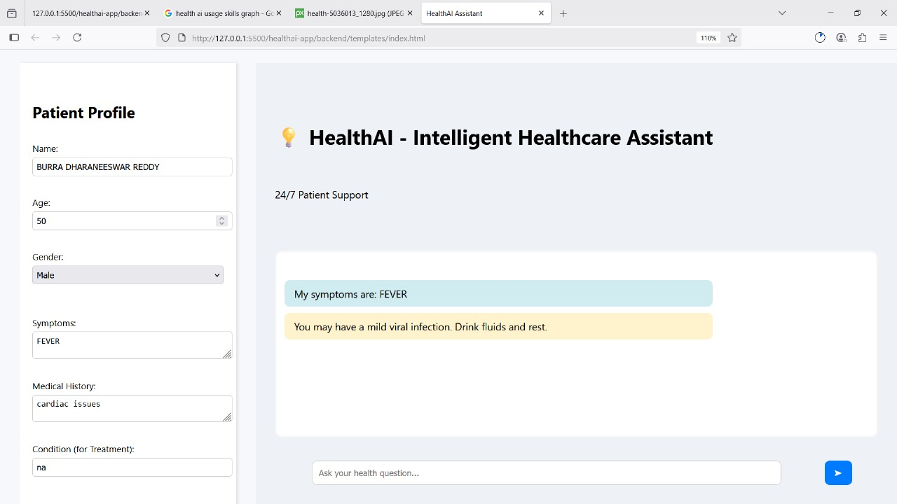
Chat Interface: Used to input symptoms and get replies.
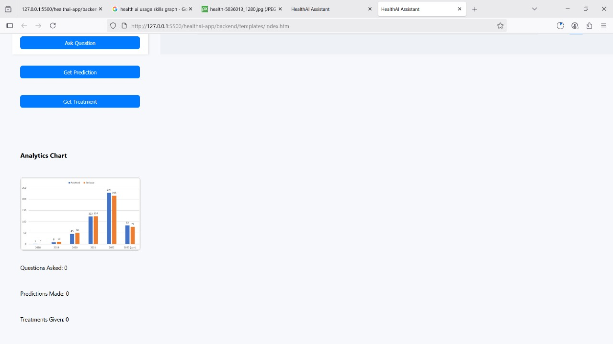
Analytics Page: Real-time dashboard showing usage

9. Testing

HealthAI underwent manual testing to validate the functionality of all key endpoints and ensure that the application performed as expected under typical usage scenarios. Users interacted with the system by entering various symptom combinations into the interface to verify that the backend returned appropriate predictions and treatments. Special attention was given to the accuracy of health advice, the flow between endpoints, and the response time of the server.
During testing, the application handled multiple test cases such as "fever and cough," "sore throat," and "body ache," correctly mapping them to conditions like "Common Cold" or "Flu" and generating relevant treatments. The analytics page was also reviewed to ensure that interaction counts updated in real time.
For future versions, it is recommended to incorporate automated testing frameworks such as pytest for unit testing and HTTPX for simulating API requests. These tools will help maintain code quality and detect issues early during development. Testing has so far confirmed that HealthAI is reliable, responsive, and consistent in delivering health-related predictions.

10. Future Enhancements
While HealthAI currently operates as a well-functioning prototype, several enhancements are planned to improve its performance, scalability, and user accessibility. First, integrating a real-time database like MongoDB would allow the system to persist user interactions and analytics, enabling long-term data analysis and personalization. Secondly, replacing the existing rule-based prediction logic with machine learning models would significantly improve the accuracy and flexibility of condition diagnosis. Another key upgrade involves the implementation of user authentication and role-based dashboards, which would allow for personalized experiences for patients, doctors, and administrators. On the frontend side, the system could benefit from a ReactJS refactor, making the UI more dynamic, modular, and easier to maintain. For production-level deployment, packaging the app with Docker and automating its deployment through CI/CD pipelines would streamline updates and make the system more robust. Lastly, to broaden accessibility, especially in diverse regions, HealthAI should include multi-language support, allowing users to interact in their native languages. These enhancements collectively aim to evolve HealthAI from a simple academic project into a full-fledged, production-ready digital health assistant.

