ENTERPRISE SALES DATA PIPELINE
End-to-End Cloud Ingestion, Zero-Trust CI/CD, and Medallion Data Warehousing
Project Author: Ekta Chhabria
Technologies: Python (Flask/Gunicorn), Azure App Service, Azure Blob Storage, Azure PostgreSQL, Snowflake, GitHub Actions (OIDC)
Date of Execution: August 14, 2026
Repository URL: https://github.com/EktaC30/enterprise-sales-pipeline

1. Executive Summary & Project Objectives
The Enterprise Sales Data Pipeline is a production-ready, cloud-native data engineering solution designed to solve the real-world operational challenges of ingesting multi-source transaction files, securing deployment automation without stored credentials, and providing real-time data cleansing and aggregated KPI reporting. The architecture bridges web-based data ingestion with a Snowflake Medallion Architecture (Bronze -> Silver -> Gold) driven by event-based Snowpipe and Change Data Capture (CDC).
Component | Technical Solution | Enterprise Value Delivered
Deployment & DevOps | GitHub Actions with Azure OIDC Authentication | Eliminates long-lived secrets/service principal keys (Zero-Trust).
Application Layer | Flask Web Portal on Azure Linux App Service | Enables authorized business users to ingest sales CSVs directly.
Data Lake / Staging | Azure Blob Storage (Container: salesfiles) | Decouples operational file uploads from data warehouse compute.
Raw Ingestion (Bronze) | Snowflake Snowpipe with Azure Storage Queue | Automated, serverless ingestion upon file landing without manual copy.
Transformation (Silver) | Snowflake Streams & CDC Tasks with QUALIFY | Automated schema enforcement, data type casting, and deduplication.
Analytics Layer (Gold) | Scheduled Downstream DAG Merges | Provides pre-computed business aggregates (Revenue, Volume, Avg Value).

2. System Architecture & Data Flow
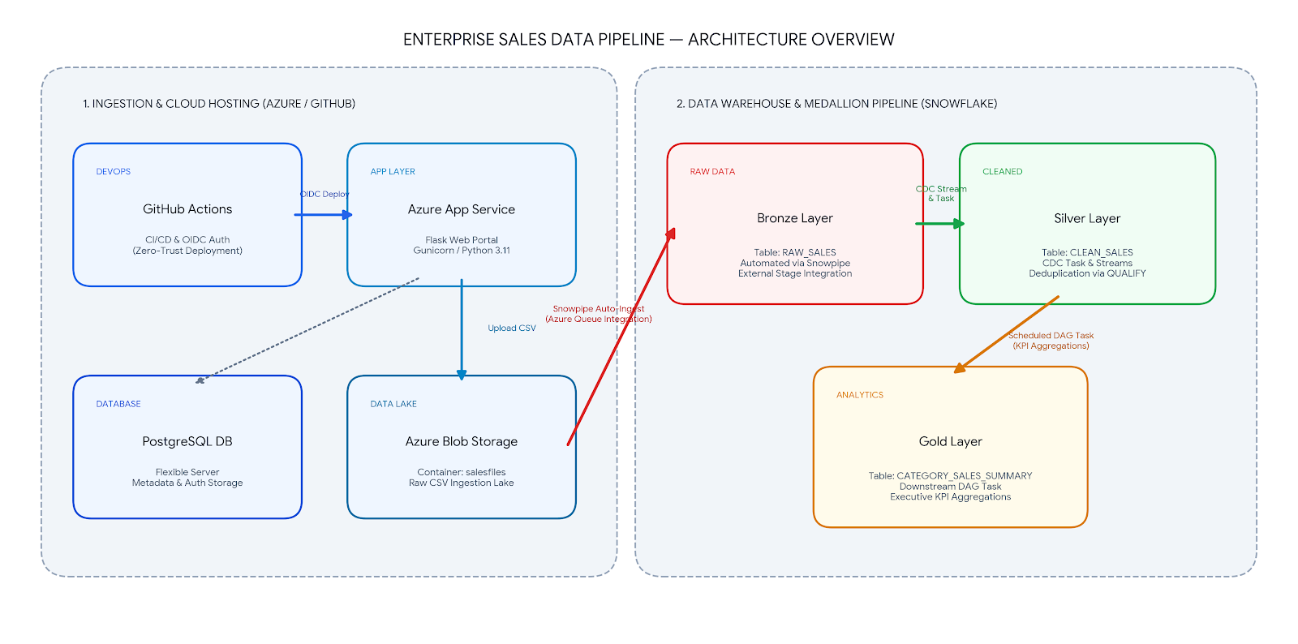
The diagram below illustrates the end-to-end flow of data and CI/CD automation across GitHub, Microsoft Azure, and Snowflake.

3. Implementation Evidence & Screenshot Walkthrough

3.1 Zero-Trust CI/CD Automation (GitHub Actions & OIDC)
Code is continuously tested and deployed to Azure App Service via GitHub Actions workflows. Rather than storing long-lived client secrets, Azure AD Federated Identity Credentials (OIDC) are used to issue short-lived OpenID tokens for zero-trust deployment.
Figure 2: GitHub Actions CI/CD Pipeline Execution
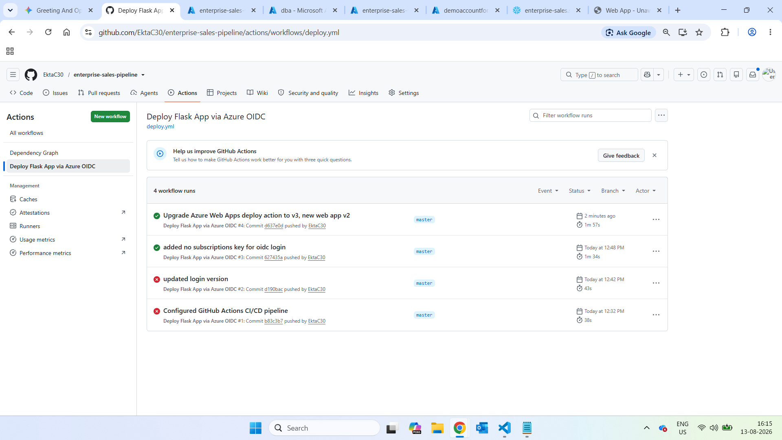
Description: Shows the green checkmark status on the master branch deployment workflow.
- Verified passwordless OIDC login via azure/login@v2.
- Automatic artifact build and deployment package transmission to Azure App Service.
- Zero failed runs after configuration of correct subscription/client parameters.

3.2 Cloud Infrastructure & Web Application Hosting
The application is hosted on an Azure Linux App Service container running Python 3.11 with Gunicorn WSGI. Secrets such as connection strings and PostgreSQL database credentials are dynamically injected into the runtime container.
Figure 3: Azure App Service Running Status & Environment Variables
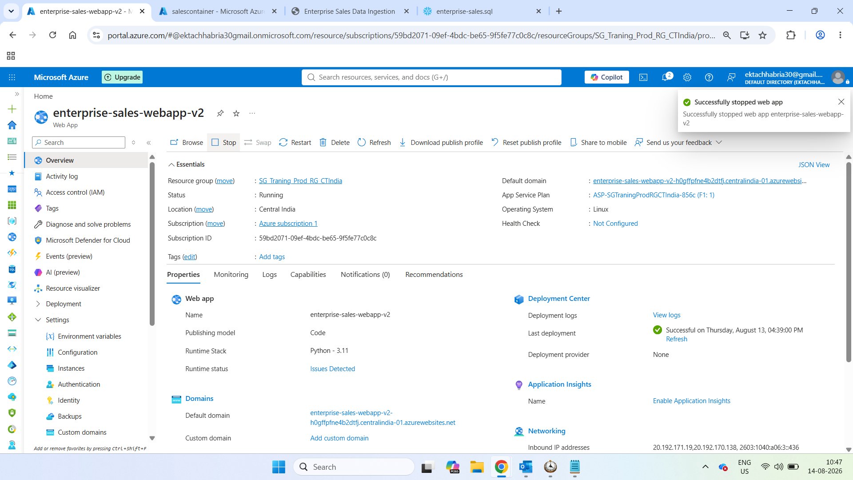
Description: Shows enterprise-sales-webapp-v2 in 'Running' state with application settings.
- App Service Plan status verified with fresh daily CPU quota allocation.
- Environment variables configured: AZURE_STORAGE_CONNECTION_STRING, POSTGRES_HOST, CONTAINER_NAME.
- Startup command mapped to: gunicorn --bind=0.0.0.0:8000 app.main:app.

3.3 Operational CSV Ingestion Portal
A responsive web interface allows business users to upload batch sales transactions. The backend streams the received payload directly into Azure Blob Storage.
Figure 4: Flask Web Application File Upload Interface
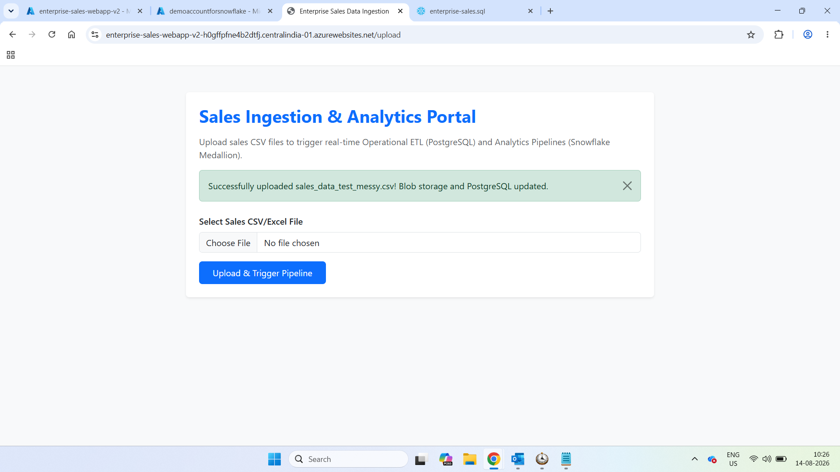
Description: Shows the live web portal at enterprise-sales-webapp-v2.azurewebsites.net after a successful upload.
- Publicly accessible HTTPS endpoint secured with Azure SSL.
- User file selection with client/server validation.
- Immediate flash feedback confirming successful upload to Azure Blob Storage.
Figure 5: Azure Blob Storage Container (salesfiles)
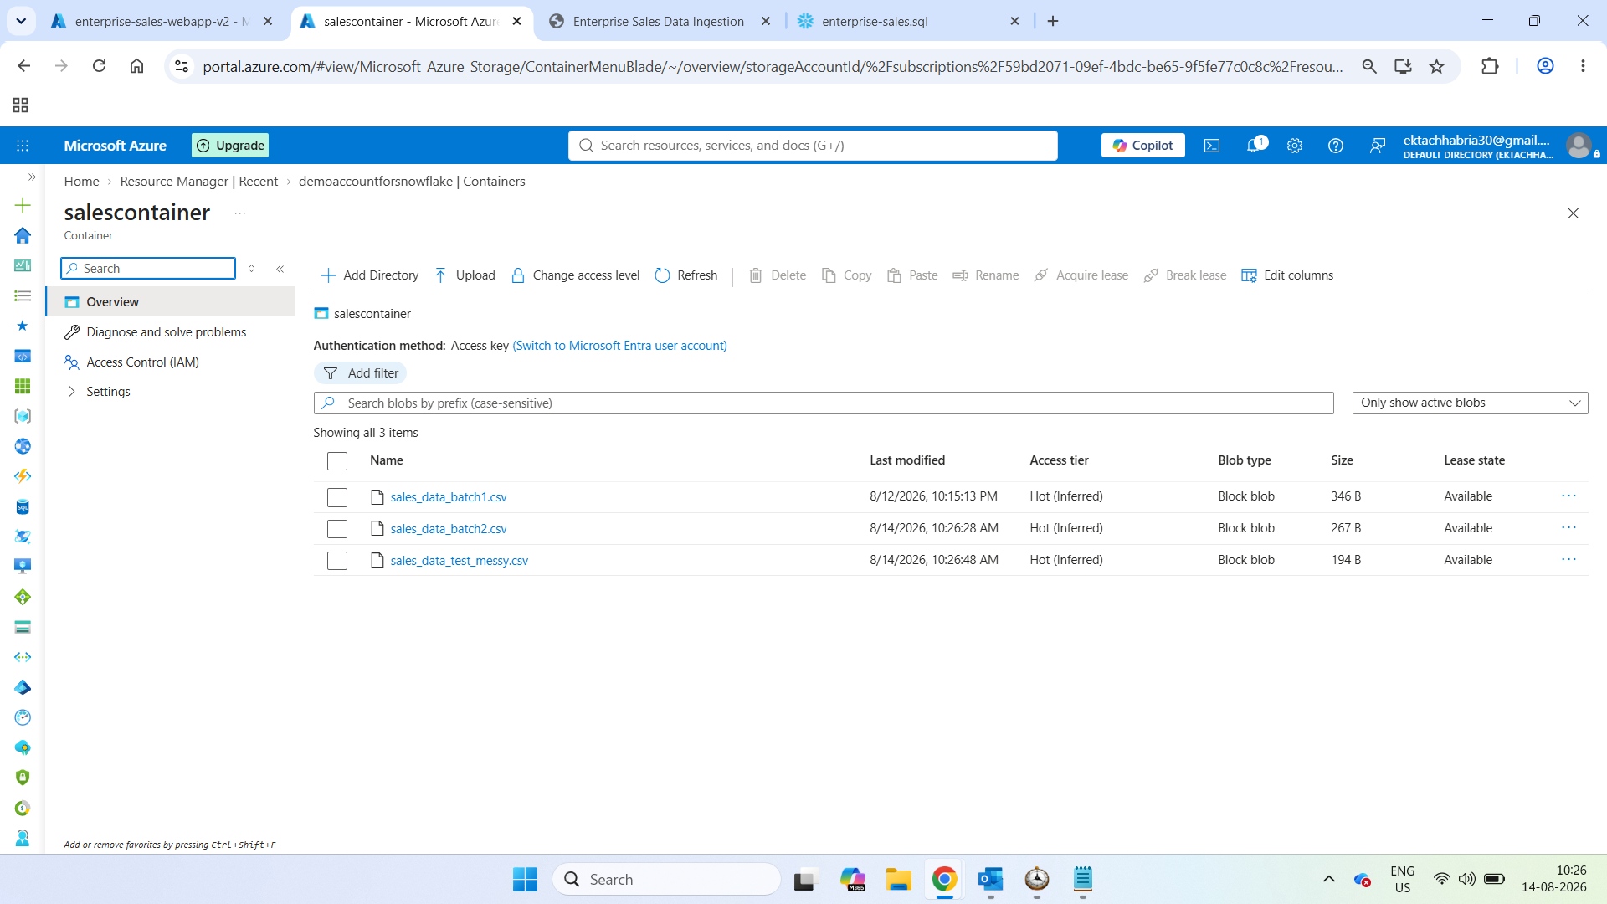
Description: Shows uploaded CSV batches (sales_data_batch1.csv, sales_data_test_messy.csv) in the storage account.
- Storage Account: demoaccountforsnowflake.
- Container: salesfiles (configured with Event Grid notifications).
- Blob timestamps matching real-time upload actions from the web portal.

3.4 Snowflake Medallion Data Warehouse Verification
The Snowflake data warehouse executes automated multi-tier transformations across Bronze, Silver, and Gold schemas.
Figure 6: Bronze Layer Ingestion (ENTERPRISE_SALES_DB.BRONZE.RAW_SALES)
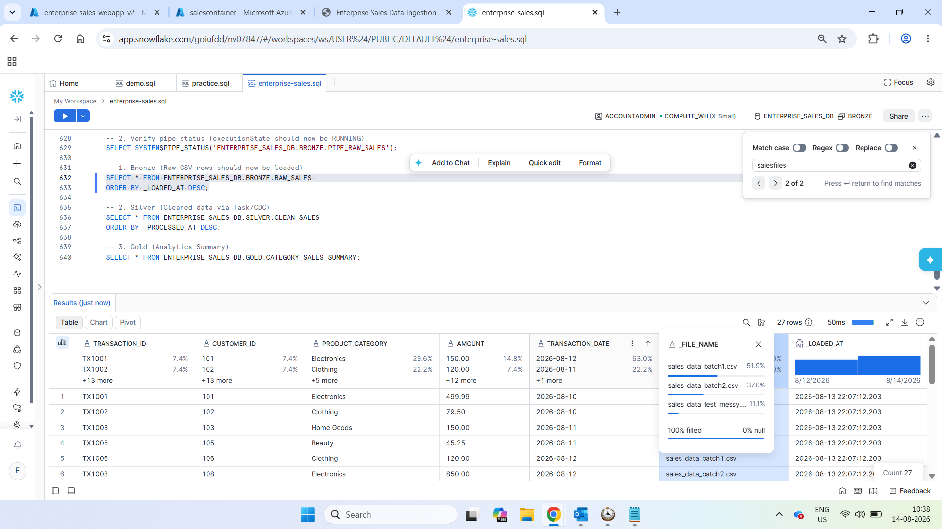
Description: Snowflake worksheet output showing raw string records loaded via Snowpipe.
- Shows raw payload including metadata columns (_FILE_NAME and _LOADED_AT).
- Preserves unparsed string data to prevent ingestion bottlenecks on malformed records.
- Continuous Snowpipe status confirmed via SYSTEM$PIPE_STATUS.
Figure 7: Silver Layer Cleaned & Deduplicated (ENTERPRISE_SALES_DB.SILVER.CLEAN_SALES)
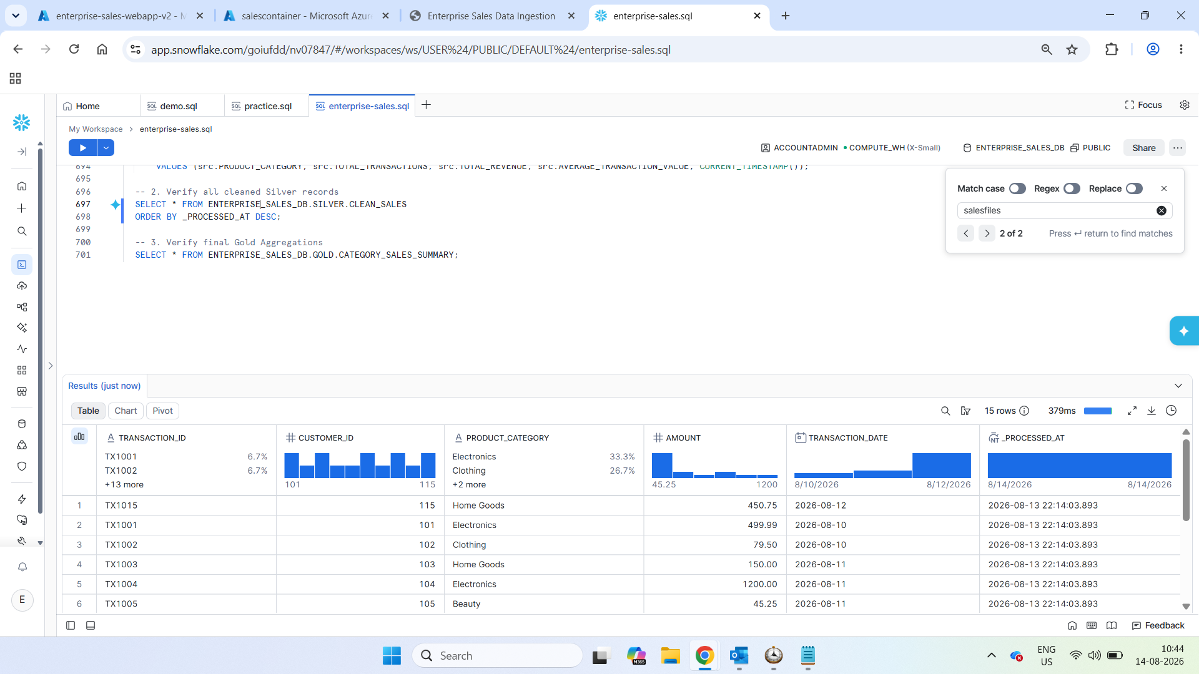
Description: Snowflake worksheet output displaying cleaned, typed, and deduplicated records.
- Type casting applied: CUSTOMER_ID (INT), AMOUNT (NUMBER(12,2)), TRANSACTION_DATE (DATE).
- Text normalization: INITCAP(TRIM(PRODUCT_CATEGORY)).
- Deduplication enforcement via QUALIFY ROW_NUMBER() OVER (PARTITION BY TRANSACTION_ID ORDER BY _LOADED_AT DESC).

Figure 8: Gold Layer KPI Summary (ENTERPRISE_SALES_DB.GOLD.CATEGORY_SALES_SUMMARY)
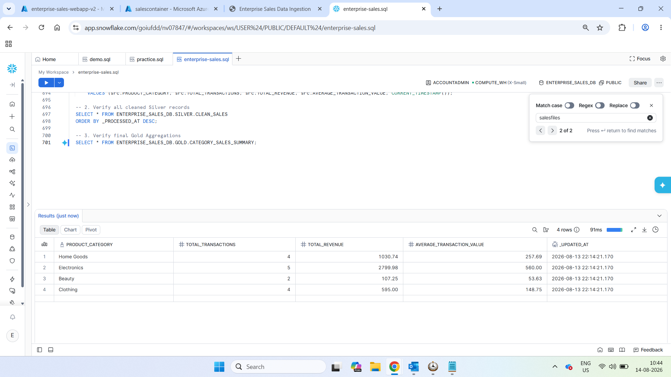
Description: Snowflake worksheet output showing aggregated business metrics by product category.
- Product Categories: Electronics, Clothing, Home Goods, Beauty.
- Aggregated KPIs: TOTAL_TRANSACTIONS, TOTAL_REVENUE, AVERAGE_TRANSACTION_VALUE.
- System timestamp (_UPDATED_AT) verifying recent DAG task refresh.

4. Production Best Practices & Architectural Lessons
• App Service Plan Quota Isolation: On Azure Free F1 tiers, quotas are shared across the App Service Plan rather than isolated to individual Web Apps. In production environments, production workloads should reside on dedicated Basic (B1) or Standard (S1) plans to avoid noisy-neighbor throttling.
• Idempotent CDC Ingestion: In event-driven pipelines, duplicate file arrivals can cause standard MERGE statements to throw non-deterministic match errors. Using QUALIFY ROW_NUMBER() guarantees that only the newest row per primary key is evaluated.
• Timezone Harmonization: Snowflake system tables and CURRENT_TIMESTAMP() default to UTC. For executive dashboards and local audit compliance, session or warehouse parameters should explicitly format timestamps to local business zones (e.g., Asia/Kolkata).

