Azure Cosmos DB (Mongo API) with ASP.NET MVC Documentation

Step 1: Create Cosmos DB Account (Azure Portal)
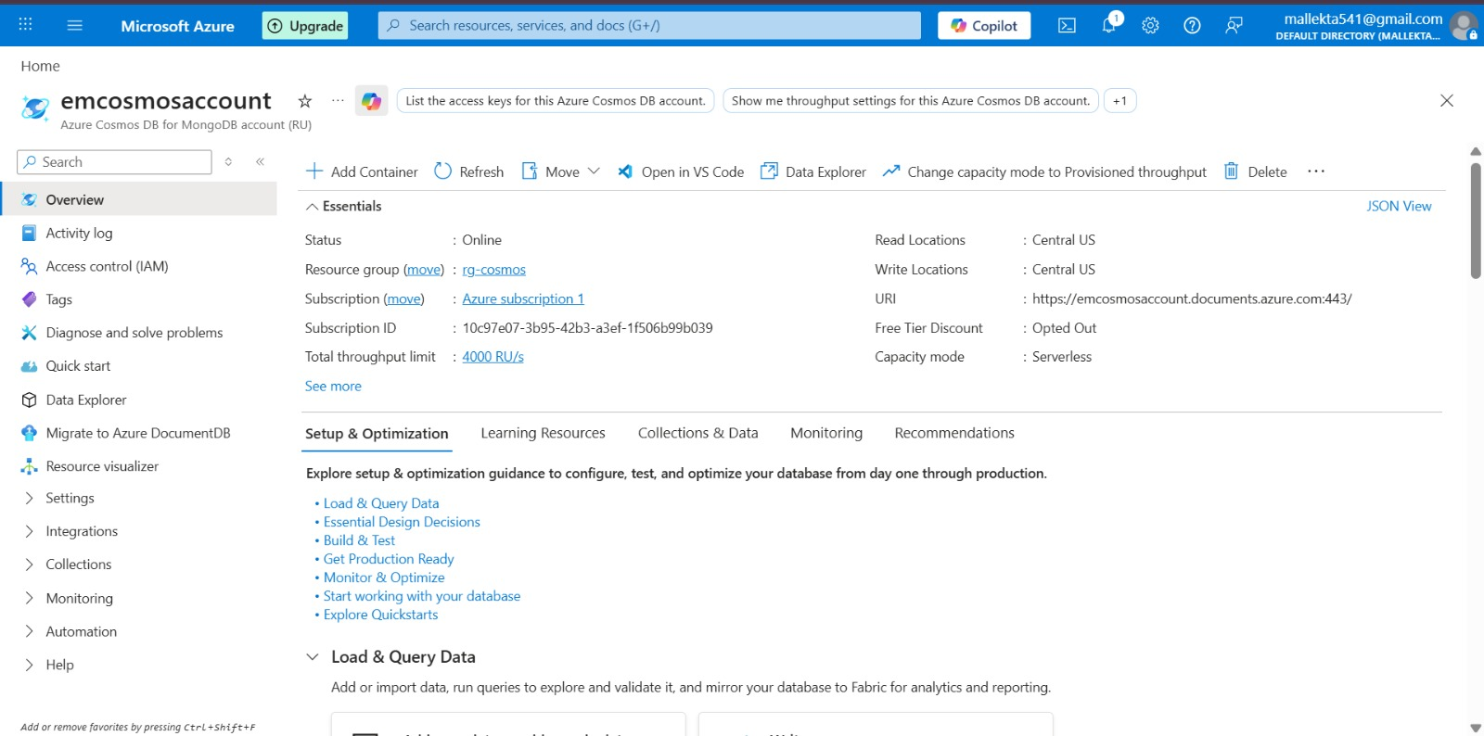

Step 2: Create Database & Collection in Data Explorer
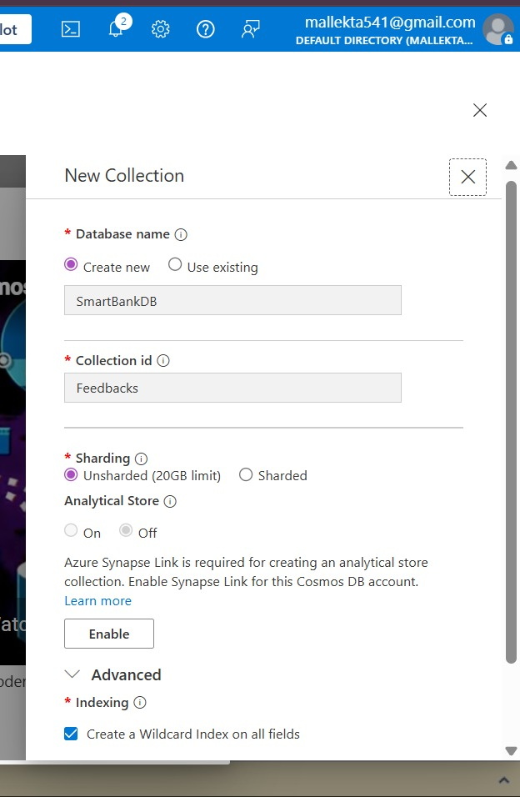.

Step 3: Get Connection String
Copied connection string from Azure portal. 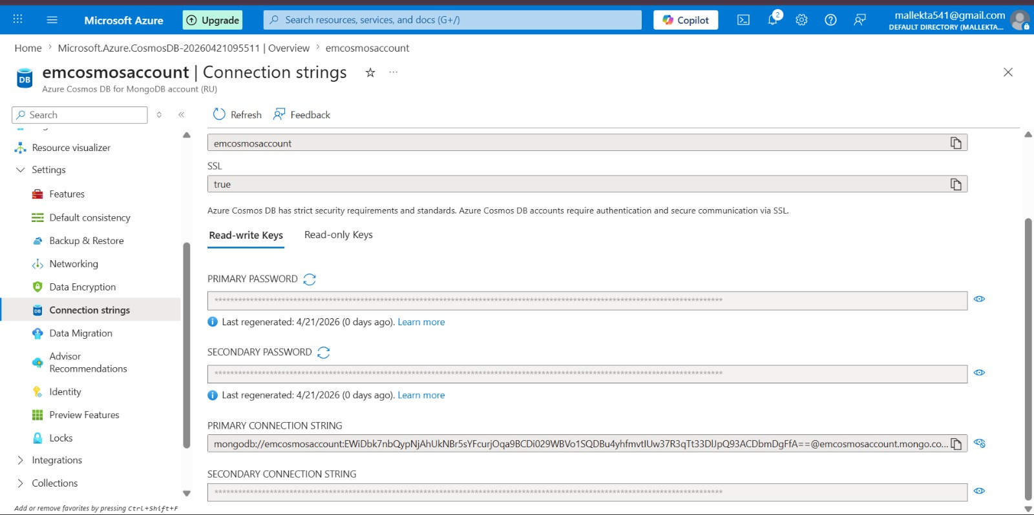

Step 4: Configure appsettings.json
Added MongoDbSettings with connection string, database, and collection.
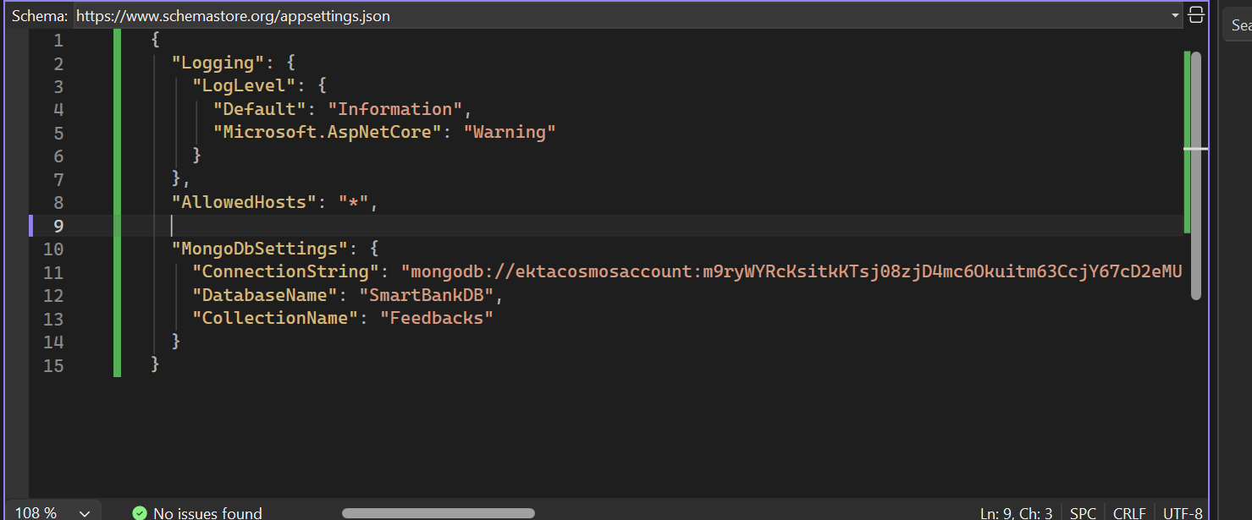

Step 5: Create Model (Feedback.cs)
Defined Feedback model with Id, Name, Email, Comment, and Rating.
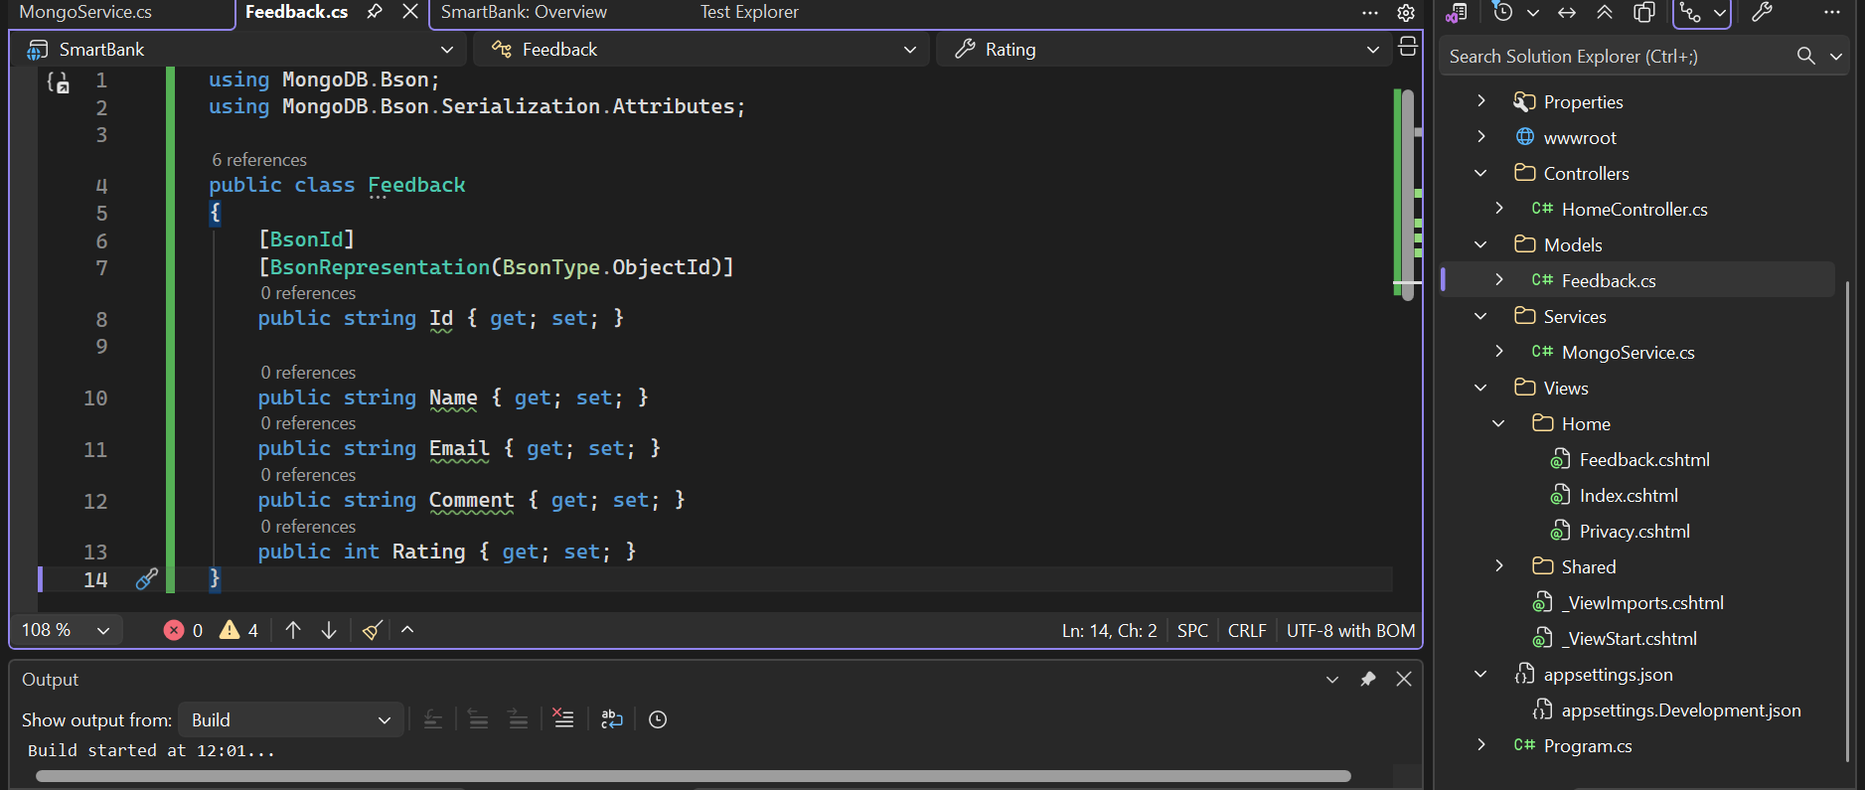

Step 6: Create Mongo Service
Implemented MongoService to connect and insert data.
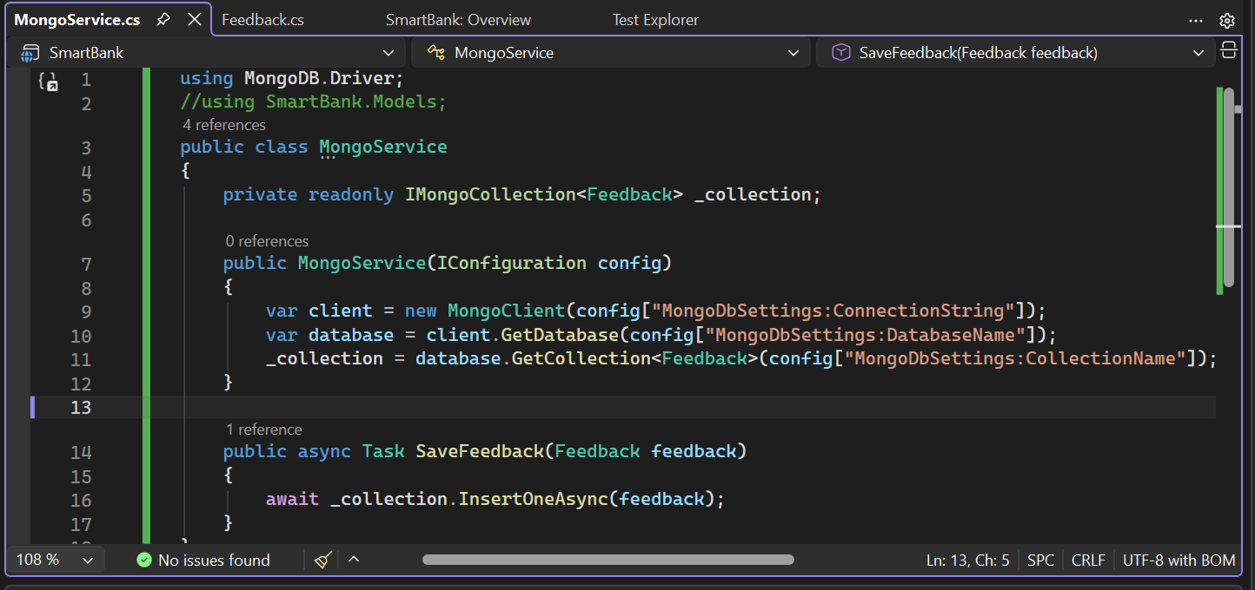

Step 7: Create Razor Page & Controller
Created UI form and controller action to save feedback.

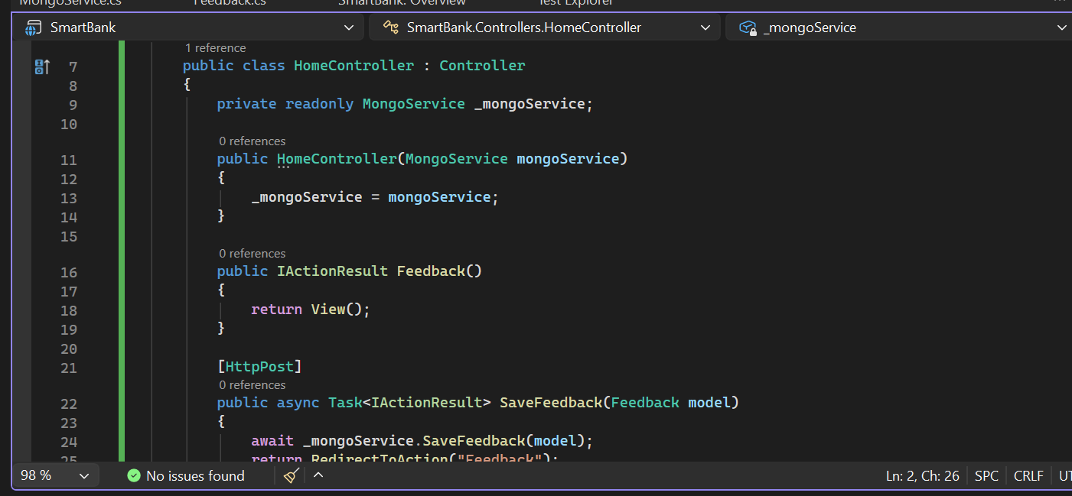

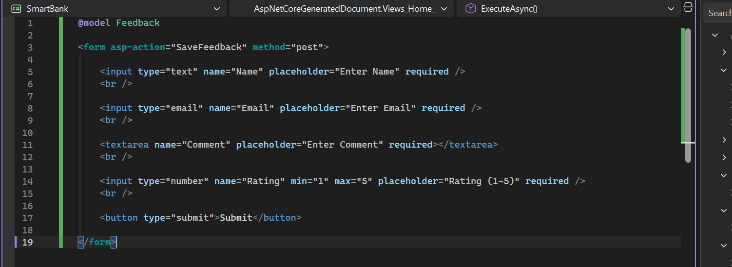

Step 8: Run Application and Submit Data
Executed application and submitted feedback form.
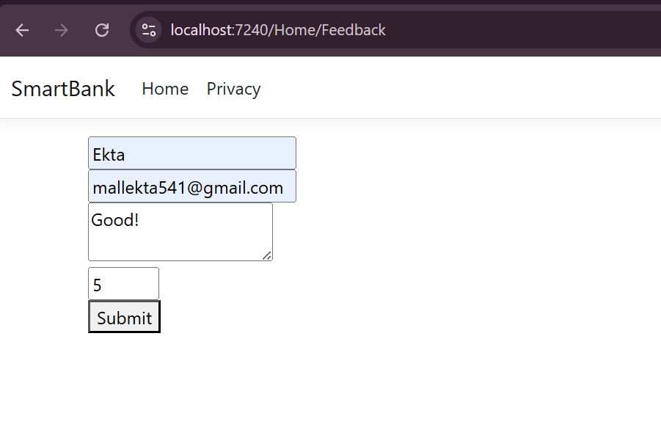

Step 9: Verify Data in Cosmos DB
Verified that data is successfully stored in Cosmos DB.
