VNet-to-VNet VPN Implementation Using Azure VPN Gateway
Name: Ekta Mall

Objective
To create a secure connection between two Azure Virtual Networks using VPN Gateway and verify connectivity using virtual machines.

Detailed Implementation Steps
Step 1: Create Resource Group
Name: rg-vnet-vpn-lab
Region: Central India
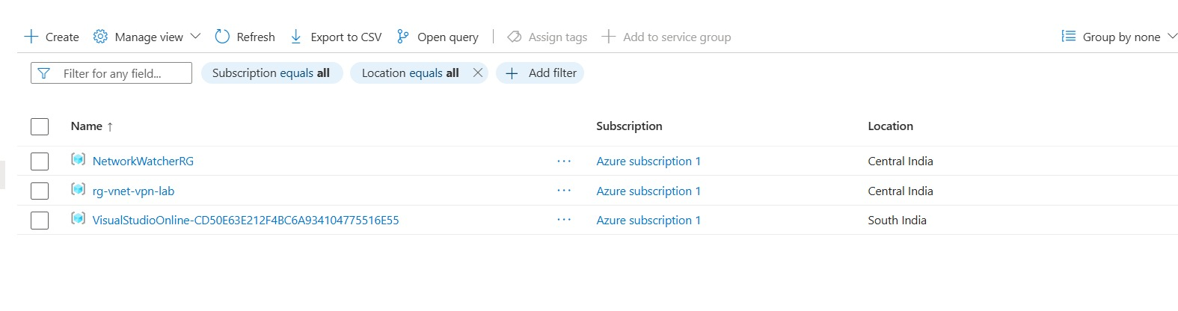
Step 2: Create VNet1
Name: vnet1
Address space: 10.0.0.0/16
Subnet1: 10.0.1.0/24
GatewaySubnet: 10.0.255.0/27
Step 3: Create VNet2
Name: vnet2
Address space: 10.1.0.0/16
Subnet1: 10.1.1.0/24
GatewaySubnet: 10.1.255.0/27

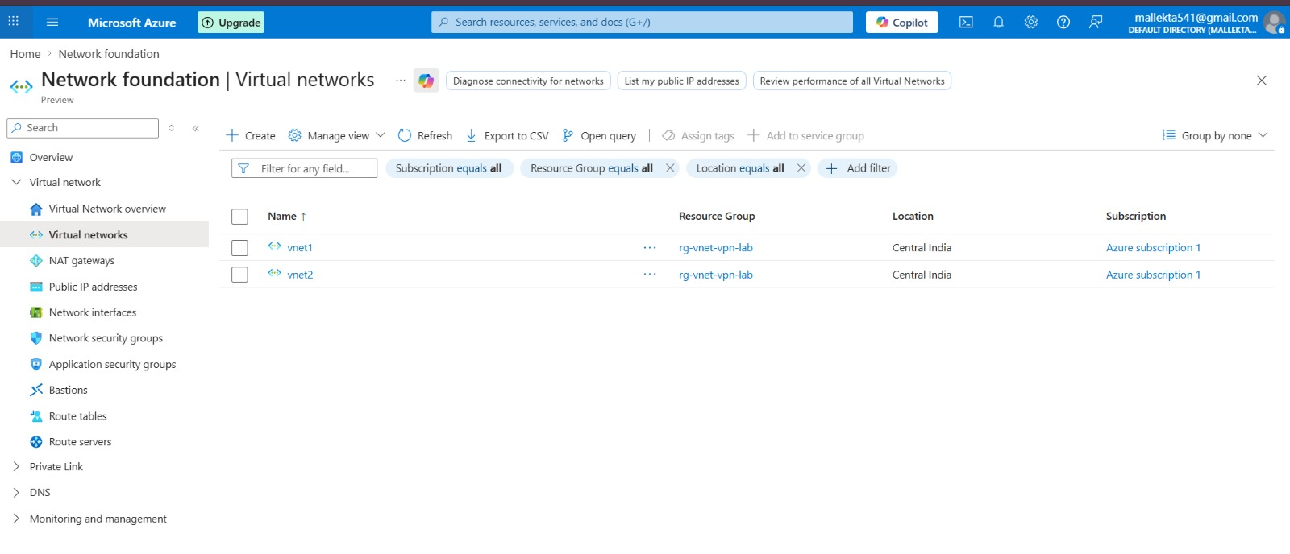
Step 4: Create VPN Gateway for VNet1
Name: vnet1-gateway
Type: VPN
VPN Type: Route-based
SKU: VpnGw1
Public IP: pip-vnet1-gw
Active-active: Disabled
BGP: Disabled
Step 5: Create VPN Gateway for VNet2
Name: vnet2-gateway
Public IP: pip-vnet2-gw
Same configuration as above
Step 6: Create Connection
Connection Name: vnet1-to-vnet2
Type: VNet-to-VNet
Shared Key: Azure123
Step 7: Reverse Connection
Connection Name: vnet2-to-vnet1
Shared Key: Azure123

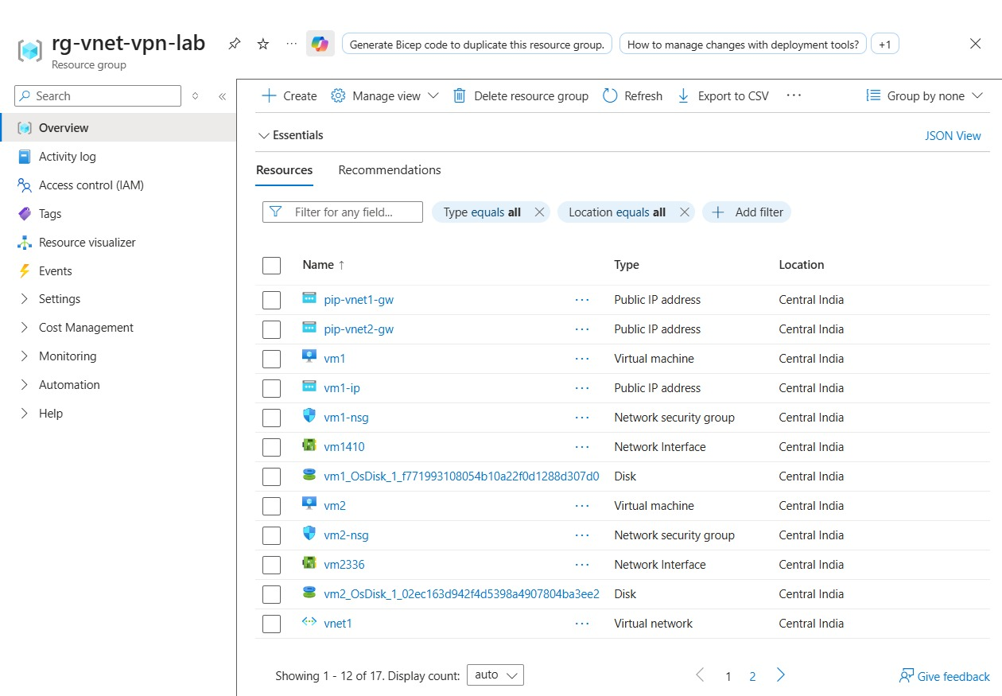
Step 8: Create Virtual Machines
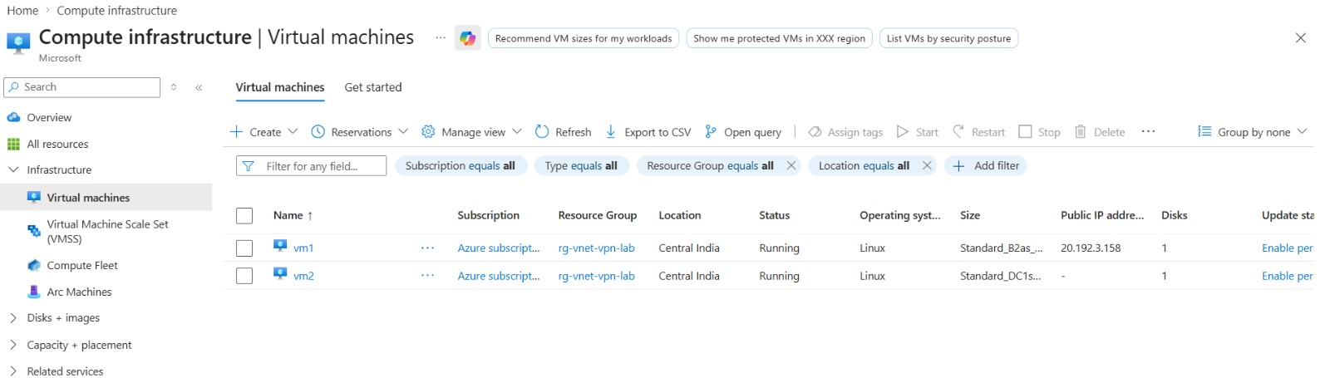

VM1:
Name: vm1
VNet: vnet1
Subnet: subnet1
Public IP: Enabled
Username: azureuser
Password: (user-defined)

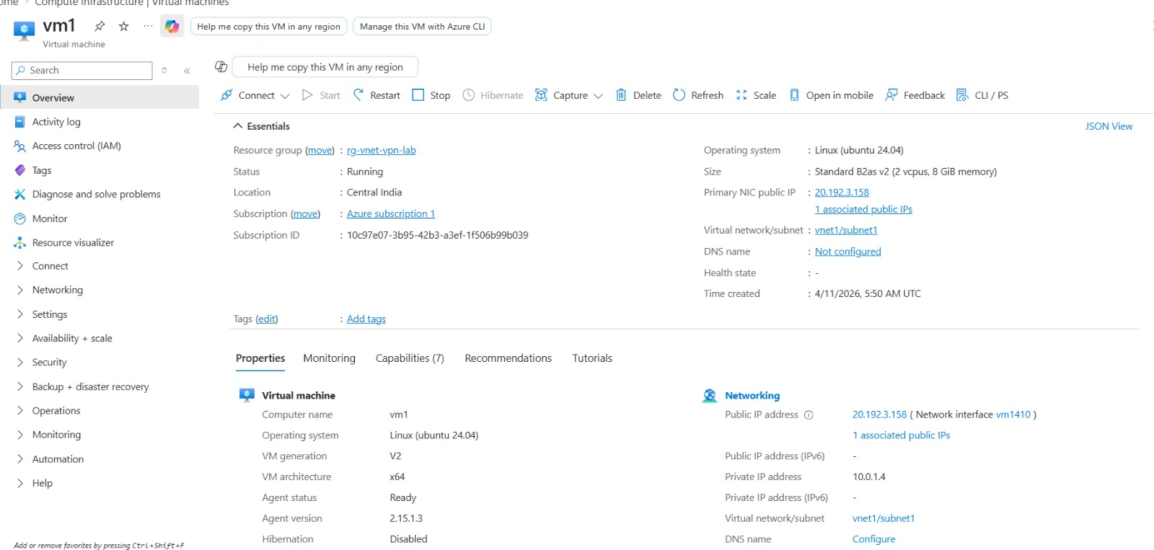
VM2:
Name: vm2
VNet: vnet2
Subnet: subnet1
Public IP: None (due to free subscription limit)
Username: azureuser1
Password: (user-defined)
Note: VM2 was created without public IP because Azure free subscription allows limited public IPs.
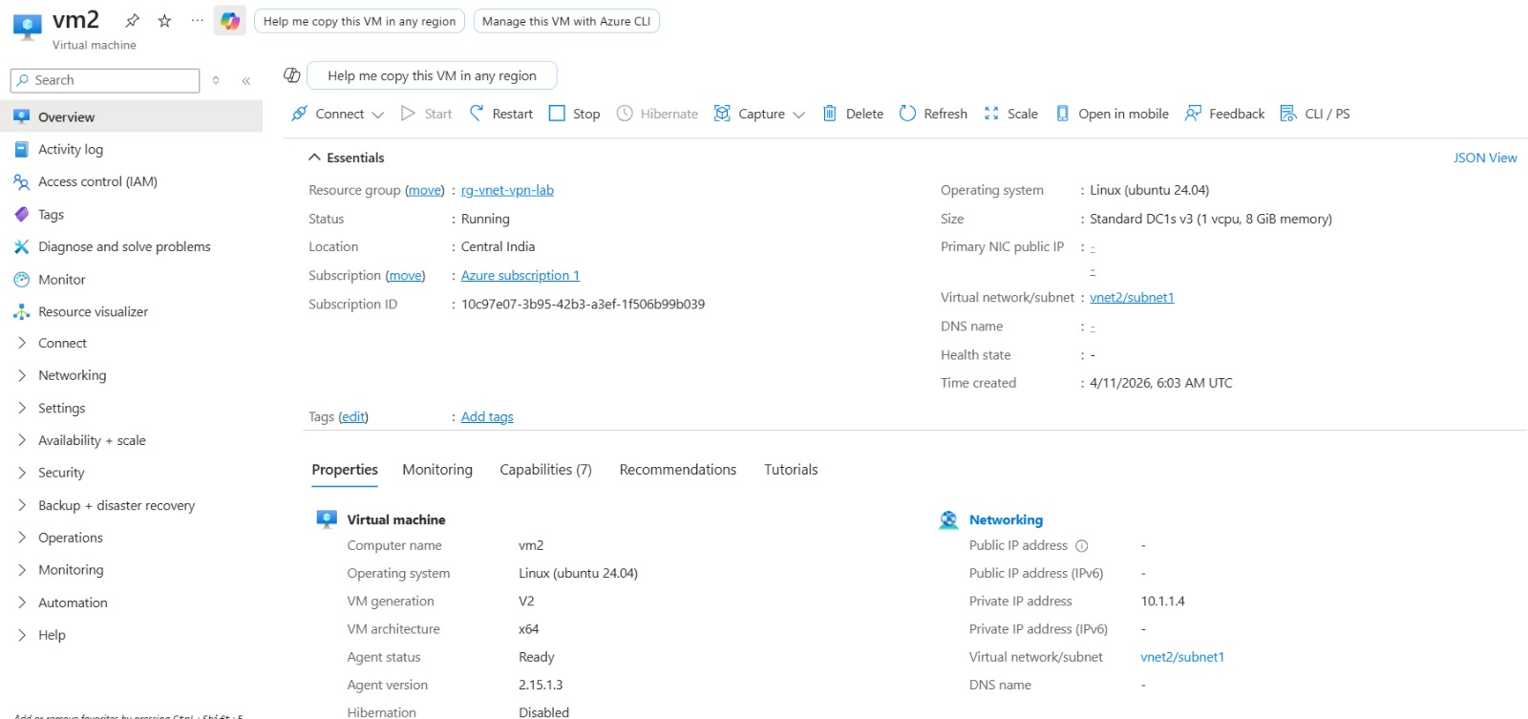
Step 9: Connectivity Test
From VM1:
ping 10.1.1.4
From VM2:
ping 10.0.1.4
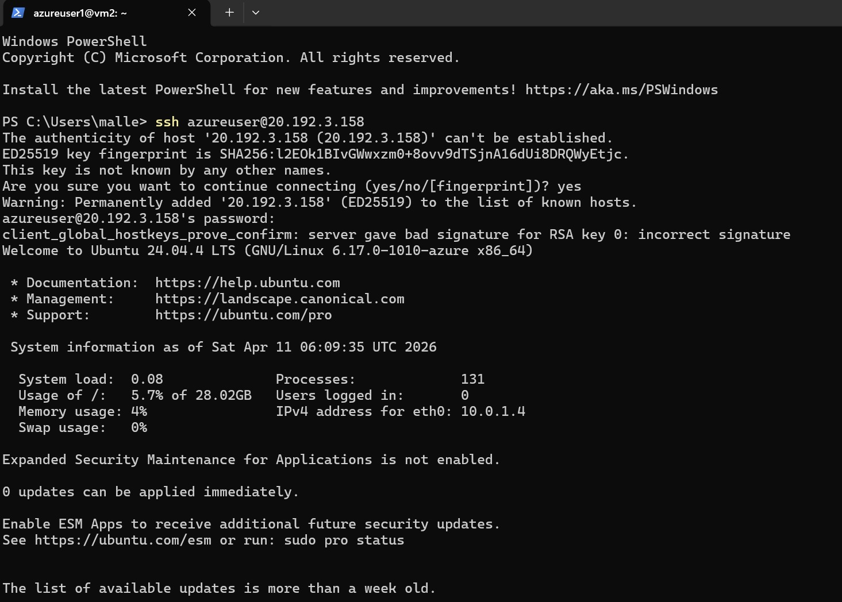
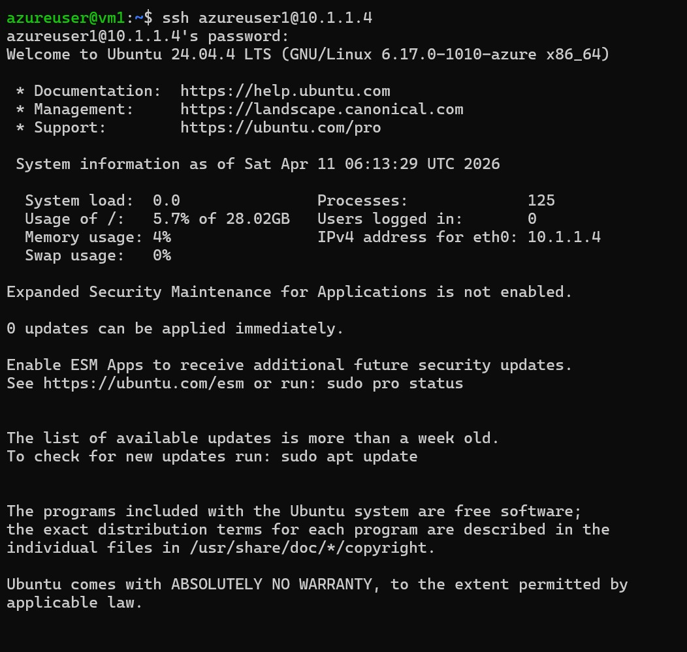

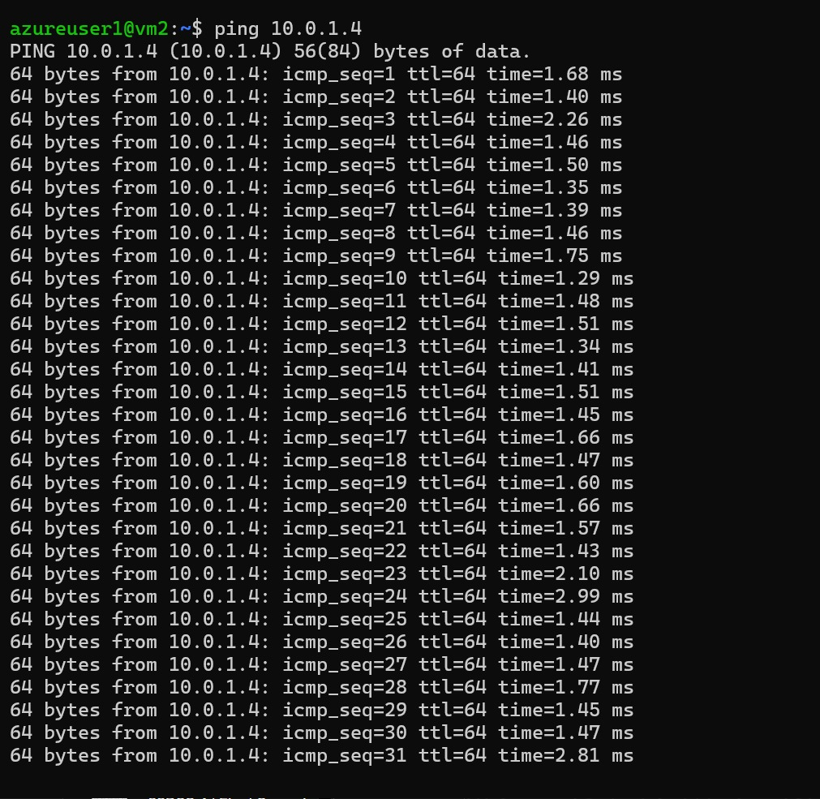

Conclusion
The VNet-to-VNet VPN was successfully created and verified using ping between virtual machines.

