Azure Blob Trigger → Function → Logic App Email Notification
Step 1: Create Resource Group and required Azure services (Storage, Function App, Logic App).
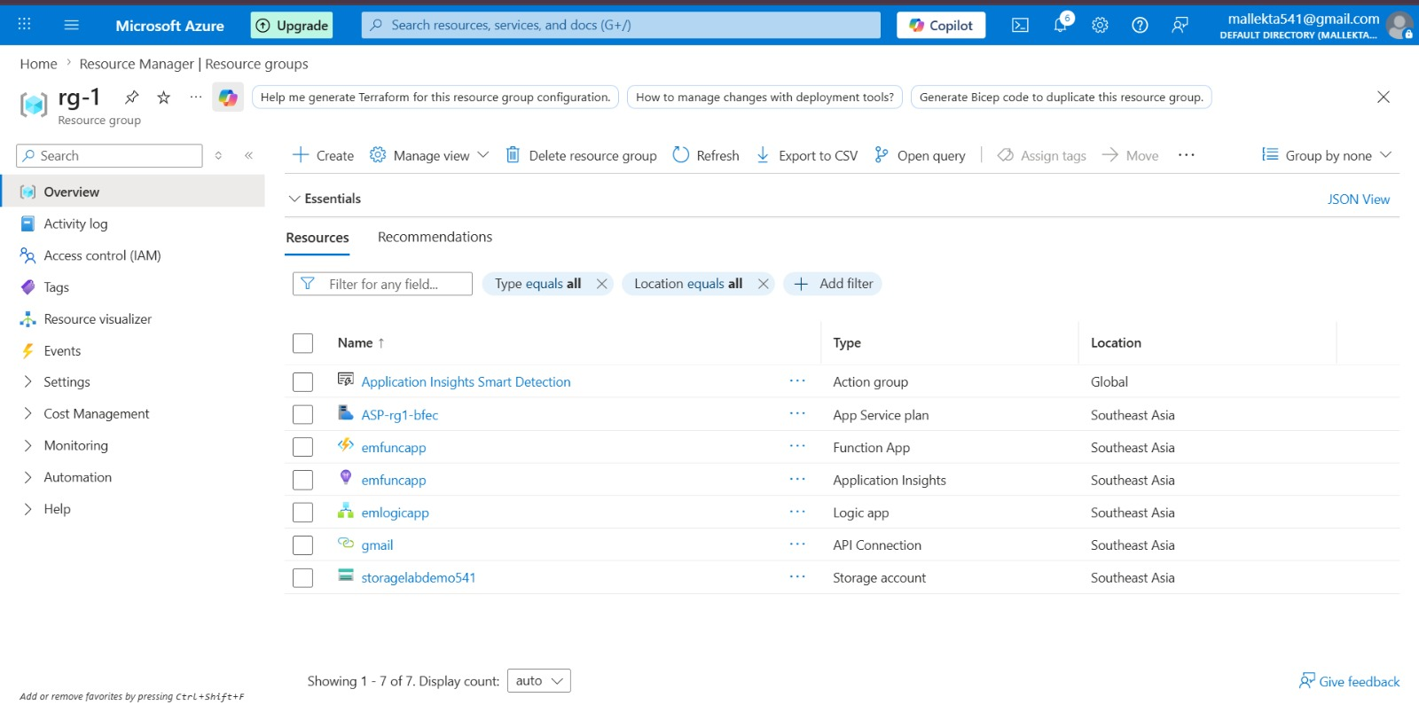

Step 2: Create Azure Storage Account and Blob Container (uploads).
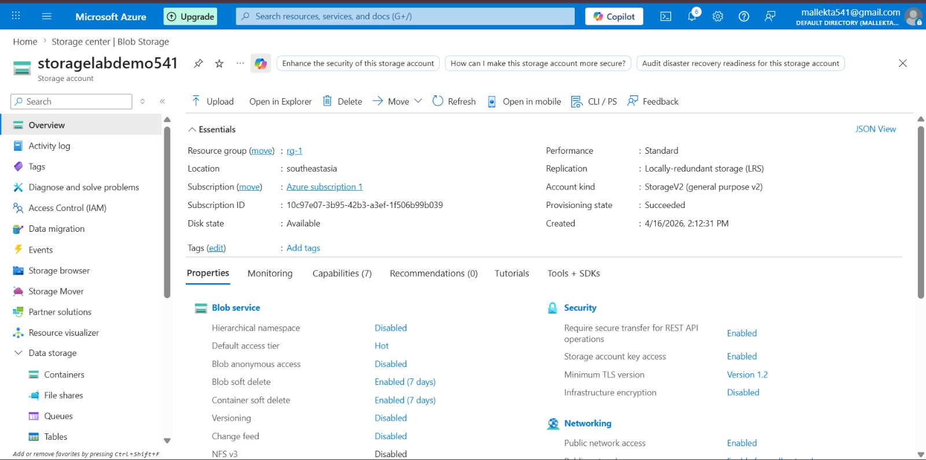

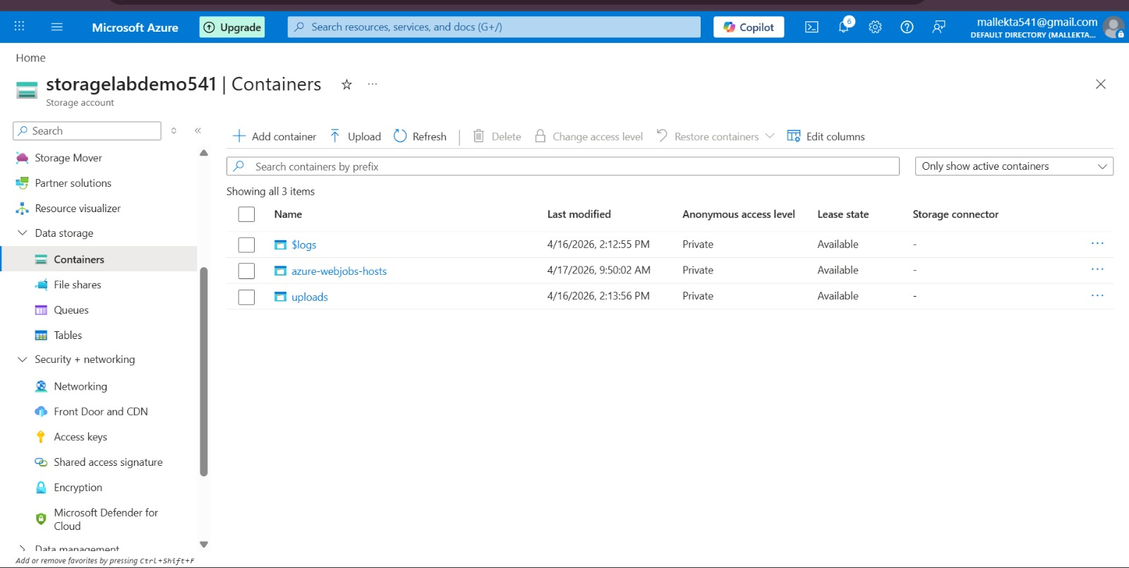

Step 3: Configure Access Keys and connection string.
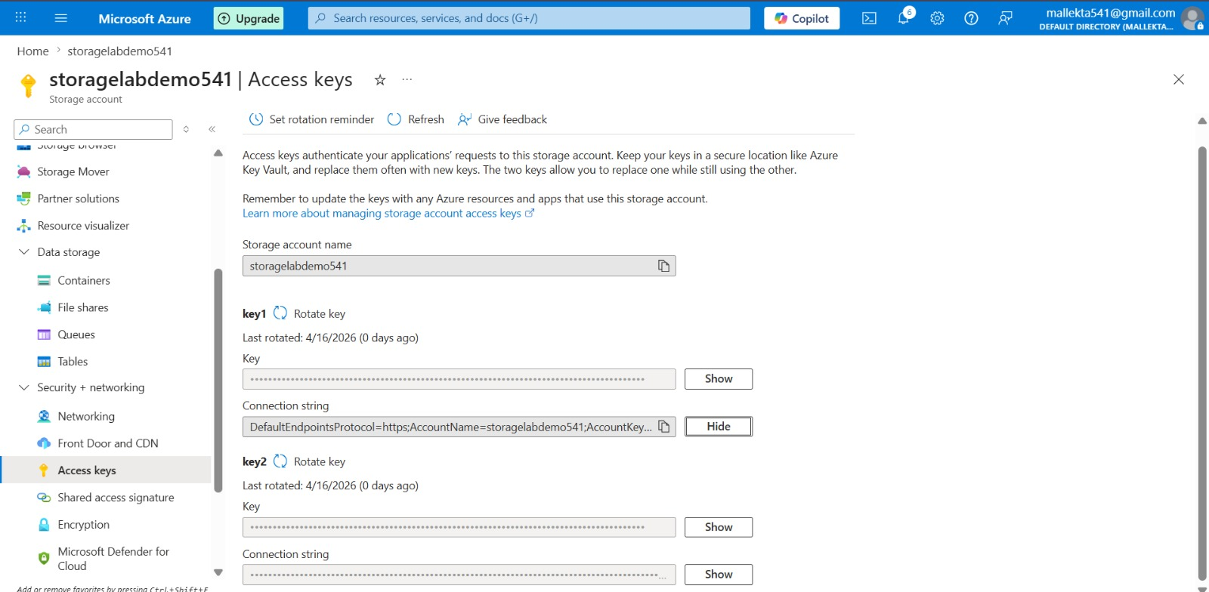

Step 4: Create Azure Function (Blob Trigger).
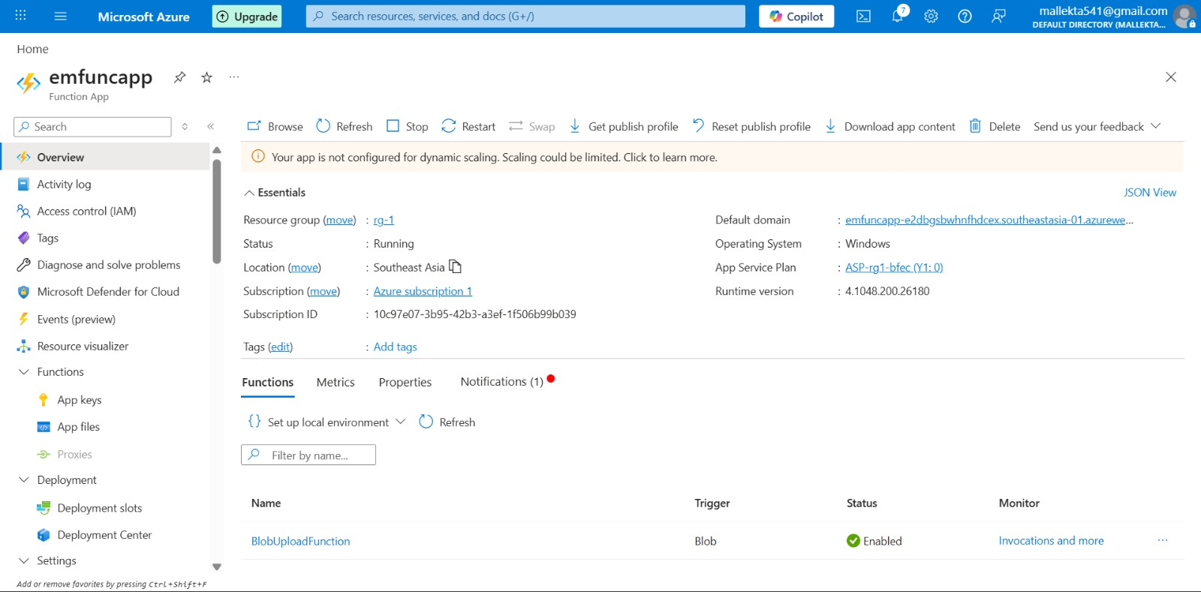

Step 5: Configure environment variable (AzureWebJobsStorage).
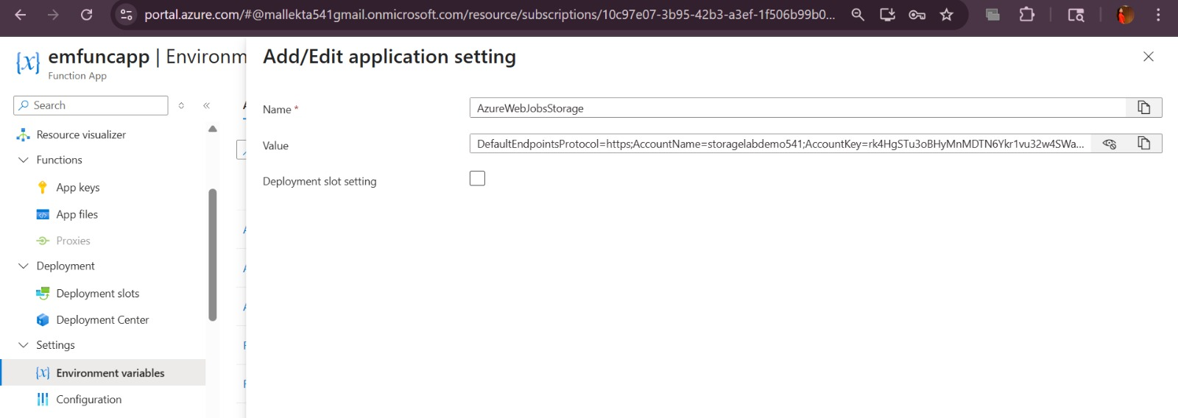

Step 6: Implement Blob Trigger function to capture file upload event.
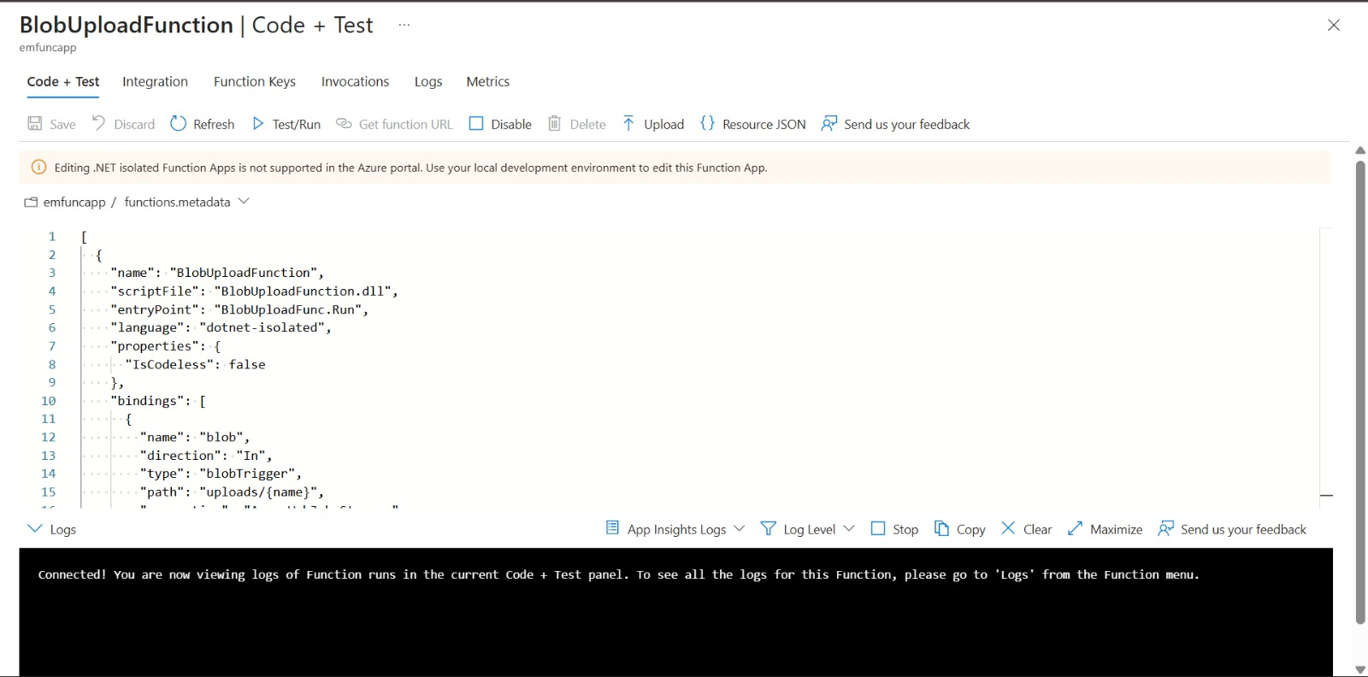

Step 7: Create Logic App.
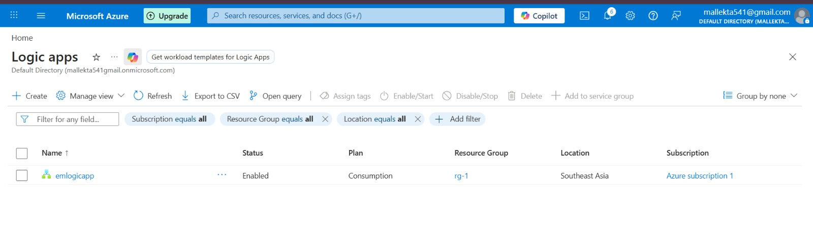
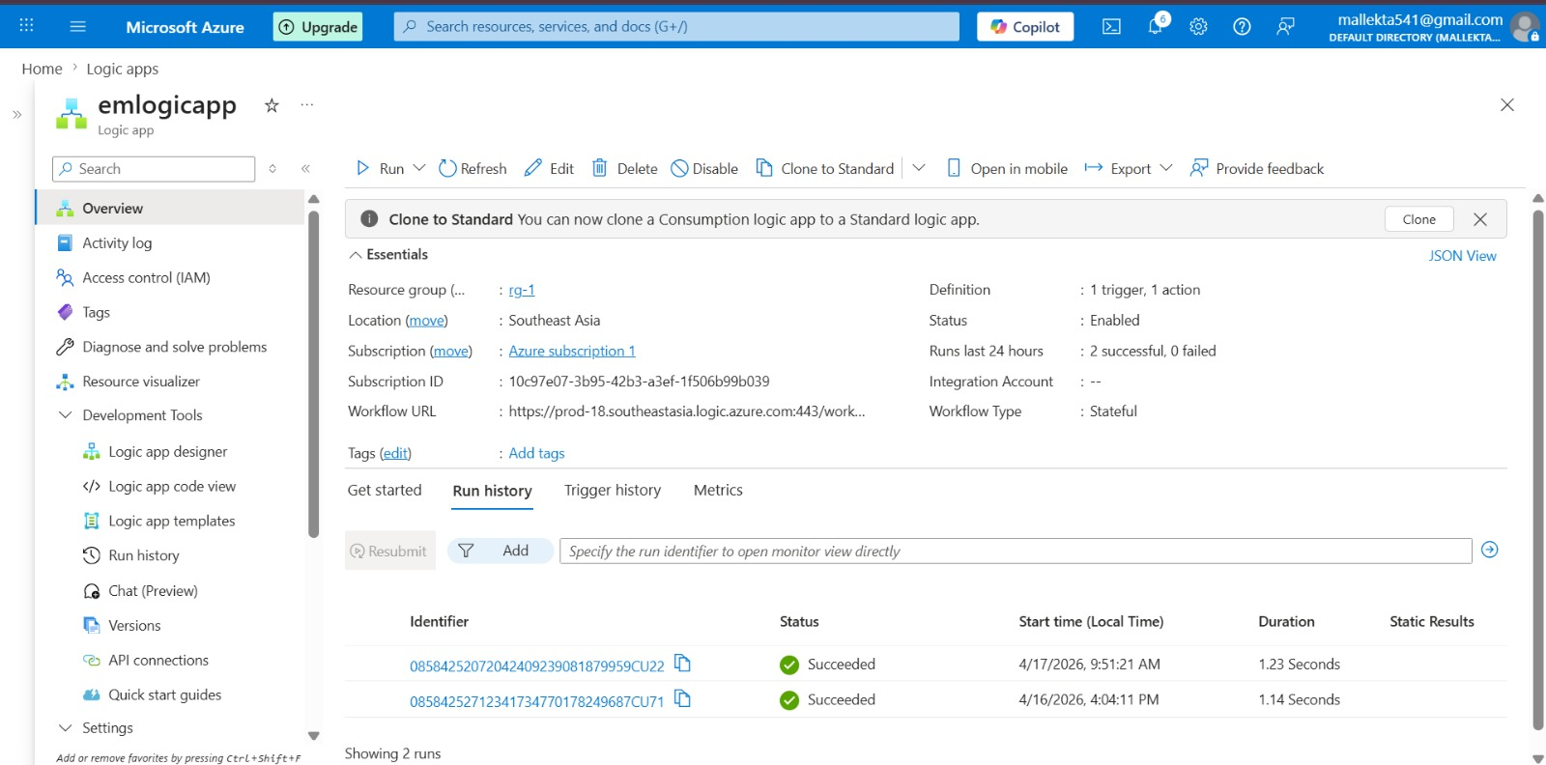

Step 8: Add trigger: When HTTP request is received.
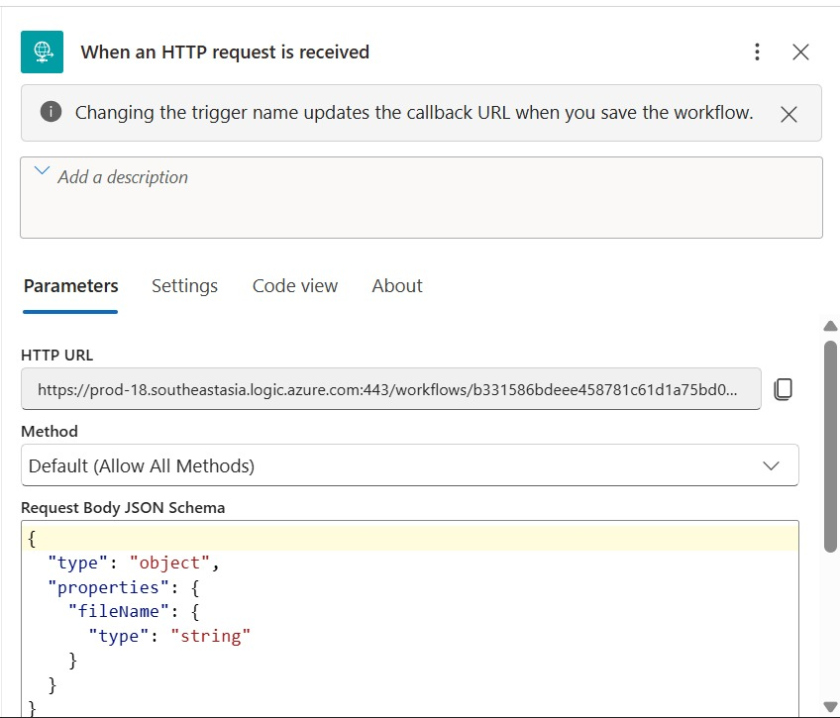
Step 9: Define JSON schema with fileName.
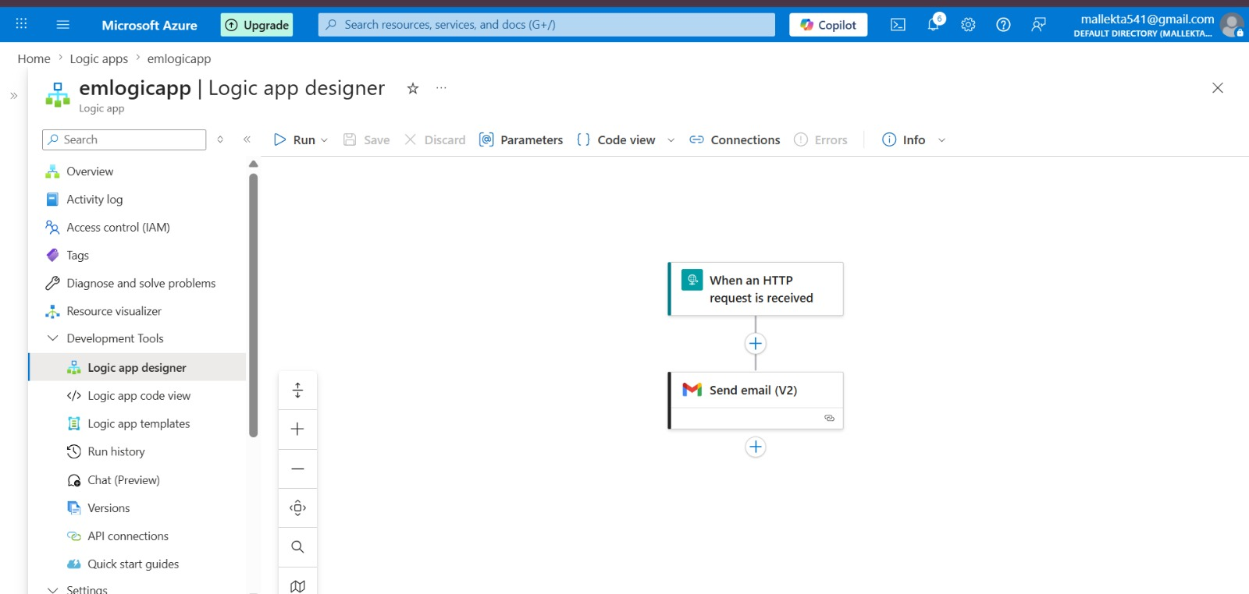

Step 10: Add action: Send Email (Gmail/Outlook).

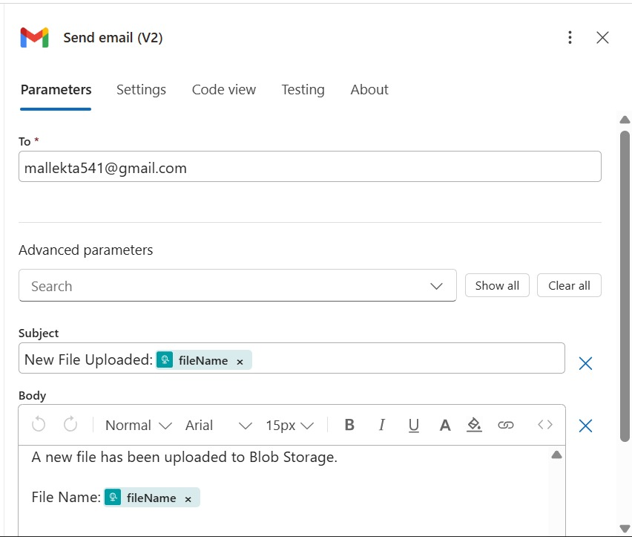

Step 11: Connect Function to Logic App via HTTP call.
Step 12: Test by uploading file to Blob container.
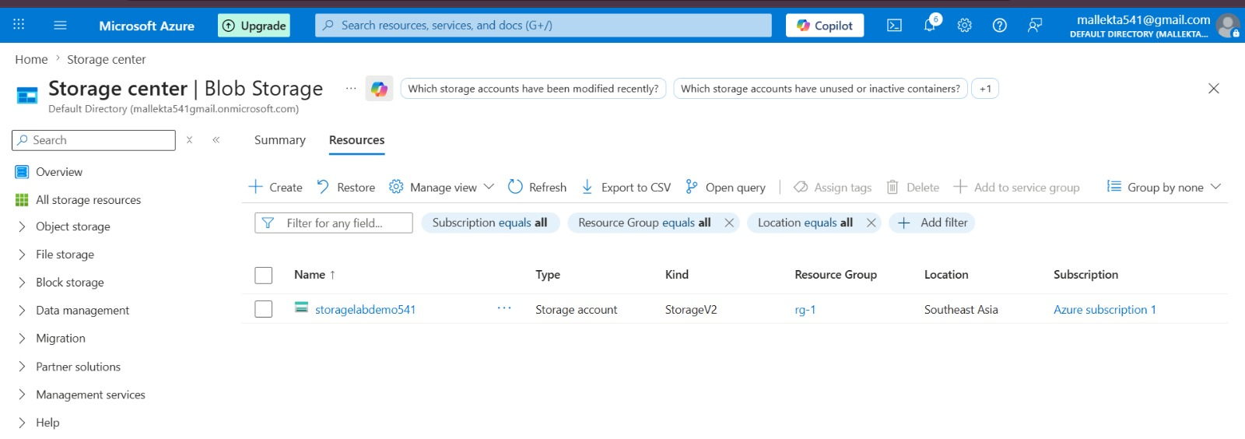

Step 13: Verify email notification received.
