UNDERSTANDING GUIDE
PlaceIQ
Everything the team needs to understand, present and defend the project
Fundamentals of Database Systems (FDS)
Prof. Debapriyay Mukhopadhyay · PGDBA Batch 12, IIM Calcutta
Member | Name | Presentation segment
M1 | Ekta Sharma | Problem & EER
M2 | [Member 2] | Schema, normalization & DDL
M3 | [Member 3] | SQL queries & rules
M4 | [Member 4] | Analytics & performance

November 2026 · github.com/EktaSharma-github/placeiq

Contents

(If page numbers are missing, right-click the table and choose Update Field.)

1. How to use this guide
This guide is for the four of us, not for the examiner. Read sections 2 and 3 once to get the whole picture. Then use section 4 as a concept-by-concept reference: for each course topic it says what the concept is, where it appears in PlaceIQ, and one sentence you can say aloud. Section 6 is the question bank; section 7 is your personal preparation sheet.
The one sentence to remember
PlaceIQ replaces the placement committee's spreadsheet with a PostgreSQL database that enforces the placement rules itself (ineligible applications, double-booked interviews and second acceptances are refused by the database, not by people), and then uses that data to find the students the process serves badly.

2. The project in two minutes
- Problem. The committee uses a spreadsheet; it duplicates data, suffers anomalies and cannot enforce rules.
- Model. We drew an EER model with every advanced construct: overlapping and disjoint specialization, a weak entity, aggregation and a union type.
- Schema. We mapped it to 22 tables and proved them to be in BCNF from the functional dependencies.
- Rules. Constraints enforce what can be declared; triggers enforce rules that span tables; a stored procedure accepts offers atomically.
- Data. 180 students and 1,184 applications, generated reproducibly and loaded through the rules.
- Questions. Five queries answer real committee questions using HAVING, division, correlated subqueries and window functions.
- Analytics. SQL computes the statistics and a feature matrix; k-means finds 4 student segments that differ sharply in placement outcome; the labels go back into the database, and S2 lists the 52 students who need help.
- Proof. 91 automated tests pass; indexing, concurrency and SQL injection were measured and demonstrated.
- Show. A web UI lets us demonstrate it live, with a recorded backup video.
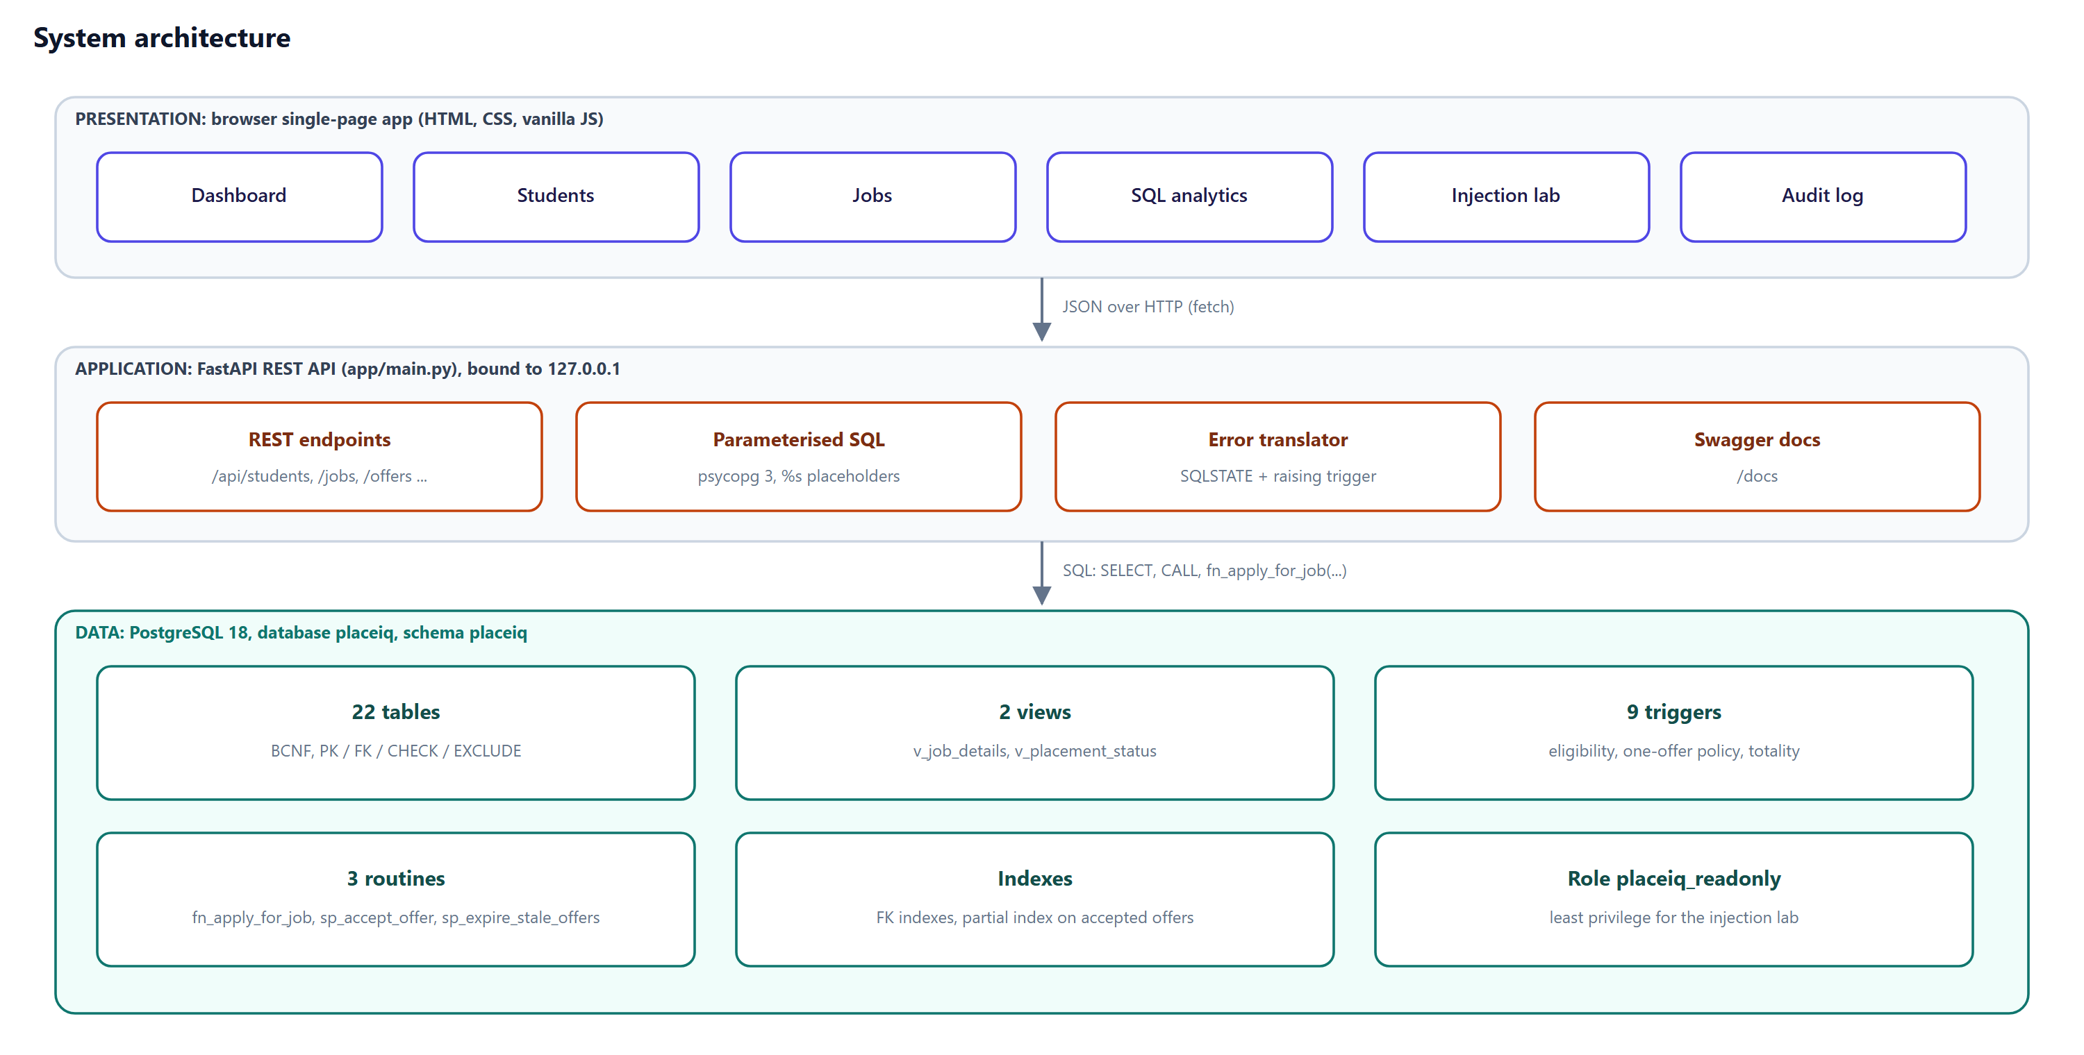
Figure 1. How the parts fit: browser → REST API → PostgreSQL.

3. Where everything lives
File | What it contains | Who presents it
01_design.md | Business rules, EER description, mapping, normalization notes | M1, M2
02_ddl.sql | CREATE TABLE statements, constraints, FK indexes | M2
03_logic.sql | Views, triggers, procedures, the read-only role | M3
04_data.sql | Mock data and the recruitment simulation | M3
05_queries.sql | The five analytical queries | M3
06_demo.sql | psql demo script (fallback for the live demo) | M3
07_analytics.sql | SQL statistics (A1–A5), feature view, segment tables, S1–S2 | M4
analytics/ | k-means notebook (.ipynb and .html) and figures | M4
app/ | Web UI and REST API | M3 (demo)
tests/ | Automated tests and results | M4
deliverables/ | Report, this guide, testing report, runbook, slides, video, diagrams | All

3.1 Build order
02_ddl.sql creates empty tables → 03_logic.sql installs views, triggers and procedures → 04_data.sql loads data through those triggers in one transaction → 07_analytics.sql adds the feature view and the (empty) segment tables. run_all.ps1 does all four; the UI's 'Reset demo data' button and the test suite do the same.
After any rebuild, rerun the notebook
A rebuild (run_all.ps1, Reset demo data, or running the tests) leaves the segment tables empty. Run analytics/placeiq_kmeans.ipynb again before showing S1, S2 or v_segment_profile.

4. Concepts, mapped to PlaceIQ
Each row: the textbook idea, where it is in our project, and a sentence you can say.
Concept | What it is | Where in PlaceIQ | Say it like this
DBMS vs file system | A DBMS manages shared data with integrity, concurrency, recovery and security; a file just stores bytes. | The spreadsheet problem in section 1: duplication, anomalies, no rule enforcement. | "We moved the rules from people into the DBMS."
Data models | Ways to describe data: hierarchical, network, relational, object-oriented. | We use the relational model; the EER model is our conceptual model. | "Relational: everything is a table of tuples with keys."
Entity, attribute types | Simple/composite, single/multi-valued, stored/derived, key. | name is composite; skills is multi-valued; placement_status is derived. | "Derived attributes are computed, not stored: our view does that."
Cardinality & participation | How many instances relate (1:1, 1:N, M:N); whether participation is total or partial. | Student–Program N:1 with total participation (double line). | "Every student must be in a program: total participation."
Specialization / generalization | Subclasses of a superclass; disjoint (d) or overlapping (o); total or partial. | PERSON → STUDENT… overlapping, partial. JOB_ROLE → INTERNSHIP / FULLTIME disjoint, total. | "A student can also be on the committee, so it's overlapping."
Weak entity | An entity with no key of its own; identified through its owner via an identifying relationship. | INTERVIEW_ROUND, key (job_id, round_no); round_no is the partial key. | "'Round 2' means nothing without its job."
Aggregation | Treating a relationship (with its entities) as an entity so it can take part in another relationship. | APPLIES_TO is aggregated; interviews and offers attach to an application. | "You interview an application, not a student in general."
Category / union type | A subclass whose superclasses are of different entity types. | SPONSOR = COMPANY ∪ ALUMNUS. | "Two different kinds of thing playing the same role."
ER → relational mapping | Standard steps converting each construct to tables and keys. | 22 tables; 8A for subclasses; surrogate key for the category. | "One table per subclass, so subtype columns can be NOT NULL."
Keys | Super key ⊇ candidate key (minimal) → primary key; others are alternate keys; foreign keys reference keys. | placement_cycle has 3 candidate keys; job natural key kept UNIQUE. | "Surrogate ids for convenience, natural keys kept as UNIQUE."
Integrity constraints | Domain (CHECK), entity (PK), referential (FK), key (UNIQUE), plus general constraints. | 45 CHECK, 30 FK, 17 UNIQUE, 1 EXCLUDE. | "If a rule can be declared, we declared it."
Functional dependency | X → Y: equal X values imply equal Y values. | roll_no → name, cgpa; prog_code → prog_name; (job, program) → min_cgpa. | "FDs are the business facts that decide the tables."
Anomalies | Update, insertion and deletion problems caused by redundancy. | Company HQ repeated; job can't exist without an applicant. | "Normalization exists to remove these three."
1NF / 2NF / 3NF / BCNF | Atomic values / no partial dependency / no transitive dependency / every determinant a super key. | skills split (1NF); student, company… split (2NF); program, eligibility split (3NF). | "Every determinant in every table is a key, so BCNF."
Lossless & dependency-preserving | Join of parts gives back the original; every FD checkable in one table. | Heath's theorem on each split; FD1–FD9 each live in one table. | "We lost no data and no rule."
DDL / DML / DQL | Define structure / change data / query data. | 02_ddl.sql / 04_data.sql / 05_queries.sql. | "Three files, three sub-languages."
Joins & outer joins | Combine tables on a condition; outer joins keep unmatched rows. | Q1 LEFT JOIN offer (not every application has an offer). | "Outer join so applicants without offers still count."
Aggregation & HAVING | GROUP BY summarises; HAVING filters groups (WHERE filters rows). | Q1: companies whose offer rate is below the campus average. | "HAVING compares a group to a scalar subquery."
Nested & correlated subqueries | A query inside a query; correlated ones reference the outer row and re-run per row. | Q5 compares each student to the average of that job's selected students. | "Correlated: it re-evaluates for each application."
Relational division | Find X related to ALL Y. No SQL operator; use double NOT EXISTS or counting. | Q2: students holding every skill a job needs. | "No required skill that the student lacks."
Views | Stored queries that act like tables. | v_job_details; v_placement_status (derived attribute). | "Status is a view, so it can never be wrong."
Window functions | Aggregates computed over a partition without collapsing rows. | Q3 DENSE_RANK, NTILE, AVG OVER; Q4 running SUM OVER. | "Ranks and running totals while keeping every row."
Triggers | Code the DBMS runs automatically before/after a change. | Eligibility on apply; one-offer cascade; totality check. | "For rules that span several tables."
Stored procedures / functions | Named server-side routines. | fn_apply_for_job, sp_accept_offer, sp_expire_stale_offers. | "Single, parameterised entry points."
Transactions & ACID | Atomicity, Consistency, Isolation, Durability. | Accept + cascade in one transaction; ROLLBACK undoes all. | "All of it happens, or none of it."
Concurrency & locking | Isolation levels; row locks (SELECT … FOR UPDATE); deadlock. | Student row locked first; second session waits then fails cleanly. | "Lock order prevents deadlock."
Indexes | B-tree (and other) structures for fast lookup; composite and partial indexes. | 2,434× faster with a composite index on 600k rows. | "An index lets the DBMS seek instead of scan."
Query optimisation / EXPLAIN | The planner chooses scans and joins by cost; EXPLAIN ANALYZE shows the plan and real time. | Seq Scan vs Bitmap Index Scan; blocks read. | "We measured, we didn't assume."
SQL injection | Untrusted input changing the SQL statement's structure. | Injection lab: 180 rows leaked vs 0 with a bound parameter. | "Parameters are data, never code."
DCL: roles & privileges | GRANT / REVOKE control who may do what. | placeiq_readonly: SELECT on two tables only. | "Least privilege limits the damage of any bug."
REST and databases | Web APIs expose resources over HTTP; the server talks SQL to the DBMS. | FastAPI endpoints → views, function, procedure. | "The API is thin; the database holds the rules."
Why a DBMS for analytics | Algorithms run in memory; the DBMS answers aggregate questions without loading every record. | A1–A5 are GROUP BY queries; Python gets only 177 rows × 5 features. | "Statistics first, in SQL; the model gets a small matrix."
Descriptive statistics | Mean, median, mode, SD, quartiles: the first look at how data behaves. | A1: percentile_cont, mode(), stddev_samp with GROUP BY ROLLUP. | "Mean ≈ median, so CGPA is symmetric."
Feature engineering | Turning the problem into measurable attributes, using domain knowledge. | v_student_features: cgpa, tech_score, biz_score, applications, interview_rate. | "Five things the committee sees early in the season."
k-means clustering | Partitions points into k groups, each assigned to its nearest centroid; minimises within-cluster sum of squares. | k = 4 segments of students on standardized features. | "Unsupervised: no labels, it finds the groups."
Choosing k | Elbow in the inertia curve; silhouette score (−1 to 1, higher is better). | Both point to k = 4 (silhouette 0.298). | "Two criteria agree, so we trust k = 4."
Hypothesis tests | ANOVA compares means of several groups; χ² tests independence of two categorical variables. | ANOVA p = 0.907 (programs equal in CGPA); χ² p = 0.000011 (segment vs offer). | "The segments differ in outcome, so they are real."
Classification threshold | A probability needs a cut-off t; moving t trades false positives against false negatives. | Flag if P(offer) < 0.6: recall 0.89, precision 0.78. | "Missing a student costs more than a spare seat."

5. What happens when someone clicks 'Accept'
Following one request end to end is the best way to understand how all the layers fit. The student is PGP62-084 (Dev Saxena), who holds a pending DataSutra offer.
- Browser. The Accept button calls POST /api/offers/89/accept.
- API (main.py). Opens a connection and runs CALL sp_accept_offer(%s) with 89 as a bound parameter.
- Procedure. Finds the offer's student and locks that student row with SELECT … FOR UPDATE. Any other session accepting for the same student now waits.
- Procedure. Re-reads the offer under the lock. If it is no longer PENDING, it raises an error and nothing changes.
- UPDATE offer SET status = 'ACCEPTED'. This fires the BEFORE trigger trg_offer_accept_guard: deadline not passed, no other accepted offer in this cycle.
- AFTER trigger trg_offer_accept_cascade. Declines the student's other pending offers, withdraws open applications, deletes their scheduled interviews for other jobs, writes rows to placement_log.
- COMMIT. The API's connection commits; everything above becomes permanent together. If any step had failed, all of it would roll back.
- Response. The API reads the log rows written 'now' and returns them; the browser shows the toast: 1 declined, 1 withdrawn.
- View. The profile reloads; v_placement_status now computes PLACED for the final cycle.
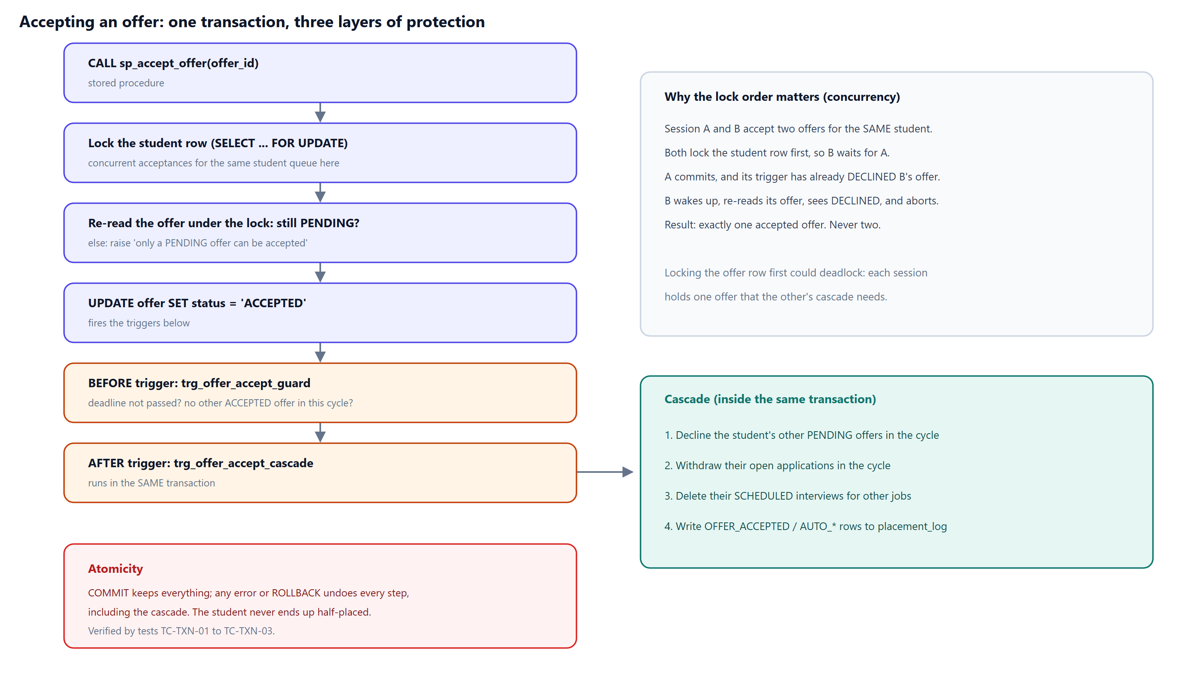
Figure 2. The accept flow and why the lock order matters.

6. Question bank
Grouped by the member who should answer. Answers are deliberately short: say them, then stop.

6.1 M1 · Ekta Sharma · Problem & EER
# | Question | Model answer
1 | Why not just use Excel with data validation? | Validation works per cell. Our rules span rows and tables (one accepted offer per cycle, no overlapping interviews, eligibility from another table), must hold under concurrent users, and must be atomic. Those need a DBMS: constraints, triggers and transactions.
2 | Why is the PERSON specialization overlapping? | A student can also be a placement committee member, so one person can belong to two subclasses. It is partial because a person (for example a faculty coordinator) need not be in any subclass.
3 | Why is JOB_ROLE disjoint and total? | A job is either an internship (stipend, duration) or a full-time role (CTC); never both, never neither.
4 | Why use aggregation instead of a ternary relationship? | An interview concerns an existing application, not any student-job-round combination. Aggregation makes the application the participant, so we can enforce (with foreign keys) that interviews and offers only exist for real applications. A ternary relationship would not express that dependency.
5 | What makes INTERVIEW_ROUND weak? | It has no identifier of its own: round_no repeats across jobs. Its key is the owner's key plus the partial key (job_id, round_no), via the identifying relationship HAS_ROUND.
6 | What is a category (union type), and why use it? | A subclass of superclasses of different types. A sponsor can be a company or an alumnus: different entity types sharing one role. We map it with a surrogate sponsor_id.
7 | Why is placement_status a derived attribute? | It follows from offers. Storing it would create redundancy that could disagree with the offers table, so a view computes it.
8 | Total vs partial participation, with an example? | Total: every student must be enrolled in a program (double line). Partial: a company need not be a sponsor.
9 | Which business rules could not be expressed in the ER model? | Eligibility (CGPA cut-off per program), one offer per cycle and non-overlapping slots. They became CHECK/EXCLUDE constraints and triggers.
10 | How did you collect the business rules? | From how the placement process works: eligibility criteria per company and program, the one-offer policy, interview scheduling. We listed 15 and mapped each to an enforcement mechanism.

6.2 M2 · [Member 2] · Schema, normalization & DDL
# | Question | Model answer
1 | Define super, candidate, primary and alternate keys using your schema. | In placement_cycle, (cycle_id, cycle_name) is a super key; cycle_id, cycle_name and (cycle_type, academic_year) are candidate keys; cycle_id is primary; the others are alternate keys, kept UNIQUE.
2 | Why use surrogate keys at all? | Shorter, stable, efficient joins (job_id instead of company, cycle and title). We kept every natural key as UNIQUE, so no dependency is lost.
3 | Show a partial dependency in your design. | In the 1NF sheet with key (roll_no, J, round_no), roll_no → cgpa: cgpa depends on part of the key. It moves to Student in 2NF.
4 | Show a transitive dependency. | roll_no → prog_code → prog_name. Program is separated in 3NF. Also (J, prog_code) → min_cgpa, giving Eligibility.
5 | Is Student in BCNF even though email → roll_no? | Yes. email and roll_no are both candidate keys, so every determinant is a super key.
6 | Give a relation in 3NF but not in BCNF. | Panel(student, job, recruiter) if each recruiter served one job: recruiter → job, recruiter is not a super key, but job is prime. We avoided the rule because the business does not need it.
7 | How do you know the decomposition is lossless? | Each split on X → Y produced (X∪Y) and (R−Y) with X a key of the first part. By Heath's theorem the natural join reconstructs R.
8 | Is it dependency-preserving? | Yes: each of FD1–FD9 is contained in a single resulting relation, so every rule can be checked locally.
9 | Why not store CTC in the offer table? | offer → job_id → ctc_lpa is transitive. Pay is a fact about the job, so it lives in fulltime_role.
10 | Why one table per subclass (8A)? | A single table would need NULLs in half its rows and could not declare that CTC is mandatory for full-time jobs. With 8A, subtype columns are NOT NULL.
11 | How is disjointness enforced without a trigger? | Each subtype has a role_type column fixed by CHECK, and a composite FK to (job_id, role_type) in job_role. A full-time job has no matching key for an internship row.
12 | Why an EXCLUDE constraint instead of UNIQUE? | UNIQUE only detects equal values. We must reject overlapping time ranges; EXCLUDE USING gist with && (overlaps) does that. It needs btree_gist for the = on student_id.
13 | Explain ON DELETE CASCADE vs RESTRICT in your schema. | CASCADE where the child cannot exist alone (subtypes, rounds). RESTRICT to protect records (offers). Deleting a student cascades to applications, but an offer's RESTRICT blocks the whole delete.
14 | Why index foreign keys manually? | PostgreSQL indexes PKs and UNIQUE constraints automatically, not FKs. Without an index, joins and ON DELETE checks scan the child table.

6.3 M3 · [Member 3] · SQL queries & rules
# | Question | Model answer
1 | How is the mock data realistic yet reproducible? | setseed() fixes the random sequence; CGPA is triangular; shortlist probability rises with CGPA; a simulation runs the recruitment process through the real triggers.
2 | Explain Q2's double NOT EXISTS. | 'Student has every required skill' = 'there is no required skill the student lacks'. Outer NOT EXISTS over required skills, inner NOT EXISTS over the student's skills.
3 | WHERE vs HAVING? | WHERE filters rows before grouping; HAVING filters groups after aggregation. Q1 uses HAVING to compare each company's offer rate with the campus rate.
4 | DENSE_RANK vs RANK vs ROW_NUMBER? | ROW_NUMBER is always unique; RANK gives ties the same rank and skips the next (1,1,3); DENSE_RANK does not skip (1,1,2).
5 | Why can't you filter on a window function in WHERE? | Window functions are computed after WHERE. We wrap the query in a subquery and filter on its result.
6 | What is a correlated subquery and what is its cost? | It references the outer row and is evaluated per row (Q5 per application). It can be slower; the planner may decorrelate it, and indexes on the inner join columns help.
7 | Why a trigger instead of application code for eligibility? | The rule must hold however data arrives: psql, the API or another app. A trigger in the DBMS cannot be bypassed and runs inside the same transaction.
8 | BEFORE vs AFTER triggers in your project? | BEFORE validates and can reject (guard, eligibility). AFTER reacts to a committed-to-be change (cascade, marking the application OFFERED).
9 | What does 'atomic' mean for accepting an offer? | Accept, decline the others, withdraw applications, delete interview slots and write the log: all in one transaction. Any error rolls back every step.
10 | What happens if two sessions accept two offers at the same time? | Both lock the student row first; the second waits. When the first commits, its cascade has declined the second offer; the second session re-reads it, sees DECLINED and fails. Exactly one acceptance survives.
11 | Why could the earlier version deadlock? | It locked the offer row first. A held offer 1 and needed offer 2 for its cascade; B held offer 2 and needed offer 1. Locking the student first gives one global order.
12 | What isolation level do you use? | PostgreSQL's default, READ COMMITTED, plus explicit row locks where needed. SERIALIZABLE with retries is an alternative.

6.4 M4 · [Member 4] · Analytics & performance
# | Question | Model answer
1 | Why was the index so much faster? | Without it, PostgreSQL reads all 600,000 rows. The B-tree seeks directly to job_id = 1234 and reads 3 blocks. Measured 60.8 ms vs 0.025 ms.
2 | What is a partial index? | An index with a WHERE clause that covers only some rows (open applications, about 4%). It is smaller and cheaper to maintain.
3 | How exactly does SQL injection work in your lab? | The unsafe code builds "… WHERE last_name = '" + input + "'". The input x' OR '1'='1 closes the quote and adds OR '1'='1', which is always true, so every row is returned.
4 | If the unsafe endpoint is vulnerable, why is it safe to ship? | It runs as a role with SELECT on two tables only, in a READ ONLY transaction with a timeout, always rolled back, and the server binds to localhost. Every real query uses parameters.
5 | Why do the statistics in SQL instead of loading everything into Python? | The DBMS answers aggregate questions with GROUP BY, without moving every record into memory. Only the final feature matrix, 177 rows × 5 columns, leaves PostgreSQL.
6 | Why these five features? | They are what the committee can see early in the season: academic record (CGPA), skill profile (technical vs business), and behaviour (how many roles a student applies to, and how often they reach interview). A2 and the correlations confirmed that they carry signal.
7 | Why not include offers as a clustering feature? | Then 'students with offers do well' would be true by construction. We cluster on profile only, and use offers to test whether the segments mean something (χ² test).
8 | Why standardize before k-means? | k-means uses Euclidean distance. Unscaled, applications (0–14) would outweigh interview_rate (0–1). Standardizing gives every feature mean 0 and SD 1, so each gets an equal say.
9 | How did you choose k = 4? | Inertia always falls as k grows, so we looked for the elbow; it is at 4. The silhouette score also peaks at 4 (0.298). Two independent criteria agree.
10 | A silhouette of 0.3 is low. Are the clusters real? | 0.3 means the segments overlap, which is normal for data about people. They are real because they differ sharply in outcome, which was never an input: χ² = 25.7, p = 0.000011.
11 | What is the most useful finding? | The Selective Appliers: average CGPA, 88% of their applications reach interview, but they apply to only about 3 roles, and 0% have an accepted offer. A CGPA cut-off would never flag them.
12 | Why store the clusters in the database? | So any SQL query can join on them (S1, S2), and the foreign keys guarantee every label belongs to a real student. Two tables keep it in BCNF: the segment name depends only on the segment, so it lives in its own table.
13 | What does the ANOVA tell you? | H₀: all three programs have the same mean CGPA. p = 0.907, so we do not reject it. Program and CGPA carry different information.
14 | How would you choose the threshold t? | By the cost of each mistake. Missing a student who ends up with no offer (false negative) is worse than one extra workshop seat (false positive), so we prefer high recall: t = 0.6 gives recall 0.89 at precision 0.78.
15 | Is the data real, and does that weaken the analysis? | It is simulated, and we say so. The effect sizes reflect how 04_data.sql generates the data; the method (SQL statistics → features → k-means → validation → write-back) carries over unchanged to a real season.

6.5 Questions anyone may get
Question | Answer
Is the data real? | No. It is synthetic and seeded, with fictional names, so results are reproducible and nobody's data is exposed. The analytics method transfers to real data unchanged; the exact numbers would not.
What would you do differently? | Row-level security per user, SERIALIZABLE isolation with retries, and materialized views for the dashboard.
What was the hardest part? | Getting the aggregation right so that interview and offer integrity could be enforced with keys, and the concurrency case.
Did you use any ORM? | No. Plain SQL with bound parameters, because the project is about SQL and the database does the work.
How did you test? | 91 pytest tests against the real database, each in a rolled-back transaction, plus a two-connection concurrency test.

7. Personal preparation sheets

M1 · Ekta Sharma · Problem & EER
Item | Detail
Slides | 1–5
Time window | 0:00–3:15
Numbers to know | 180 students, 16 companies, 15 business rules  Constructs: overlapping (o), disjoint (d), weak entity, aggregation, union (U)
You must be able to explain | Why we chose this problem (we live it; rich, multi-stage data)  The three anomalies with the Northbridge example  Why APPLIES_TO is aggregated  Overlapping vs disjoint; total vs partial; Category = Company ∪ Alumnus
Rehearse with the speaker notes in the slide deck (each slide's notes contain your script with timing).

M2 · [Member 2] · Schema, normalization & DDL
Item | Detail
Slides | 6–9
Time window | 3:15–7:00
Numbers to know | 22 tables, 30 foreign keys  45 CHECK, 17 UNIQUE, 1 EXCLUDE, 55 indexes  FD1–FD9; Eligibility and Program come from 3NF
You must be able to explain | Mapping steps 1, 2, 5, 6, 8A, 9; super / candidate / primary / alternate keys  Walk UNF → 1NF → 2NF → 3NF on the diagram  Heath's theorem; the Panel 3NF-not-BCNF trap  Composite FK for disjointness; EXCLUDE with tstzrange &&
Rehearse with the speaker notes in the slide deck (each slide's notes contain your script with timing).

M3 · [Member 3] · SQL queries & rules
Item | Detail
Slides | 10–14
Time window | 7:00–10:30
Numbers to know | 1,184 applications, 1,057 interviews, 96 offers  Q2 → 8 students; Q5 → 3 students
You must be able to explain | What kind of data this is, and why it is simulated  Double NOT EXISTS; SUM() OVER running total  The accept flow: lock → guard → update → cascade → commit; lock order  Run the live demo, about 55 seconds (see the Demo Runbook)
Rehearse with the speaker notes in the slide deck (each slide's notes contain your script with timing).

M4 · [Member 4] · Analytics & performance
Item | Detail
Slides | 15–19
Time window | 10:30–14:35
Numbers to know | CGPA bands: 0% → 56% placed; ANOVA p = 0.907  k = 4, silhouette 0.298; χ² = 25.7, p = 0.000011  Selective Appliers: n = 19, 0% accepted; S2 flags 52 students  2,434× index speed-up; 180 vs 0 injection rows; 91/91 tests
You must be able to explain | Why the DBMS does the statistics (A2 is one GROUP BY)  The five features, and why offers are NOT a feature  Standardize → k-means → elbow + silhouette → k = 4  Read the four segment fingerprints; the Selective Appliers finding  Write-back to BCNF tables; S2 as an action list; the threshold t trade-off
Rehearse with the speaker notes in the slide deck (each slide's notes contain your script with timing).

8. Glossary
Term | Meaning
Aggregate (EER) | A relationship treated as an entity so it can join another relationship
BCNF | Every non-trivial FD has a super key on its left side
Bound parameter | A value sent separately from SQL text ($1), never parsed as SQL
Centroid | The mean point of a k-means cluster; each student is assigned to the nearest one
χ² test of independence | Tests whether two categorical variables (segment, offer) are associated
Elbow / inertia | Inertia = within-cluster sum of squares; the elbow is where adding clusters stops paying off
Cascade (trigger) | The automatic follow-up changes made by trg_offer_accept_cascade
Composite key / FK | A key or foreign key made of more than one column
Deferred constraint | A check postponed until COMMIT, so related rows can be inserted in any order
Discriminator | A column (role_type, sponsor_type) telling which subtype a row belongs to
EXCLUDE constraint | Rejects rows that conflict under an operator, e.g. overlapping ranges
GiST | Index type supporting ranges and overlap searches
Heath's theorem | Splitting R on X → Y into (XY) and (R − Y) is lossless
Partial index | An index built only over rows matching a WHERE clause
Partial key | The attribute that distinguishes weak-entity instances of the same owner
Precision / recall | Of those flagged, the share truly at risk / of those truly at risk, the share flagged
Seed (setseed) | Fixes the random sequence so generated data is identical every run
Silhouette score | How much closer a point is to its own cluster than to the next one (−1 to 1)
Standardization | Rescaling a feature to mean 0, SD 1 so distance-based methods weigh features equally
SQLSTATE | Five-character standard error code, e.g. 23514 check violation
Surrogate key | An artificial identifier (job_id) used instead of a natural key
Window function | A function computed over a set of related rows without grouping them away

9. Numbers cheat sheet
Fact | Value
Tables / foreign keys / CHECK / UNIQUE | 22 / 30 / 45 / 17 (designed schema; analytics adds 2 tables, 2 FKs)
Triggers / views / routines | 9 / 2 (+2 analytics views) / 3
Students / companies / jobs | 180 / 16 / 25
Applications / interviews / offers | 1,184 / 1,057 / 96
Final cycle placed so far | 30 of 177; median CTC ₹29 LPA; top ₹38 LPA
Q1 hardest recruiter | Meridian Insurance (8.6% offer rate)
Q2 talent match for job 25 | 8 students, led by DBA12-039 (Tanvi Jain)
Index speed-up (600k rows) | 60.8 ms → 0.025 ms (2,434×)
Partial vs full index size | 176 KB vs 4,488 KB
Injection lab | 180 rows (unsafe) vs 0 rows (safe)
Tests | 91 / 91 passed
Placement rate by CGPA band | 6.0 - 7.0: 0% · 7.0 - 8.0: 6% · 8.0 - 9.0: 28% · 9.0 - 10.0: 56%
k-means | k = 4, silhouette 0.298; χ² = 25.7, p = 0.000011
Segments (n, % accepted) | High-Achieving Generalists 68, 41% · Tech Specialists 56, 36% · Selective Appliers 19, 0% · At-Risk 34, 3%
S2 action list | 52 students: 29 apply to more roles, 12 CV review, 10 technical skills workshop, 1 mock interviews
Demo student / demo job | PGP62-084 (Dev Saxena, offer from DataSutra) / job 25 (Tidewater)

