DEMO RUNBOOK
PlaceIQ
Click-by-click script for the live demonstration, with timing, expected results and fallbacks
Fundamentals of Database Systems (FDS)
Prof. Debapriyay Mukhopadhyay · PGDBA Batch 12, IIM Calcutta
Member | Name | Presentation segment
M1 | Ekta Sharma | Problem & EER
M2 | [Member 2] | Schema & normalization
M3 | [Member 3] | DDL, data & queries
M4 | [Member 4] | Rules, transactions & performance

November 2026 · github.com/EktaSharma-github/placeiq

Contents

(If page numbers are missing, right-click the table and choose Update Field.)

1. Purpose and timing
Item | Detail
Presenter | M4 · [Member 4] (driving); M3 can operate the laptop
When | Slide 14, at about 12:00 into the talk
Length | 75 seconds for the core demo (steps 4–6); the rest is optional for Q&A
Goal | Show the database enforcing the one-offer policy atomically, and refusing invalid actions with its own messages
Backup | PlaceIQ_Demo_Video.webm (same steps, captioned) and the psql script 06_demo.sql

2. Checklists

2.1 The day before
- Run the full test suite once: all tests must pass (see the Testing Report).
- Watch the backup video end to end on the presentation laptop, and copy it to a USB stick together with the PDF slides.
- Rehearse the 75-second core path twice with a timer.
- Check that PostgreSQL starts on the presentation laptop and that the password is known.

2.2 Thirty minutes before
- Confirm PostgreSQL is running (Services → postgresql-x64-18, or the command below).
- Start the web app and open http://127.0.0.1:8000 in the browser; the bottom-left indicator must show a green dot and 'PostgreSQL 18.x · placeiq'.
- Click 'Reset demo data' so the seeded state is exact.
- Open a second browser tab on Students → PGP62-084 so it is one click away.
- Set browser zoom to 110–125% so the back row can read it; close notifications and other tabs.

2.3 Two minutes before slide 14
- Browser on the Jobs page.
- Video file open in a paused player, in case of failure.
- Do not click anything else in the app after the reset.

3. Setup commands
# PostgreSQL service status (PowerShell)
Get-Service postgresql-x64-18

# Start the web app (from the Project folder)
app\.venv\Scripts\python app\main.py
# -> open http://127.0.0.1:8000 API docs: http://127.0.0.1:8000/docs

# Rebuild the database without the UI
.\run_all.ps1 -Password <postgres-password>

4. The core demo (75 seconds)
Read the 'Say' column naturally; do not read the 'Do' column aloud.
# | Do | Say | You should see
1 | Jobs → Monsoon Foods (job 21) → in Applicants, click 'Make offer' for PGP62-084. | Now a recruiter makes a second offer. A trigger moves the application to OFFERED. | Green toast 'Offer made'; the row shows Offered / Pending
2 | Students → PGP62-084 → click Accept on the DataSutra row → OK in the dialog. | Dev accepts DataSutra. One transaction: the other offer is declined, the open application withdrawn, the interview slots freed, and everything logged. | Toast: '1 application(s) withdrawn, 1 other offer(s) declined'; rows show Declined and Withdrawn; Final Placements card says Placed
3 | In 'Apply for a job', choose #25 Tidewater → Apply. | Now that Dev is placed, the eligibility trigger refuses any further application in this cycle. | Red toast 'Rejected by the database … already accepted an offer in this placement cycle' with SQLSTATE 23514

If something goes wrong
Say 'Let me show you the recording of exactly this', switch to the paused video, and continue narrating. Never debug live.

5. Full walkthrough, step by step
All thirteen steps of the recorded demo, with the screen you should see. Steps 4–6 are the core demo; the others are useful during Q&A.

Step 1. Open the dashboard
Do | Say
Open http://127.0.0.1:8000 (Dashboard). Point at the KPIs and the velocity chart. | This is PlaceIQ running live on PostgreSQL. Every number here is computed by SQL views and window functions.
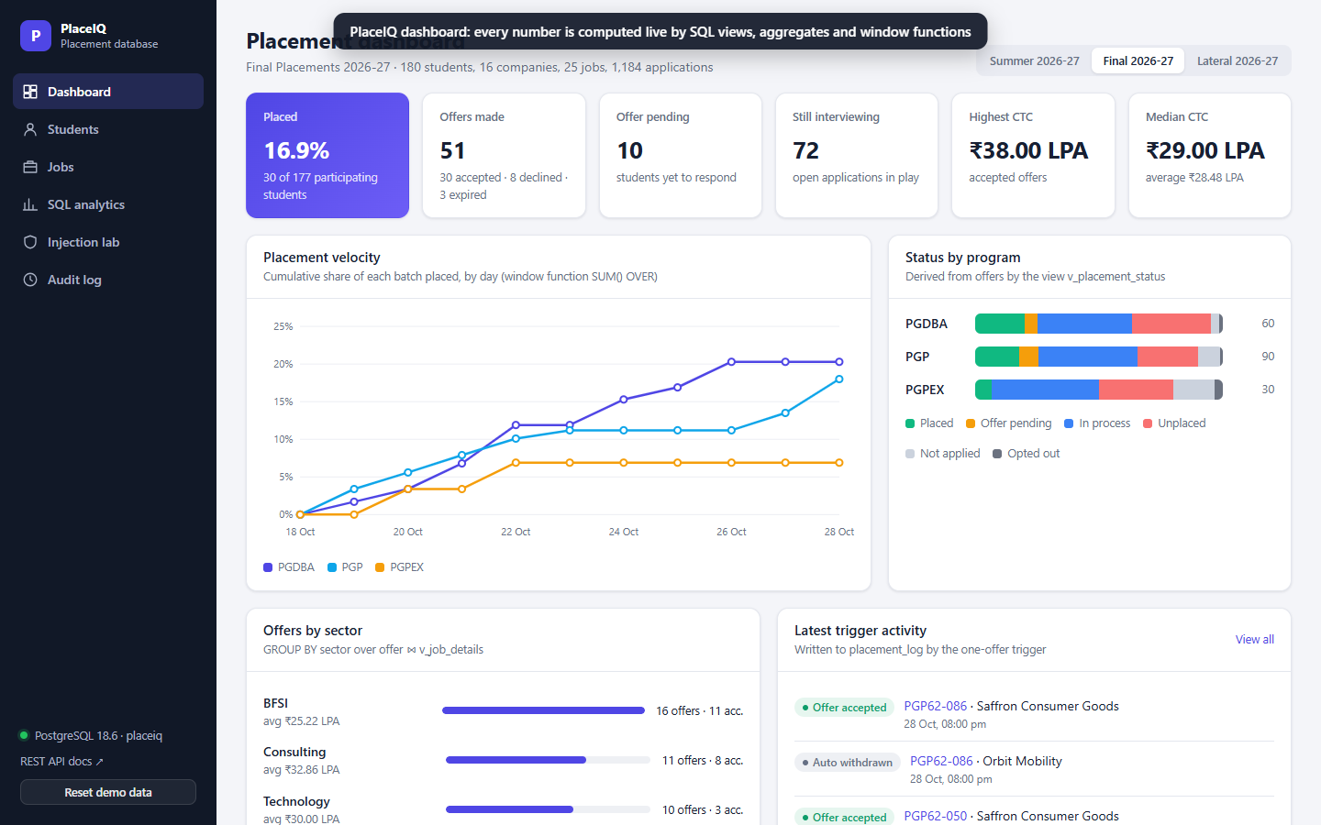
Figure 1. PlaceIQ dashboard: every number is computed live by SQL views, aggregates and window functions

Step 2. Search students
Do | Say
Click Students; type 'Saxena' in the search box. | Placement status isn't a column; it's derived by a view from the offers table, so it can never be wrong.
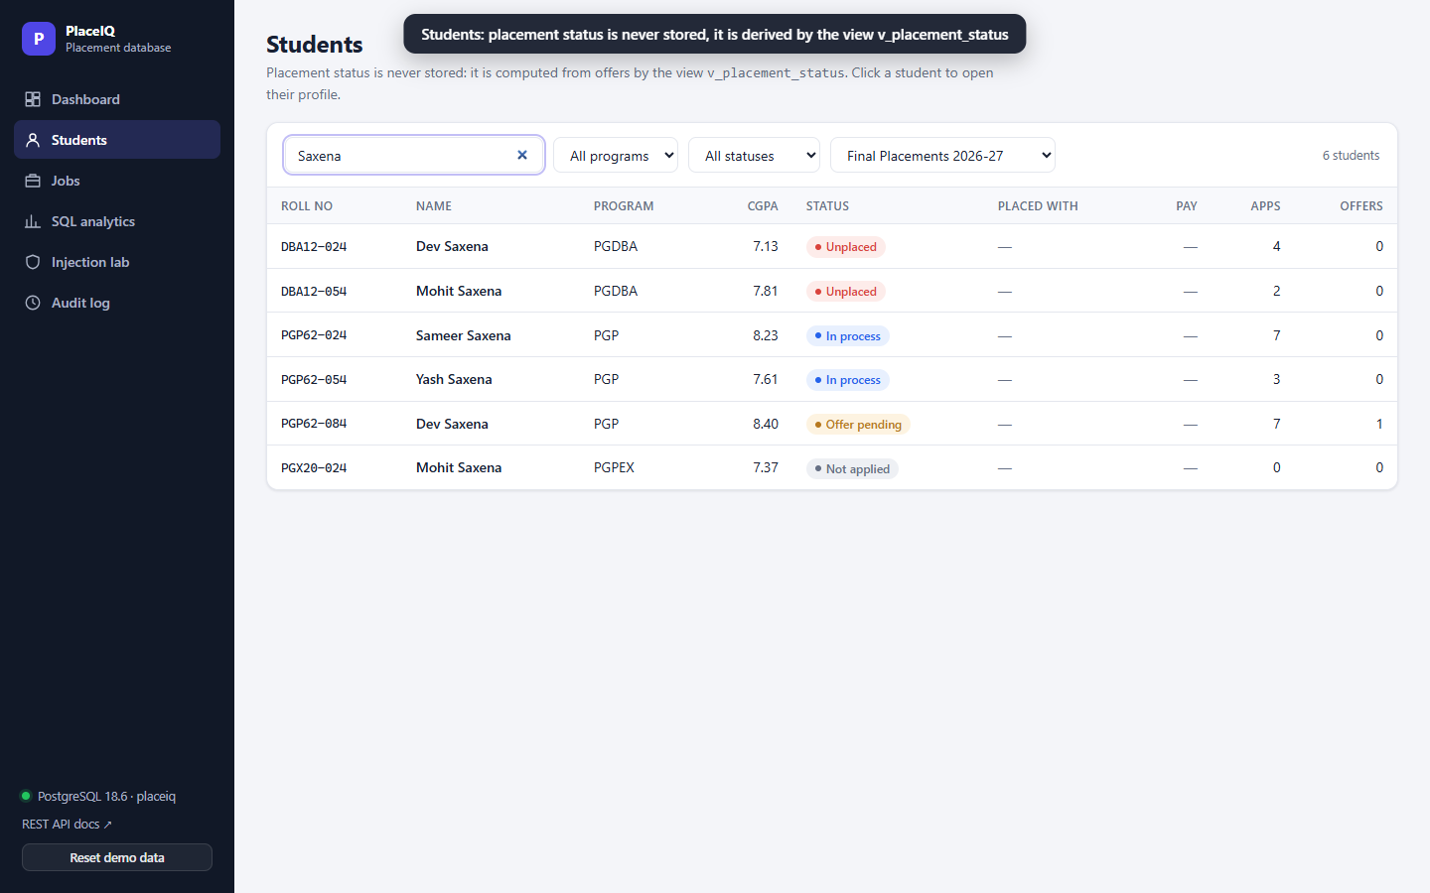
Figure 2. Students: placement status is never stored, it is derived by the view v_placement_status

Step 3. Dev Saxena before the demo
Do | Say
Click the row for PGP62-084. Point at the offer row (Pending) and the Final Placements card. | Dev Saxena holds a pending offer from DataSutra and is shortlisted for two December interviews.
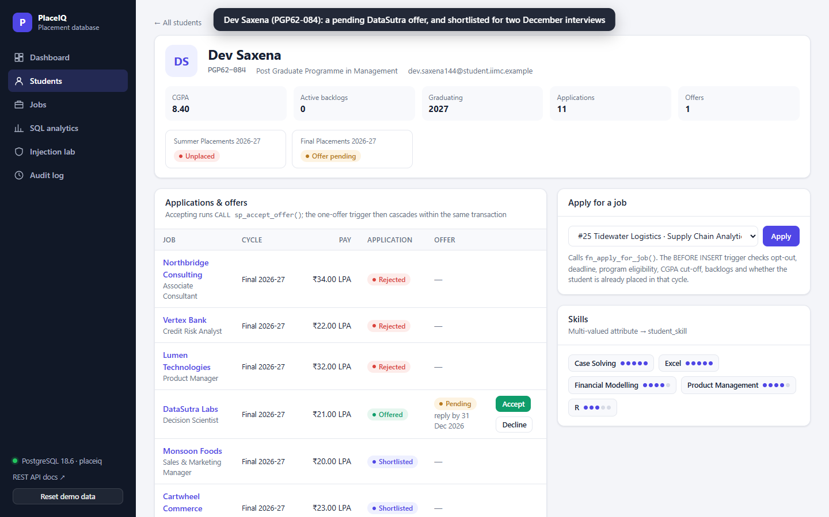
Figure 3. Dev Saxena (PGP62-084): a pending DataSutra offer, and shortlisted for two December interviews

Step 4. Recruiter makes a second offer (core demo)
Do | Say
Jobs → Monsoon Foods (job 21) → in Applicants, click 'Make offer' for PGP62-084. | Now a recruiter makes a second offer. A trigger moves the application to OFFERED.
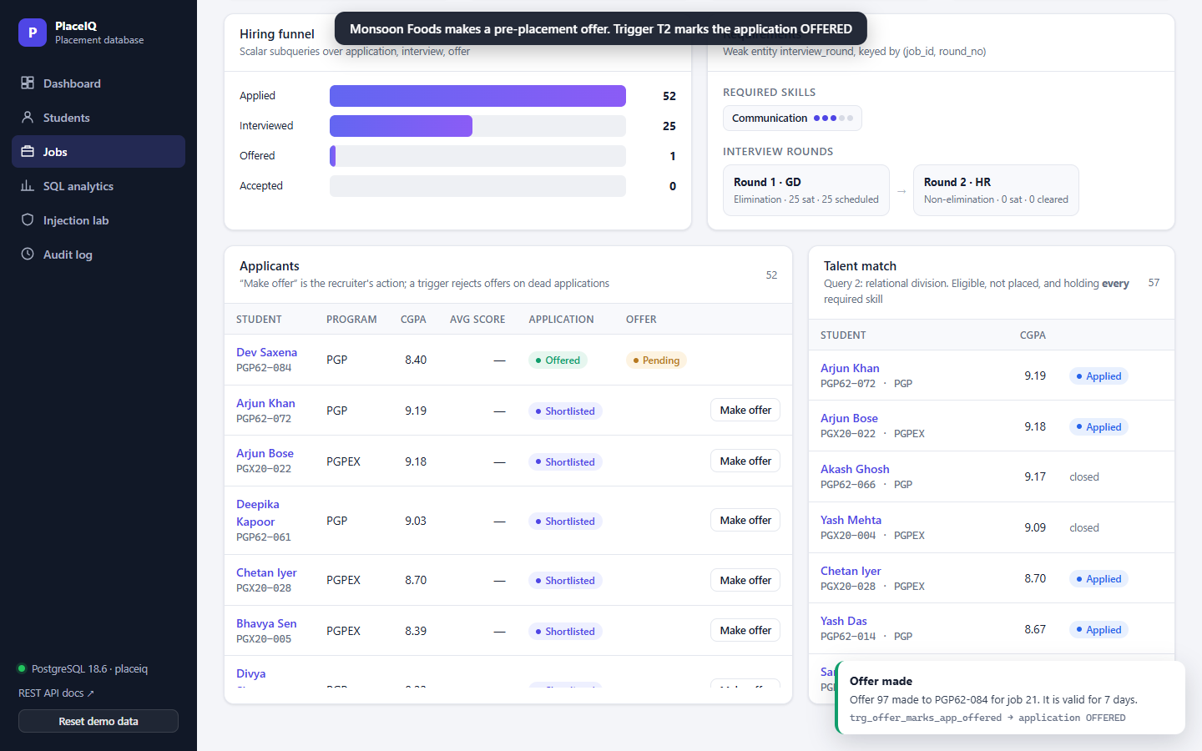
Figure 4. Monsoon Foods makes a pre-placement offer. Trigger T2 marks the application OFFERED

Step 5. Accept: the one-offer cascade (core demo)
Do | Say
Students → PGP62-084 → click Accept on the DataSutra row → OK in the dialog. | Dev accepts DataSutra. One transaction: the other offer is declined, the open application withdrawn, the interview slots freed, and everything logged.
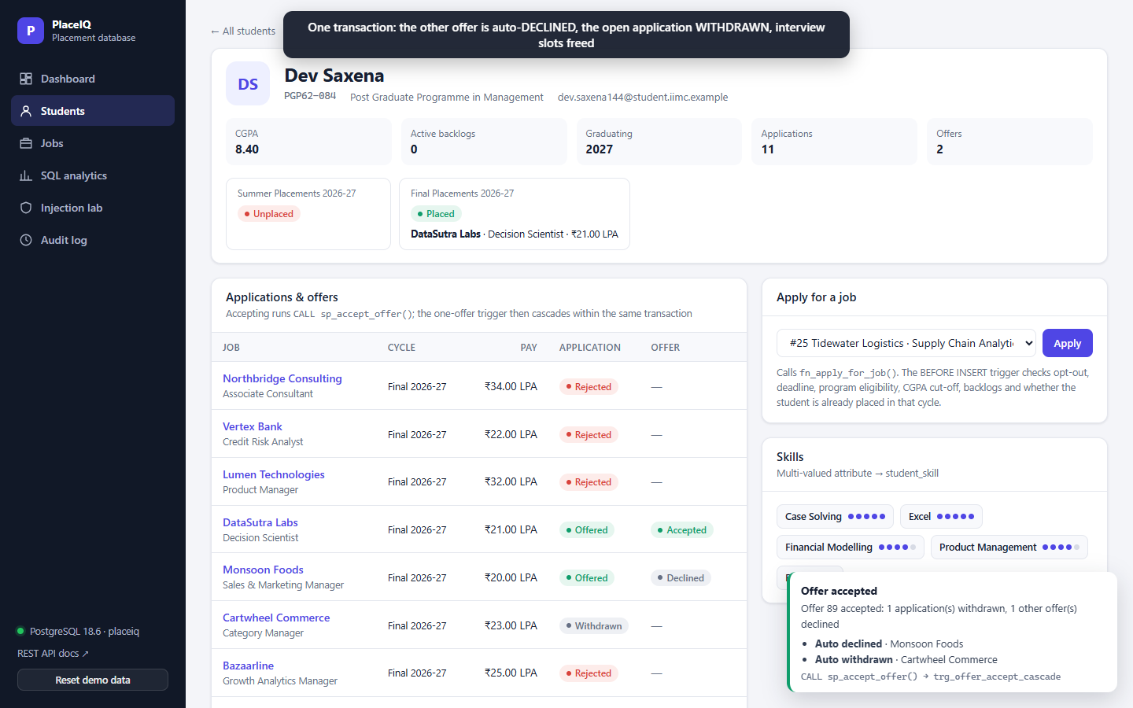
Figure 5. One transaction: the other offer is auto-DECLINED, the open application WITHDRAWN, interview slots freed

Step 6. Placed student tries to apply again (core demo)
Do | Say
In 'Apply for a job', choose #25 Tidewater → Apply. | Now that Dev is placed, the eligibility trigger refuses any further application in this cycle.
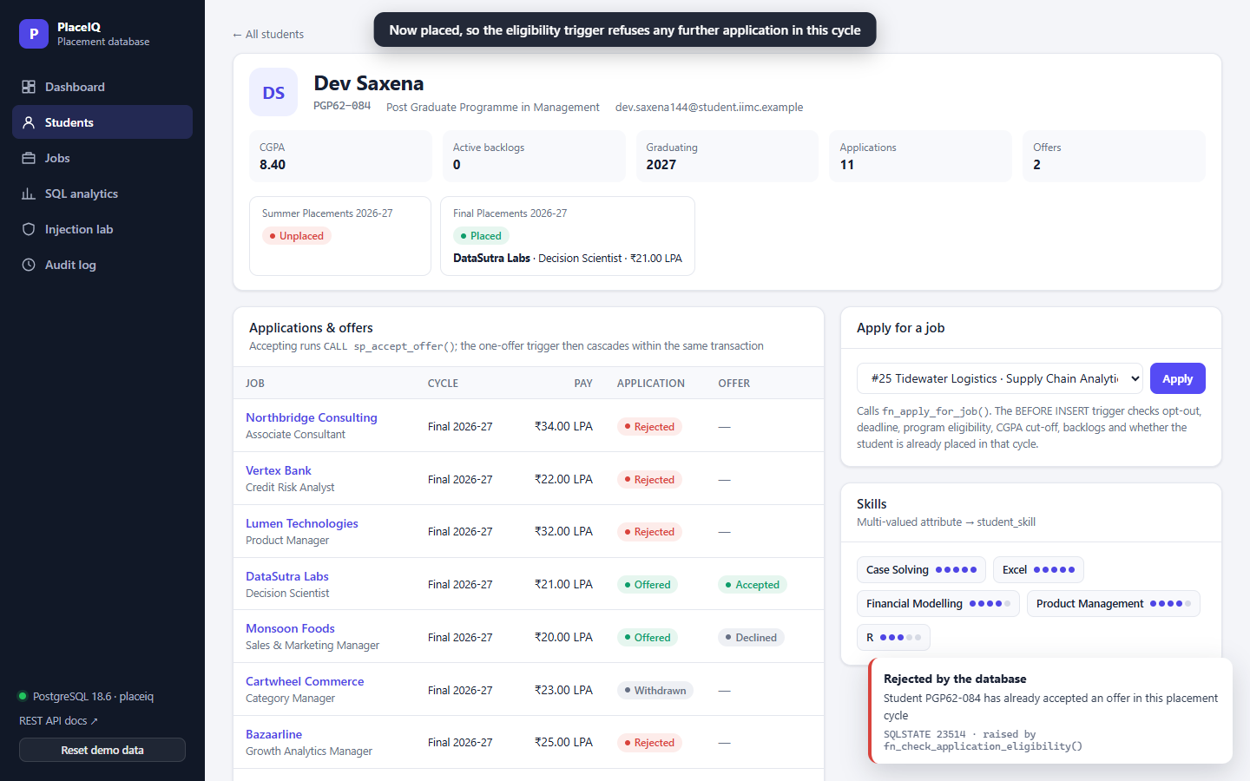
Figure 6. Now placed, so the eligibility trigger refuses any further application in this cycle

Step 7. Below-cut-off student is refused
Do | Say
Open student PGP62-022 → choose #25 → Apply. | A student below the cut-off is refused with the trigger's own message and SQLSTATE.
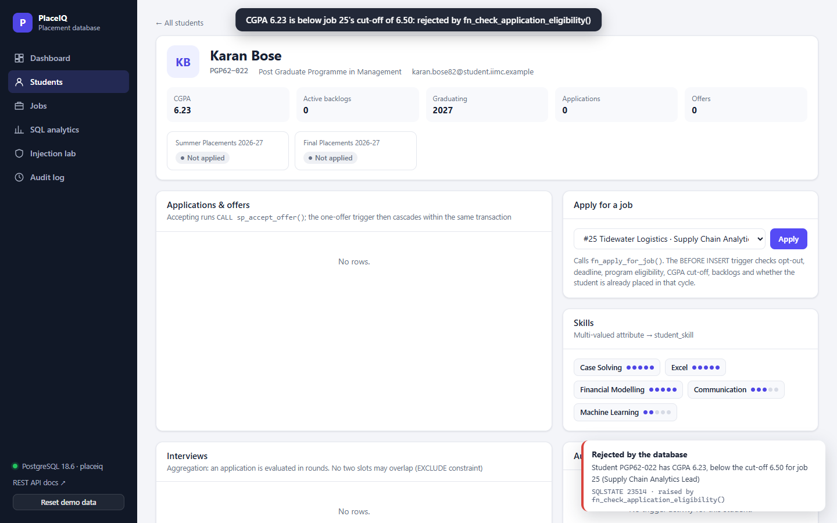
Figure 7. CGPA 6.23 is below job 25's cut-off of 6.50: rejected by fn_check_application_eligibility()

Step 8. Talent match → apply
Do | Say
Jobs → job 25 (Tidewater) → in Talent match, click Apply for Tanvi Jain (DBA12-039). | The talent match is our relational-division query. Tanvi has every required skill, so her application goes through.
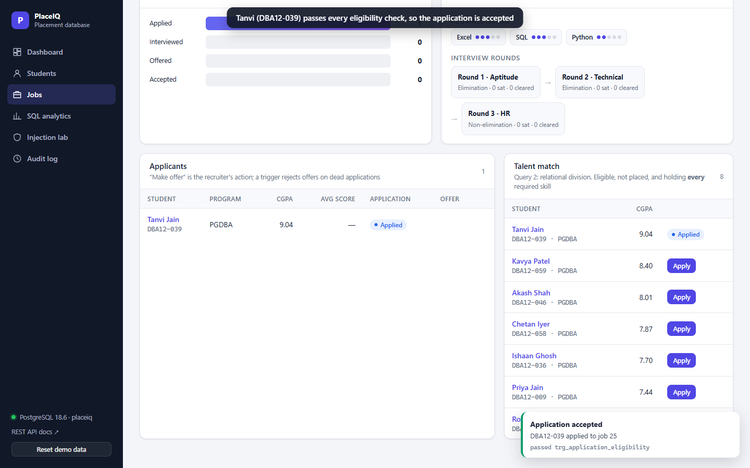
Figure 8. Tanvi (DBA12-039) passes every eligibility check, so the application is accepted

Step 9. Run an analytical query
Do | Say
SQL analytics → Run query on Q1 (or Q2). | Our five queries run live from the SQL file, read-only.
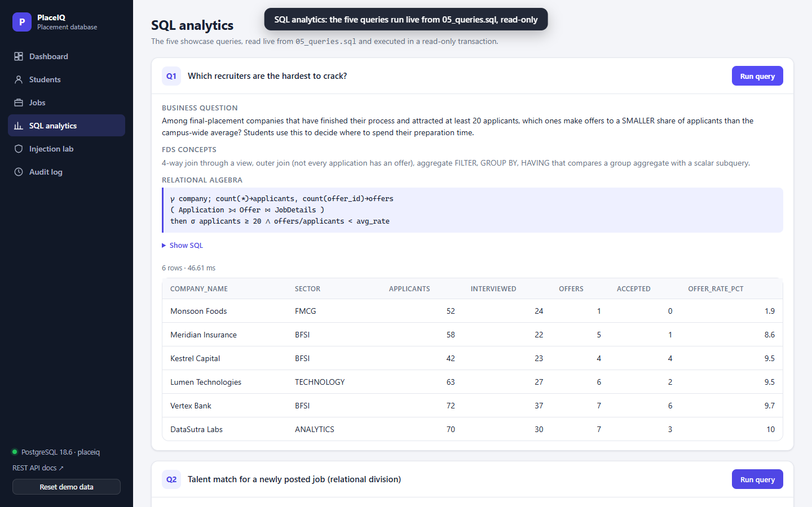
Figure 9. SQL analytics: the five queries run live from 05_queries.sql, read-only

Step 10. SQL injection: unsafe vs safe
Do | Say
Injection lab → click the preset x' OR '1'='1 → Run UNSAFE → Run SAFE. | Same input: concatenation leaks all 180 students; a bound parameter returns zero.
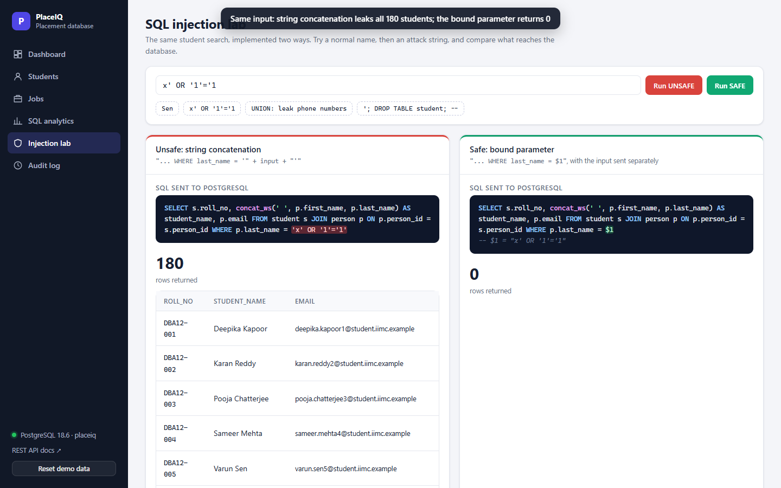
Figure 10. Same input: string concatenation leaks all 180 students; the bound parameter returns 0

Step 11. DROP TABLE attempt is contained
Do | Say
Click the DROP TABLE preset → Run UNSAFE. | Even a DROP TABLE is refused: read-only transaction, least-privilege role.
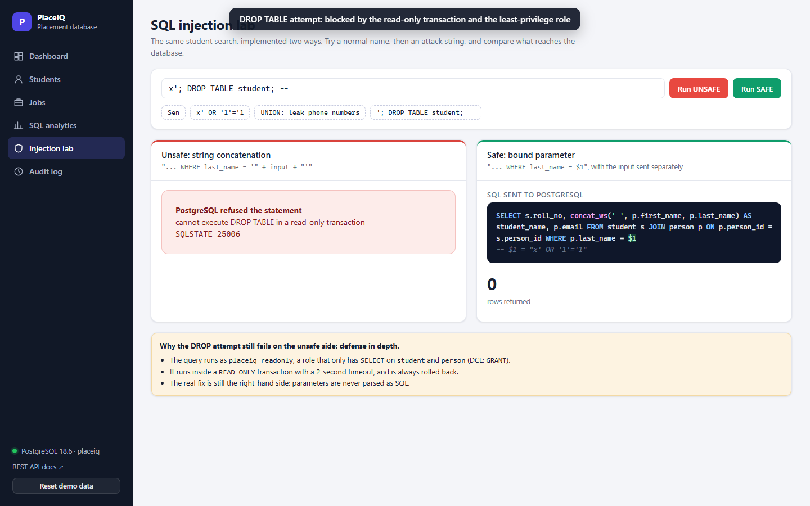
Figure 11. DROP TABLE attempt: blocked by the read-only transaction and the least-privilege role

Step 12. Audit log
Do | Say
Click Audit log. | Every row here was written by the trigger, not by application code.
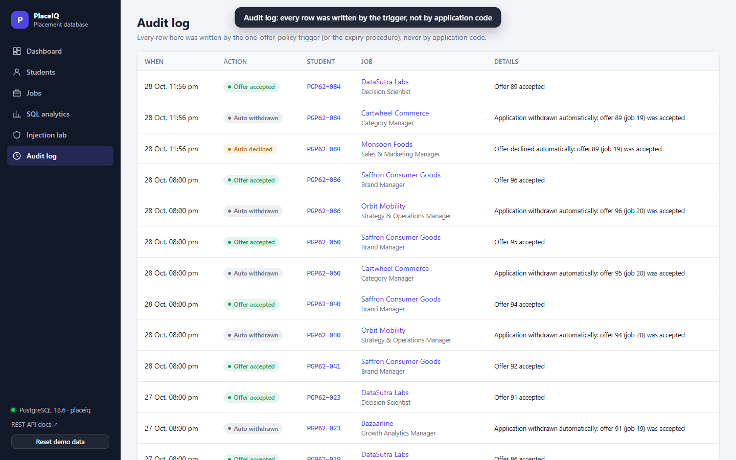
Figure 12. Audit log: every row was written by the trigger, not by application code

Step 13. Reset demo data
Do | Say
Click 'Reset demo data' (bottom-left) → OK. | And one click restores the original data for the next run.
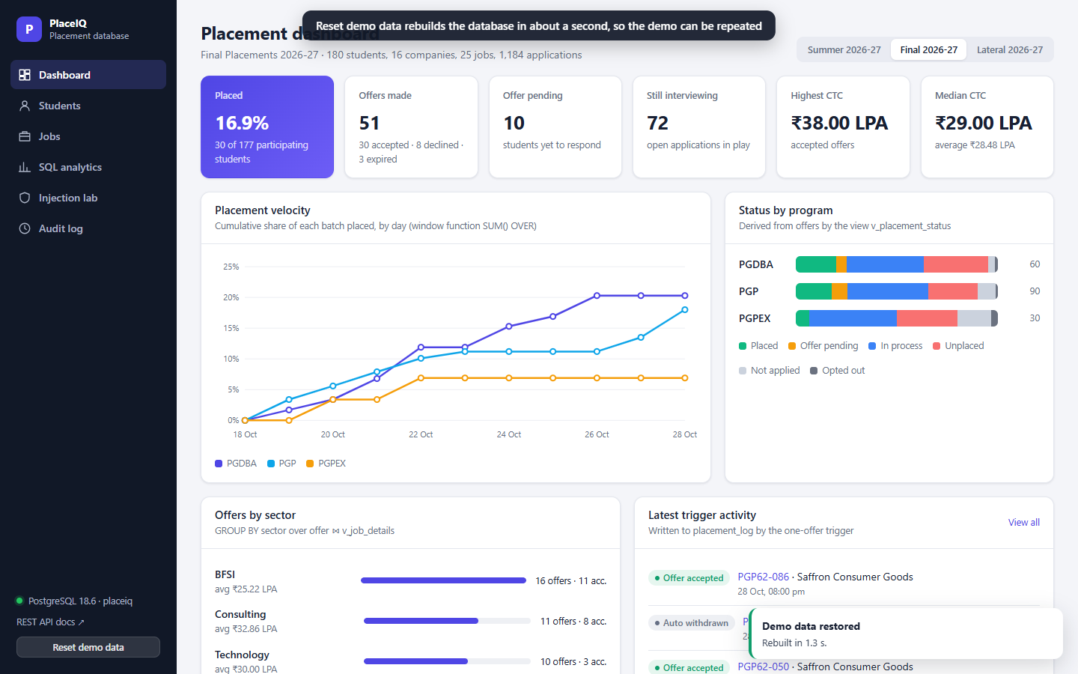
Figure 13. Reset demo data rebuilds the database in about a second, so the demo can be repeated

6. Fallback plans
Failure | Fallback | What to say
Web UI will not load or errors | Play PlaceIQ_Demo_Video.webm | "Here is the recording of the same steps."
Video will not play either | Open psql and run 06_demo.sql (it ends in ROLLBACK) | "Let me show it directly in SQL."
Laptop fails | Present from the PDF slides on a USB stick; slide 14's screenshot shows the cascade | "The screenshot shows the result of the cascade."
Database data is not in the seeded state | Click 'Reset demo data' (about 2 s) | "One second while I reset the demo data."

7. Troubleshooting
Symptom | Likely cause | Fix
Red dot / 'Database offline' | PostgreSQL service stopped | Start the service postgresql-x64-18, then refresh
'Address already in use' when starting the app | App already running in another terminal | Use the running one at http://127.0.0.1:8000, or close the other terminal
Accept says 'Offer … is DECLINED/ACCEPTED' | The demo was already run | Click 'Reset demo data'
Accept says 'Offer … expired' | Presenting after 31 Dec 2026 (seeded deadline) | Reset still works; or skip to the video
Make offer button missing on job 21 | PGP62-084 is no longer SHORTLISTED | Reset demo data
Reset fails | psql not found or wrong password | Run run_all.ps1 -Password <pw> in a terminal

8. Extras for Q&A
- API documentation: http://127.0.0.1:8000/docs shows every endpoint (Swagger), useful for questions about REST.
- Any query live: SQL analytics → Show SQL → Run query.
- Concurrency: the two-window psql exercise at the end of 06_demo.sql (it commits, so reset afterwards).
- Indexing: run part 4 of 06_demo.sql to show EXPLAIN ANALYZE before and after.

