PROJECT REPORT
PlaceIQ
Campus Placement & Recruitment Management System: a PostgreSQL database that enforces its own rules
Fundamentals of Database Systems (FDS)
Prof. Debapriyay Mukhopadhyay · PGDBA Batch 12, IIM Calcutta
Member | Name | Presentation segment
M1 | Ekta Sharma | Problem & EER
M2 | [Member 2] | Schema & normalization
M3 | [Member 3] | DDL, data & queries
M4 | [Member 4] | Rules, transactions & performance

November 2026 · github.com/EktaSharma-github/placeiq

Abstract
Campus placement committees typically run recruitment from shared spreadsheets: one row per student, per company, per interview round. Such files duplicate data, suffer update, insertion and deletion anomalies, and cannot enforce policy. PlaceIQ replaces the spreadsheet with a relational database in PostgreSQL 18 whose design follows the full arc of the Fundamentals of Database Systems course. We built an Enhanced ER model using overlapping and disjoint specialization, a weak entity, aggregation and a category (union type); mapped it to 22 relations; and proved every relation to be in Boyce–Codd Normal Form. Fifteen business rules are enforced inside the database by 45 CHECK constraints, 30 foreign keys (several composite), an exclusion constraint, 9 triggers and stored procedures. Seeded mock data for 180 students, 16 companies, 1,184 applications and 1,057 interviews is loaded through those same rules. Five analytical queries demonstrate joins, HAVING, relational division, correlated subqueries and window functions. A composite index made a representative query 2,160 times faster on 600,000 rows. A FastAPI web interface, an SQL-injection laboratory sandboxed by a least-privilege role, and an automated suite of 91 tests (all passing) complete the project.
Contents

(If page numbers are missing, right-click the table and choose Update Field.)

1. Introduction

1.1 Background and problem
Every year the placement committee coordinates hundreds of students, dozens of recruiters and several hiring cycles (summer internships, final placements and lateral hiring). The committee's working tool is a spreadsheet. Because a spreadsheet is a single flat file, the same company details repeat on every applicant's row, nothing prevents an ineligible student from being added, two interviews can be booked into the same slot, and a student who has already accepted an offer can keep interviewing. These are the classic limitations of file-processing systems discussed in Module 1: redundancy and inconsistency, difficulty of access, integrity problems, atomicity problems and concurrent-access anomalies.

1.2 Objectives
- Model the placement domain conceptually with an Enhanced ER diagram that uses every Module 4 construct.
- Map the model to a relational schema and normalize it to BCNF, with explicit functional dependencies and proofs of lossless, dependency-preserving decomposition.
- Enforce the committee's policy inside the database: declaratively where possible, procedurally (triggers) where a rule spans several tables.
- Generate realistic, reproducible data and answer real business questions with advanced SQL.
- Demonstrate transactions, concurrency control, indexing and SQL-injection defence with measurements, not assertions.
- Verify everything with an automated test suite and present it through a working web interface.

1.3 Scope and assumptions
- One institute, three programs (PGDBA, PGP, PGPEX) and three placement cycles for the academic year 2026-27.
- All company and person names are fictional; the dataset is synthetic but statistically plausible.
- The data snapshot is taken on 28 October 2026: summer placements are complete, final placements are in progress, one job is newly posted.
- Authentication of real users is out of scope; the web interface is a local teaching application.

1.4 Tools and environment
Table 1. Technology stack
Layer | Technology | Purpose
Database | PostgreSQL 18.6 (pgAdmin, psql) | Schema, constraints, triggers, procedures, views, roles
Scripts | SQL files 02–06, PowerShell run_all.ps1 | Repeatable build: DDL → logic → data → queries → demo
Application | Python 3.12, FastAPI, psycopg 3 | REST API using parameterized SQL only
Front end | HTML, CSS, vanilla JavaScript | Single-page UI: dashboard, students, jobs, analytics, labs
Testing | pytest 8, FastAPI TestClient | 91 automated tests against the real database
Version control | Git, GitHub | github.com/EktaSharma-github/placeiq

2. Requirements

2.1 Users
User | Needs
Student | See eligible jobs, apply, track interviews and offers, accept or decline an offer
Recruiter | Post jobs with eligibility and skill requirements, shortlist, interview, make offers
Placement committee | Enforce policy, schedule interviews without clashes, monitor progress, report statistics
Sponsors | Companies and alumni who fund scholarships, events and awards for a cycle

2.2 Business rules
The rules below were collected from the committee's policy and drive every constraint in the design. The third column states where each rule is enforced.
Table 2. Business rules and their enforcement mechanism
ID | Rule | Enforced by
BR-1 | Every student belongs to exactly one program | NOT NULL foreign key student.program_id
BR-2 | Roll number and e-mail are unique | UNIQUE constraints (alternate keys)
BR-3 | CGPA lies between 0 and 10 | CHECK constraint
BR-4 | A job is an internship or a full-time role: never both, never neither | Composite FK on (job_id, role_type) for disjointness; deferred constraint trigger for totality
BR-5 | The recruiter posting a job works for that company | Composite FK (posted_by, company_id) → recruiter(person_id, company_id)
BR-6 | A student applies to a job at most once | UNIQUE (student_id, job_id)
BR-7 | Interviews only in a round of the job applied for | Two composite FKs on interview sharing job_id
BR-8 | No overlapping interview slots for a student | EXCLUDE USING gist (student_id =, tstzrange &&)
BR-9 | An offer needs an application; at most one per application | FK + UNIQUE; trigger requires a live application
BR-10 | responded_at is set iff the offer was accepted or declined | CHECK constraint
BR-11 | Eligibility to apply: program, CGPA, backlogs, deadline, not opted out, not placed | BEFORE INSERT trigger (spans 4 tables)
BR-12 | One accepted offer per student per cycle; accepting withdraws the rest | BEFORE + AFTER triggers, stored procedure, row lock
BR-13 | A sponsor is a company or an alumnus (union type) | Discriminator + composite FK
BR-14 | Placed status is derived, never typed in | View v_placement_status
BR-15 | A student holding an offer cannot be deleted | ON DELETE RESTRICT blocks the cascade

2.3 Functional requirements
- Maintain programs, cycles, companies, recruiters, students, alumni, committee members and sponsors.
- Post jobs (internship or full-time) with eligibility per program, required skills and interview rounds.
- Accept applications only from eligible students, before the deadline.
- Schedule interview rounds without overlap and record results and scores.
- Make offers; accept, decline or expire them; apply the one-offer policy automatically.
- Report placement status, compensation statistics, selectivity and progress over time.

2.4 Non-functional requirements
- Integrity: rules hold even if the application layer is bypassed (enforced in the DBMS).
- Atomicity: multi-step operations such as accepting an offer either complete fully or not at all.
- Reproducibility: the database can be rebuilt to an identical state in about two seconds.
- Security: no SQL injection in application queries; least privilege where untrusted input is demonstrated.
- Performance: foreign keys indexed; hot lookups supported by composite and partial indexes.

3. Conceptual design: Enhanced ER model
The EER model is presented in two views for readability. Figure 1 covers people, programs and sponsorship; Figure 2 covers the recruitment pipeline. Both use Chen notation: rectangles for entities (double for weak), diamonds for relationships (double for identifying), ovals for attributes, double lines for total participation, and circles for specialization ('o' overlapping, 'd' disjoint, 'U' category).
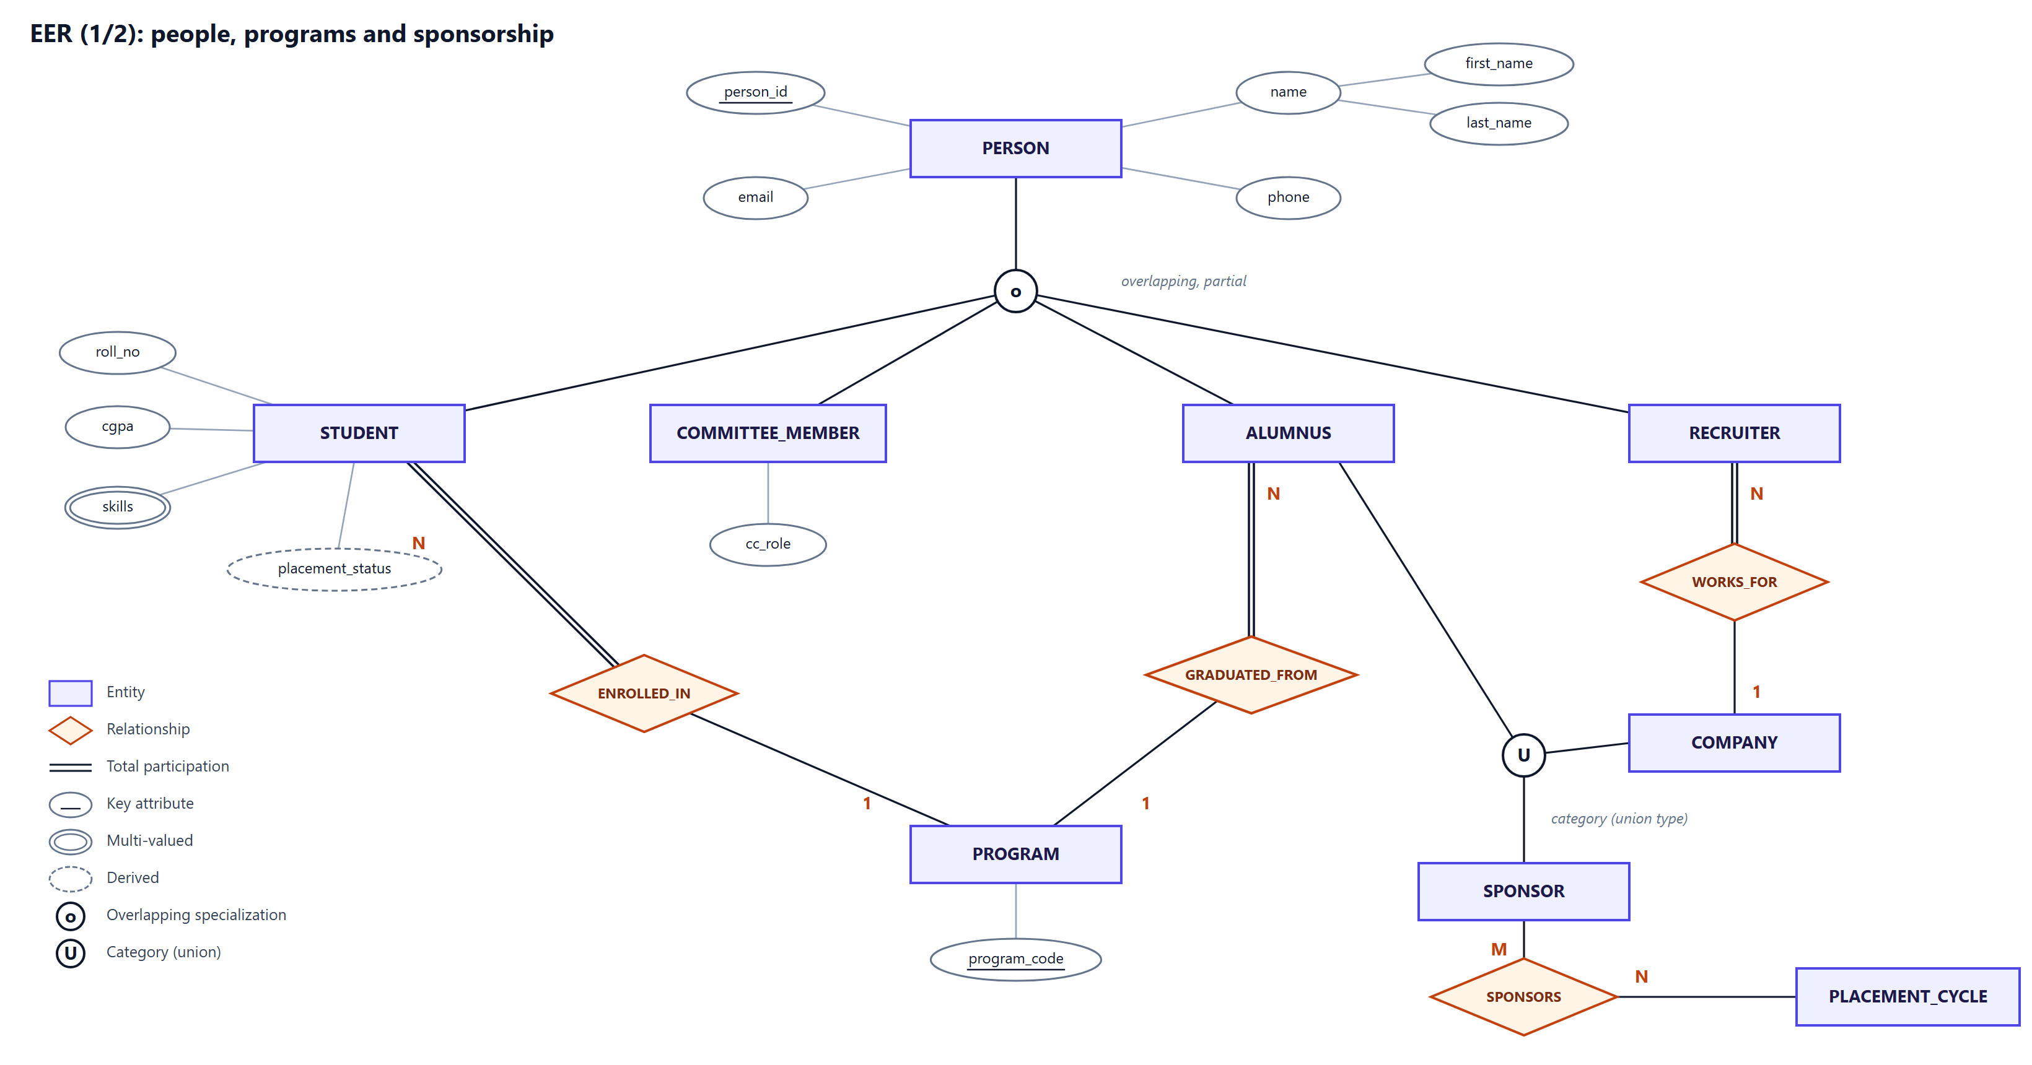
Figure 1. EER view 1: Person hierarchy (overlapping, partial), programs, and the Sponsor category (union type).
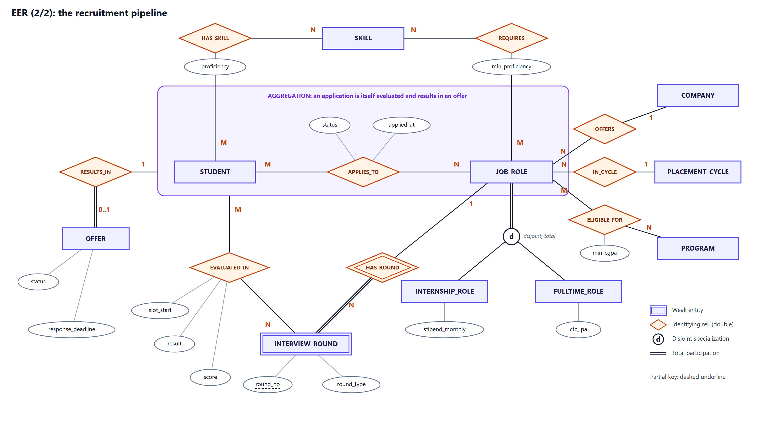
Figure 2. EER view 2: recruitment pipeline with aggregation, weak entity INTERVIEW_ROUND and disjoint, total job specialization.

3.1 Entities and attributes
Table 3. Entities
Entity | Type | Key and notable attributes
PERSON | Strong, superclass | person_id (key); name (composite: first, last); email (candidate key); phone
STUDENT | Subclass of PERSON | roll_no (candidate key), cgpa, backlogs, opted_out; {skills} multi-valued; placement_status derived
RECRUITER / COMMITTEE_MEMBER / ALUMNUS | Subclasses of PERSON | designation / cc_role, term / graduation_year, current_employer
PROGRAM, COMPANY, PLACEMENT_CYCLE, SKILL | Strong | Surrogate id plus natural candidate key (program_code, company_name, cycle_name, skill_name)
SPONSOR | Category of COMPANY ∪ ALUMNUS | sponsor_id (surrogate), sponsor_type
JOB_ROLE | Strong, superclass | job_id; title, location, openings, deadline
INTERNSHIP_ROLE / FULLTIME_ROLE | Subclasses of JOB_ROLE | stipend_monthly, duration_weeks, ppo_possible / ctc_lpa, fixed_lpa, joining_bonus
INTERVIEW_ROUND | Weak, owner JOB_ROLE | round_no (partial key), round_type, is_elimination
OFFER | Strong (via aggregation) | offered_at, response_deadline, status, responded_at

3.2 Relationships
Table 4. Relationships with cardinality and participation
Relationship | Between | Cardinality | Participation / notes
ENROLLED_IN | STUDENT – PROGRAM | N : 1 | Student total
GRADUATED_FROM | ALUMNUS – PROGRAM | N : 1 | Alumnus total
WORKS_FOR | RECRUITER – COMPANY | N : 1 | Recruiter total
OFFERS / IN_CYCLE | COMPANY – JOB_ROLE / JOB_ROLE – CYCLE | 1 : N / N : 1 | Job total in both
ELIGIBLE_FOR | JOB_ROLE – PROGRAM | M : N | Attributes min_cgpa, max_backlogs
HAS_SKILL / REQUIRES | STUDENT – SKILL / JOB_ROLE – SKILL | M : N | proficiency / min_proficiency
APPLIES_TO | STUDENT – JOB_ROLE | M : N | status, applied_at; treated as an aggregate
HAS_ROUND | JOB_ROLE – INTERVIEW_ROUND | 1 : N | Identifying; round total
EVALUATED_IN | [APPLIES_TO] – INTERVIEW_ROUND | M : N | slot, venue, result, score
RESULTS_IN | [APPLIES_TO] – OFFER | 1 : 0..1 | Offer total
SPONSORS | SPONSOR – PLACEMENT_CYCLE | M : N | purpose, amount

3.3 Design decisions
- Overlapping, partial specialization of PERSON: a student may also be a committee member; a guest speaker is only a person.
- Disjoint, total specialization of JOB_ROLE: stipend and CTC are different attributes and every job is exactly one kind.
- Aggregation of APPLIES_TO: an interview evaluates a specific application (a student for a job), not a student in general; the same applies to an offer. Modelling it this way makes it possible to enforce that a student is interviewed only for a job they applied to.
- Weak entity INTERVIEW_ROUND: 'round 2' has no identity outside its job.
- Category SPONSOR: companies and alumni are different entity types that play the same sponsoring role.
- Derived attribute placement_status: computed from offers, so it can never disagree with them.

4. Logical design: relational schema

4.1 Mapping the EER model
Table 5. ER-to-relational mapping steps (Elmasri–Navathe)
Step | Rule | Applied to
1 | Strong entity → relation | program, person, company, placement_cycle, job_role, skill
2 | Weak entity → relation; PK = owner PK + partial key | interview_round (job_id, round_no)
3 | 1:1 → FK on the total side + UNIQUE | offer → application (student_id, job_id)
4 | 1:N → FK on the N side | student.program_id, recruiter.company_id, job_role.company_id, cycle_id, posted_by
5 | M:N → bridge relation | eligibility, student_skill, job_required_skill, application, interview, sponsorship
6 | Multi-valued attribute → relation | student_skill
8A | Specialization → one relation per subclass sharing the superclass key | student, recruiter, committee_member, alumnus; internship_role, fulltime_role
9 | Category → surrogate key relation; FK in each member | sponsor ← company.sponsor_id, alumnus.sponsor_id
Option 8A (a table per subclass) was preferred over a single wide JOB_ROLE table because the single table would need NULLs in half its rows and could not declare that CTC is mandatory for full-time roles with a simple NOT NULL. With 8A every subtype attribute is NOT NULL.
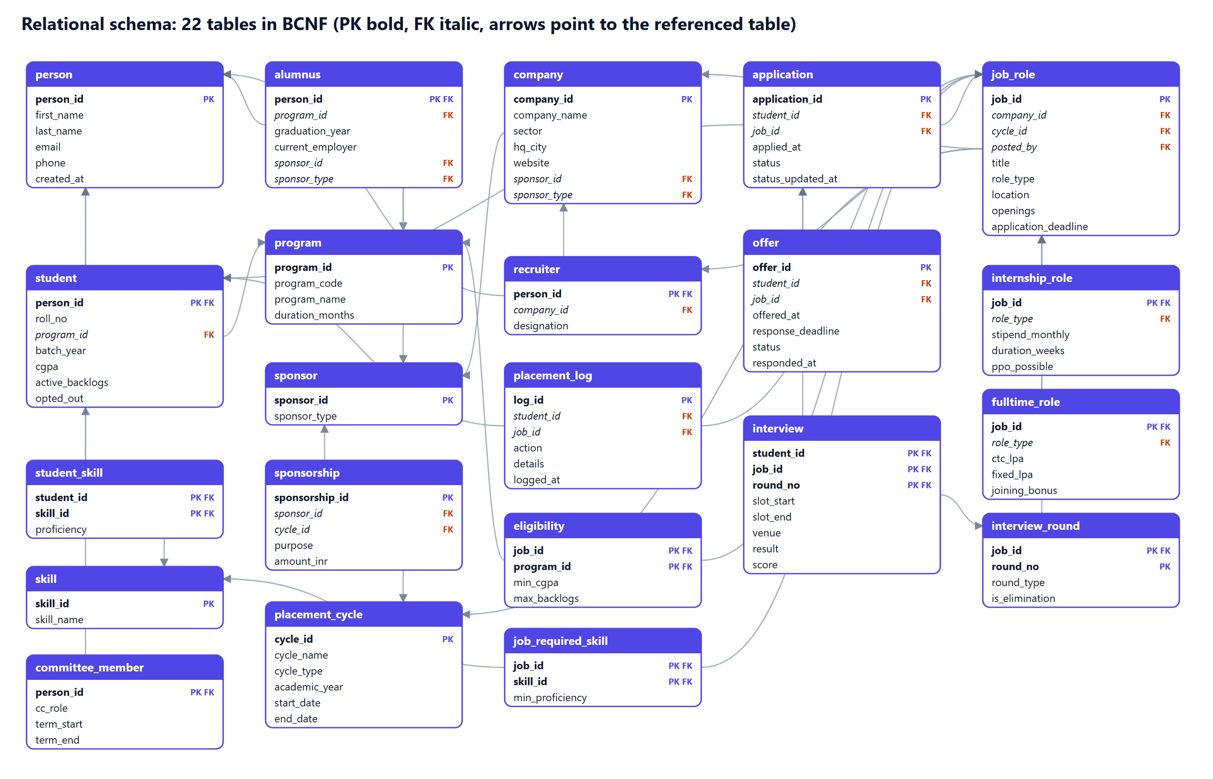
Figure 3. Relational schema generated from the live catalog: 22 relations; arrows point from a foreign key to the referenced relation.

4.2 Keys
Table 6. Keys in the schema
Key type | Definition | Example in PlaceIQ
Super key | Any attribute set that uniquely identifies a tuple | (person_id, email) in person
Candidate key | A minimal super key | placement_cycle has three: cycle_id; cycle_name; (cycle_type, academic_year)
Primary key | The candidate key chosen for identification | job_id in job_role
Alternate key | A candidate key not chosen as primary, kept UNIQUE | (company_id, cycle_id, title) in job_role; roll_no; email
Foreign key | Attributes referencing a key of another relation | 30 in total, e.g. composite (posted_by, company_id) → recruiter
Surrogate keys were introduced after normalization for convenience (short, stable, efficient joins). Every natural key was preserved as a UNIQUE constraint, so no functional dependency is lost by the substitution.

5. Normalization

5.1 The starting relation and its anomalies
The committee's spreadsheet is an unnormalized relation PLACEMENT_SHEET(roll_no, name, email, prog_code, prog_name, cgpa, {skills}, company, sector, hq_city, cycle, job_title, role_type, pay, min_cgpa, round_no, round_type, slot, result, app_status).
- Update anomaly: a company changing its headquarters must be edited on every applicant and round row.
- Insertion anomaly: a job cannot be recorded before someone applies, because roll_no is part of the key.
- Deletion anomaly: deleting the only applicant to a job deletes the job's pay, cut-off and rounds.

5.2 Functional dependencies
Let J denote (company, cycle, job_title), the natural identifier of a job.
Table 7. Functional dependencies of PLACEMENT_SHEET
FD | Dependency
FD1 | roll_no → name, email, prog_code, cgpa
FD2 | email → roll_no
FD3 | prog_code → prog_name
FD4 | company → sector, hq_city
FD5 | J → role_type, pay
FD6 | J, prog_code → min_cgpa
FD7 | J, round_no → round_type
FD8 | roll_no, J → app_status
FD9 | roll_no, J, round_no → slot, result
MVD | roll_no →→ skills (independent of every other attribute)
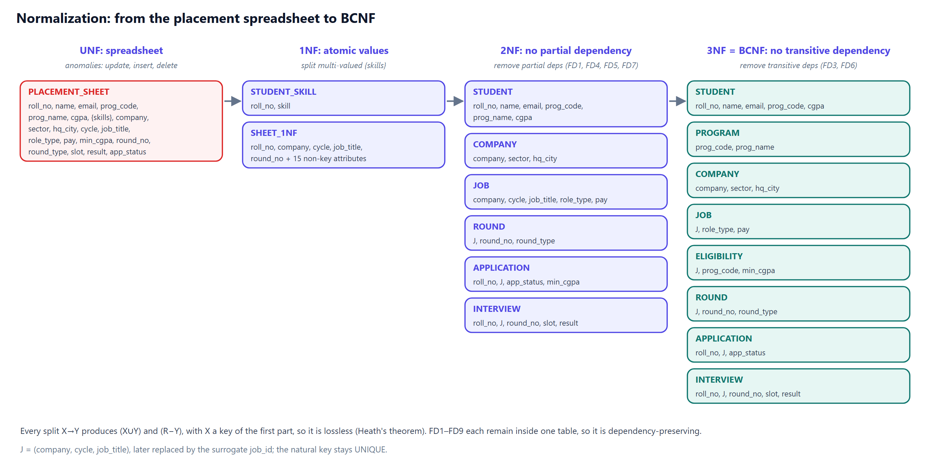
Figure 4. Decomposition from the spreadsheet to BCNF.

5.3 First normal form
skills is a list, violating atomicity. Splitting it into one row per skill would multiply rows by the number of rounds and skills (the multi-valued dependency at work), so it moves to StudentSkill(roll_no, skill). The remaining relation has atomic values and key {roll_no, company, cycle, job_title, round_no}.

5.4 Second normal form
Several non-key attributes depend on part of the composite key: student details on roll_no (FD1), company details on company (FD4), job details on J (FD5), round type on (J, round_no) (FD7) and application status on (roll_no, J) (FD8). Each partial dependency becomes its own relation: Student, Company, Job, Round, Application and Interview.

5.5 Third normal form
Two transitive dependencies remain. In Student, roll_no → prog_code → prog_name, so Program(prog_code, prog_name) is separated. In Application, (roll_no, J) → roll_no → prog_code and (J, prog_code) → min_cgpa, so the cut-off moves to Eligibility(J, prog_code, min_cgpa).

5.6 Boyce–Codd normal form
Table 8. BCNF verification
Relation | Non-trivial FDs | Every determinant a super key?
Program | prog_code → prog_name | Yes
Student | roll_no → all; email → roll_no | Yes: roll_no and email are both candidate keys
Company | company → sector, hq_city | Yes
Job | J → role_type, pay | Yes
Eligibility | (J, prog_code) → min_cgpa | Yes
Round | (J, round_no) → round_type | Yes
Application | (roll_no, J) → app_status | Yes
Interview | (roll_no, J, round_no) → slot, result | Yes
StudentSkill | none non-trivial (MVD isolated, so also 4NF) | Yes
placement_cycle | each of three candidate keys → all | Yes

5.7 Lossless join and dependency preservation
Each decomposition step split a relation R on a dependency X → Y into (X ∪ Y) and (R − Y), where X is a key of the first part. By Heath's theorem such a binary decomposition is lossless: the natural join of the parts reproduces R exactly. Every dependency FD1–FD9 is contained within a single resulting relation, so the decomposition is also dependency-preserving and every rule can be checked locally.

5.8 The 3NF-but-not-BCNF case we avoided
Design discussion
Suppose each recruiter interviewed for exactly one job. A relation Panel(student, job, recruiter) would have (student, job) → recruiter and recruiter → job.
recruiter is not a super key, so Panel violates BCNF; but job is a prime attribute, so Panel is still in 3NF.
The BCNF decomposition (recruiter, job) + (student, recruiter) is lossless but not dependency-preserving: (student, job) → recruiter can no longer be checked inside one table.
Decision: the business does not need the rule (a recruiter may interview for several roles), so it was not modelled and the schema remains in BCNF without loss.

5.9 Deliberately non-redundant choices
Not stored | Reason
CTC or stipend on offer | offer → job_id → ctc_lpa would be a transitive dependency; the job subtype tables hold pay
placement_status on student | Derived from offers by the view v_placement_status
cycle_id on application | job_id → cycle_id would be transitive; the one-offer-per-cycle rule is a trigger instead
The constant discriminator columns (for example internship_role.role_type = 'INTERNSHIP') are not a normal-form violation: their domain has a single value, so they introduce no non-trivial dependency. They exist only so that composite foreign keys can enforce disjointness declaratively.

6. Physical design and DDL

6.1 Data types
Kind of data | Type chosen | Why
Surrogate keys | INT / SMALLINT GENERATED BY DEFAULT AS IDENTITY | Standard SQL identity columns; small tables use SMALLINT
Money and grades | NUMERIC(p, s) | Exact decimal arithmetic; never floating point
Timestamps | TIMESTAMPTZ | Unambiguous across time zones; required by tstzrange for EXCLUDE
Codes and enumerations | VARCHAR + CHECK (… IN (…)) | Readable values with a closed domain
Flags | BOOLEAN | opted_out, ppo_possible, is_elimination

6.2 Integrity techniques

Disjoint specialization with a composite foreign key
CREATE TABLE internship_role (
job_id INT PRIMARY KEY,
role_type VARCHAR(10) NOT NULL DEFAULT 'INTERNSHIP' CHECK (role_type = 'INTERNSHIP'),
stipend_monthly NUMERIC(10,2) NOT NULL CHECK (stipend_monthly >= 0),
duration_weeks SMALLINT NOT NULL CHECK (duration_weeks BETWEEN 4 AND 26),
ppo_possible BOOLEAN NOT NULL DEFAULT FALSE,
CONSTRAINT fk_internship_job FOREIGN KEY (job_id, role_type)
REFERENCES job_role (job_id, role_type) ON DELETE CASCADE
);
job_role declares UNIQUE (job_id, role_type). A full-time job has role_type 'FULLTIME', so an internship row for it has nothing to reference and is rejected by the database. Totality (every job has some subtype row) cannot be expressed declaratively and is checked by a deferred constraint trigger at COMMIT.

Interview integrity across the aggregation
CONSTRAINT fk_interview_application FOREIGN KEY (student_id, job_id)
REFERENCES application (student_id, job_id) ON DELETE CASCADE,
CONSTRAINT fk_interview_round FOREIGN KEY (job_id, round_no)
REFERENCES interview_round (job_id, round_no) ON DELETE CASCADE,
CONSTRAINT excl_student_double_booking
EXCLUDE USING gist (student_id WITH =, tstzrange(slot_start, slot_end) WITH &&)
The two foreign keys share job_id, which guarantees that a student is interviewed only in a round belonging to the job they applied for (BR-7). The exclusion constraint forbids two rows for the same student whose time ranges overlap (BR-8), something no UNIQUE constraint can express; it relies on the btree_gist extension.

Cross-entity consistency
CONSTRAINT fk_job_posted_by FOREIGN KEY (posted_by, company_id)
REFERENCES recruiter (person_id, company_id) ON DELETE SET NULL (posted_by)
A recruiter can post a job only for the company they work for (BR-5). The PostgreSQL 15+ column list in SET NULL (posted_by) nulls only the recruiter reference if the recruiter is deleted, keeping the job and its company.

6.3 Referential actions
Action | Used for | Reason
CASCADE | person → subtypes; job_role → rounds and subtypes; application → interviews | The dependent row has no meaning without its owner
RESTRICT | program → student; job_role → application; application → offer | Protect history and formal records
SET NULL (col) | recruiter → job_role.posted_by; sponsor → company/alumnus | Keep the row, forget the link

The RESTRICT-blocks-CASCADE chain (BR-15)
Deleting a person cascades to student and then to application; if an application has an offer, the RESTRICT on offer aborts the entire statement. A student who holds an offer therefore cannot be erased.

6.4 Catalog summary
Table 9. Objects in the placeiq schema (from the system catalog)
Object | Count
Tables | 22
Primary keys | 22
Foreign keys | 30
UNIQUE constraints | 17
CHECK constraints | 45
EXCLUDE constraints | 1
Indexes (including key indexes) | 55
Triggers | 9
Views | 2
Stored routines | 3
PostgreSQL indexes primary keys and UNIQUE constraints automatically but not foreign-key columns. The DDL therefore creates an index for every foreign key not already covered by the leading columns of another index; test TC-SCH-04 verifies this for all 30 foreign keys.

7. Business logic: views, triggers and procedures
Rules that involve several tables cannot be CHECK constraints, which see only the row being written. These are implemented in PL/pgSQL in 03_logic.sql and are installed before the data is loaded, so the seeded data itself passes them.
Table 10. Triggers
Trigger | Timing | Rule
trg_application_eligibility | BEFORE INSERT/UPDATE on application | BR-11: opted out, deadline, program eligible, CGPA cut-off, backlogs, already placed in cycle
trg_offer_requires_open_app | BEFORE INSERT on offer | An offer needs an APPLIED or SHORTLISTED application
trg_offer_marks_app_offered | AFTER INSERT on offer | Application status becomes OFFERED
trg_offer_accept_guard | BEFORE INSERT/UPDATE on offer | BR-12: only pending offers, before the deadline, no second acceptance in the cycle; locks the student row
trg_offer_accept_cascade_upd / _ins | AFTER UPDATE/INSERT on offer | Decline other offers, withdraw open applications, free interview slots, write the audit log
trg_job_total_on_* (3) | Deferred constraint triggers | BR-4 totality: every job has a subtype row at COMMIT
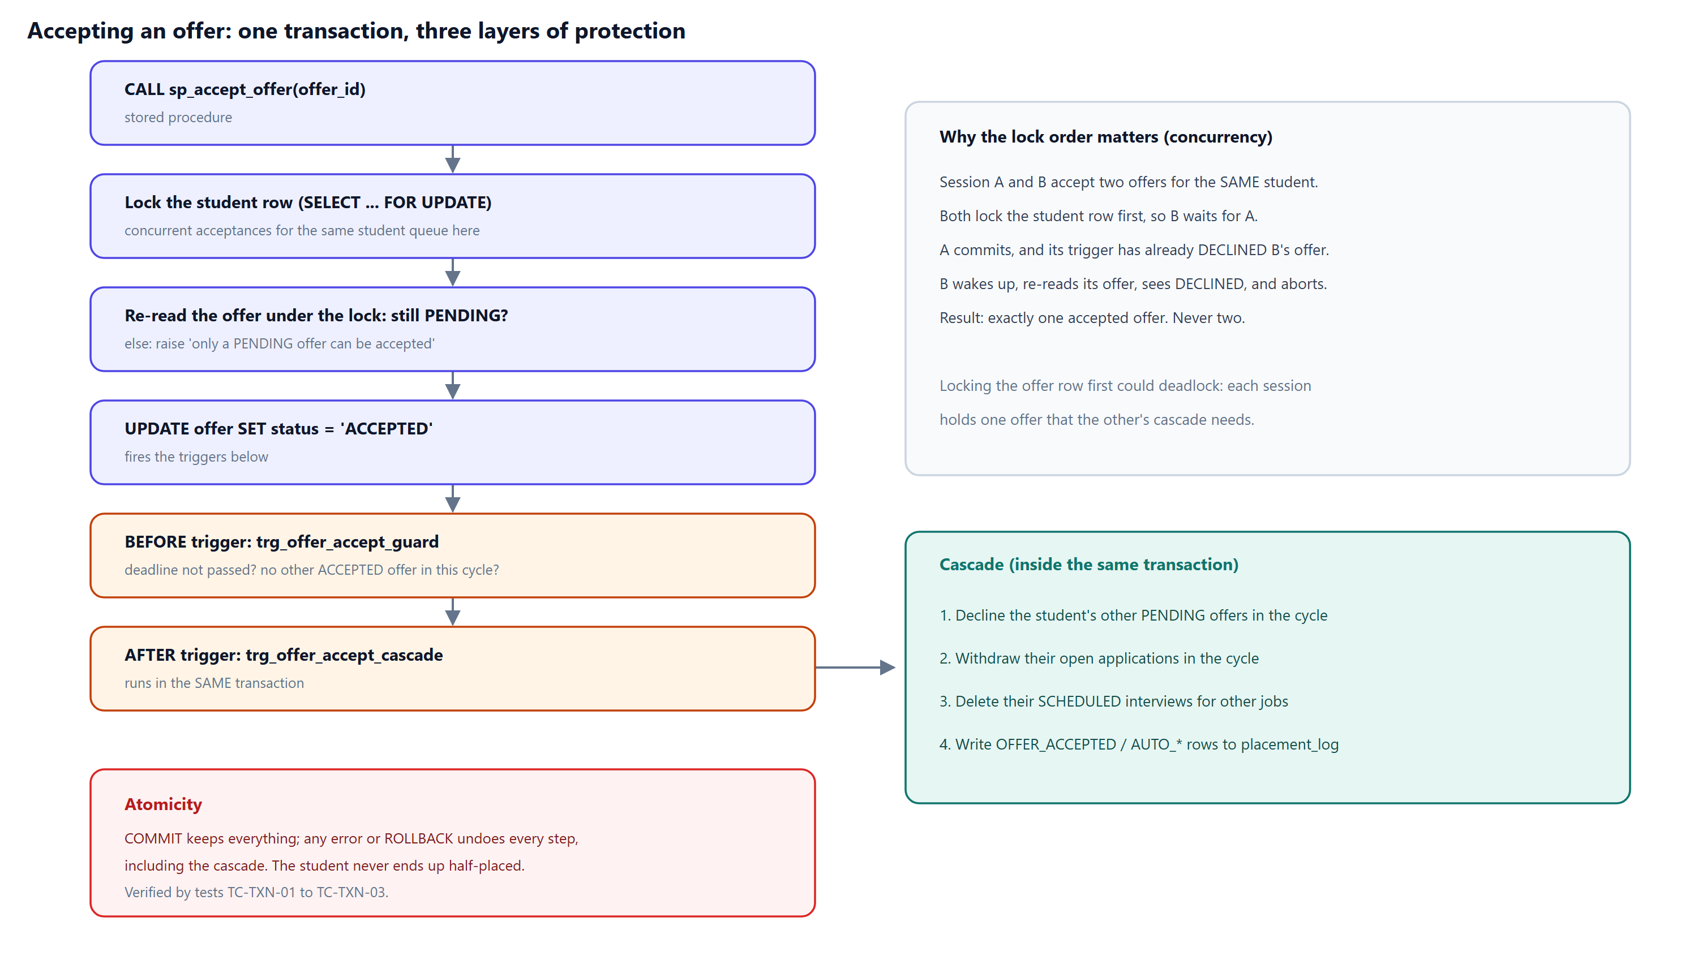
Figure 5. Accepting an offer: procedure, guard trigger and cascade trigger inside one transaction.

The cascade (excerpt)
WITH withdrawn AS (
UPDATE application a
SET status = 'WITHDRAWN',
status_updated_at = GREATEST(v_when, a.applied_at)
FROM job_role j
WHERE j.job_id = a.job_id AND j.cycle_id = v_cycle
AND a.student_id = NEW.student_id
AND a.status IN ('APPLIED', 'SHORTLISTED')
RETURNING a.job_id
)
INSERT INTO placement_log (student_id, job_id, action, details, logged_at)
SELECT NEW.student_id, w.job_id, 'AUTO_WITHDRAWN', ..., v_when FROM withdrawn w;
Table 11. Views and stored routines
Object | Purpose
v_job_details | Flattens the job specialization: one row per job with its CTC or stipend (LEFT JOINs to both subtypes)
v_placement_status | BR-14: derived status per (student, cycle): PLACED, OFFER_PENDING, IN_PROCESS, UNPLACED, NOT_APPLIED, OPTED_OUT
fn_apply_for_job(roll_no, job_id) | Parameterized entry point for applying; the trigger validates
sp_accept_offer(offer_id) | Locks the student row first, re-reads the offer, accepts it; the triggers cascade; reports a summary
sp_expire_stale_offers() | Batch job: expires overdue pending offers and logs each

8. Data generation
Reference data (programs, cycles, skills, sixteen fictional companies, recruiters, alumni, jobs, eligibility, required skills) is written as plain INSERT statements so that it can be read on a slide. Students are generated set-based with generate_series; setseed() makes the pseudo-random CGPAs, skills and applications identical on every run. A PL/pgSQL block then simulates recruitment job by job in date order: shortlisting weighted by CGPA, interview rounds with scores, offers to the top performers, and responses. Each acceptance fires the real trigger, which withdraws the student from later jobs in the same cycle.
The whole load is a single transaction. Because the triggers are already installed, every row is validated as it is inserted: if any row broke a rule nothing would be loaded. Identity sequences are advanced with setval() afterwards, because inserting explicit ids does not move them.
Table 12. Data volumes
Table | Rows | Table | Rows
student | 180 | application | 1,184
company | 16 | interview | 1,057
job_role | 25 | offer | 96
student_skill | 1,146 | placement_log | 144
person | 211 | eligibility | 54
As of the snapshot, summer placements placed 31 of 148 participating students; final placements have placed 30 of 177 so far, with 10 offers pending and a median accepted CTC of ₹29 LPA (highest ₹38 LPA).

9. Analytical queries
The five queries in 05_queries.sql each answer a question the committee actually asks. Results below were produced on the seeded database.

Q1. Which recruiters are the hardest to crack?
Business question. Among final-placement companies that have finished their process and attracted at least 20 applicants, which ones make offers to a SMALLER share of applicants than the campus-wide average? Students use this to decide where to spend their preparation time.
Concepts. 4-way join through a view, outer join (not every application has an offer), aggregate FILTER, GROUP BY, HAVING that compares a group aggregate with a scalar subquery.
Relational algebra.
γ company; count(*)→applicants, count(offer_id)→offers
( Application ⟕ Offer ⋈ JobDetails )
then σ applicants ≥ 20 ∧ offers/applicants < avg_rate
SELECT d.company_name,
d.sector,
count(*) AS applicants,
count(*) FILTER (WHERE iv.interviewed) AS interviewed,
count(o.offer_id) AS offers,
count(o.offer_id) FILTER (WHERE o.status = 'ACCEPTED') AS accepted,
round(100.0 * count(o.offer_id) / count(*), 1) AS offer_rate_pct
FROM application a
JOIN v_job_details d ON d.job_id = a.job_id
LEFT JOIN offer o ON o.student_id = a.student_id AND o.job_id = a.job_id
LEFT JOIN LATERAL (SELECT TRUE AS interviewed
FROM interview i
WHERE i.student_id = a.student_id AND i.job_id = a.job_id
LIMIT 1) iv ON TRUE
WHERE d.cycle_type = 'FINAL'
AND EXISTS (SELECT 1 FROM offer x WHERE x.job_id = a.job_id) -- process complete
GROUP BY d.company_id, d.company_name, d.sector
HAVING count(*) >= 20
AND count(o.offer_id)::numeric / count(*) <
(SELECT count(o2.offer_id)::numeric / count(*) -- campus-wide offer rate
FROM application a2
JOIN job_role j2 ON j2.job_id = a2.job_id
LEFT JOIN offer o2 ON o2.student_id = a2.student_id AND o2.job_id = a2.job_id
WHERE j2.cycle_id = 2
AND EXISTS (SELECT 1 FROM offer x WHERE x.job_id = a2.job_id))
ORDER BY offer_rate_pct;
Table 13. Q1 result (5 rows)
company_name | sector | applicants | interviewed | offers | accepted | offer_rate_pct
Meridian Insurance | BFSI | 58 | 22 | 5 | 1 | 8.60
Kestrel Capital | BFSI | 42 | 23 | 4 | 4 | 9.50
Lumen Technologies | TECHNOLOGY | 63 | 27 | 6 | 2 | 9.50
Vertex Bank | BFSI | 72 | 37 | 7 | 6 | 9.70
DataSutra Labs | ANALYTICS | 70 | 30 | 7 | 2 | 10

Q2. Talent match for a newly posted job (relational division)
Business question. Job 25 (Tidewater Logistics, Supply Chain Analytics Lead) has just been posted. Which students are eligible, not yet placed this cycle, and hold EVERY skill the job requires at the required level? The committee will nudge them to apply.
Concepts. Division expressed as "there is NO required skill that the student does NOT have" (double NOT EXISTS, two nested correlated subqueries), plus an anti-join for "not yet placed".
Relational algebra.
Qualified(student, skill) = π student,skill (σ proficiency ≥ min (StudentSkill ⋈ JobRequiredSkill_25))
Result = Qualified ÷ π skill (σ job_id = 25 (JobRequiredSkill))
WITH params AS (SELECT 25 AS job_id)
SELECT s.roll_no,
concat_ws(' ', p.first_name, p.last_name) AS student_name,
pr.program_code,
s.cgpa
FROM params
JOIN eligibility e ON e.job_id = params.job_id
JOIN student s ON s.program_id = e.program_id
JOIN person p ON p.person_id = s.person_id
JOIN program pr ON pr.program_id = s.program_id
WHERE s.cgpa >= e.min_cgpa
AND s.active_backlogs <= e.max_backlogs
AND NOT s.opted_out
-- division: no required skill exists ...
AND NOT EXISTS (
SELECT 1
FROM job_required_skill r
WHERE r.job_id = params.job_id
-- ... that this student lacks at the required level
AND NOT EXISTS (
SELECT 1
FROM student_skill ss
WHERE ss.student_id = s.person_id
AND ss.skill_id = r.skill_id
AND ss.proficiency >= r.min_proficiency))
-- anti-join: not already placed in this job's cycle
AND NOT EXISTS (
SELECT 1
FROM offer o
JOIN job_role j ON j.job_id = o.job_id
JOIN job_role jt ON jt.job_id = params.job_id
WHERE o.student_id = s.person_id
AND o.status = 'ACCEPTED'
AND j.cycle_id = jt.cycle_id)
ORDER BY s.cgpa DESC;
Table 14. Q2 result (8 rows)
roll_no | student_name | program_code | cgpa
DBA12-039 | Tanvi Jain | PGDBA | 9.04
DBA12-059 | Kavya Patel | PGDBA | 8.40
DBA12-046 | Akash Shah | PGDBA | 8.01
DBA12-058 | Chetan Iyer | PGDBA | 7.87
DBA12-036 | Ishaan Ghosh | PGDBA | 7.70
DBA12-009 | Priya Jain | PGDBA | 7.44
DBA12-038 | Rohan Singh | PGDBA | 7.12
PGP62-079 | Kavya Verma | PGP | 6.99

Q3. Final-placement CTC leaderboard by program (window functions)
Business question. For each program, who are the top 3 earners in final placements so far, how far above their program's average are they, and which pay quartile are they in? This feeds the placement report.
Concepts. Query over a VIEW (v_placement_status, a derived attribute); a named WINDOW with PARTITION BY + ORDER BY; DENSE_RANK (ties share a rank, no gaps), NTILE, AVG() OVER (aggregates without collapsing rows); a subquery to filter on a window result (WHERE cannot see it directly).
SELECT program_code, rank_in_program, roll_no, student_name, placed_with, ctc_lpa,
program_avg_ctc, above_avg_by, pay_quartile, placed_in_program
FROM (
SELECT program_code,
roll_no,
student_name,
placed_with,
ctc_lpa,
DENSE_RANK() OVER w AS rank_in_program,
round(AVG(ctc_lpa) OVER (PARTITION BY program_code), 2) AS program_avg_ctc,
round(ctc_lpa - AVG(ctc_lpa) OVER (PARTITION BY program_code), 2) AS above_avg_by,
NTILE(4) OVER w AS pay_quartile,
COUNT(*) OVER (PARTITION BY program_code) AS placed_in_program
FROM v_placement_status
WHERE cycle_id = 2 AND placement_status = 'PLACED'
WINDOW w AS (PARTITION BY program_code ORDER BY ctc_lpa DESC)
) ranked
WHERE rank_in_program <= 3
ORDER BY program_code, rank_in_program, roll_no;
Table 15. Q3 result (14 rows)
program_code | rank_in_program | roll_no | student_name | placed_with | ctc_lpa | program_avg_ctc | above_avg_by | pay_quartile | placed_in_program
PGDBA | 1 | DBA12-019 | Kavya Verma | Kestrel Capital | 38 | 29.71 | 8.29 | 1 | 12
PGDBA | 1 | DBA12-026 | Pranav Mishra | Kestrel Capital | 38 | 29.71 | 8.29 | 1 | 12
PGDBA | 2 | DBA12-037 | Neha Mukherjee | Northbridge Consulting | 34 | 29.71 | 4.29 | 1 | 12
PGDBA | 3 | DBA12-003 | Pooja Chatterjee | Lumen Technologies | 32 | 29.71 | 2.29 | 2 | 12
PGDBA | 3 | DBA12-033 | Siddharth Chatterjee | Lumen Technologies | 32 | 29.71 | 2.29 | 2 | 12
PGP | 1 | PGP62-049 | Ananya Verma | Kestrel Capital | 38 | 27.78 | 10.22 | 1 | 16
PGP | 1 | PGP62-063 | Pooja Chatterjee | Kestrel Capital | 38 | 27.78 | 10.22 | 1 | 16
PGP | 2 | PGP62-003 | Aditi Chatterjee | Northbridge Consulting | 34 | 27.78 | 6.22 | 1 | 16
PGP | 2 | PGP62-007 | Sanya Mukherjee | Northbridge Consulting | 34 | 27.78 | 6.22 | 1 | 16
PGP | 2 | PGP62-051 | Meera Rao | Northbridge Consulting | 34 | 27.78 | 6.22 | 2 | 16
PGP | 3 | PGP62-053 | Siddharth Kumar | Arcadia Strategy Partners | 31.50 | 27.78 | 3.72 | 2 | 16
PGP | 3 | PGP62-077 | Zoya Gupta | Arcadia Strategy Partners | 31.50 | 27.78 | 3.72 | 2 | 16
PGPEX | 1 | PGX20-029 | Kavya Patel | Arcadia Strategy Partners | 31.50 | 26.75 | 4.75 | 1 | 2
PGPEX | 2 | PGX20-027 | Zoya Sharma | Vertex Bank | 22 | 26.75 | -4.75 | 2 | 2
Note. DENSE_RANK gives tied CTCs the same rank; NTILE does not. It deals rows into 4 equal buckets, so two students with the same CTC can land in different quartiles. Use PERCENT_RANK() if ties must stay together.

Q4. Placement velocity: day-by-day cumulative progress
Business question. During final placements, how many students from each program accepted an offer each day, and what share of each batch is placed by the end of each day? (The committee's daily progress chart.)
Concepts. Multiple CTEs; generate_series to build a calendar (so days with zero placements still appear); CROSS JOIN calendar x program; LEFT OUTER JOIN to the facts; running total with SUM() OVER (PARTITION BY ... ORDER BY ...).
WITH calendar AS (
SELECT d::date AS day
FROM generate_series(DATE '2026-10-18', DATE '2026-10-28', INTERVAL '1 day') AS d
),
batch AS (
SELECT pr.program_id, pr.program_code,
count(*) FILTER (WHERE NOT s.opted_out) AS batch_size
FROM program pr JOIN student s ON s.program_id = pr.program_id
GROUP BY pr.program_id, pr.program_code
),
daily AS (
SELECT s.program_id,
(o.responded_at AT TIME ZONE 'Asia/Kolkata')::date AS day,
count(*) AS accepted
FROM offer o
JOIN job_role j ON j.job_id = o.job_id
JOIN student s ON s.person_id = o.student_id
WHERE j.cycle_id = 2 AND o.status = 'ACCEPTED'
GROUP BY s.program_id, (o.responded_at AT TIME ZONE 'Asia/Kolkata')::date
)
SELECT c.day,
b.program_code,
COALESCE(dl.accepted, 0) AS placed_today,
SUM(COALESCE(dl.accepted, 0)) OVER run AS placed_cumulative,
b.batch_size,
round(100.0 * SUM(COALESCE(dl.accepted, 0)) OVER run / b.batch_size, 1) AS pct_batch_placed
FROM calendar c
CROSS JOIN batch b
LEFT JOIN daily dl ON dl.program_id = b.program_id AND dl.day = c.day
WINDOW run AS (PARTITION BY b.program_id ORDER BY c.day)
ORDER BY b.program_code, c.day;
Table 16. Q4 result: final day for each program (full output has one row per program per day)
day | program_code | placed_today | placed_cumulative | batch_size | pct_batch_placed
2026-10-28 | PGDBA | 0 | 12 | 59 | 20.30
2026-10-28 | PGP | 4 | 16 | 89 | 18
2026-10-28 | PGPEX | 0 | 2 | 29 | 6.90

Q5. Hidden gems: strong academics, lost in the interview room
Business question. Which students are still unplaced in final placements even though, at a company that rejected them in an interview round, their CGPA was HIGHER than the average CGPA of the students that company selected? These students need interview coaching, not academic help, and the failed round says which kind.
Concepts. Correlated subquery (re-evaluated for each application row) used both in SELECT and in WHERE; LATERAL join to find the eliminating round; join on a composite key (job_id, round_no); built on a VIEW.
SELECT ps.roll_no,
ps.student_name,
ps.program_code,
ps.cgpa,
d.company_name,
elim.round_no || ' - ' || elim.round_type || ' (' || elim.result || ')' AS eliminated_in,
(SELECT round(avg(s2.cgpa), 2)
FROM offer o2 JOIN student s2 ON s2.person_id = o2.student_id
WHERE o2.job_id = a.job_id) AS selected_avg_cgpa
FROM v_placement_status ps
JOIN application a ON a.student_id = ps.student_id AND a.status = 'REJECTED'
JOIN v_job_details d ON d.job_id = a.job_id AND d.cycle_id = ps.cycle_id
JOIN LATERAL (
SELECT i.round_no, r.round_type, i.result
FROM interview i
JOIN interview_round r ON r.job_id = i.job_id AND r.round_no = i.round_no
WHERE i.student_id = a.student_id AND i.job_id = a.job_id
AND i.result IN ('NOT_CLEARED', 'ABSENT')) elim ON TRUE
WHERE ps.cycle_id = 2
AND ps.placement_status IN ('UNPLACED', 'IN_PROCESS')
AND ps.cgpa > (SELECT avg(s2.cgpa) -- correlated on a.job_id
FROM offer o2 JOIN student s2 ON s2.person_id = o2.student_id
WHERE o2.job_id = a.job_id)
ORDER BY ps.cgpa DESC, d.company_name;
Table 17. Q5 result (3 rows)
roll_no | student_name | program_code | cgpa | company_name | eliminated_in | selected_avg_cgpa
DBA12-039 | Tanvi Jain | PGDBA | 9.04 | Helix Analytics | 3 - HR (ABSENT) | 8.81
DBA12-049 | Priya Verma | PGDBA | 8.98 | Quanta Cloud | 1 - APTITUDE (NOT_CLEARED) | 8.33
DBA12-035 | Bhavya Sen | PGDBA | 8.51 | Quanta Cloud | 1 - APTITUDE (NOT_CLEARED) | 8.33
Q2 was additionally cross-checked against the division-by-counting formulation (GROUP BY … HAVING count(*) = number of required skills) for all 25 jobs; both give identical sets (test TC-QRY-06).

10. Transactions and concurrency
Table 18. ACID properties in PlaceIQ
Property | How the project demonstrates it | Test
Atomicity | Accepting an offer and its whole cascade is one transaction; a ROLLBACK restores offers, applications, interviews and the log | TC-TXN-01
Consistency | Constraints at statement end; deferred totality trigger at COMMIT; a job without a subtype cannot commit | TC-TXN-04, TC-CON-05
Isolation | Concurrent acceptances for one student are serialized by a row lock on the student | TC-TXN-02, 03
Durability | After COMMIT returns, PostgreSQL's write-ahead log preserves the change across a crash | (engine guarantee)

10.1 The concurrency scenario
Under the default READ COMMITTED isolation level, two sessions accepting two different offers for the same student could both pass the 'no other accepted offer' check before either commits, leaving the student with two accepted offers. sp_accept_offer therefore takes SELECT … FOR UPDATE on the student's row before touching any offer. Session B blocks until session A commits; it then re-reads its offer, finds that A's cascade has already declined it, and aborts. The automated test runs this with two real connections and a thread, and asserts that exactly one accepted offer remains.

10.2 Lock order and deadlock
An earlier version locked the offer row first. Two concurrent acceptances could then each hold one offer while their cascades needed the other's, a classic deadlock (PostgreSQL would detect it and abort one session). Locking the common parent row, the student, first imposes a single global lock order, which eliminates the cycle.

11. Performance and indexing
The live tables are small enough that sequential scans are optimal, so indexing was measured on a 600,000-row application archive built inside a transaction. Each figure is the best of three EXPLAIN ANALYZE runs recorded by the performance tests.
Table 19. Index measurements (query: open applications for one job)
Configuration | Plan | Execution time | Index size
No index | Sequential scan of 600,000 rows | 62.654 ms | —
B-tree (job_id, status) | Bitmap index scan | 0.029 ms | 4,488 KB
Partial (job_id) WHERE status IN ('APPLIED','SHORTLISTED') | Bitmap index scan | 0.021 ms | 176 KB
The composite index is about 2,160 times faster than the sequential scan. The partial index, covering only the roughly 4% of rows that are still open, is 26 times smaller than the full index and faster still. A partial index is used in production too: idx_offer_accepted_student supports the triggers' 'has an accepted offer?' lookups.
Finding: the leading-column rule on PostgreSQL 18
We expected a filter on status alone to ignore the (job_id, status) index. PostgreSQL 18 did use it, but by reading the entire index: 4,383 blocks, against 3 blocks for a proper seek on job_id.
The accurate statement of the rule is that an index cannot be used to seek on a non-leading column; at best the whole index (or the whole table) is read. Our test and demo script were corrected accordingly.

12. Security

12.1 SQL injection
Every query in the application passes user input as a bound parameter (psycopg %s placeholders, sent separately from the SQL text as $1, $2 …), so input can never change the structure of a statement. To demonstrate the difference, the web interface includes a laboratory that runs the same student search two ways.
Input | String concatenation | Bound parameter
Sen | 6 rows | 6 rows
x' OR '1'='1 | 180 rows: every student leaked | 0 rows
x' UNION SELECT roll_no, cgpa::text, phone … | 180 rows of CGPAs and phone numbers | 0 rows
x'; DROP TABLE student; -- | Refused: SQLSTATE 25006 (read-only transaction) | 0 rows

12.2 Least privilege (DCL)
CREATE ROLE placeiq_readonly NOLOGIN;
GRANT USAGE ON SCHEMA placeiq TO placeiq_readonly;
GRANT SELECT ON placeiq.student, placeiq.person TO placeiq_readonly;
The deliberately vulnerable path runs as this role, inside a READ ONLY transaction with a two-second statement timeout, and is always rolled back. Even a successful injection can therefore only read two tables: writes fail, other tables are denied (SQLSTATE 42501) and superuser functions such as pg_read_file are unavailable. The web server binds to 127.0.0.1 only.

13. Application layer
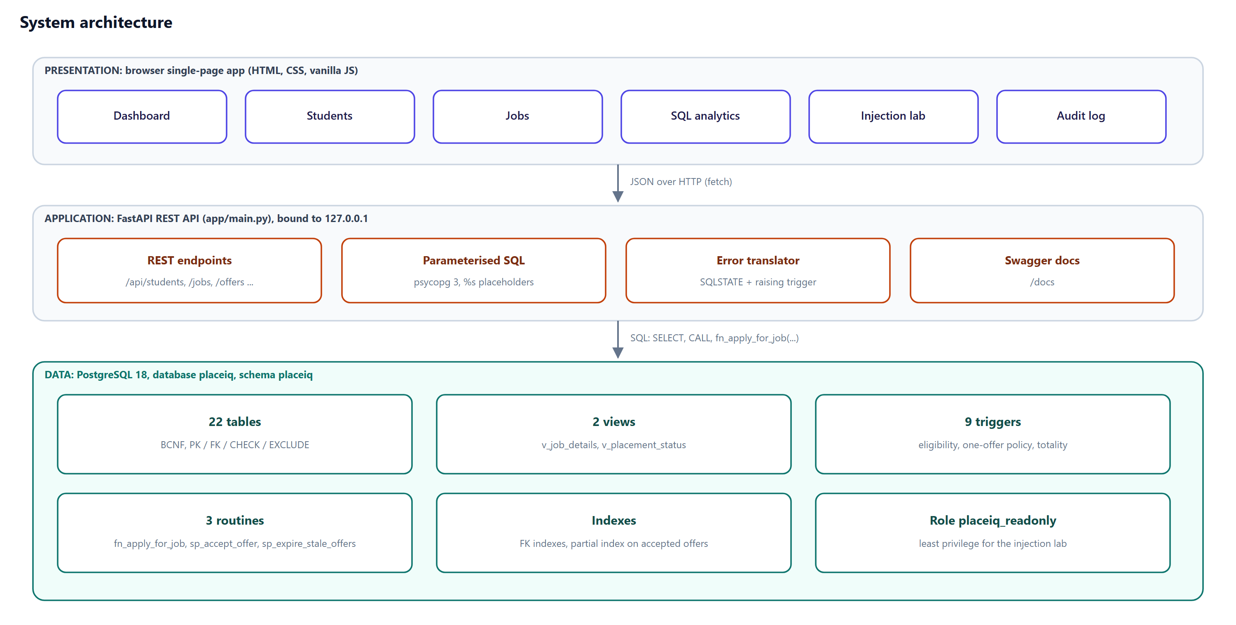
Figure 6. Three-tier architecture: browser single-page app, FastAPI REST API, PostgreSQL.
The REST API (app/main.py) is a thin layer: it calls the views, the stored function and the procedures, and translates database errors into JSON containing PostgreSQL's message, the SQLSTATE and the name of the trigger function that raised it. The browser shows that explanation directly, so users see why the database refused an action.
Table 20. Main REST endpoints
Method and path | Purpose
GET /api/summary, /api/velocity | Dashboard KPIs, status by program, cumulative placement series
GET /api/students, /api/students/{roll} | Search; full profile with applications, interviews, skills, audit trail
POST /api/applications | Apply (fn_apply_for_job; eligibility trigger)
POST /api/offers, /api/offers/{id}/accept | decline | Recruiter offer; acceptance via sp_accept_offer with the cascade returned
GET /api/jobs, /api/jobs/{id} | Jobs, funnel, rounds, applicants, talent match (Query 2)
GET/POST /api/queries, /api/queries/{n}/run | The five queries, parsed from 05_queries.sql, run read-only
GET /api/security/search | SQL-injection laboratory (sandboxed)
POST /api/admin/reset | Rebuild the seeded database
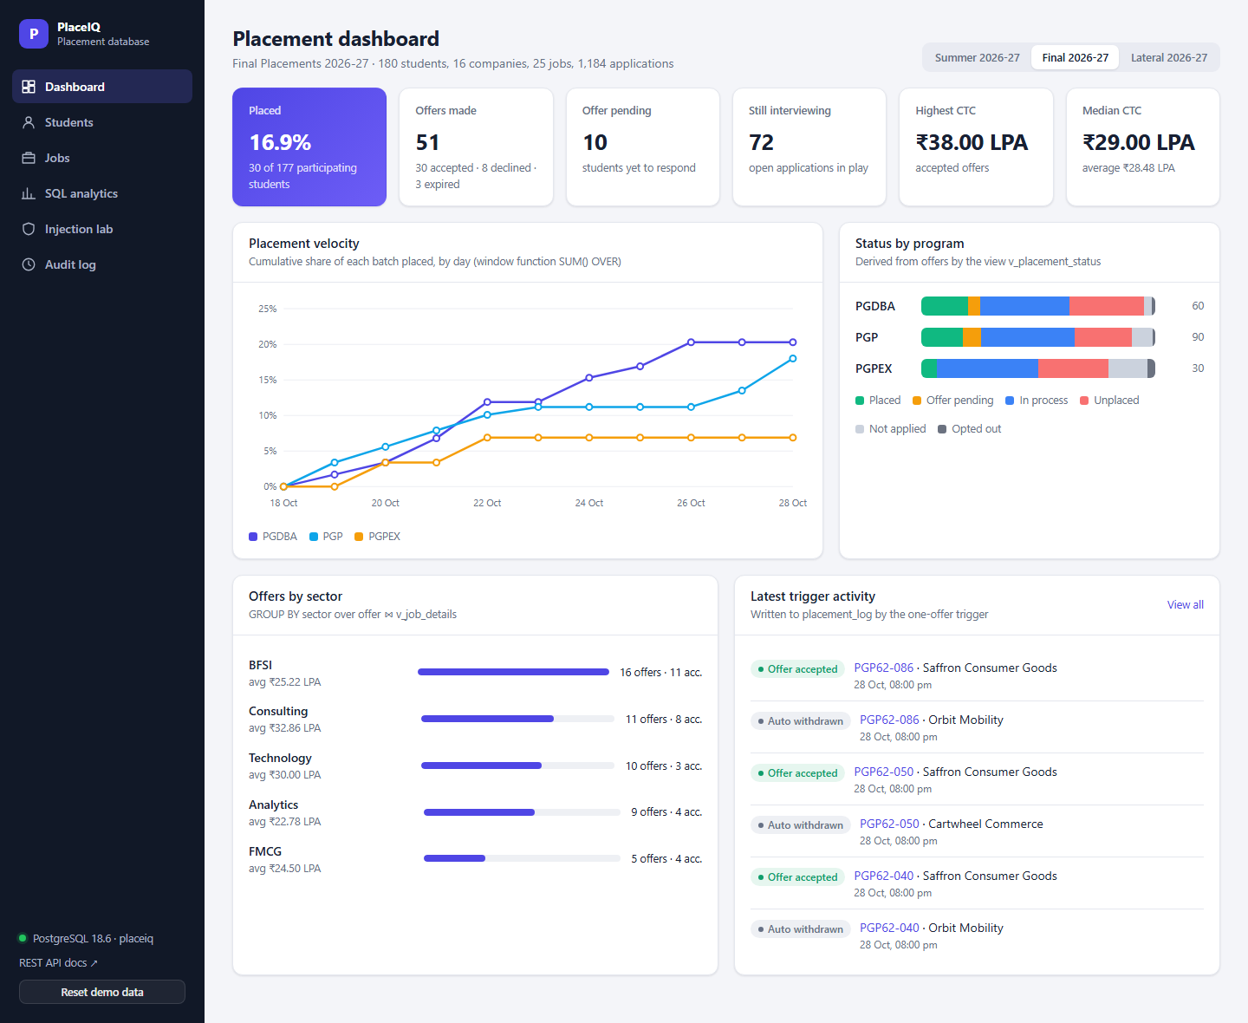
Figure 7. Dashboard: KPIs, placement velocity (window function) and status by program (view).
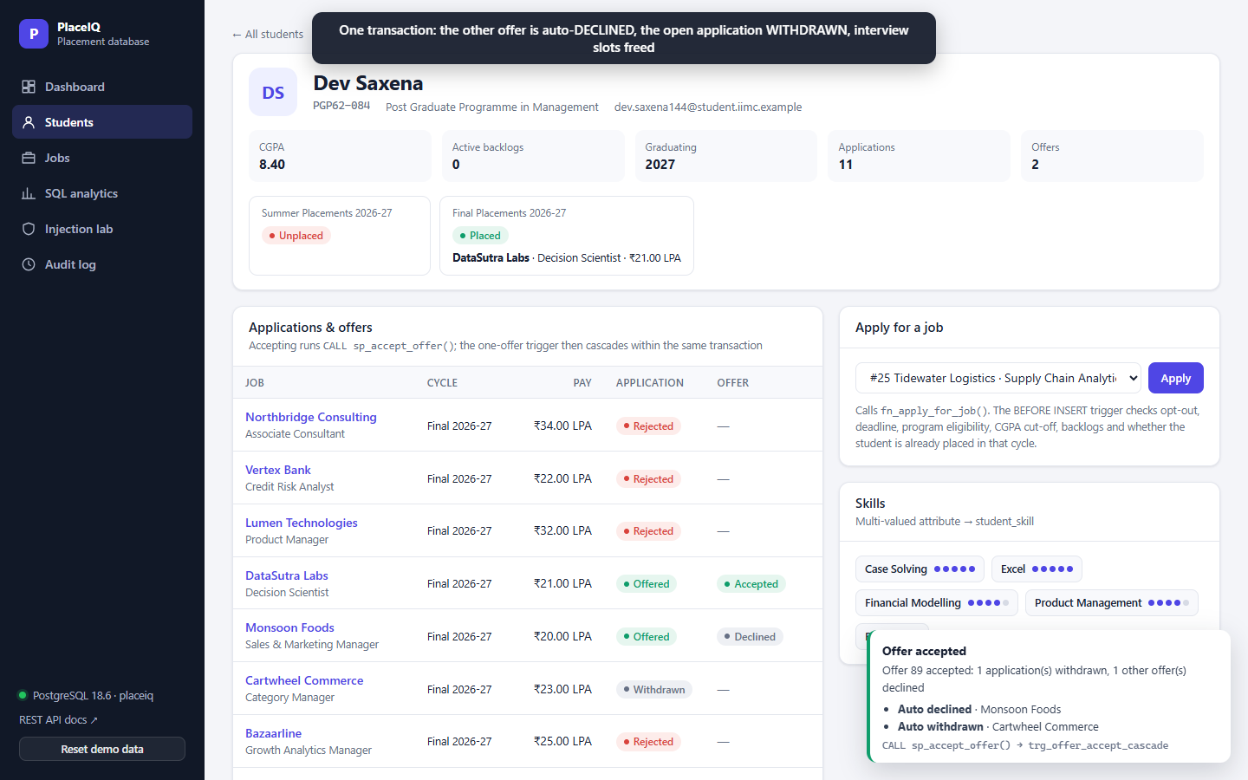
Figure 8. Student profile after accepting an offer: the cascade declined one offer and withdrew one application.

14. Testing summary
The automated suite (tests/) contains 91 test cases that run against the real database with pytest; all 91 pass. Each test runs in a transaction that is rolled back, the database is rebuilt at the start and end of a run, and tests that must commit (concurrency, API writes) restore the seed afterwards. Full details, the traceability matrix and the defect log are in the separate Testing Report.
Module | Tests | Result
api | 11 | All passed
constraints | 20 | All passed
data | 9 | All passed
performance | 3 | All passed
queries | 9 | All passed
schema | 10 | All passed
security | 9 | All passed
transactions | 4 | All passed
triggers | 16 | All passed

15. Learnings, limitations and future work

15.1 What we learned
- Modelling decides what can be enforced. Treating the application as an aggregation is what made it possible to guarantee, with plain foreign keys, that interviews and offers belong to a real application.
- Normalization is a proof, not a feeling. Writing every functional dependency exposed the transitive dependency hidden in min_cgpa and justified the Eligibility table.
- Declare before you code. CHECK constraints, composite foreign keys and an exclusion constraint reject bad data even when the application is bypassed; triggers are for what cannot be declared.
- Concurrency must be tested, not assumed. A two-connection test showed why lock order matters and turned a possible deadlock into a clean queue.
- Measure performance. The leading-column rule behaved differently on PostgreSQL 18 than the textbook summary suggested; measuring blocks read gave the accurate explanation.

15.2 Limitations
- Synthetic data: distributions are plausible but not drawn from a real placement season.
- No user authentication or row-level security per student or recruiter.
- The UI is a teaching interface, tested end to end through the recorded demo rather than a browser test suite.

15.3 Future work
- Row-level security policies so that each student sees only their own rows.
- SERIALIZABLE isolation as an alternative to explicit locking, with retry logic.
- Table partitioning of the application archive by academic year.
- Materialized views for the dashboard with scheduled refresh.

16. Team contribution
Member | Name | Owned in the project and the presentation
M1 | Ekta Sharma | Problem analysis, business rules, EER model (both views), Chen diagrams
M2 | [Member 2] | ER-to-relational mapping, keys, functional dependencies, normalization to BCNF and proofs
M3 | [Member 3] | DDL and integrity techniques, data generation, the five analytical queries
M4 | [Member 4] | Triggers and procedures, transactions and concurrency, indexing, security, testing, live demo
All members reviewed each other's sections; the presentation follows the same split.

References
- A. Silberschatz, H. F. Korth and S. Sudarshan, Database System Concepts, 7th ed., McGraw-Hill Education, 2019.
- R. Elmasri and S. B. Navathe, Fundamentals of Database Systems, 7th ed., Pearson, 2016.
- PostgreSQL Global Development Group, PostgreSQL 18 Documentation: constraints, triggers, transaction isolation, indexes, EXPLAIN.
- NPTEL (IIT Madras), Database Management Systems: ER model, relational model, SQL, relational schema design, storage and indexing.
- Course material, Fundamentals of Database Systems, PGDBA Batch 12: data models, relational algebra, SQL, query optimization, SQL injection, REST and databases.

Appendix A. How to run
# 1. Database (PostgreSQL 15+; from the Project folder)
.\run_all.ps1 -Password <postgres-password>

# 2. Queries and the scripted demo
psql -U postgres -h localhost -d placeiq -f 05_queries.sql
psql -U postgres -h localhost -d placeiq -f 06_demo.sql # ends in ROLLBACK

# 3. Web UI
cd app
python -m venv .venv
.venv\Scripts\pip install -r requirements.txt
.venv\Scripts\python main.py # http://127.0.0.1:8000

# 4. Tests (pip install pytest httpx into the same venv)
app\.venv\Scripts\python -m pytest tests -v

Appendix B. Repository contents
Path | Contents
01_design.md | Design notes: rules, EER, mapping, normalization
02_ddl.sql | Schema
03_logic.sql | Views, triggers, procedures, role
04_data.sql | Seeded data and recruitment simulation
05_queries.sql | The five queries
06_demo.sql | Scripted psql demo
app/ | FastAPI backend and web UI
tests/ | pytest suite and results
deliverables/ | Report, guide, testing report, runbook, slides, video, diagrams

