**DEERWALK INSTITUTE OF TECHNOLOGY**

**Tribhuvan University**

**Institute of Science and Technology**



**SMART STICK FOR VISUALLY IMPAIRED USING IoT**

**A PROJECT REPORT**

**Submitted to**

**Department of Computer Science and Information Technology**

**DWIT College**

***In partial fulfillment of the requirements for the Bachelor’s Degree in Computer Science and Information Technology***

Submitted by

Akriti Sharma

Ekta Shrestha

22nd January, 2021

**DWIT College**

**DEERWALK INSTITUTE OF TECHNOLOGY**

**Tribhuvan University**

**SUPERVISOR’S RECOMENDATION**

I hereby recommend that this project prepared under my supervision by AKRITI SHARMA and EKTA SHRESTHA entitled **“SMART STICK FOR VISUALLY IMPAIRED USING IoT”** in partial fulfillment of the requirements for the degree of B.Sc. in Computer Science and Information Technology be processed for the evaluation.

…………………………………………

Mr. Bijay Babu Regmi

Lecturer

Deerwalk Institute of Technology

DWIT College

**DWIT College**

**DEERWALK INSTITUTE OF TECHNOLOGY**

**Tribhuvan University**

**LETTER OF APPROVAL**

This is to certify that this project prepared by AKRITI SHARMA and EKTA SHRESTHA entitled **“SMART STICK FOR VISUALLY IMPAIRED USING IoT”** in partial fulfillment of the requirements for the degree of B.Sc. in Computer Science and Information Technology has been well studied. In our opinion, it is satisfactory in the scope and quality as a project for the required degree.

|  |  |
| --- | --- |
| ……………………………………  Mr. Bijay Babu Regmi  Lecturer  DWIT College | …………………………………………  Dr. Subarna Shakya  Professor  IOE, Tribhuvan University |

# ACKNOWLEDGEMENT

We would like to thank Mr. Bijay Babu Regmi, Lecturer, DWIT College for supervising this project and giving assistance when faced with problems. This project would not have been possible without his guidance and persistent help. We would like to thank him for providing deeper knowledge about the technology needed for this project.

We would also like to thank Mr. Hitesh Karki, Chief Academic Officer, DWIT College and Mr. Milan Lamichhane, Faculty, DWIT College for providing help with various aspect of this project.

Last but not the least, our sincere thanks go to our parents and family members, who have always supported us and to all our friends who directly or indirectly helped us to complete this project.

Akriti Sharma (TU Exam Roll no: 10477)

Ekta Shrestha (TU Exam Roll no: 10491)

22nd January, 2021

# ABSTRACT

In real life, there are a lot of obstacles that are present around you at all times. It is easier for someone who has the capability to see things and react accordingly but in real life scenarios, there are a large number of people who are visually impaired. Keeping that in mind, it has introduced the need of creating an application that can allow a person to know what lies in front or around them. This project implements sensors which effectively detect objects that are present in the environment and warn them about the obstacles that lie there.

Visually impaired people need some help while travelling to feel safe. In this project, we have developed a smart stick which increases the accessibility of visually impaired person to move around and audio output is given when obstacle is detected. This smart stick is lightweight and fast. The stick consists of an ultrasonic sensor for obstacle detection. The android application is linked with ultrasonic sensors to notify an obstacle. The application also consists of real time navigation system with speech recognized destination and Gesture detection with features like emergency call etc.

**Keywords:** *Visually Impaired people, GPS (Global Positioning System) navigation, Ultrasonic Sensors, Arduino, Gestures.*

# TABLE OF CONTENTS

ACKNOWLEDGEMENT iv

ABSTRACT v

TABLE OF CONTENTS vi

LIST OF FIGURES viii

LIST OF TABLES ix

LIST OF ABBREVATIONS x

CHAPTER 1: INTRODUCTION 1

1.1 Overview 1

1.2 Background and Motivation 1

1.3 Problem Statement 2

1.4 Objective of the Project 3

1.5 Scope of the Project 3

1.6 Outline of the Report 4

CHAPTER 2: LITERATURE REVIEW 5

CHAPTER 3: REQUIREMENT AND FEASIBILITY 8

3.1 Requirement Analysis 8

3.1.1 Functional Requirement 8

3.1.2 Non-Functional Requirement 9

3.2 Feasibility Analysis 10

3.2.1 Technical Feasibility 10

3.2.2 Economic Feasibility 10

3.3.3 Operational Feasibility 11

3.3.4 Schedule Feasibility 11

CHAPTER 4: METHODOLOGY 13

4.1 Data Preparation 13

4.1.1 Data Collection 13

4.1.2 Data Selection / Filtering 13

4.2 Algorithms Studied and Implemented 13

4.2.1 Algorithm 13

4.2.2 Suitability of Algorithm 14

4.3 System Design 14

4.3.1 State Diagram 14

4.3.2 Class Diagram 16

CHAPTER 5: DEVELOPMENT METHOD 17

5.1 Waterfall Model 17

CHAPTER 6: IMPLEMENTATION AND EVALUATION 19

6.1 Tools and Technologies Used 19

6.2 Implementation 22

6.3 Testing and their Results 23

6.3.1 Testing Approach 23

6.3.2 Testing Plan 24

6.3.3 Unit Test Cases 25

6.3.4 Integrated System Test Cases 26

CHAPTER 7: CONCLUSION AND LIMITATIONS 27

7.1 Conclusion 27

7.2 Limitations 28

REFERENCES 29

APPENDIX 31

# LIST OF FIGURES

Figure 1: Outline of the project 4

Figure 2: Use case Diagram 9

Figure 3: Network diagram to identify critical path 12

Figure 4: State Diagram 15

Figure 5: Class Diagram 16

Figure 6: WaterFall Model 17

Figure 7: NodeMCU [10] 20

Figure 8: Ultrasonic sensor [11] 20

Figure 9: Breadboard 21

Figure 10: Jumper Wires 21

Figure 11: Components of a product 22

# LIST OF TABLES

Table 1: Project Expense 10

Table 2: Work Breakdown Structure 11

Table 3: Result of voice navigation 25

Table 4: Result of gesture recognition 26

Table 5: Integrated System Test Cases for obstacle detection 26

# LIST OF ABBREVATIONS

API: Application Program Interface

GPS: Global Positioning System

IDE: Integrated Development Environment

RAM: Random Access Memory

SDK: Software Development Kit

SMS: Short Message Service

UI: User Interface

UML: Unified Modeling Language

USB: Universal Serial Bus

WHO: World Health Organization

# CHAPTER 1: INTRODUCTION

## Overview

This project helps visually impaired people to efficiently navigate their way by listening the audio signal which provides an information regarding an obstacle lied in front of them. The android application is used to alert a user about the various signals received from the sensors and also provides other functionalities like gesture recognition and real time navigation. When an obstacle is detected, the application uses google API to convert text to speech and alert the user regarding an obstacle that lies near them. It notifies the user about the obstacle.

The user can also start navigation from his current location by double tapping the screen. Double tapping launches the speech to text service where the user has to speak out the name of destination and the navigation gets started. Swiping right bottom of screen launches gesture recognition. Since the person is visually impaired, just sliding finger in particular pattern will recognize number using gesture recognition. Each number is assigned to call specific number.

## Background and Motivation

Navigation is a very important aspect in human life. People use their senses to find and detect different objects in the environment. The most used sense is the eye which helps to detect what obstacles are there around us. But there are many cases where people are visually impaired and who have a hard time navigating their path.

According to WHO, globally, it is estimated that approximately 2.2 billion people in the world live with some form of visual impairment [1] i.e. almost around 20% of the world population. They have used various techniques to overcome the problem and live their life but still the means are really difficult during execution.

The visually impaired people generally need an assistance of some other person or some tool to navigate their way. The availability of a second person at all times might not be feasible. So mostly, they use various sticks to ensure if there are any objects around them or not. Not being able to see what lies in front of you is a very tough life to live. So, to help these visually impaired people, this application makes things a little easier for them.

The application we have built helps these people to know an obstacle present in front of them. Currently, they use the traditional stick which detects obstacle only when they touch it and hence prior detection of obstacle is problem.

Traditional stick also cannot properly detect obstacle which are at certain height. Thus, visually impaired people will feel confident to move around only when obstacles are known from far distance. This can be done with help of Ultrasonic sensors. There are various types of technologies and sensors available but ultrasonic sensors are chosen because they are cheap and light weight and can detect obstacle up to 400 cm. There is also a possibility that those people might not know the route or might have some emergency which can be taken care with real time navigation and gesture recognition. Smart stick will help the visually impaired person in easy mobility just like normal person.

## Problem Statement

## 

We have been seeing that finding path to the visually impaired people is really difficult. Someone who is in need of some assistance have a really hard time to live their life. They are making use of either some devices or some tools as senses to get an information on what is around them. In most of the cases, we found them with second person for their assist to travel.

So, this application can be used as a helping tool to help these people to eliminate the need of having someone for their assistance.

## Objective of the Project

The objectives of this project are:

* To help visually impaired people to walk in their desired place independently.
* To make life of visually impaired people easier and more comfortable.
* To help users to know about an obstacle that lies in front of them.
* To help users for proper directions through detection of obstacle and associated audio signal.

## Scope of the Project

The application will provide the following functions:

* Detect obstacles by using obstacle detection algorithms.
* Alert users about obstacles through voice output.
* Guide users for proper directions through detection of obstacle and associated voice outputs.
* Navigation using location service for user’s start location and voice-based input for destination.
* Gesture based emergency features.

This application is developed using android operating system since it is most easily available operating system in today’s world. The hardware was developed using NodeMCU, which is most widely used microcontroller for controlling multiple sensors simultaneously. Ultrasonic sensors are used for distance measurement. These sensors are widely used sensors and their multiple concurrent use is simple.

This project develops a smart stick for visually impaired people. It contains a ultrasonic sensors on the stick which is used to detect an obstacle. These sensors are connected to NodeMCU which is connected to the Android App. The app receives the data from NodeMCU and gives voice feedback to the user. The app also has accessibility features like gesture recognition for emergency calling and voice navigation to help person move around.

## Outline of the Report

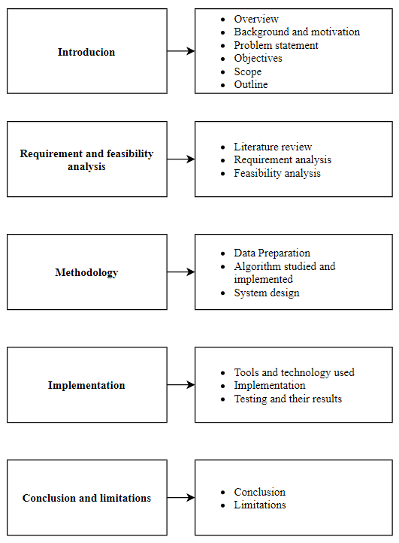

Figure 1: Outline of the project

# CHAPTER 2: LITERATURE REVIEW

So far researchers have done significant work for the blind and visually impaired by developing many different kinds of assistive technologies to aid them in navigation. Some of the different designs of the smart stick are described below along with their modes of operation.

The paper [2] focuses on developing a new type of cane that can be used by blind and visually challenged people for navigating indoors and outdoors as well. The cane consists obstacle detection system and a GPS navigation assistance. The setup implemented by using rechargeable power sources and with low power consumption. For GPS navigation, the data is read from GPS, the coordinates are compared and the user is informed. In case of Obstacle detection, the echo waves are received using ultrasonic sensors and sent to Raspberry pi to calculate the distance.

The GPS artificial vision assistance was developed by Shruti Kumbhare and A. Sakhore[3]. The device features object detections, real-time assistance via GPS, artificial vision, and a voice circuit. A camera is fitted on the blind user’s head, which will employ algorithms to identify obstacles in front of him/her. Ultrasonic sensors also assist with object detection. The GPS guides the user to his/her destination. One strength of this system is that precision of the artificial unit affords the user with high output accuracy. The gadget’s drawback, however, is that its design is highly complex, which makes it difficult to operate.

The assisted vision smart glasses were designed to aid individuals with very low vision to navigate unfamiliar settings, recognize obstacles, and achieve a higher degree of independence[4]. The glasses are based on the fact that most blind individuals have at least some dim vision. The assisted vision smart glasses are intended to capitalize on this sight. The glasses are made of OLED displays, with a gyroscope, a GPS module, an earpiece, a compass, and two small cameras. Incoming data is processed, and then used in a myriad of ways, for instance, brilliance can be used to show depth. Since most visually impaired persons can distinguish brilliance from dullness, the glasses can brighten anything close to the wearer so that they can discern obstacles and persons. The GPS module can provide directions, and the gyroscope assists the glasses in calculating perspective changes as the wearer moves. The camera can also work with the computing module to help read markers along the way.

This version [5]of the smart cane uses a sick fitted with ultrasonic sensors, an audio output system, and a GPS module. The GPS module has a memory chip used to save different locations. The user can set the location via voice, and the GPS will guide him/her to that location. This system also gives the speed of motion, along with the distance left to reach the destination. The ultrasonic sensors will trigger the cautioning voice whenever they detect an obstacle along the path. Its voice guide has remarkable accuracy. The device uses the AR processor, which has a substantial memory space that allows for highspeed operation. The one drawback for the cane, however, is that it cannot be used indoors since the GPS signal will be lost. Moreover, the precision of the GPS signal requires improvement as it is only controllable within a 16 feet radius. Also, users have to undergo thorough training before they can use the system effectively.

It comprises an ultrasound displacement sensor, a microcontroller, and two DC motors, with a total weight of 4kgs[6]. The guide stick’s height and width are 85 and 24 cm respectively. The system’s AI can detect the exact position of an object and relate that information to the user. Detection entails a “map-matching technique” that involves the ultrasonic sensors, the DC motors, and the controller that connects to an encoder. When the rotators turn 18 degrees, the IR sensors that are attached to both wheels will convey the signal to the CPU to give a location update. This way the intelligent guide stick is incredibly accurate in detection and can provide continuous updates about obstacle position. The downside of this gadget, however, is that it is highly complex and costly. Moreover, the 4kg weight makes it quite heavy as compared to the other systems.

The above-mentioned projects are similar to this project. But these projects don’t have separate android application that alerts the user about the various signals received from the sensors. Also, it is easier to use for visually impaired people as compared to above mentioned projects as it has double tapping functionality which launches speech to text service where user has to speak out the name of destination and the navigation gets started. All these above-mentioned projects lack gesture recognition functionality which helps visually impaired people contact their loved ones in case of an emergency.

# CHAPTER 3: REQUIREMENT AND FEASIBILITY

## Requirement Analysis

### 3.1.1 Functional Requirement

The functional requirements of this product are:

* The android phone shall start serial connection.
* The android phone shall launch app on connection.
* The Arduino shall monitor distance values.
* The Arduino shall find obstacle location.
* The Arduino with the help of android phone shall send alert to the user when the obstacles are detected.
* The android phone shall detect the gesture provided by the user.

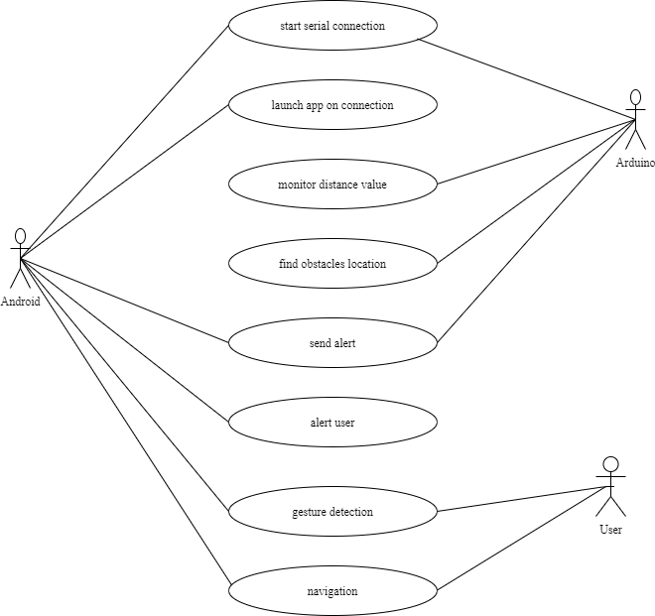

Figure 2: Use case Diagram

### Non-Functional Requirement

The Non-functional requirements of this product are:

* The connection and service must be reliable.
* The system must be easy to use.
* The system must be portable.
* The system must provide output within a desired time frame.

## 3.2 Feasibility Analysis

### 3.2.1 Technical Feasibility

The proposed system consists of an android phone, a stick and ultrasonic sensor connected to the NodeMCU. The stick is made up of polycarbonate plastic which makes it reliable and feasible for any kind of roads and weather. The NodeMCU and sensors are easily available and can be easily connected making the project technically feasible.

### 3.2.2 Economic Feasibility

Every individual is assumed to own an android phone which is used to alert and navigate the user. The cost of project includes the price of NodeMCU, ultrasonic sensor, 9V battery, battery connector, jumper wires, buzzer and breadboard which is around 1425 rupees thereby making it feasible by cost.

Table 1: Project Expense

|  |  |  |
| --- | --- | --- |
| **S.N.** | **Components** | **Cost (Rs. )** |
| 1 | NodeMCU | 840 |
| 2 | Breadboard | 120 |
| 3 | Ultrasonic sensor | 240 |
| 4 | Jumper wire | 100 |
| 5 | 9V battery | 45 |
| 6 | Battery connector | 20 |
| 7 | Buzzer | 60 |
|  | Total | 1425 |

### 3.3.3 Operational Feasibility

The application is designed for visually impaired people so the UI and the application flow are really simple. Someone who has a basic knowledge of using mobile device can operate the application. Hence, it is understood that this application is operationally feasible.

### 3.3.4 Schedule Feasibility

The schedule feasibility of the system was analyzed using the critical path method. This method helps to find the order of activities, following which system can be built efficiently, depending on the criticality of activities, and time required to complete the project as earlier or as longer.

The following table identifies the activities, their respective duration (in days) and their precedents.

Table 2: Work Breakdown Structure

|  |  |  |
| --- | --- | --- |
| **Activity** | **Duration (in days)** | **Predecessors** |
| Research on existing system and previous papers presented(A) | 15 | - |
| Finalizing algorithm (B) | 8 | A |
| System architecture design(C) | 12 | B |
| Implementing Algorithm (D) | 10 | B, C |
| Hardware implementation(E) | 10 | A, D |
| Testing (F) | 15 | D, E |
| Integration (G) | 10 | F |

The following network diagram was constructed using forward and backward pass.

|  |  |  |
| --- | --- | --- |
| 0 | 15 | 15 |
| A | | |
| 0 | 0 | 15 |

|  |  |  |  |  |
| --- | --- | --- | --- | --- |
| 15 | 8 | | 23 | |
| B | | | | |
| 15 | | 0 | | 23 |

|  |  |  |
| --- | --- | --- |
| 23 | 12 | 35 |
| C | | |
| 23 | 0 | 35 |

|  |  |  |
| --- | --- | --- |
| 35 | 10 | 45 |
| D | | |
| 35 | 0 | 45 |

|  |  |  |
| --- | --- | --- |
| 45 | 10 | 55 |
| E | | |
| 45 | 0 | 55 |

|  |  |  |
| --- | --- | --- |
| 55 | 15 | 70 |
| F | | |
| 55 | 0 | 70 |

|  |  |  |
| --- | --- | --- |
| 70 | 10 | 80 |
| G | | |
| 70 | 0 | 80 |

Figure 3: Network diagram to identify critical path

# CHAPTER 4: METHODOLOGY

## 4.1 Data Preparation

### 4.1.1 Data Collection

“Smart stick for visually impaired” consists of ultrasonic sensor as one of its important components. Ultrasonic sensor is simply a device that measures the distance of an object by using sound waves. It measures distance by sending out a sound wave at a specific frequency and waits for that sound wave to bounce back. By recording the time taken between the sound wave being generated and the sound wave bouncing back, it is possible to calculate the distance between the sensor and the object. On the basis of distance, a pulse is generated in the ultrasonic sensor to send the data to NodeMCU.

The data collected by the sensor is stored in the database and the data collection is real time. The data is used by the Android application to give the voice output to the user regarding the obstacle detection.

### 4.1.2 Data Selection / Filtering

To collect the data, Android application extracts the data from the database which are less than 30 cm which produces the voice output.

## 4.2 Algorithms Studied and Implemented

### 4.2.1 Algorithm

**Obstacle detection algorithm:**

The sensor placed on the stick are used for obstacle detection. The sensor senses the obstacle towards the front using time required to receive the signal and then distance is calculated in NodeMCU using distance formula. This distance is then captured in Firebase. Android application and firebase communicates in order to result the presence of an obstacle through voice output and aware the user.

The algorithm used for obstacle detection is:

Step 1: dist_front = distance received from a sensor.

Step 2: if (dist_front>=0 && dist_front<=30)

alert that obstacle is ahead.

Step 3: check dist_front again for closeness

This output is sent to android application using firebase which provides voice output to the user regarding obstacle detection.

### 4.2.2 Suitability of Algorithm

Since the project uses a hardware i.e. ultrasonic sensor which is used for obstacle detection, obstacle detection algorithm is much needed to implement in order to run the project. This algorithm mimics the human behavior of detecting the obstacles that are located around them. Also, this is needed to estimate the size ratios of the approaching obstacles from the consecutive frames.

That’s why obstacle detection algorithm is must suitable to carry out this project.

## 4.3 System Design

### 4.3.1 State Diagram

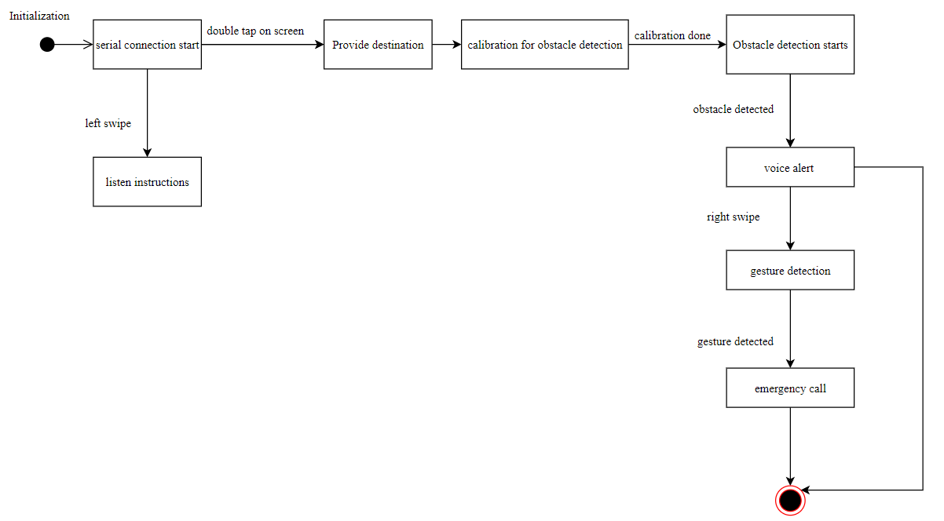

Figure 4: State Diagram

Figure 4 illustrates state diagram. It is used to represent the condition of the system or part of the system at finite instances of time. It’s a behavioral diagram and it represents the behavior using finite state transitions. Here, the serial connection gets started by clicking on start button of an application. The user can left swipe to listen an instructions and get familiar to an application. In order to provide destination, user must double tap on the screen and speak where he/she wants to go. Then, the calibration for obstacle detection starts. When the calibration is done, obstacle detection starts. An obstacle is detected by the help of ultrasonic sensor. The user gets audio signal from an application regarding the detection of obstacle. This is how user gets an alert signal. In case of any emergency, user can right swipe and draw gestures like 0, ^, v to call their loved ones and inform them that they are in danger.

### 4.3.2 Class Diagram

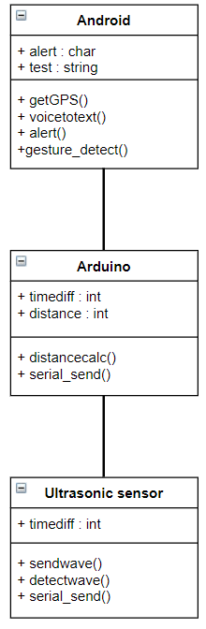

Figure 5: Class Diagram

Figure 5 illustrates class diagram. It is a type of static structure diagram that describes the structure of a system by showing the system's:

* classes,
* their attributes,
* operations (or methods),
* and the relationships among objects.

Here Android, Arduino and Ultrasonic sensor are three classes which has their respective attributes and methods. “+” sign in the figure represents an attribute as public.

# CHAPTER 5: DEVELOPMENT METHOD

The project followed the Waterfall software development methodology where the development of different phases of the project are processed and completed one at a time and these phases do not overlap.

## 5.1 Waterfall Model

Waterfall model is referred to as a linear-sequential life cycle model. It is very simple to understand and use. In a waterfall model, each phase must be completed before the next phase can begin and there is no overlapping in the phases. In this approach, the whole process of software development is divided into separate phases. Typically, the outcome of one phase acts as the input for the next phase sequentially.

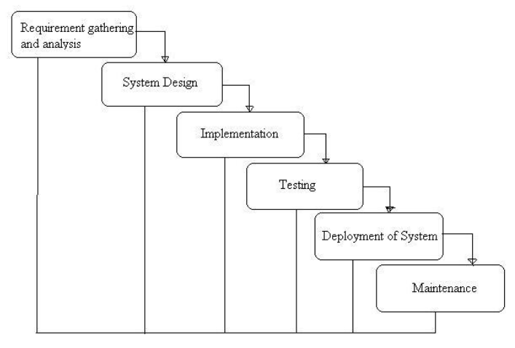

Figure 6: WaterFall Model

In the first phase of waterfall model, all the possible requirements of the project to be developed were capture and documented in a requirement specification document. Also, different types of feasible study were also conducted to determine if there would be any constraints which could affect the development process. Feasibility study such as economic, schedule, technical and operational feasibility study were carried out and then moved on the succeeding steps.

Likewise, in system design phase, the requirements specification from requirement analysis phase were studied and the system design was prepared. The hardware aspects of our project which consisted of – NodeMCU, an ultrasonic sensor, jump wires, breadboard and battery were accumulated. Also, the system flow was planned and pseudocode was prepared on how the system should work and the analysis of the base level of the model.

Similarly, in the implementation phase, the source code as per the defined requirements was written. The construction of the planned model was also completed. The development of system was done in small units, after which, each of the units were integrated.

As soon as the implementation phase was completed, the testing phase was carried out. The testing phase were divided into two portions- the Android Application and the IOT system. Faults and Failures were tested in these both portions. The test was done to determine if the system would detect an obstacle and whether or not it outputs the audio signal when the obstacles are detected. All of the various aspects in testing ensured that the system worked as expected.

Lastly, the system was locally deployed in order to perform various tests. After the production, a test server in order to deploy the system so that one could understand what changes the system had to undergo and what new updates could be brought up to enhance the feature of the system.

# CHAPTER 6: IMPLEMENTATION AND EVALUATION

## 6.1 Tools and Technologies Used

The tools and technologies used are:

**CASE tools:**

* Draw.io

Draw.io is completely free online diagram editor built around Google Drive, that enables you to create flowcharts, UML, entity relation, network diagrams, mockups and more. It can import from. vsdx, Gliffy and Lucidchart files [7].

* Creately.com

It is the visual software to draw and collaborate on ideas, concepts and processes. It is used as a chart and diagram maker/collaboration tool/visual space [8].

**Programming Tools:**

* JAVA

Java is a powerful general-purpose programming language. It is used to develop desktop and mobile applications, big data processing, embedded systems, and so on.

* Arduino

Arduino is an open-source electronics platform based on easy-to-use hardware and software. [Arduino boards](https://www.arduino.cc/en/Main/Products) are able to read inputs - light on a sensor, a finger on a button, or a Twitter message - and turn it into an output - activating a motor, turning on an LED, publishing something online [9].

**Hardware tools:**

* NodeMCU

The NodeMCU with cp2102 Wifi Board is an all-in-one microcontroller plus WiFi platform that is very easy to use to create projects with WiFi and IoT (Internet of Things) applications. The board is based on the highly popular ESP8266 WiFi Module chip with the ESP-12 SMD footprint. This WiFi development board already embeds in its board all the necessary components for the ESP8266 (ESP-12E) to program and upload a code. It has a built-in USB to serial chip upload codes, 3.3V regulator and logic level converter circuit so you can immediately upload codes and connect your 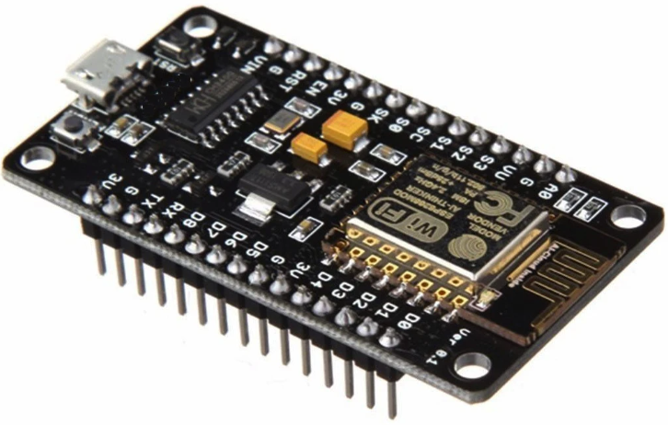circuits.

Figure 7: NodeMCU [10]

* Ultrasonic sensor

Ultrasonic (US) sensor is a 4-pin module, whose pin names are Vcc, Trigger, Echo and Ground respectively. This sensor is a very popular sensor used in many applications where measuring distance or sensing objects are required. The module has two eyes like projects in the front which forms the Ultrasonic transmitter and Receiver. The sensor works with the simple high school formula

i.e Distance = Speed × Time

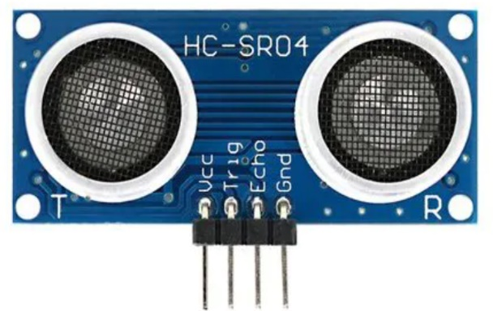

Figure 8: Ultrasonic sensor [11]

* Breadboard

A breadboard is used to build and test circuits quickly before finalizing any circuit design. The breadboard has many holes into which circuit components like ICs and resistors can be inserted. The bread board has strips of metal which run underneath the board and connect the holes on the top of the board. The metal strips are laid out. The top and bottom rows of holes are connected horizontally while the remaining holes are connected vertically [12].

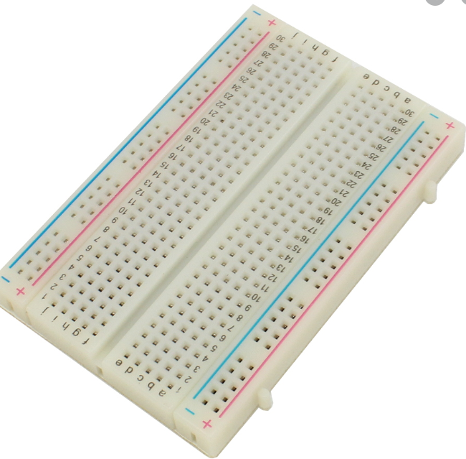

Figure 9: Breadboard

* Jumper Wires

Jumper wires are simply wiring that have connector pins at each end, allowing them to be used to connect two points to each other without soldering. Jumper wires are typically used with breadboards and other prototyping tools in order to make it easy to change a circuit as needed.

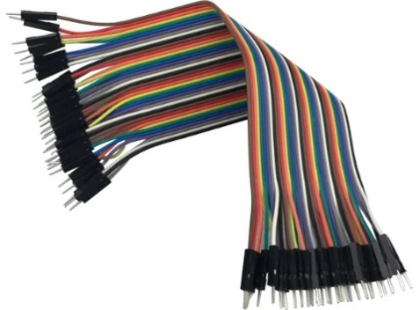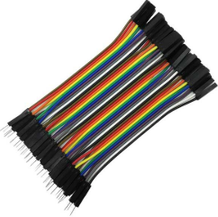

Figure 10: Jumper Wires

* 9V battery and battery connector

**Software tools:**

* Android studio

Android Studio is the official Integrated Development Environment (IDE) for Android app development, based on IntelliJ IDEA.

* Arduino IDE

The [Arduino](https://en.wikipedia.org/wiki/Arduino) Integrated Development Environment (IDE) is a [cross-platform](https://en.wikipedia.org/wiki/Cross-platform) application (for [Windows](https://en.wikipedia.org/wiki/Windows), macOS, [Linux](https://en.wikipedia.org/wiki/Linux)) that is written in functions from [C](https://en.wikipedia.org/wiki/C_(programming_language)) and [C++](https://en.wikipedia.org/wiki/C%2B%2B_(programming_language)). It is used to write and upload programs to Arduino compatible boards, but also, with the help of 3rd party cores, other vendor development boards.

## 6.2 Implementation

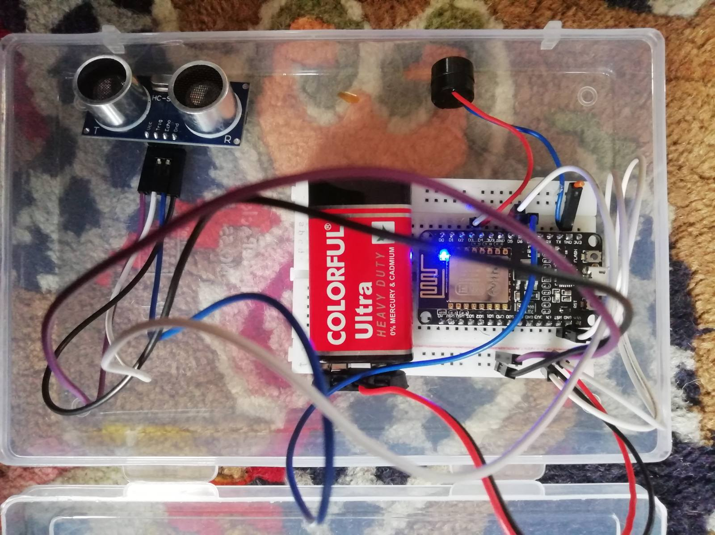

Figure 11: Components of a product

It consists of android phone connected to NodeMCU and ultrasonic sensor attached to the stick. The Android to NodeMCU connection is done using firebase and android phone is connected to internet for navigation.

Ultrasonic sensors connected to NodeMCU are used to calculate distances of objects. The following formula implemented in Arduino code calculates the distance of any object within the range of sensors.

Speed of sound in air =340 m/s

Distance= (speed*time)/2

Distance is divided by 2 because initial distance received is for sending signal plus receiving signal.

## 6.3 Testing and their Results

### 6.3.1 Testing Approach

Reactive testing technique used as the modules were tested after they were coded and compiled successfully. As in Reactive testing technique, the testing is not started until after the designing and coding of modules is completed.

Various modules implemented:

1. Obstacle detection
2. Navigation
3. Gestures

Each module was tested in a reactive testing approach wherein the module was first designed, coded and then tested for various test cases. Every module was tested independently after its completion after which bugs were corrected and updates were made until the test results were as desired. After successful completion of testing, next module was designed and coded.

### 6.3.2 Testing Plan

Every important module of the project was individually coded and tested following the reactive approach. Test conditions and input values for desired outputs were detailed and the actual outputs were compared with the estimated outputs. Every module was tested and updated till the actual outputs were almost close to desired values.

**Test Items:**

* Android phone to check appropriate warnings and alerts.
* Microphone for voice input.
* Android log to verify values calculated by algorithms.
* Database to check if the data is captured by sensor or not.

**Features to be tested:**

* Obstacle detection and appropriate alerts with guidance.
* Voice recognition with accurate interpretation of spoken destination.
* Gestures detection.

**Approach:**

1. Obstacle detection testing:

* Sensors at the end of the stick detect obstacles.
* Using the stick along with sensors for commuting.
* Walking the stick in various traffic and crowd conditions.
* Recording the response suggested by the obstacle detection algorithm.

1. Voice recognition:

* Various voice inputs to test the conversion to text.
* Numerous locations tested to test the interpretation capability.

1. Gestures detection:

* Launching the gesture screen using accurate method.
* Using applied gestures along with random patterns.
* Checking for proper gesture recognition.

**Test Environment:**

Environment used for testing purpose was simulated close to real world conditions in which visually challenged people might use the setup. Various crowded locations and busy streets for obstacle detection simulation. Various locations tested for obstacle detection. Noisy as well as silent locations used to test working of voice recognition module for navigation.

**Risks**: Various risks identified during testing period:

* Proper connections and handling of equipment necessary for accurate results.
* Net connectivity required for navigation purposes.
* Cautious power supply mechanism.
* Mobile coverage availability for emergency calling feature.

### 6.3.3 Unit Test Cases

1. The result of voice navigation. First column shows the destination given by user. Second column shows whether it was converted properly from voice to text. Third column shows whether navigation was started or not.

Table 3: Result of voice navigation

|  |  |  |
| --- | --- | --- |
| **Destination** | **Voice to Text destination** | **Navigation started?** |
| Deerwalk Institute of Technology | "Deerwalk Institute of Technology” | Yes |
| Koteshwor | “Koteshwor” | Yes |

1. The output of gesture recognition. Column one shows what gesture is drawn by user. Column two shows what gesture is detected and column three shows whether function specific to that gesture is called or not.

Table 4: Result of gesture recognition

|  |  |  |
| --- | --- | --- |
| **Gesture Drawn** | **Gesture Detected** | **Function Called** |
| “0” | “0” | call emergency contact 1 |
| “V” | “V” | call emergency contact 2 |
| “^” | “^” | call emergency contact 3 |

### 6.3.4 Integrated System Test Cases

The result of obstacle detection. First column shows in which direction the obstacle is present. The second column shows the actual output of the direction of obstacle as detected by sensors. The third column shows the range at which obstacle is detected and fourth column shows how accurate the result is.

Table 5: Integrated System Test Cases for obstacle detection

|  |  |  |  |
| --- | --- | --- | --- |
| **Obstacle from** | **Output** | **Range(cm)** | **Result** |
| front | “Obstacle Detected” | 26 | accurate |
| front | - | 78 | accurate |
| front | “Obstacle Detected” | 11 | accurate |

# CHAPTER 7: CONCLUSION AND LIMITATIONS

## 7.1 Conclusion

The project “SMART STICK FOR VISUALLY IMPAIRED” was selected keeping the needs of visually impaired people in mind. These people need some help while travelling to feel safe along with proper guided navigation. Through this project, we have developed a smart stick which increases the accessibility of visually impaired person to move around by providing alerts about obstacles that might occur on his/her path while travelling. The stick developed in this project, called “Smart Stick”, uses ultrasonic sensor and obstacle detection algorithm to detect obstacles within fixed range close to the user.

The android application is linked with ultrasonic sensor for notification of obstacles. The application also consists of real time navigation system with speech recognized destination. Gesture detection detects the specified pattern drawn by the user and call their emergency contact in case of any emergency. The project makes an effort to help visually challenged people travel safely without help of others.

The project is divided into two layers: Android and Arduino. There are various functions in Android: based on functions selection, appropriate procedure call is made. If Navigation is selected, then first the procedure call of voice input is called to enter the destination, then the procedure for Google API is called to start the navigation.

If Gesture Activity is called, the procedure call for gesture recognition is done. Based on gesture drawn, the appropriate number is called. The sensor senses the distance and sends the data about the detection of obstacle in firebase. The data transfer between two layers takes place via Firebase database. The data is then received by Android and thus appropriate decision is displayed as well as voice output is provided.

## 7.2 Limitations

After several numbers of tests performed, the limitations of the applications were observed as:

* It only detects an obstacle that lies within 30cm.
* It does not detect pothole.
* The speech to text recognition does not have 100% accuracy where accents and audio quality plays a big role.

# REFERENCES

|  |  |
| --- | --- |
| [1] | WHO, "World Health Organization," 8 10 2019. [Online]. Available: https://www.who.int/news-room/fact-sheets/detail/blindness-and-visual-impairment. |
| [2] | S. A. Gupta, " Advanced guide cane for the visually impaired people," in *2015 1st International Conference on Next Generation Computing Technologies (NGCT)*, 2015. |
| [3] | S. K. a. A. Sakhore, "GPS Artificial Vision Assistance," *International Journal of Computer Applications,* 2019. |
| [4] | M. ,. t. t. b. Ali, smart glasses for visually impaired people, 2016/07/13. |
| [5] | R. M. Somnath koley, "VOICE OPERATED OUTDOOR NAVIGATION SYSTEM FOR VISUALLY IMPAIRED PERSONS," *International Journal of Engineering Trends and Technology,* vol. 3, no. 2, p. 5, 2012. |
| [6] | Y. K. a. H. M. Sung Kang, "Development of an intelligent guide-stick for the blind," in *EEE International Conference on Robotics and Automation*, Seoul, South Korea, 2001. |
| [7] | "G Suite Marketplace," [Online]. Available: https://gsuite.google.com/marketplace/app/diagramsnet/671128082532. |
| [8] | "Creately," 2008. [Online]. Available: https://creately.com/. |
| [9] | "Arduino," [Online]. Available: https://www.arduino.cc/en/Guide/Introduction. |
| [10] | "ElectronicWings," [Online]. Available: https://www.electronicwings.com/nodemcu/introduction-to-nodemcu. |
| [11] | M. MURRAY, "The Greek pub," 15 dec 2019. [Online]. Available: https://www.thegeekpub.com/235425/arduino-ultrasonic-sensor-tutorial/. |
| [12] | "educypedia.karadimov.info," [Online]. Available: http://educypedia.karadimov.info/library/breadboard.pdf. |
| [13] | M. G. A. G. T. G. P. K. Rucha Doiphode, "Be My Eyes: Android Voice Application for Visually Impaired People," ResearchGate, 2017. |
| [14] | H. P. H. P. &. N. P. u. t. g. o. P. G. S. Dhruvin Patel, "smart-stick-using-arduino-ultrasonic," [Online]. Available: https://www.electronicsforu.com/electronics-projects/smart-stick-using-arduino-ultrasonic. |
| [15] | S. Microsystems, "wikipedia," 23 may 1995. [Online]. Available: https://en.wikipedia.org/wiki/Java_(programming_language). |
| [16] | V. Badami, "Hackerearth," [Online]. Available: https://www.hackerearth.com/blog/developers/a-tour-of-the-arduino-uno-board/. |

# APPENDIX

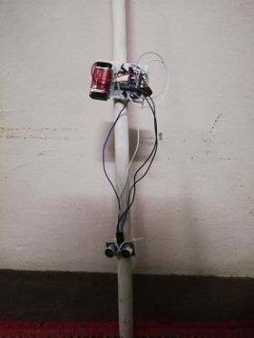  
fig: Actual implementation of stick

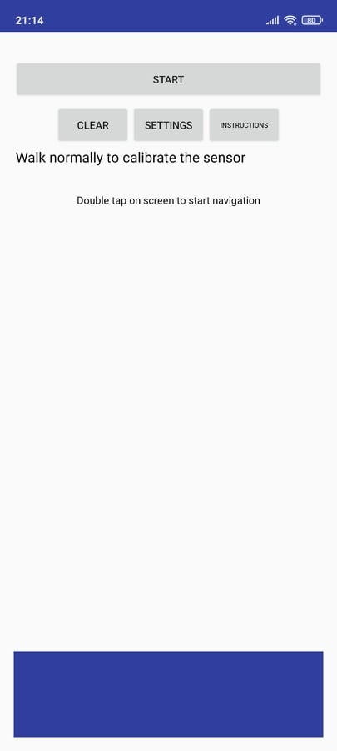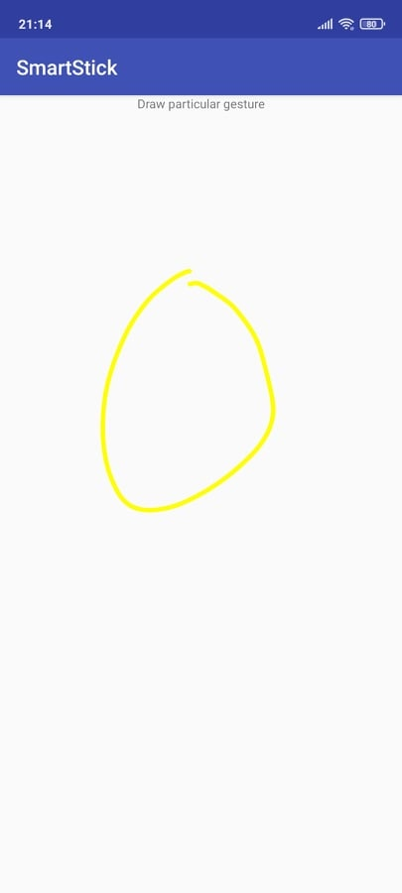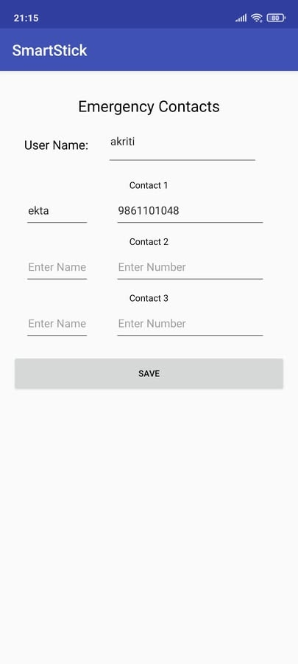

Screenshot 1: Screenshot of application for Gesture detection

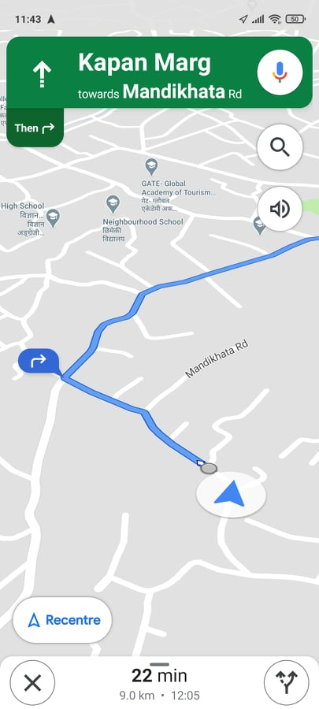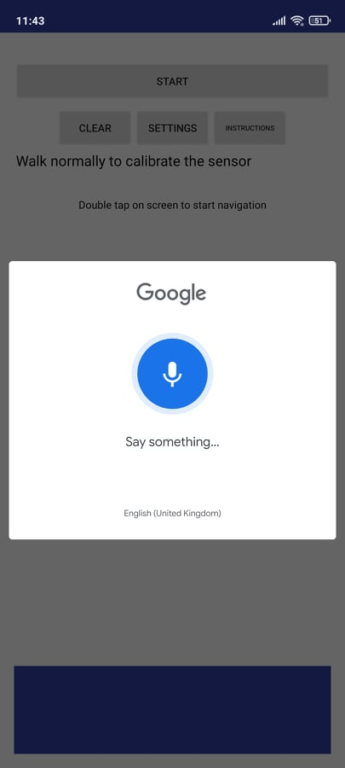

Screenshot 2: Screenshot of application for Navigation