Report 16/01/2023

Since the last lesson, I work on different aspect. I started to end my test with the brushless motor and I could come with an understanding of the rotation speed evolution. It’s as followed: 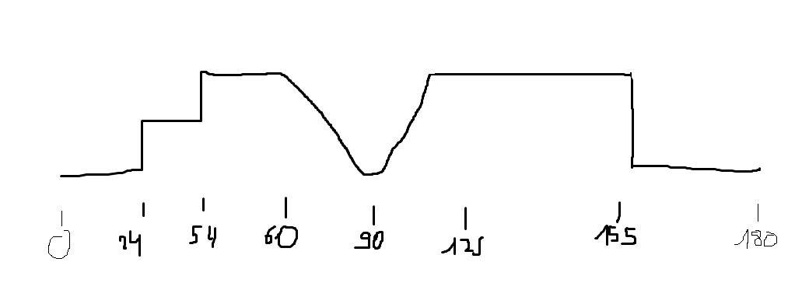I state all the value of the PWM pin, so it’s between 0 and 180. The range of action is from 24 to 155 but what’s interesting for us are the linear part, between 60 and 125. It’s this part that will be of use for the project.

The next aspect that I worked on was the understanding and calibration of the pH-meter. It wasn’t easy to comprehend it because of the module which modify values of the sensor and it has his datasheet missing. However with different test, and research, I could calibrate it by using a method of averaging with 10 value. I took the 6 center value and convert it in voltage and then in pH. This value must be adjusted for a neutral pH before each use, otherwise it will lose in accuracy. Then you just need to adjust the corrective value at the beginning of the program as it’s stipulated in comment.

After talking with Nino, we will probably switch from an Arduino card to a Raspberry Pi card. So I began to translated the program in Python. It took me time and the program doesn’t work yet but the foundation is present. It was my first time using the Python language.

For using my program on a Rasberry Pi pico W card, I needed to search how to use the Pwm on it. There are three pin available on the raspberry pi, from pin 26 to 28.

I also help a little bit Nino on the research on the Jetson nano, I search how to use PWM pin on it, however, to be able to do so, you need to totally reconfigurate tue card and we don’t have neither the time nor the software to do so.

Finally I adjust my modeling on Fusion 360 and I notice that some part of each part couldn’t really work with the other when I assembles them all together so next time I will correct it before printing it.