Report 31/01/2023

During this session, I focused in my modeling. The base wasn’t wrong but there was some correction to add. Firstly behind the motor, the tree can’t rotate due to an inappropriate size of the hole for it.   
Also, when I tried to assembled the rudder, I saw that it wasn’t the right size, and with the support, there was a stacking of material. I start to correct it but I couldn’t finish it during the session.

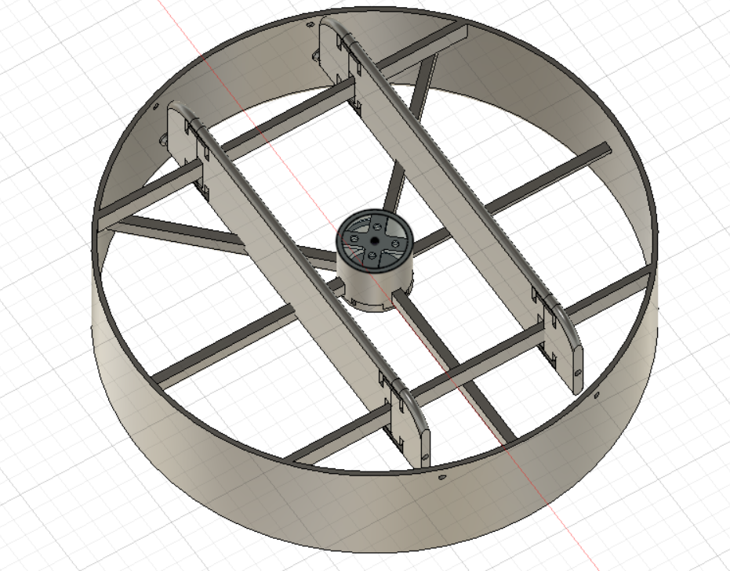

There was also an issue with the hole for the screw to fix the motor. I haven’t the tool to measure it. The emplacement of the hole wasn’t right. It was the same to check the size of the propeller and the one for the motor. I will do it next time when I will be at school.