Report 07/02/2023

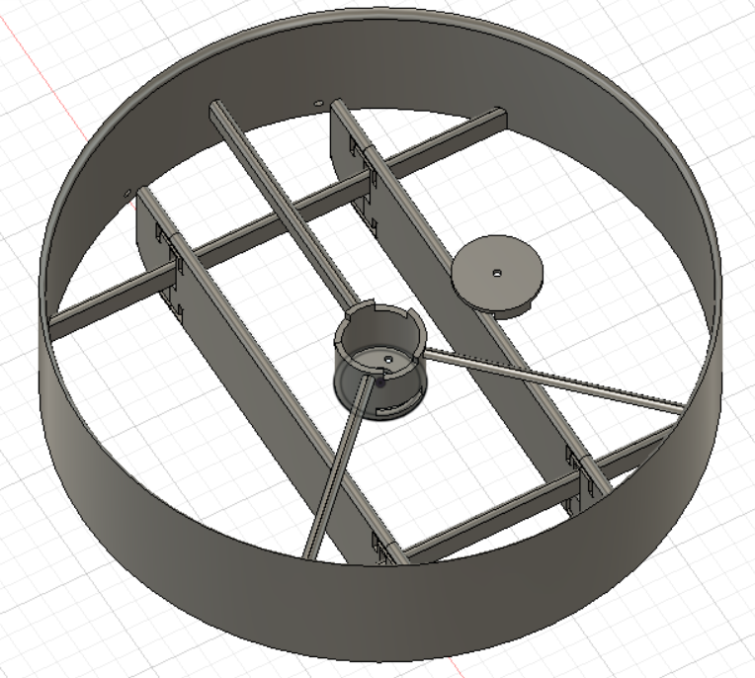As said in my last report, I began the session by finishing the correction of the different piece of the cover. It took me some time due to the different measure I needed to take and correct the actual model. To test the change, I print on a 3D printer the motor cover. It’s the most delicate part because it must let the motor rotate efficiently.

During the printing I made a desoldering, it was the part between the ESC and the motor because the motor can’t be insert on the cover with the ESC fix to it.

After that, I follow Nino to see how he tested the drag force and listen to the teacher who help him.

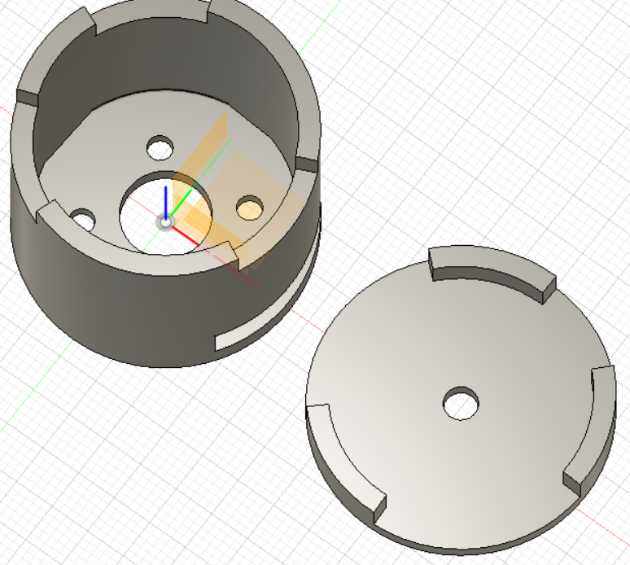Once the piece is printed, I directly put the motor on it. It was pleasant because all the modification were perfect. The screw were at the right place, it was the most difficult part because of the precision of the 3D printer but also the placement in cross and not in symmetry. It was also nice that the rotation wasn’t obstruct at the bottom point. The motor can rotate easily, it can be fix and it cover almost all the motor as excepted.

I need to do another soldering to be able to test it and after that, I launched my program test. It was conclusive and work almost the same as before. In fact, when the motor rotate at low speed, the motor rotate by fits and starts. However, at high speed there was no problem, even for the deceleration until it stop itself.