Rapport 14/10/2022

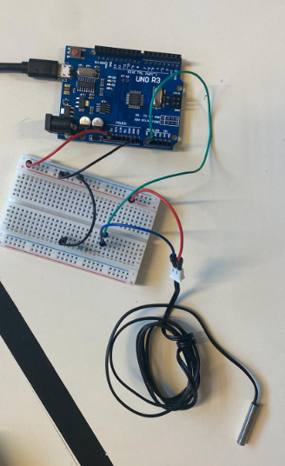Today I’ll start by studying an analog temperature sensor.

Therefore, I began by set up a voltage divider bridge to protect and try to understand the link between the temperature and the voltage. In this divider bridge, the temperature sensor act as a variable resistance.

When I wrote my first code, values wrote on the monitor were always 0, so I try to understand why. The reason was easy, I just connect the voltage input on the pin “ref” instead of “5V”.

I found that the value corresponding to the hand heat is 54 so around 37°C. The value corresponding to the temperature in the room was 39, and by looking at a thermometer, it correspond approximatively to 21.5°C.

We assume that the value giving by sensor is linear function.

By doing a cross product, we found that the relation between the voltage and the temperature is approximatively:

Temp = voltage / 1.6 + cst

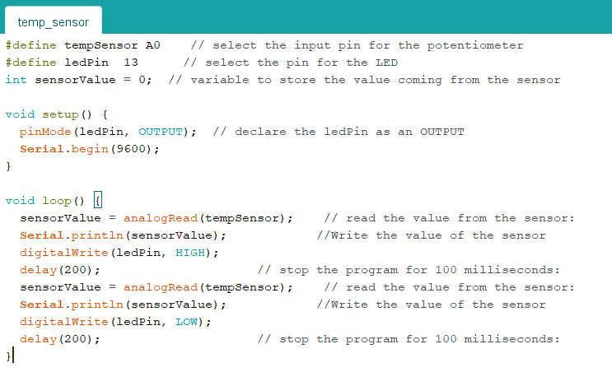Program test:

I also tested a digital temperature sensor, the connection is a little different, however there is still a voltage divider bridge to protect it. This time we have a digital pin, not an analogic one, and thanks to some library, I could write a program to have a temperature directly in degree Celsius without calibration.

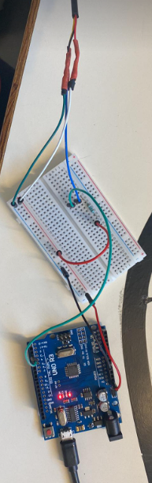

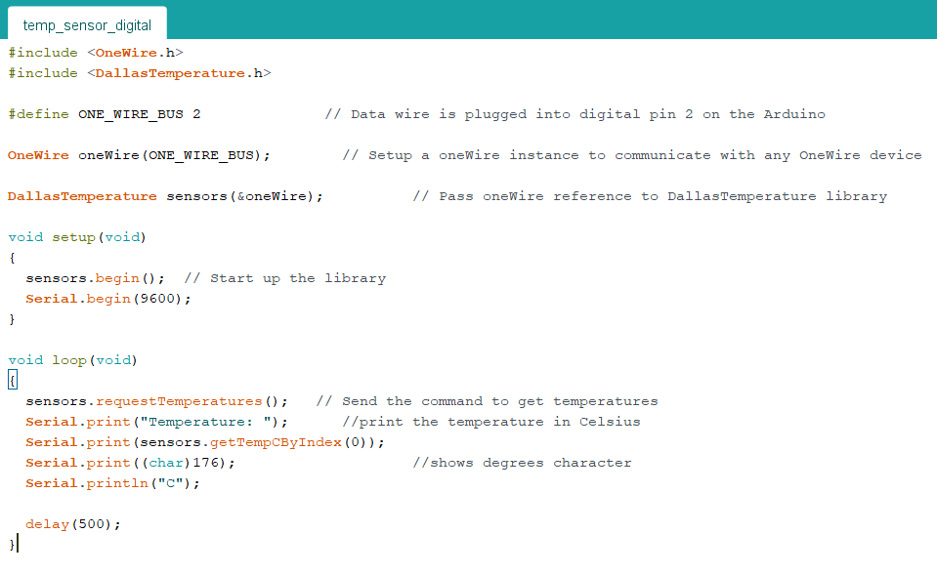Program test:

After that, I began to analyze the brushless motor. My objectives were to create a program in which I can reverse the motor, and know the rotation speed of it.

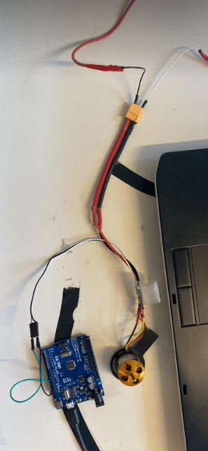I had at disposition one brushless motor and an ESC to control it. The issue was that to test it I need to check their datasheet to not damage it. I did it and found a datasheet, the one for the ESC BLheli-S. And I also checked if the servo motor TD-8135MG 180° was waterproof, however it only have splash water resistance.

I couldn’t test it but found a program for that, In a first time I will just control his speed, the inversion will come later

Program test:

